Sunday 25th June 2017

Name:

Class:

Due Date: Saturday 1st July 2017

Description: Description: Description: Description: Description: Description: Description: Description: http://www.timshen.truepath.com/christian/goldcrosswhite.gifCompleted Bible Study = 15 points,

Handed in by the due date = 5 points

**ACTS of the Apostles**

Year 5 – Bible Study 21 (Chapters 11 & 12)

**Monday** **26th June Read Chapter 11 verses 1 – 18**

**Peter questioned why he was with believing non Jews**

*1 Now the apostles and brethren who were in Judea heard that the Gentiles had also received the word of God. 2And when Peter came up to Jerusalem, those of the circumcision contended with him, 3saying, “You went in to uncircumcised men and ate with them!”*

### Peter Defends God’s Grace

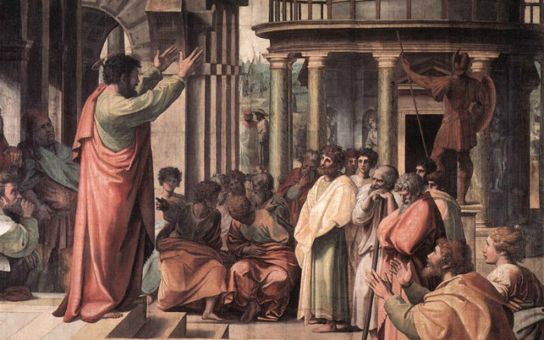*4But Peter explained it to them in order from the beginning, saying: 5“I was in the city of Joppa praying; and in a trance I saw a vision, an object descending like a great sheet, let down from heaven by four corners; and it came to me. 6When I observed it intently and considered, I saw four-footed animals of the earth, wild beasts, creeping things, and birds of the air. 7And I heard a voice saying to me, ‘Rise, Peter; kill and eat.’ 8But I said, ‘Not so, Lord! For nothing common or unclean has at any time entered my mouth.’ 9But the voice answered me again from heaven, ‘What God has cleansed you must not call common.’ 10Now this was done three times, and all were drawn up again into heaven. 11At that very moment, three men stood before the house where I was, having been sent to me from Caesarea. 12Then the Spirit told me to go with them, doubting nothing. Moreover these six brethren accompanied me, and we entered the man’s house. 13And he told us how he had seen an angel standing in his house, who said to him, ‘Send men to Joppa, and call for Simon whose surname is Peter, 14who will tell you words by which you and all your household will be saved.’ 15And as I began to speak, the Holy Spirit fell upon them, as upon us at the beginning. 16Then I remembered the word of the Lord, how He said, ‘John indeed baptized with water, but you shall be baptized with the Holy Spirit.’ 17If therefore God gave them the same gift as He gave us when we believed on the Lord Jesus Christ, who was I that I could withstand God?” 18When they heard these things they became silent; and they glorified God, saying, “Then God has also granted to the Gentiles repentance to life.”*

1. Match the word to its definition- Men of the Circumcision, Uncircumcised men

|  |  |
| --- | --- |
|  | Everybody that was not a Jew, also known as Gentiles |
|  | The Jewish people who were not supposed to live with other people. They were the first chosen people of God |

1. Remember last week’s homework? What was the name of the man that sent the three men from Cesarea?

a) Phillip

b) Cornelius

c) Cameron

d) Peter

**Tuesday 27th June Read Chapter 11 verses 19 – 21**

### Barnabas and Saul at Antioch

*19Now those who were scattered after the persecution that arose over Stephen traveled as far as Phoenicia, Cyprus, and Antioch, preaching the word to no one but the Jews only. 20But some of them were men from Cyprus and Cyrene, who, when they had come to Antioch, spoke to the Hellenists, preaching the Lord Jesus. 21And the hand of the Lord was with them, and a great number believed and turned to the Lord.*

1. Where were the three areas that the discpiples started preaching at?

(i)

(ii)

(iii)

1. According to Verse 21 why were the people that preached successful?

**Wednesday 28th June Read Chapter 11 verses 22 – 30**

**Disciples were now called Christians**

*22Then news of these things came to the ears of the church in Jerusalem, and they sent out Barnabas to go as far as Antioch. 23When he came and had seen the grace of God, he was glad, and encouraged them all that with purpose of heart they should continue with the Lord. 24For he was a good man, full of the Holy Spirit and of faith. And a great many people were added to the Lord. 25Then Barnabas departed for Tarsus to seek Saul. 26And when he had found him, he brought him to Antioch. So it was that for a whole year they assembled with the church and taught a great many people. And the disciples were first called Christians in Antioch.*

### Relief to Judea

*27And in these days prophets came from Jerusalem to Antioch. 28Then one of them, named Agabus, stood up and showed by the Spirit that there was going to be a great famine throughout all the world, which also happened in the days of Claudius Caesar. 29Then the disciples, each according to his ability, determined to send relief to the brethren dwelling in Judea. 30This they also did, and sent it to the elders by the hands of Barnabas and Saul.*

**The Prophets (Verse 27) refer to people that had a specific rank in the church. Remember at this early stage in the church almost** **everybody was blessed with a gift- the prophets received visions**

1. How long did Barnabas and Saul stay in Antioch to establish the church?

a) 2 months

b) 2 years

c) 1 month

d) 1 year

1. True or False…
2. The main church for the disciples was in Jerusalem. **True/False**
3. Antioch was a new church that was established by Saul and Barnabas. **True/False**
4. Agabus was originally from Jerusalem. **True/False**
5. Barnabas and Saul found out about the famine from Agabus. **True/False**
6. There was going to be a famine in only Antioch. **True/False**
7. When the disciples found out about the famine they did nothing to help. **True/False**.
8. Barnabas and Saul sent relief to the church in Judea. **True/False**

**Thursday 29th June Read Chapter 12 verses 1 – 11**

### *Herod’s Violence to the Church*

*Now about that time Herod the king stretched out his hand to harass some from the church. 2Then he killed James the brother of John with the sword. 3And because he saw that it pleased the Jews, he proceeded further to seize Peter also. Now it was during the Days of Unleavened Bread. 4So when he had arrested him, he put him in prison, and delivered him to four squads of soldiers to keep him, intending to bring him before the people after Passover.*

### *Peter Freed from Prison*

*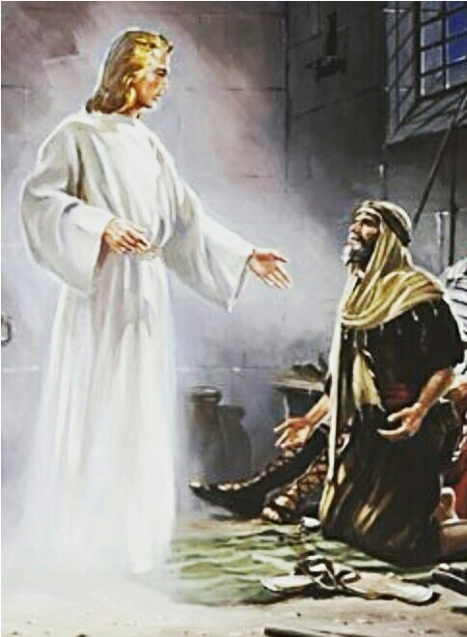5Peter was therefore kept in prison, but constant[*[*a*](https://www.biblegateway.com/passage/?search=Acts+12&version=NKJV#fen-NKJV-27343a)*] prayer was offered to God for him by the church. 6And when Herod was about to bring him out, that night Peter was sleeping, bound with two chains between two soldiers; and the guards before the door were keeping the prison. 7Now behold, an angel of the Lord stood by him, and a light shone in the prison; and he struck Peter on the side and raised him up, saying, “Arise quickly!” And his chains fell off his hands. 8Then the angel said to him, “Gird yourself and tie on your sandals”; and so he did. And he said to him, “Put on your garment and follow me.” 9So he went out and followed him, and did not know that what was done by the angel was real, but thought he was seeing a vision. 10When they were past the first and the second guard posts, they came to the iron gate that leads to the city, which opened to them of its own accord; and they went out and went down one street, and immediately the angel departed from him.*

*11And when Peter had come to himself, he said, “Now I know for certain that the Lord has sent His angel, and has delivered me from the hand of Herod and from all the expectation of the Jewish people.”*

1. Who caused the next persecution, and whom did he kill? What did he do to Peter?
2. What did the Angel tell Peter to do while in prison?
3. Kill the guards
4. Get dressed and stay in prison for three days
5. Get dressed and follow me
6. Get ready because the disciples are coming to get you

**Friday 30th June Read Chapter 12 verses 12 – 19**

*12So, when he had considered this, he came to the house of Mary, the mother of John whose surname was Mark, where many were gathered together praying. 13And as Peter knocked at the door of the gate, a girl named Rhoda came to answer. 14When she recognized Peter’s voice, because of her gladness she did not open the gate, but ran in and announced that Peter stood before the gate. 15But they said to her, “You are beside yourself!” Yet she kept insisting that it was so. So they said, “It is his angel.”*

*16Now Peter continued knocking; and when they opened the door and saw him, they were astonished. 17But motioning to them with his hand to keep silent, he declared to them how the Lord had brought him out of the prison. And he said, “Go, tell these things to James and to the brethren.” And he departed and went to another place.*

*18Then, as soon as it was day, there was no small stir among the soldiers about what had become of Peter. 19But when Herod had searched for him and not found him, he examined the guards and commanded that they should be put to death. And he went down from Judea to Caesarea, and stayed there.*

1. Where did Peter find the disciples and what were they doing?
2. Why didn’t Rhoda open the door for Peter?
3. She was scared
4. She thought she was being tricked by Herod’s guards
5. She was too excited
6. She wanted a second opinion of who the voice might be

**Saturday 1st July Read Chapter 12 verses 20 – 25**

### *Herod’s Violent Death*

*20Now Herod had been very angry with the people of Tyre and Sidon; but they came to him with one accord, and having made Blastus the king’s personal aide their friend, they asked for peace, because their country was supplied with food by the king’s country. 21So on a set day Herod, arrayed in royal apparel, sat on his throne and gave an oration to them. 22And the people kept shouting, “The voice of a god and not of a man!” 23Then immediately an angel of the Lord struck him, because he did not give glory to God. And he was eaten by worms and died. 24But the word of God grew and multiplied.*

### *Barnabas and Saul Appointed*

*25And Barnabas and Saul returned from Jerusalem when they had fulfilled their ministry, and they also took with them John whose surname was Mark.*

1. What caused God to be angry with Herod? What happened to Herod?
2. Using a few examples from this week, describe how we as Christians should treat each other.

**PARENTS SECTION:**

We kindly ask you as a parent to read (a little each day) in the Holy Bible with your family.

**Now email your answers to your teacher, choose ONE of the email addresses below.**

**What to do when you finish your Bible Study.**

Send it by email to your class email address or print and hand it to your servants next Sunday.

* Year 5B1 St Thomas[stthomas5b@gmail.com](mailto:stthomas5b@gmail.com) Class Servant- Uncle Andrew

(0416744100)

* Year 5B2 St Philip[saintphilip5g@gmail.com](mailto:saintphilip5g@gmail.com) Class Servant- Uncle Mark

(0413495921)

* Year 5G St Matthew [stmatthew5g@gmail.com](mailto:stmatthew5g@gmail.com) Class Servant – Aunty Dina

(0404604507)