C:\Documents and Settings\suzy\Local Settings\Temporary Internet Files\Content.IE5\3JXW24R5\MC900383922[1].wmfSunday 26th March, 2017

Name:

Class:

Finish Date: Saturday 25th March, 2017

Completed Bible Study = 15 points

Email Homework by the due date = 5 points

**Year 6 Bible Study John Chapters 20-21**

**For the questions below Highlight or change the font colour to choose the correct answer.**

* **MONDAY: Read John Chapter 20:1-18 and answer the questions:**

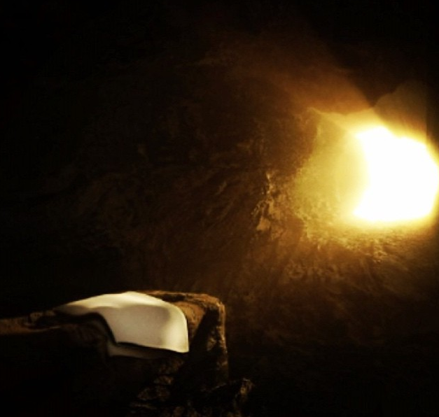***The Empty Tomb***

*20 Now on the first day of the week Mary Magdalene went to the tomb early, while it was still dark, and saw that the stone had been taken away from the tomb. 2 Then she ran and came to Simon Peter, and to the other disciple, whom Jesus loved, and said to them, “They have taken away the Lord out of the tomb, and we do not know where they have laid Him.”*

*3 Peter therefore went out, and the other disciple, and were going to the tomb. 4 So they both ran together, and the other disciple outran Peter and came to the tomb first. 5 And he, stooping down and looking in, saw the linen cloths lying there; yet he did not go in. 6 Then Simon Peter came, following him, and went into the tomb; and he saw the linen cloths lying there, 7 and the handkerchief that had been around His head, not lying with the linen cloths, but folded together in a place by itself. 8 Then the other disciple, who came to the tomb first, went in also; and he saw and believed. 9 For as yet they did not know the Scripture, that He must rise again from the dead. 10 Then the disciples went away again to their own homes.*

**Question 1**

Verse 2 says Simon Peter was with another disciple, and his description is “whom Jesus loved.” Who was he?

1. Judas
2. John
3. Matthew
4. James

* 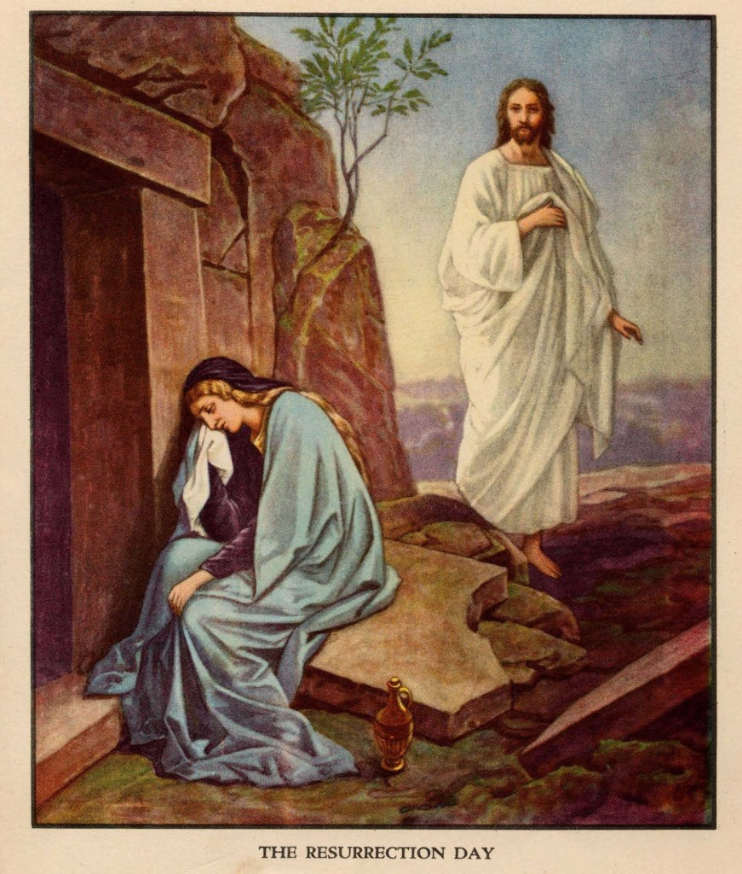**TUESDAY: Read John Chapter 20:11-18 and answer the questions:**

***Mary Magdalene Sees the Risen Lord***

*11 But Mary stood outside by the tomb weeping, and as she wept she stooped down and looked into the tomb. 12 And she saw two angels in white sitting, one at the head and the other at the feet, where the body of Jesus had lain. 13 Then they said to her, “Woman, why are you weeping?”*

*She said to them, “Because they have taken away my Lord, and I do not know where they have laid Him.”*

*14 Now when she had said this, she turned around and saw Jesus standing there, and did not know that it was Jesus. 15 Jesus said to her, “Woman, why are you weeping? Whom are you seeking?”*

*She, supposing Him to be the gardener, said to Him, “Sir, if You have carried Him away, tell me where You have laid Him, and I will take Him away.”*

*16 Jesus said to her, “Mary!”*

*She turned and said to Him,[a] “Rabboni!” (which is to say, Teacher).*

*17 Jesus said to her, “Do not cling to Me, for I have not yet ascended to My Father; but go to My brethren and say to them, ‘I am ascending to My Father and your Father, and to My God and your God.’”*

*18 Mary Magdalene came and told the disciples that she had seen the Lord,[b] and that He had spoken these things to her.*

**Question 2**

**True/ False**

|  |  |
| --- | --- |
| Mary was looking for Jesus in the tomb | True/ False |
| Mary was weeping | True/ False |
| There were angels in the tomb | True/ False |
| Mary did not recognise Jesus first because she did not look up | True/ False |
| Mary recognised Jesus after He said her name | True/ False |
| Rabboni means teacher | True/ False |
| Mary did not tell the other disciples that she had seen Jesus | True/ False |

* **WEDNESDAY: Read John Chapter 20:19- 23 and answer the questions:**

***The Apostles Commissioned***

*19 Then, the same day at evening, being the first day of the week, when the doors were shut where the disciples were assembled,[c] for fear of the Jews, Jesus came and stood in the midst, and said to them, “Peace be with you.” 20 When He had said this, He showed them His hands and His side. Then the disciples were glad when they saw the Lord.* 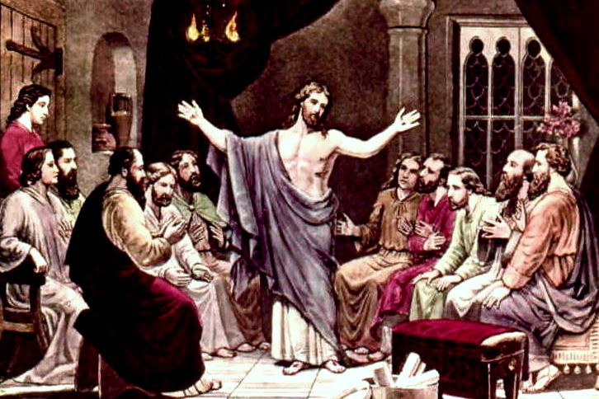

*21 So Jesus said to them again, “Peace to you! As the Father has sent Me, I also send you.” 22 And when He had said this, He breathed on them, and said to them, “Receive the Holy Spirit. 23 If you forgive the sins of any, they are forgiven them; if you retain the sins of any, they are retained.”*

**Question 3**

Highlight the correct word to complete the sentences

The disciples were sitting in a (locked/open room.) They were (afraid/not afraid) of the Jews blaming them for stealing the body of Jesus so they (hid/ stayed in the open.) Jesus appeared inside the room even though He (did/did not) knock on the door for the disciples to open it. When Jesus (breathed/spoke) on the disciples, they received the Holy Spirit and the ability to forgive sins.

* **THURSDAY: Read John Chapter 21:24-31 and answer the questions:**

***Seeing and Believing***

 *24 Now Thomas, called the Twin, one of the twelve, was not with them when Jesus came. 25 The other disciples therefore said to him, “We have seen the Lord.”*

*So he said to them, “Unless I see in His hands the print of the nails, and put my finger into the print of the nails, and put my hand into His side, I will not believe.”*

*26 And after eight days His disciples were again inside, and Thomas with them. Jesus came, the doors being shut, and stood in the midst, and said, “Peace to you!” 27 Then He said to Thomas, “Reach your finger here, and look at My hands; and reach your hand here, and put it into My side. Do not be unbelieving, but believing.”*

*28 And Thomas answered and said to Him, “My Lord and my God!”*

*29 Jesus said to him, “Thomas,[d] because you have seen Me, you have believed. Blessed are those who have not seen and yet have believed.”*

***That You May Believe***

*30 And truly Jesus did many other signs in the presence of His disciples, which are not written in this book; 31 but these are written that you may believe that Jesus is the Christ, the Son of God, and that believing you may have life in His name.*

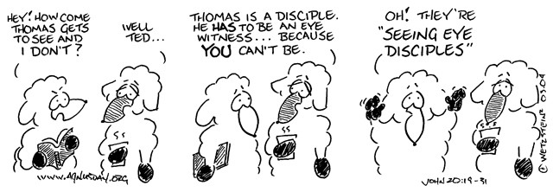

**Question 4**

Order the events that take place in this passage. The first one has been done for you.

**a)** Thomas believes

**b)** Jesus appeared again to the disciples after 8 days

**c)** Thomas told the disciples that the only way he would believe would be to put his finger into the mark of the nails

**d)** Thomas was not with the disciples when Jesus appeared the first time

**e)** Thomas sees Jesus and Jesus tells him to put his finger in His side

**f)** Thomas did not believe that the disciples has seen Jesus

|  |  |  |  |  |  |
| --- | --- | --- | --- | --- | --- |
| *d* |  |  |  |  |  |

* **FRIDAY: Read John Chapter 21:1-14 and answer the questions:**

***Breakfast by the Sea***

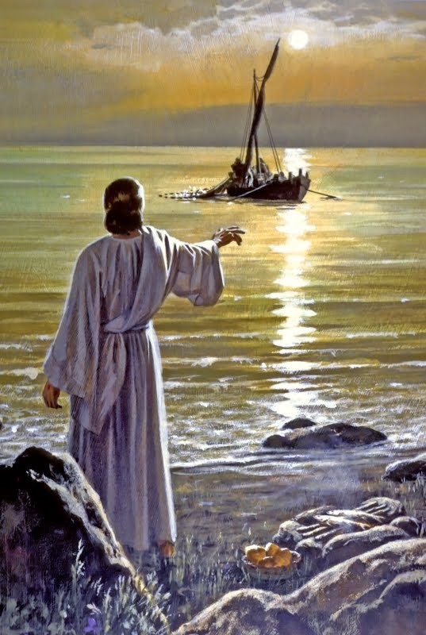 *After these things Jesus showed Himself again to the disciples at the Sea of Tiberias, and in this way He showed* Himself: *2Simon Peter, Thomas called the Twin, Nathanael of Cana in Galilee, the* sons *of Zebedee, and two others of His disciples were together. 3Simon Peter said to them, “I am going fishing.”*

*They said to him, “We are going with you also.” They went out and immediately[a] got into the boat, and that night they caught nothing. 4But when the morning had now come, Jesus stood on the shore; yet the disciples did not know that it was Jesus. 5Then Jesus said to them, “Children, have you any food?”*

*They answered Him, “No.”*

*6And He said to them, “Cast the net on the right side of the boat, and you will find* some.*” So they cast, and now they were not able to draw it in because of the multitude of fish.*

*7Therefore that disciple whom Jesus loved said to Peter, “It is the Lord!” Now when Simon Peter heard that it was the Lord, he put on* his *outer garment (for he had removed it), and plunged into the sea. 8But the other disciples came in the little boat (for they were not far from land, but about two hundred cubits), dragging the net with fish. 9 Then, as soon as they had come to land, they saw a fire of coals there, and fish laid on it, and bread. 10Jesus said to them, “Bring some of the fish which you have just caught.”*

*11Simon Peter went up and dragged the net to land, full of large fish, one hundred and fifty-three; and although there were so many, the net was not broken. 12Jesus said to them, “Come* and *eat breakfast.” Yet none of the disciples dared ask Him, “Who are You?”—knowing that it was the Lord. 13Jesus then came and took the bread and gave it to them, and likewise the fish.*

*14This* is *now the third time Jesus showed Himself to His disciples after He was raised from the dead.*

**Question 5**

Did the disciples recognise Jesus when they first saw Him at the shore? Yes/ No

**Question 6**

1. How many times In Verse 1 were the words “showed Himself” said?

1. What do you think “showed Himself” means?

* **SATURDAY: Read John Chapter 21:15-25 and answer the questions:**

***Jesus Restores Peter***

*15So when they had eaten breakfast, Jesus said to Simon Peter, “Simon,* son *of Jonah,[b] do you love Me more than these?”*

*He said to Him, “Yes, Lord; You know that I love You.”*

*He said to him, “Feed My lambs.”*

*16He said to him again a second time, “Simon,* son *of Jonah,[c] do you love Me?”*

*He said to Him, “Yes, Lord; You know that I love You.”*

*He said to him, “Tend My sheep.”*

*17He said to him the third time, “Simon,* son *of Jonah,[d] do you love Me?” Peter was grieved because He said to him the third time, “Do you love Me?”*

*And he said to Him, “Lord, You know all things; You know that I love You.”*

*Jesus said to him, “Feed My sheep. 18Most assuredly, I say to you, when you were younger, you girded yourself and walked where you wished; but when you are old, you will stretch out your hands, and another will gird you and carry* you *where you do not wish.” 19This He spoke, signifying by what death he would glorify God. And when He had spoken this, He said to him, “Follow Me.”*

***The Beloved Disciple and His Book***

*20Then Peter, turning around, saw the disciple whom Jesus loved following, who also had leaned on His breast at the supper, and said, “Lord, who is the one who betrays You?” 21Peter, seeing him, said to Jesus, “But Lord, what* about *this man?”*

*22Jesus said to him, “If I will that he remain till I come, what* is that *to you? You follow Me.”*

*23Then this saying went out among the brethren that this disciple would not die. Yet Jesus did not say to him that he would not die, but, “If I will that he remain till I come, what* is that *to you?”*

*24This is the disciple who testifies of these things, and wrote these things; and we know that his testimony is true.*

*25And there are also many other things that Jesus did, which if they were written one by one, I suppose that even the world itself* *could not contain the books that would be* *written. Amen.*

**Question 6**

Match the number with the event

153, 3, 1

|  |  |
| --- | --- |
|  | The number of people that know all things |
|  | The amount of times that Jesus asked Simon Peter if he loved Him |
|  | The amount of fish that were caught before breakfast |

**Question 8**

Who was the other person in the Bible that had to “stretch out” their hands, representing their death?

a) John

b) Jesus

c) Judas

d) Lazarus

**What to do when you finish your Bible Study.**

Send it by email to your class email address or print and hand it to your servants next Sunday.

* Year 6B1 St Mark [stmark6b1@gmail.com](mailto:stmark6b1@gmail.com) Class Servant- Uncle Fady (0424740775)
* Year 6B2 St Luke [stluke6b2@gmail.com](mailto:stluke6b2@gmail.com) Class Servant- Uncle Adel (0422884699)
* Year 6G St John[stjohn6g@gmail.com](mailto:stjohn6g@gmail.com) Class Servant- Aunty Nancy (0400212921)