C:\Documents and Settings\suzy\Local Settings\Temporary Internet Files\Content.IE5\3JXW24R5\MC900383922[1].wmfSunday 26th February, 2017

Name:

Class:

Finish Date: Saturday 4th March, 2017

Completed Bible Study = 15 points

Email Homework by due date = 5 extra points

**Year 6 Bible Study John Chapters 8-10**

**For the questions below Highlight or change the font colour to choose the correct answer.**

* Monday 26th February: Read John Chapter 8:1-12 and answer the questions:

***Chapter 8 - Scribes and Pharisees bring a woman caught in sin to Jesus***

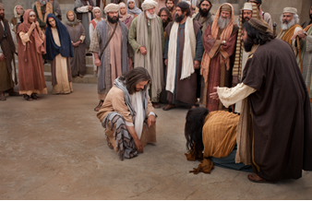*But Jesus went to the Mount of Olives. Now early in the morning He came again into the temple, and all the people came to Him; and He sat down and taught them. 3 Then the scribes and Pharisees brought to Him a woman caught in adultery. And when they had set her in the midst, 4 they said to Him, “Teacher, this woman was caught in adultery, in the very act. 5Now Moses, in the law, commanded us that such should be stoned. But what do You say?” 6 This they said, testing Him, that they might have* something *of which to accuse Him. But Jesus stooped down and wrote on the ground with* His *finger, as though He did not hear.*

*7 So when they continued asking Him, He raised Himself up and said to them, “He who is without sin among you, let him throw a stone at her first.” 8And again He stooped down and wrote on the ground. 9Then those who heard* it, *being convicted by* their *conscience, went out one by one, beginning with the oldest* even *to the last. And Jesus was left alone, and the woman standing in the midst. 10When Jesus had raised Himself up and saw no one but the woman, He said to her, “Woman, where are those accusers of yours? Has no one condemned you?”*

*11She said, “No one, Lord.” And Jesus said to her, “Neither do I condemn you; go and sin no more.”*

*12Then Jesus spoke to them again, saying, “I am the light of the world. He who follows Me shall not walk in darkness, but have the light of life.”*

**Question 1**

The Pharisees brought a sinful woman to Christ and asked Him what if He thinks the woman should be stoned. Christ responded, “He who has no sin, let him throw a stone first”.  What does this teach us?



* Tuesday 27th February: Read John Chapter 8:13-30 and answer the questions:

***Jesus Defends His Self-Witness***

*13The Pharisees therefore said to Him, “You bear witness of Yourself; Your witness is not true.”*

*14Jesus answered and said to them, “Even if I bear witness of Myself, My witness is true, for I know where I came from and where I am going; but you do not know where I come from and where I am going. 15You judge according to the flesh; I judge no one. 16And yet if I do judge, My judgment is true; for I am not alone, but I* am *with the Father who sent Me. 17It is also written in your law that the testimony of two men is true. 18I am One who bears witness of Myself, and the Father who sent Me bears witness of Me.”*

*19Then they said to Him, “Where is Your Father?”*

*Jesus answered, “You know neither Me nor My Father. If you had known Me, you would have known My Father also.”*

*20These words Jesus spoke in the treasury, as He taught in the temple; and no one laid hands on Him, for His hour had not yet come.*

*Jesus Predicts His Departure*

*21Then Jesus said to them again, “I am going away, and you will seek Me, and will die in your sin. Where I go you cannot come.”*

*22So the Jews said, “Will He kill Himself, because He says, ‘Where I go you cannot come’?”*

*23And He said to them, “You are from beneath; I am from above. You are of this world; I am not of this world. 24Therefore I said to you that you will die in your sins; for if you do not believe that I am* He, *you will die in your sins.”*

*25Then they said to Him, “Who are You?”*

*And Jesus said to them, “Just what I have been saying to you from the beginning. 26I have many things to say and to judge concerning you, but He who sent Me is true; and I speak to the world those things which I heard from Him.”*

*27They did not understand that He spoke to them of the Father.*

*28Then Jesus said to them, “When you lift up the Son of Man, then you will know that I am* He, *and* that *I do nothing of Myself; but as My Father taught Me, I speak these things. 29And He who sent Me is with Me. The Father has not left Me alone, for I always do those things that please Him.” 30As He spoke these words, many believed in Him.*

**Question 2**

If you look up Exodus 3:14, you will be reminded of God’s special name.

1. Who does God say He is?



1. Which verse does Jesus use the same name?



***Jesus is also known by the words shown in the poster below.***

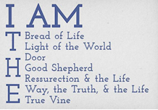

**Question 3**

In Jewish Law, two witnesses had to agree that something was true. Then this proved that it was true (Deuteronomy 19:15). Jesus had two witnesses that His words about himself were true:

Who were the two witnesses?

1. Himself and God
2. Himself and Joseph
3. Himself and His disciples
4. Mary and Joseph

**Question 4**

The Jews are struggling to understand who Jesus really is, and Jesus’ predictions about His own death. Jesus explains to them how they can be saved what is the one thing they need to do to be saved?



* Wednesday 28th February: Read John Chapter 8:31-59 and answer the questions:

***The Truth Shall Make You Free***

*31Then Jesus said to those Jews who believed Him, “If you abide in My word, you are My disciples indeed. 32And you shall know the truth, and the truth shall make you free.”*

*33They answered Him, “We are Abraham’s descendants, and have never been in bondage to anyone. How* can *You say, ‘You will be made free’?”*

*34Jesus answered them, “Most assuredly, I say to you, whoever commits sin is a slave of sin. 35And a slave does not abide in the house forever,* but *a son abides forever. 36Therefore if the Son makes you free, you shall be free indeed.*

**Question 5**

The Jews are unsure of what Jesus meant when He said *‘the truth shall make you free’*. What does Jesus promise to free us from?



**Question 6**

Find the verse in today’s passage that matches the statement.

|  |  |
| --- | --- |
| **Statement** | **Verse** |
| They answered, ‘But we are Abraham’s descendants. We have never been anybody’s slaves! But  you say that we will become free! What do you mean?’ |  |
| Then, Jesus spoke to the Jews who had believed in him. He said, ‘Obey me. Continue to follow what I teach you. If you do this, you are really my disciples |  |
| Jesus told them, ‘I tell you the truth! Anybody who sins is like a slave. Sin controls that person. |  |
| Then you will know the truth. And the truth will make you free.’ |  |
| A slave does not belong to a family permanently. However, a son belongs to a family permanently |  |
| If Jesus makes you free, then you are really free!’ |  |

***Abraham’s Seed and Satan’s***

*37“I know that you are Abraham’s descendants, but you seek to kill Me, because My word has no place in you. 38I speak what I have seen with My Father, and you do what you have seen with[l] your father.”*

*39They answered and said to Him, “Abraham is our father.”*

*Jesus said to them, “If you were Abraham’s children, you would do the works of Abraham. 40But now you seek to kill Me, a Man who has told you the truth which I heard from God. Abraham did not do this. 41You do the deeds of your father.”*

*Then they said to Him, “We were not born of fornication; we have one Father—God.”*

*42Jesus said to them, “If God were your Father, you would love Me, for I proceeded forth and came from God; nor have I come of Myself, but He sent Me. 43Why do you not understand My speech? Because you are not able to listen to My word. 44You are of* your *father the devil, and the desires of your father you want to do. He was a murderer from the beginning, and does not stand in the truth, because there is no truth in him. When he speaks a lie, he speaks from his own* resources, *for he is a liar and the father of it. 45But because I tell the truth, you do not believe Me. 46Which of you convicts Me of sin? And if I tell the truth, why do you not believe Me? 47He who is of God hears God’s words; therefore you do not hear, because you are not of God.*

**Question 7**

1. Christ came to earth to set as free. **True / False**
2. He who commits sin is a slave to sin  **True / False**

Jesus did not always do what pleased the Father. **True / False**

***Before Abraham Was, I AM***

*48Then the Jews answered and said to Him, “Do we not say rightly that You are a Samaritan and have a demon?”*

*49Jesus answered, “I do not have a demon; but I honor My Father, and you dishonor Me. 50And I do not seek My* own *glory; there is One who seeks and judges. 51Most assuredly, I say to you, if anyone keeps My word he shall never see death.”*

*52Then the Jews said to Him, “Now we know that You have a demon! Abraham is dead, and the prophets; and You say, ‘If anyone keeps My word he shall never taste death.’ 53Are You greater than our father Abraham, who is dead? And the prophets are dead. Who do You make Yourself out to be?”*

*54Jesus answered, “If I honor Myself, My honor is nothing. It is My Father who honors Me, of whom you say that He is your[m] God. 55Yet you have not known Him, but I know Him. And if I say, ‘I do not know Him,’ I shall be a liar like you; but I do know Him and keep His word. 56Your father Abraham rejoiced to see My day, and he saw* it *and was glad.”*

*57Then the Jews said to Him, “You are not yet fifty years old, and have You seen Abraham?”*

*58Jesus said to them, “Most assuredly, I say to you, before Abraham was, I AM.”*

*59Then they took up stones to throw at Him; but Jesus hid Himself and went out of the temple,[n] going through the midst of them, and so passed by.*

**Question 8**

John 8 verse 58 is one of the most powerful statements uttered by Jesus: *Jesus said to them, “Most assuredly, I say to you, before Abraham was, I AM.”*

The Jews were completely confused. How could Jesus have existed before Abraham and how could He declare equality with God?!



In verse 59 what did the Jews try to do to Jesus?

* Thursday 29th February: Read John Chapter 9:1-41 and answer the questions:

**Chapter 9 - A Man Born Blind Receives Sight**

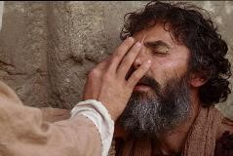*Now as Jesus passed by, He saw a man who was blind from birth.* ***2****And His disciples asked Him, saying, “Rabbi, who sinned, this man or his parents, that he was born blind?”*

*3**Jesus answered, “Neither this man nor his parents sinned, but that the works of God should be revealed in him.* ***4****I[a] must work the works of Him who sent Me while it is day; the night is coming when no one can work.* ***5****As long as I am in the world, I am the light of the world.”*

***6****When He had said these things, He spat on the ground and made clay with the saliva; and He anointed the eyes of the blind man with the clay.* ***7****And He said to him, “Go, wash in the pool of Siloam” (which is translated, Sent). So he went and washed, and came back seeing.*

***8****Therefore the neighbors and those who previously had seen that he was blind[b] said, “Is not this he who sat and begged?”*

***9****Some said, “This is he.” Others said, “He is like him.”[c]*

*He said, “I am he.”*

***10****Therefore they said to him, “How were your eyes opened?”*

***11****He answered and said, “A Man called Jesus made clay and anointed my eyes and said to me, ‘Go to the pool of[d] Siloam and wash.’ So I went and washed, and I received sight.”*

***12****Then they said to him, “Where is He?”*

*He said, “I do not know.”*

**Watch the video link below to tell you this beautiful story showing the love and mercy of our Lord Jesus.**

<https://www.youtube.com/watch?v=Uo9ILFTVdhQ>

**Question 9**

The man described in today’s reading had been born blind. So the disciples believed that either he or his parents had sinned. Jesus told them in this particular case, the man’s sins or his parent’s sins were not the cause.  What was the cause of this man’s blindness?



**What should this story remind us of?**

*That good people suffer, too. Problems can also provide an opportunity for God to show His power in a person’s life. In this man’s case, which is what actually happened. It reminds people that Jesus can cure spiritual blindness, too.*

**The Pharisees Excommunicate the Healed Man**

***13****They brought him who formerly was blind to the Pharisees.* ***14****Now it was a Sabbath when Jesus made the clay and opened his eyes.* ***15****Then the Pharisees also asked him again how he had received his sight. He said to them, “He put clay on my eyes, and I washed, and I see.”*

***16****Therefore some of the Pharisees said, “This Man is not from God, because He does not keep the Sabbath.”*

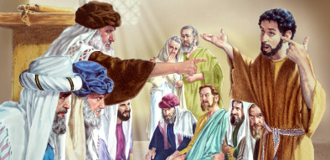*Others said, “How can a man who is a sinner do such signs?” And there was a division among them.*

***17****They said to the blind man again, “What do you say about Him because He opened your eyes?”*

*He said, “He is a prophet.”*

***18****But the Jews did not believe concerning him, that he had been blind and received his sight, until they called the parents of him who had received his sight.* ***19****And they asked them, saying, “Is this your son, who you say was born blind? How then does he now see?”*

***20****His parents answered them and said, “We know that this is our son, and that he was born blind;* ***21****but by what means he now sees we do not know, or who opened his eyes we do not know. He is of age; ask him. He will speak for himself.”* ***22****His parents said these things because they feared the Jews, for the Jews had agreed already that if anyone confessed that He was Christ, he would be put out of the synagogue.* ***23****Therefore his parents said, “He is of age; ask him.”*

***24****So they again called the man who was blind, and said to him, “Give God the glory! We know that this Man is a sinner.”*

***25****He answered and said, “Whether He is a sinner or not I do not know. One thing I know: that though I was blind, now I see.”*

***26****Then they said to him again, “What did He do to you? How did He open your eyes?”*

***27****He answered them, “I told you already, and you did not listen. Why do you want to hear it again? Do you also want to become His disciples?”*

***28****Then they reviled him and said, “You are His disciple, but we are Moses’ disciples.* ***29****We know that God spoke to Moses; as for this fellow, we do not know where He is from.”*

***30****The man answered and said to them, “Why, this is a marvelous thing, that you do not know where He is from; yet He has opened my eyes!* ***31****Now we know that God does not hear sinners; but if anyone is a worshiper of God and does His will, He hears him.* ***32****Since the world began it has been unheard of that anyone opened the eyes of one who was born blind.* ***33****If this Man were not from God, He could do nothing.”*

***34****They answered and said to him, “You were completely born in sins, and are you teaching us?” And they cast him out.*

*True Vision and True Blindness*

***35****Jesus heard that they had cast him out; and when He had found him, He said to him, “Do you believe in the Son of God?”[e]*

***36****He answered and said, “Who is He, Lord, that I may believe in Him?”*

***37****And Jesus said to him, “You have both seen Him and it is He who is talking with you.”*

***38****Then he said, “Lord, I believe!” And he worshiped Him.*

***39****And Jesus said, “For judgment I have come into this world, that those who do not see may see, and that those who see may be made blind.”*

***40****Then some of the Pharisees who were with Him heard these words, and said to Him, “Are we blind also?”*

***41****Jesus said to them, “If you were blind, you would have no sin; but now you say, ‘We see.’ Therefore your sin remains.*

**Question 10**

On what day did Jesus heal the blind man? According to the Jews it was unlawful to heal on this day.



**Question 11**

Why did the blind man’s parents tell the Pharisees that their son could speak for himself?



**Question 12**

Jesus said the blind man was not born blind because of sin, but was born blind so that the works of God should be revealed. How did this man reveal the beautiful work of God?



**Question 13**

In verse 35 “Jesus heard **they** cast **him** out”. Who are **“they”** and **“him”?**

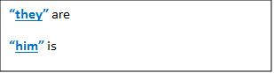

* Friday 30th February: Read John Chapter 10:1-21 and answer the questions:

***Chapter 10 Jesus the True Shepherd***

***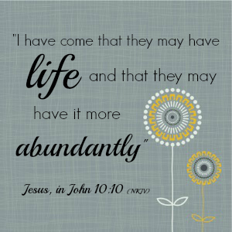****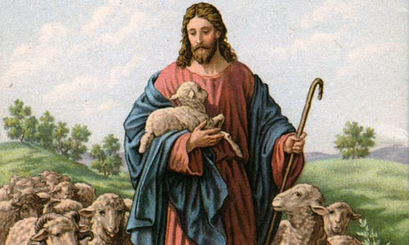“Most assuredly, I say to you, he who does not enter the sheepfold by the door, but climbs up some other way, the same is a thief and a robber.* ***2****But he who enters by the door is the shepherd of the sheep.* ***3****To him the doorkeeper opens, and the sheep hear his voice; and he calls his own sheep by name and leads them out.* ***4****And when he brings out his own sheep, he goes before them; and the sheep follow him, for they know his voice.* ***5****Yet they will by no means follow a stranger, but will flee from him, for they do not know the voice of strangers.”* ***6****Jesus used this illustration, but they did not understand the things which He spoke to them.*

**Jesus the Good Shepherd**

***7****Then Jesus said to them again, “Most assuredly, I say to you, I am the door of the sheep.* ***8****All who ever came before Me[a] are thieves and robbers, but the sheep did not hear them.* ***9****I am the door. If anyone enters by Me, he will be saved, and will go in and out and find pasture.* ***10****The thief does not come except to steal, and to kill, and to destroy. I have come that they may have life, and that they may have it more abundantly.*

***11****“I am the good shepherd. The good shepherd gives His life for the sheep.* ***12****But a hireling, he who is not the shepherd, one who does not own the sheep, sees the wolf coming and leaves the sheep and flees; and the wolf catches the sheep and scatters them.* ***13****The hireling flees because he is a hireling and does not care about the sheep.* ***14****I am the good shepherd; and I know My sheep, and am known by My own.* ***15****As the Father knows Me, even so I know the Father; and I lay down My life for the sheep.* ***16****And other sheep I have which are not of this fold; them also I must bring, and they will hear My voice; and there will be one flock and one shepherd.*

***17****“Therefore My Father loves Me, because I lay down My life that I may take it again.* ***18****No one takes it from Me, but I lay it down of Myself. I have power to lay it down, and I have power to take it again. This command I have received from My Father.”*

***19****Therefore there was a division again among the Jews because of these sayings.* ***20****And many of them said, “He has a demon and is mad. Why do you listen to Him?”*

***21****Others said, “These are not the words of one who has a demon. Can a demon open the eyes of the blind?”*

**Question 14**

If we know the voice of the Shepherd (Jesus) what should we do when we hear the voice of a stranger (the devil) telling us to follow him?

**Question 15**

What do we call these short stories that Jesus used to illustrate things that people did not understand?

* 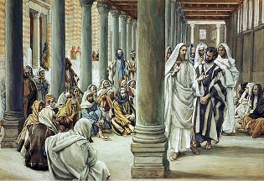Saturday 31st February: Read John Chapter 10:22-40 and answer the questions:

**The Shepherd Knows His Sheep**

***22****Now it was the Feast of Dedication in Jerusalem, and it was winter.* ***23****And Jesus walked in the temple, in Solomon’s porch.* ***24****Then the Jews surrounded Him and said to Him, “How long do You keep us in doubt? If You are the Christ, tell us plainly.”*

***25****Jesus answered them, “I told you, and you do not believe. The works that I do in My Father’s name, they bear witness of Me.* ***26****But you do not believe, because you are not of My sheep, as I said to you.[b]* ***27****My sheep hear My voice, and I know them, and they follow Me.* ***28****And I give them eternal life, and they shall never perish; neither shall anyone snatch them out of My hand.* ***29****My Father, who has given them to Me, is greater than all; and no one is able to snatch them out of My Father’s hand.* ***30****I and My Father are one.”*

***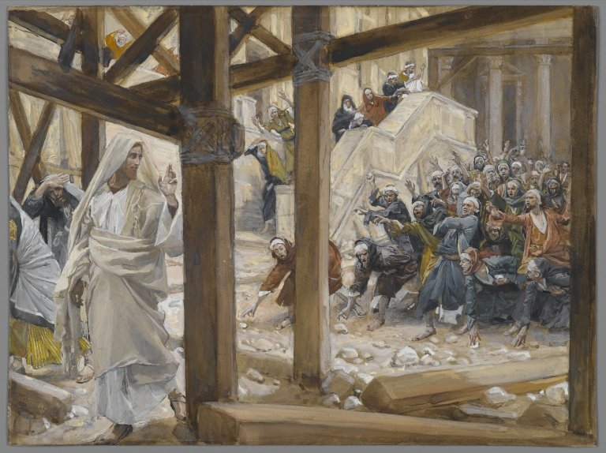*Renewed Efforts to Stone Jesus**

***31****Then the Jews took up stones again to stone Him.* ***32****Jesus answered them, “Many good works I have shown you from My Father. For which of those works do you stone Me?”*

***33****The Jews answered Him, saying, “For a good work we do not stone You, but for blasphemy, and because You, being a Man, make Yourself God.”*

***34****Jesus answered them, “Is it not written in your law, ‘I said, “You are gods”’?[c]* ***35****If He called them gods, to whom the word of God came (and the Scripture cannot be broken),* ***36****do you say of Him whom the Father sanctified and sent into the world, ‘You are blaspheming,’ because I said, ‘I am the Son of God’?* ***37****If I do not do the works of My Father, do not believe Me;* ***38****but if I do, though you do not believe Me, believe the works, that you may know and believe[d] that the Father is in Me, and I in Him.”* ***39****Therefore they sought again to seize Him, but He escaped out of their hand.*

**Do you know what the Feast of Dedication is?**

*The Feast of Dedication is today known as Hanukkah, it is a festival that is celebrated in December. It celebrates the Temple of Jerusalem being used for burnt offerings, and as a general temple for the Jewish people. This was the SAME temple that Jesus started preaching in throughout this passage*

**Question 16**

Fill in the blanks

And I give them life, and they shall perish;

neither shall anyone them out of my (Verse 29)

**The Believers Beyond Jordan**

***40****And He went away again beyond the Jordan to the place where John was baptizing at first, and there He stayed.* ***41****Then many came to Him and said, “John performed no sign, but all the things that John spoke about this Man were true.”* ***42****And many believed in Him there.*

**Question 17**

Why do you think Jesus went to the river Jordan? How did the people their react to Him?