C:\Documents and Settings\suzy\Local Settings\Temporary Internet Files\Content.IE5\3JXW24R5\MC900383922[1].wmfSunday 19th February, 2017

Name:

Class:

Finish Date: Saturday 25th February, 2017

Completed Bible Study = 15 points

Email Homework by the due date = 5 points

**Year 6 Bible Study John Chapter 5**

**For the questions below Highlight or change the font colour to choose the correct answer.**

* Monday 20th February: Read **John Chapter 5:1-23** and answer the questions:

**The Healing at the Pool**

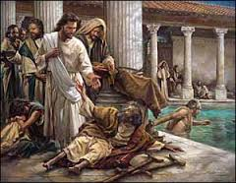*After this there was a feast of the Jews, and Jesus went up to Jerusalem. 2 Now there is in Jerusalem by the Sheep* Gate *a pool, which is called in Hebrew, Bethesda, having five porches. 3 In these lay a great multitude of sick people, blind, lame, paralyzed, waiting for the moving of the water. 4 For an angel went down at a certain time into the pool and stirred up the water; then whoever stepped in first, after the stirring of the water, was made well of whatever disease he had. 5 Now a certain man was there who had an infirmity thirty-eight years. 6When Jesus saw him lying there, and knew that he already had been* in that condition *a long time, He said to him, “Do you want to be made well?”*

*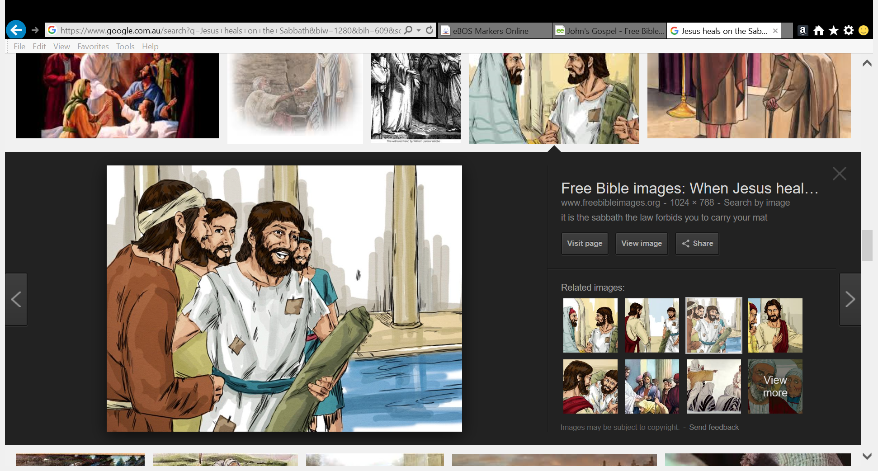7The sick man answered Him, “Sir, I have no man to put me into the pool when the water is stirred up; but while I am coming, another steps down before me.”*

*8Jesus said to him, “Rise, take up your bed and walk.” 9And immediately the man was made well, took up his bed, and walked.*

*And that day was the Sabbath. 10The Jews therefore said to him who was cured, “It is the Sabbath; it is not lawful for you to carry your bed.”*

*11He answered them, “He who made me well said to me, ‘Take up your bed and walk.’”*

*12Then they asked him, “Who is the Man who said to you, ‘Take up your bed and walk’?” 13But the one who was healed did not know who it was, for Jesus had withdrawn, a multitude being in* that *place. 14Afterward Jesus found him in the temple, and said to him, “See, you have been made well. Sin no more, lest a worse thing come upon you.”*

*15The man departed and told the Jews that it was Jesus who had made him well.*

**Question 1**

Where was Jesus going before He met the paralyzed man at the pool?

**Did you know all adult Jewish males go to 3 festivals a year?**

*These festivals were called:*

* *The Passover- an important holy day for the Jews. They eat a special meal on this day every year. This is to remember that God freed them. Before God freed them, they were slaves in the country called Egypt. This happened at the time of Moses. So Passover became an important holiday. At the time of Jesus, the Jews came to Jerusalem to pray in the Temple. And families shared a special meal together.*
* *Pentecost- a festival when the Jews thank God for their food.*
* *Festival of Shelters – a festival in the autumn, after people had harvested the fruit. People camped in tents to remind themselves of the time when the Israelites had lived in the desert.*

*Many experts on the *New Testament think that John was referring to Pentecost in this verse.*

**Question 2**

In John’s Gospel, John showed that Jesus attended these special Jewish festivals. Why do you think John did this?

To show Jesus followed the rules about this. It is clear that he loved to worship God with his own people. **TRUE/FALSE**

**Question 3**

How was the paralysed man at the pool cured?

1. Jesus put him in the water
2. The man had faith Jesus would heal him.
3. Jesus wanted to perform a miracle because of the festival.

**Honor the Father and the Son**

*16For this reason the Jews persecuted Jesus, and sought to kill Him, because He had done these things on the Sabbath. 17But Jesus answered them, “My Father has been working until now, and I have been working.”*

*18Therefore the Jews sought all the more to kill Him, because He not only broke the Sabbath, but also said that God was His Father, making Himself equal with God. 19Then Jesus answered and said to them, “Most assuredly, I say to you, the Son can do nothing of Himself, but what He sees the Father do; for whatever He does, the Son also does in like manner. 20For the Father loves the Son, and shows Him all things that He Himself does; and He will show Him greater works than these, that you may marvel. 21For as the Father raises the dead and gives life to* them, *even so the Son gives life to whom He will. 22For the Father judges no one, but has committed all judgment to the Son, 23that all should honor the Son just as they honor the Father. He who does not honor the Son does not honor the Father who sent Him.*

**Question 4**

Why did the Jewish Leaders persecute Jesus? There are 2 reasons

**Question 5**

1. Jesus is equal with God. **TRUE/FALSE**
2. Jesus said that God His Father, never stopped his work. So that was why Jesus had to work too. Even on the Sabbath, God continued to love people. So when Jesus cured people on the Sabbath, he was doing God’s work. **TRUE/FALSE**
3. Jesus was saying that His work was really God’s work. And he was saying that he was equal with God. **TRUE/FALSE**
4. God didn’t make Jesus the judge of every person who has ever lived on the earth. **TRUE/FALSE**

* Tuesday 21st February Read **John Chapter 5:24 – 47**

**Life and Judgment Are Through the Son**

*24“Most assuredly, I say to you, he who hears My word and believes in Him who sent Me has everlasting life, and shall not come into judgment, but has passed from death into life. 25Most assuredly, I say to you, the hour is coming, and now is, when the dead will hear the voice of the Son of God; and those who hear will live. 26For as the Father has life in Himself, so He has granted the Son to have life in Himself, 27and has given Him authority to execute judgment also, because He is the Son of Man. 28Do not marvel at this; for the hour is coming in which all who are in the graves will hear His voice 29and come forth—those who have done good, to the resurrection of life, and those who have done evil, to the resurrection of condemnation. 30I can of Myself do nothing. As I hear, I judge; and My judgment is righteous, because I do not seek My own will but the will of the Father who sent Me.*

**Question 6**

Choose the verse from the above passage to match the statement.

|  |  |
| --- | --- |
| Verse | Statement |
|  | The Father has the power to give life. And he has given that same power to the Son. |
|  | Do not be surprised! There will be a time when dead people will hear the voice of God’s Son. |
|  | I tell you the truth. In order to have eternal life, people must hear my words. Then they must believe in the Father, who sent me. God will never condemn such people because of their sins. They have already passed out of death and into life. |
|  | Also the Father has given to his Son the authority to judge everyone. This is because His Son is the Son of Man. |
|  | I cannot do anything by means of my own authority. The Father, who sent me, tells me how to judge. So my judgement is fair because I obey him. I do not try to do what I want. I do only what he wants.’ |
|  | I tell you the truth. Soon, in fact now, dead people will hear the voice of God’s Son. Everyone who hears it will live! |
|  | And they will come out of their graves. They will become alive again. All those who have done good things will receive eternal life. But all those who have done bad things will become alive in order to receive punishment. |

**The Fourfold Witness**

*31 “If I bear witness of Myself, My witness is not true. 32 There is another who bears witness of Me, and I know that the witness which He witnesses of Me is true. 33 You have sent to John, and he has borne witness to the truth. 34 Yet I do not receive testimony from man, but I say these things that you may be saved. 35 He was the burning and shining lamp, and you were willing for a time to rejoice in his light. 36 But I have a greater witness than John’s; for the works which the Father has given Me to finish—the very works that I do—bear witness of Me, that the Father has sent Me. 37 And the Father Himself, who sent Me, has testified of Me. You have neither heard His voice at any time, nor seen His form. 38 But you do not have His word abiding in you, because whom He sent, Him you do not believe. 39 You search the Scriptures, for in them you think you have eternal life; and these are they which testify of Me. 40 But you are not willing to come to Me that you may have life.*

*41 “I do not receive honor from men. 42 But I know you, that you do not have the love of God in you. 43 I have come in My Father’s name, and you do not receive Me; if another comes in his own name, him you will receive. 44 How can you believe, who receive honor from one another, and do not seek the honor that comes from the only God? 45 Do not think that I shall accuse you to the Father; there is one who accuses you—Moses, in whom you trust. 46 For if you believed Moses, you would believe Me; for he wrote about Me. 47 But if you do not believe his writings, how will you believe My words?”*

**Question 7**

Jesus compared John the Baptist to a lamp (verse 35)

Choose the best answer to help explain this.

1. John loved to burn candles.
2. A lamp cannot produce light by itself. It needs someone to light it. In the same way, John the Baptist was not the light of the world. But God had sent him to tell people about Jesus. Jesus is the real light of the world.
3. John loved to light a lamp when Jesus was around.

Wednesday 30th November: Read **John Chapter 6:1 -21**  and answer the questions:

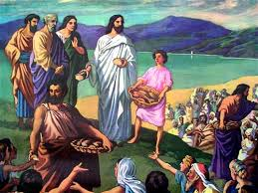**Feeding the Five Thousand**

*After these things Jesus went over the Sea of Galilee, which is the Sea of Tiberias. 2 Then a great multitude followed Him, because they saw His signs which He performed on those who were diseased. 3 And Jesus went up on the mountain, and there He sat with His disciples.*

*4 Now the Passover, a feast of the Jews, was near. 5 Then Jesus lifted up His eyes, and seeing a great multitude coming toward Him, He said to Philip, “Where shall we buy bread, that these may eat?” 6 But this He said to test him, for He Himself knew what He would do.*

*7 Philip answered Him, “Two hundred denarii worth of bread is not sufficient for them, that every one of them may have a little.”*

*8 One of His disciples, Andrew, Simon Peter’s brother, said to Him, 9 “There is a lad here who has five barley loaves and two small fish, but what are they among so many?”*

*10 Then Jesus said, “Make the people sit down.” Now there was much grass in the place. So the men sat down, in number about five thousand. 11 And Jesus took the loaves, and when He had given thanks He distributed them to the disciples, and the disciples[a] to those sitting down; and likewise of the fish, as much as they wanted. 12 So when they were filled, He said to His disciples, “Gather up the fragments that remain, so that nothing is lost.” 13 Therefore they gathered them up, and filled twelve baskets with the fragments of the five barley loaves which were left over by those who had eaten. 14 Then those men, when they had seen the sign that Jesus did, said, “This is truly the Prophet who is to come into the world.”*

**Question 2**

Why did Jesus ask Philip, *“Where shall we buy bread for these people to eat?”*

1. Because Philip would know where to buy the food
2. Jesus knew that they were tired and hungry. He would need to do a miracle in order to feed so many people. But he wanted to see if Philip knew this.
3. Philip knew from whom to borrow money from to pay for the food.
4. Philip knew Jesus would perform a miracle

**Question 4**

1. How much food did Jesus start off with before He fed the crowd?
2. How much food did Jesus end up with when the crowd was completely satisfied with what they ate?

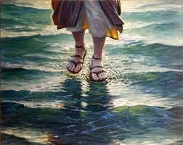**Jesus Walks on the Sea**

*15 Therefore when Jesus perceived that they were about to come and take Him by force to make Him king, He departed again to the mountain by Himself alone.*

*16 Now when evening came, His disciples went down to the sea, 17 got into the boat, and went over the sea toward Capernaum. And it was already dark, and Jesus had not come to them. 18 Then the sea arose because a great wind was blowing. 19 So when they had rowed about three or four miles,[b] they saw Jesus walking on the sea and drawing near the boat; and they were afraid. 20 But He said to them, “It is I; do not be afraid.” 21 Then they willingly received Him into the boat, and immediately the boat was at the land where they were going.*

**Question 5**

Number the pictures below in the correct order as they appear in the passage above:

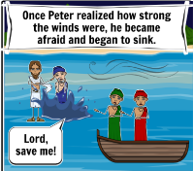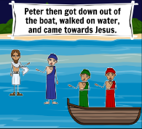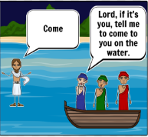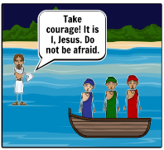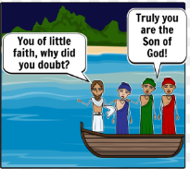

Thursday 1st December: **John Chapter 6: 22-71** and answer the questions:

**The Bread from Heaven**

*22 On the following day, when the people who were standing on the other side of the sea saw that there was no other boat there, except that one which His disciples had entered,[c] and that Jesus had not entered the boat with His disciples, but His disciples had gone away alone— 23 however, other boats came from Tiberias, near the place where they ate bread after the Lord had given thanks— 24 when the people therefore saw that Jesus was not there, nor His disciples, they also got into boats and came to Capernaum, seeking Jesus. 25 And when they found Him on the other side of the sea, they said to Him, “Rabbi, when did You come here?”*

*26 Jesus answered them and said, “Most assuredly, I say to you, you seek Me, not because you saw the signs, but because you ate of the loaves and were filled. 27 Do not labor for the food which perishes, but for the food which endures to everlasting life, which the Son of Man will give you, because God the Father has set His seal on Him.”*

*28 Then they said to Him, “What shall we do, that we may work the works of God?”*

*29 Jesus answered and said to them, “This is the work of God, that you believe in Him whom He sent.”*

*30 Therefore they said to Him, “What sign will You perform then, that we may see it and believe You? What work will You do? 31 Our fathers ate the manna in the desert; as it is written, ‘He gave them bread from heaven to eat.’”[d]*

*32 Then Jesus said to them, “Most assuredly, I say to you, Moses did not give you the bread from heaven, but My Father gives you the true bread from heaven. 33 For the bread of God is He who comes down from heaven and gives life to the world.”*

*34 Then they said to Him, “Lord, give us this bread always.”*

*35 And Jesus said to them, “I am the bread of life. He who comes to Me shall never hunger, and he who believes in Me shall never thirst. 36 But I said to you that you have seen Me and yet do not believe. 37 All that the Father gives Me will come to Me, and the one who comes to Me I will by no means cast out. 38 For I have come down from heaven, not to do My own will, but the will of Him who sent Me. 39 This is the will of the Father who sent Me, that of all He has given Me I should lose nothing, but should raise it up at the last day. 40 And this is the will of Him who sent Me, that everyone who sees the Son and believes in Him may have everlasting life; and I will raise him up at the last day.”*

**Question 6**

For each statement write if it relates to physical or Spiritual Bread

|  |  |
| --- | --- |
| Statement | Physical or Spiritual Bread |
| Do not work for bread that goes mouldy |  |
| The Son of Man will give you this |  |
| Food that endures to eternal life |  |
| The men ate the loaves until they were full. |  |
| Moses gave them the bread from heaven (manna). |  |
| “I am the bread of life. Whoever comes to me will never go hungry” |  |
| Our ancestors ate the manna in the wilderness |  |
| For the bread of God is the bread that comes down from heaven and gives life to the world.” |  |

**Rejected by His Own**

*41The Jews then complained about Him, because He said, “I am the bread which came down from heaven.” 42And they said, “Is not this Jesus, the son of Joseph, whose father and mother we know? How is it then that He says, ‘I have come down from heaven’?”*

***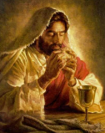****43Jesus therefore answered and said to them, “Do not murmur among yourselves. 44No one can come to Me unless the Father who sent Me draws him; and I will raise him up at the last day. 45It is written in the prophets, ‘And they shall all be taught by God.’[e] Therefore everyone who has heard and learned[f] from the Father comes to Me. 46Not that anyone has seen the Father, except He who is from God; He has seen the Father. 47Most assuredly, I say to you, he who believes in Me[g] has everlasting life. 48I am the bread of life. 49Your fathers ate the manna in the wilderness, and are dead. 50This is the bread which comes down from heaven, that one may eat of it and not die. 51I am the living bread which came down from heaven. If anyone eats of this bread, he will live forever; and the bread that I shall give is My flesh, which I shall give for the life of the world.”*

*52The Jews therefore quarreled among themselves, saying, “How can this Man give us His flesh to eat?”*

*53Then Jesus said to them, “Most assuredly, I say to you, unless you eat the flesh of the Son of Man and drink His blood, you have no life in you. 54Whoever eats My flesh and drinks My blood has eternal life, and I will raise him up at the last day. 55For My flesh is food indeed,[h] and My blood is drink indeed. 56He who eats My flesh and drinks My blood abides in Me, and I in him. 57As the living Father sent Me, and I live because of the Father, so he who feeds on Me will live because of Me. 58This is the bread which came down from heaven—not as your fathers ate the manna, and are dead. He who eats this bread will live forever.”*

*59These things He said in the synagogue as He taught in Capernaum.*

*Many Disciples Turn Away*

*60Therefore many of His disciples, when they heard this, said, “This is a hard saying; who can understand it?”*

*61When Jesus knew in Himself that His disciples complained about this, He said to them, “Does this offend you? 62What then if you should see the Son of Man ascend where He was before? 63It is the Spirit who gives life; the flesh profits nothing. The words that I speak to you are spirit, and they are life. 64But there are some of you who do not believe.” For Jesus knew from the beginning who they were who did not believe, and who would betray Him. 65And He said, “Therefore I have said to you that no one can come to Me unless it has been granted to him by My Father.”*

*66From that time many of His disciples went back and walked with Him no more. 67Then Jesus said to the twelve, “Do you also want to go away?”*

*68But Simon Peter answered Him, “Lord, to whom shall we go? You have the words of eternal life. 69Also we have come to believe and know that You are the Christ, the Son of the living God.”[i]*

*70Jesus answered them, “Did I not choose you, the twelve, and one of you is a devil?” 71He spoke of Judas Iscariot, the son of Simon, for it was he who would betray Him, being one of the twelve.*

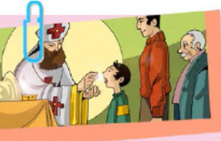**Question 7**

If we eat of Christ’s flesh and drink of His blood what shall happen? Underline the correct answer.

a) We abide in Christ

b) Be full

c) Hunger again

**Question 8**

Find the Verse that gives us the answer to each of the questions in the table

|  |  |  |
| --- | --- | --- |
| **Question** | **Answer** | **Verse** |
| Who can come to Jesus? |  |  |
| Who said they came to believe and know that Jesus is the Son of God? |  |  |
| Who did Jesus say was going to betray Him? |  |  |
| Did all 12 disciples believe in Jesus? |  |  |

Friday 2nd December: Read **John Chapter 7: 1-24**  and answer the questions:

**Jesus’ Brothers Disbelieve**

*After these things Jesus walked in Galilee; for He did not want to walk in Judea, because the Jews[a] sought to kill Him. 2Now the Jews’ Feast of Tabernacles was at hand. 3His brothers therefore said to Him, “Depart from here and go into Judea, that Your disciples also may see the works that You are doing. 4For no one does anything in secret while he himself seeks to be known openly. If You do these things, show Yourself to the world.” 5For even His brothers did not believe in Him.*

*6Then Jesus said to them, “My time has not yet come, but your time is always ready. 7The world cannot hate you, but it hates Me because I testify of it that its works are evil. 8You go up to this feast. I am not yet[b] going up to this feast, for My time has not yet fully come.” 9When He had said these things to them, He remained in Galilee.*

**Question 9**

John mentions that the Jews’ Feast was at hand, what was this feast?

(A) Passover

(B) Unleavened bread

(C) First fruits

(D) Tabernacles

**The Heavenly Scholar**

*10But when His brothers had gone up, then He also went up to the feast, not openly, but as it were in secret. 11Then the Jews sought Him at the feast, and said, “Where is He?” 12And there was much complaining among the people concerning Him. Some said, “He is good”; others said, “No, on the contrary, He deceives the people.” 13However, no one spoke openly of Him for fear of the Jews.*

*14Now about the middle of the feast Jesus went up into the temple and taught. 15And the Jews marveled, saying, “How does this Man know letters, having never studied?”* 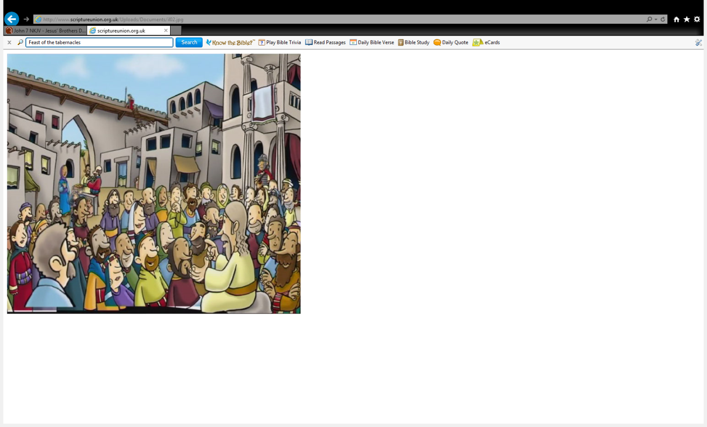

*16Jesus[c] answered them and said, “My doctrine is not Mine, but His who sent Me. 17If anyone wills to do His will, he shall know concerning the doctrine, whether it is from God or whether I speak on My own authority. 18He who speaks from himself seeks his own glory; but He who seeks the glory of the One who sent Him is true, and no unrighteousness is in Him. 19Did not Moses give you the law, yet none of you keeps the law? Why do you seek to kill Me?”*

*20The people answered and said, “You have a demon. Who is seeking to kill You?”*

*21Jesus answered and said to them, “I did one work, and you all marvel. 22Moses therefore gave you circumcision (not that it is from Moses, but from the fathers), and you circumcise a man on the Sabbath. 23If a man receives circumcision on the Sabbath, so that the law of Moses should not be broken, are you angry with Me because I made a man completely well on the Sabbath? 24Do not judge according to appearance, but judge with righteous judgment.”*

**Question 10**

Some Jews said Jesus was good, other Jews said Jesus deceives people. However, when Jesus went to teach in the temple they all marveled (they were all amazed). Why were they all amazed?

Saturday 2nd December **: Read John Chapter 7: 25-53 and answer the questions:**

**Could This Be the Christ?**

*25Now some of them from Jerusalem said, “Is this not He whom they seek to kill? 26But look! He speaks boldly, and they say nothing to Him. Do the rulers know indeed that this is truly[d] the Christ? 27However, we know where this Man is from; but when the Christ comes, no one knows where He is from.”*

*28Then Jesus cried out, as He taught in the temple, saying, “You both know Me, and you know where I am from; and I have not come of Myself, but He who sent Me is true, whom you do not know. 29But[e] I know Him, for I am from Him, and He sent Me.”*

*30Therefore they sought to take Him; but no one laid a hand on Him, because His hour had not yet come. 31And many of the people believed in Him, and said, “When the Christ comes, will He do more signs than these which this Man has done?”*

**Jesus and the Religious Leaders**

*32The Pharisees heard the crowd murmuring these things concerning Him, and the Pharisees and the chief priests sent officers to take Him. 33Then Jesus said to them,[f] “I shall be with you a little while longer, and then I go to Him who sent Me. 34You will seek Me and not find Me, and where I am you cannot come.”*

*35Then the Jews said among themselves, “Where does He intend to go that we shall not find Him? Does He intend to go to the Dispersion among the Greeks and teach the Greeks? 36What is this thing that He said, ‘You will seek Me and not find Me, and where I am you cannot come’?”*

**Question 11**

Many of the people believed in Jesus because He showed them many signs that He is the Christ. **TRUE/FALSE**

***The other Gospels referred to these signs as miracles***

**Question 12**

“…because His hour has not come…” Verse 31 means.. **Underline** the correct answer

a) 60 minutes have not past

b) Jesus time has not come to depart from the world.

c) It was too early for Jesus to leave the temple

**The Promise of the Holy Spirit**

*37On the last day, that great day of the feast, Jesus stood and cried out, saying, “If anyone thirsts, let him come to Me and drink. 38He who believes in Me, as the Scripture has said, out of his heart will flow rivers of living water.” 39But this He spoke concerning the Spirit, whom those believing[g] in Him would receive; for the Holy[h] Spirit was not yet given, because Jesus was not yet glorified.*

**Who Is He?**

*40Therefore many[i] from the crowd, when they heard this saying, said, “Truly this is the Prophet.” 41Others said, “This is the Christ.”*

*But some said, “Will the Christ come out of Galilee? 42Has not the Scripture said that the Christ comes from the seed of David and from the town of Bethlehem, where David was?” 43So there was a division among the people because of Him. 44Now some of them wanted to take Him, but no one laid hands on Him.*

**Question 13**

The Living Water is the Holy Spirit given to people who believe in Jesus. **True/False?**

**Question 14**

Jesus said the Holy Spirit was not yet given. When did Jesus give the Holy Spirit to believers?

1. The last supper
2. Good Friday
3. Pentecost Sunday
4. Easter Sunday

**Rejected by the Authorities**

*45Then the officers came to the chief priests and Pharisees, who said to them, “Why have you not brought Him?”*

*46The officers answered, “No man ever spoke like this Man!”*

*47Then the Pharisees answered them, “Are you also deceived? 48Have any of the rulers or the Pharisees believed in Him? 49But this crowd that does not know the law is accursed.”*

*50Nicodemus (he who came to Jesus by night,[j] being one of them) said to them, 51“Does our law judge a man before it hears him and knows what he is doing?”*

*52They answered and said to him, “Are you also from Galilee? Search and look, for no prophet has arisen[k] out of Galilee.”*

**An Adulteress Faces the Light of the World**

*53And everyone went to his own house.[l]*

**Question 10**

Jesus was rejected by the authorities (chief priests and Pharisees)

Who in the above Verses believed Jesus was the Messiah?

*Note: The chief priests were members of the high priestly families or those acting with the authority of the high priest –*

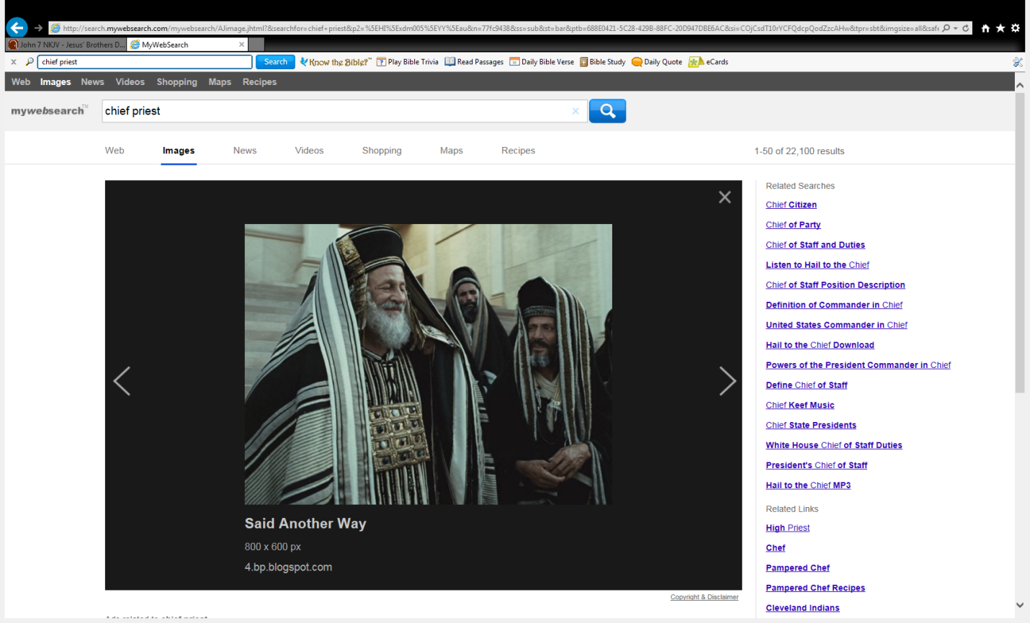

**Chief Priests**

***The Jews were divided into 2 types***

1. ***Pharisees- The Pharisees believed in the resurrection***
2. ***Sadducees did not believe in the resurrection***

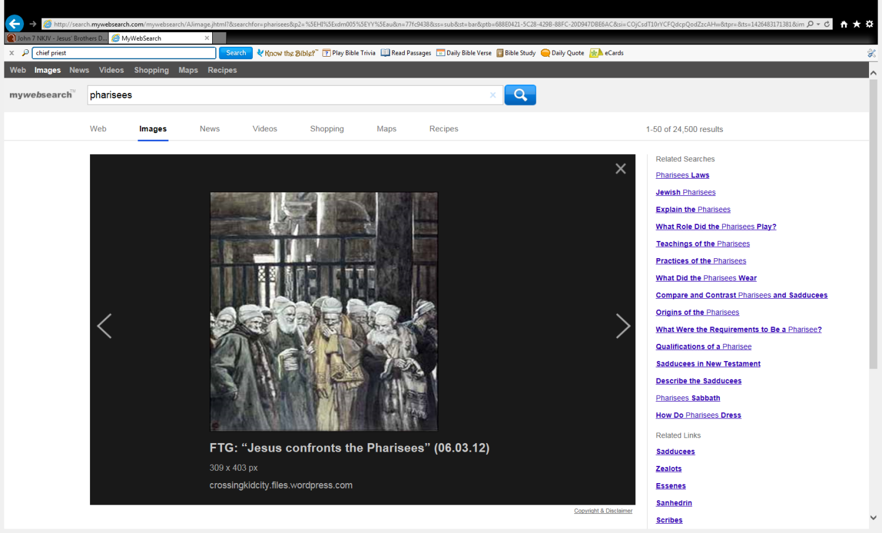

**Pharisees**