C:\Documents and Settings\suzy\Local Settings\Temporary Internet Files\Content.IE5\3JXW24R5\MC900383922[1].wmfSunday 7th January, 2018

Name:

Class:

Finish Date: Saturday 13th January, 2018

Completed Bible Study = 6 points

Email Homework by the due date = 12 points

**Year 4 Bible Study Genesis Chapter 30**

**For the questions below Highlight or change the font colour to choose the correct answer.**

* Monday 8th January: Read **Genesis 30: 1-13** and answer the questions:

**Rachel and Leah’s maid’s have children**

*1 Now when Rachel saw that she bore Jacob no children, Rachel envied her sister, and said to Jacob, “Give me children, or else I die!”*

*2And Jacob’s anger was aroused against Rachel, and he said, “Am I in the place of God, who has withheld from you the fruit of the womb?”*

*3So she said, “Here is my maid Bilhah; go in to her, and she will bear a child on my knees, that I also may have children by her.” 4Then she gave him Bilhah her maid as wife, and Jacob went in to her. 5And Bilhah conceived and bore Jacob a son. 6Then Rachel said, “God has judged my case; and He has also heard my voice and given me a son.” Therefore she called his name Dan.7And Rachel’s maid Bilhah conceived again and bore Jacob a second son. 8Then Rachel said, “With great wrestlings I have wrestled with my sister, and indeed I have prevailed.” So she called his name Naphtali.When Leah saw that she had stopped bearing, she took Zilpah her maid and gave her to Jacob as wife. 10And Leah’s maid Zilpah bore Jacob a son. 11Then Leah said, “A troop comes!”So she called his name Gad. 12And Leah’s maid Zilpah bore Jacob a second son. 13Then Leah said, “I am happy, for the daughters will call me blessed.” So she called his name Asher.*

**Question 1**

Why is Rachel jealous of her sister, Leah?

a) Leah is wealthier

b) Leah has had children

c) Leah has more pretty dresses

**Question 2**

Why does Jacob get angry with Rachel for demanding children?

a) He is happy with the children he has from Leah

b) He thinks she's wrong to think he can play God and give her children

c) He is fed up of her complaining

**Do you know what a concubine is?**

**Rachel and Leah’s maids, Bilhah and Zilpah were concubines.**

*Many many years ago before Jesus’ time, married women who could not have children (they were said to be barren) would give their maids or slaves to their husbands. The practice of taking concubines as "wife" was used to provide a male heir for a woman who could not have children. This was considered normal at that time, but not anymore. This is not a Christian practice.*

**Question 3**

Last week’s Bible study we read Leah had 4 children as shown below. Name the children that Jacob had through Leah’s and Rachael’s maids.



Reuben

Simeon

Judah

Levi



* Tuesday 9th January: Read **Genesis 30: 17-24** and answer the questions:

**Rachael has a son named Joseph**

*17And God listened to Leah, and she conceived and bore Jacob a fifth son. 18Leah said, “God has given me my wages, because I have given my maid to my husband.” So she called his name Issachar. 19Then Leah conceived again and bore Jacob a sixth son. 20And Leah said, “God has endowed me with a good endowment; now my husband will dwell with me, because I have borne him six sons.” So she called his name Zebulun. 21Afterward she bore a daughter, and called her name Dinah.*

*22Then God remembered Rachel, and God listened to her and opened her womb. 23And she conceived and bore a son, and said, “God has taken away my reproach.” 24So she called his name Joseph, and said, “The Lord shall add to me another son.”*

**Question 4**

Copy the names of the 4 boys you added in last night’s homework.

Leah had 2 more sons and a daugher, and Rachael had her first son. Add their names to the family tree below.



Reuben

Simeon

Judah

Levi



* Wednesday 10th January: Read **Genesis 30: 25-29** and answer the questions:

**Jacob wants to return home to Beersheba**

*25And it came to pass, when Rachel had borne Joseph, that Jacob said to Laban, “Send me away, that I may go to my own place and to my country. 26Give me my wives and my children for whom I have served you, and let me go; for you know my service which I have done for you.”*

*27And Laban said to him, “Please stay, if I have found favor in your eyes, for I have learned by experience that the Lord has blessed me for your sake.” 28Then he said, “Name me your wages, and I will give it.”*

**Question 5**

What does Laban offer Jacob to make him stay?

a) Wages

b) Another wife

c) A house

* Thursday 11th January: Read **Genesis 30: 29-30** and answer the questions:

*29So Jacob said to him, “You know how I have served you and how your livestock has been with me. 30For what you had before I came was little, and it has increased to a great amount; the Lord has blessed you since my coming. And now, when shall I provide for my own house?”*

**Question 6**

Laban does not want Jacob to return home.

The number of Laban’s livestock (sheep, goats, cows) increased to a great amount since Jacob came and lived with him. This is because

1. The Lord blessed Jacob
2. The Lord blessed Laban because of Jacob
3. The animals had a lot of food to eat.

* Friday 12th January: Read **Genesis 30: 31-36** and answer the questions:

**Jacob chooses sheep, lambs and goats to take with him back home to Beersheba.**

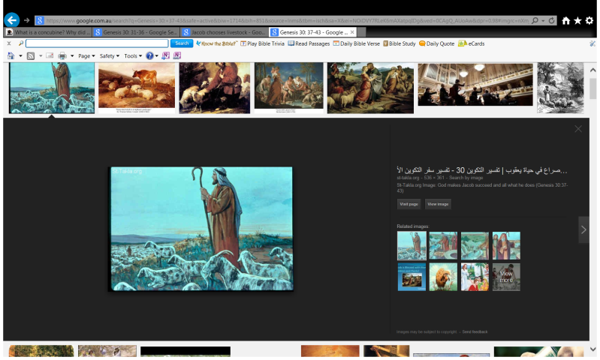*31So he said, “What shall I give you?”*

*And Jacob said, “You shall not give me anything. If you will do this thing for me, I will again feed and keep your flocks: 32Let me pass through all your flock today, removing from there all the speckled and spotted sheep, and all the brown ones among the lambs, and the spotted and speckled among the goats; and these shall be my wages. 33So my righteousness will answer for me in time to come, when the subject of my wages comes before you: every one that is not speckled and spotted among the goats, and brown among the lambs, will be considered stolen, if it is with me.”*

*34And Laban said, “Oh, that it were according to your word!” 35So he removed that day the male goats that were speckled and spotted, all the female goats that were speckled and spotted, every one that had some white in it, and all the brown ones among the lambs, and gave them into the hand of his sons. 36Then he put three days’ journey between himself and Jacob, and Jacob fed the rest of Laban’s flocks.*

**Question 7**

Which of the livestock below did Jacob keep for Laban? Highlight the correct answer.

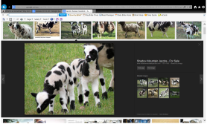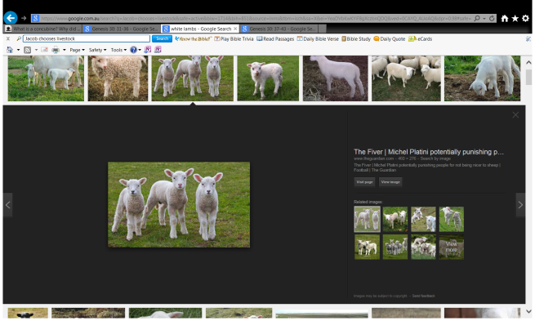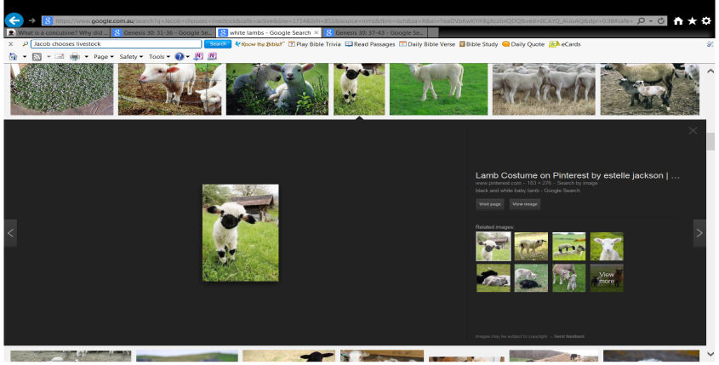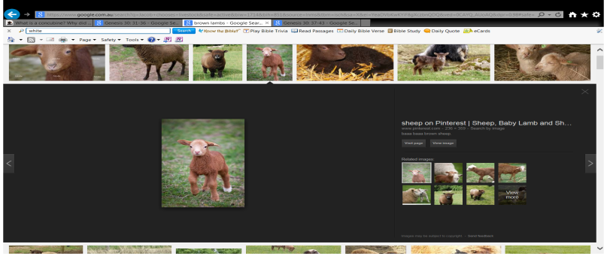

**A**

**B**

**C**

**D**

**Question 8**

How many days travel does Laban put between him and Jacob after separating the flock?

a) 4

b) 3

c) 2

* Saturday 13th January: Read **Genesis 30: 37-43** and answer the questions:

**God Blesses Jacob**

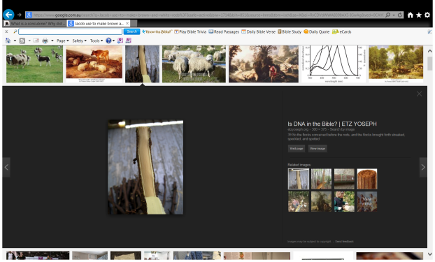*37Now Jacob took for himself rods of green poplar and of the almond and chestnut trees, peeled white strips in them, and exposed the white which was in the rods. 38And the rods which he had peeled, he set before the flocks in the gutters, in the watering troughs where the flocks came to drink, so that they should conceive when they came to drink. 39So the flocks conceived before the rods, and the flocks brought forth streaked, speckled, and spotted. 40Then Jacob separated the lambs, and made the flocks face toward the streaked and all the brown in the flock of Laban; but he put his own flocks by themselves and did not put them with Laban’s flock.*

*41And it came to pass, whenever the stronger livestock conceived, that Jacob placed the rods before the eyes of the livestock in the gutters, that they might conceive among the rods. 42But when the flocks were feeble, he did not put them in; so the feebler were Laban’s and the stronger Jacob’s. 43Thus the man became exceedingly prosperous, and had large flocks, female and male servants, and camels and donkeys.*

**Question 9**

Which three of the following trees did Jacob use to make brown and white rods?

1. Hazelnut
2. Oak
3. Poplar
4. Sycamore
5. Almond
6. Chestnut

**Question 10**

God made Jacob very successful. What did he own at the end of the chapter?

**What to do when you finish your Bible Study.**

Send it by email to your class email address or print and hand it to your servants next Sunday.

* Year 3A St Bishoy[stbishoy3a@gmail.com](mailto:stbishoy3a@gmail.com) Class Servant: Uncle Emile (0416895236)
* Year 3B St Paul[saintpaul3b@gmail.com](mailto:saintpaul3b@gmail.com) Class Servant: Aunty Marena (0433677290)
* Year 3C St Moses [stmoses3c@gmail.com](mailto:stmoses3c@gmail.com) Class Servant: Uncle Mina (0433520175)