C:\Documents and Settings\suzy\Local Settings\Temporary Internet Files\Content.IE5\3JXW24R5\MC900383922[1].wmfSunday 24th December, 2017

Name:

Class:

Finish Date: Saturday 30th December, 2017

Completed Bible Study = 6 points

Email Homework by the due date = 12 points

**Year 4 Bible Study Genesis Chapter 28**

**For the questions below Highlight, or change the font colour to choose the correct answer.**

* Monday 25th December: Read **Genesis 28: 1-5** and answer the questions:

**Isaac blesses Jacob**

*1 Then Isaac called Jacob and blessed him, and charged him, and said to him: “You shall not take a wife from the daughters of Canaan. 2Arise, go to Padan Aram, to the house of Bethuel your mother’s father; and take yourself a wife from there of the daughters of Laban your mother’s brother.*

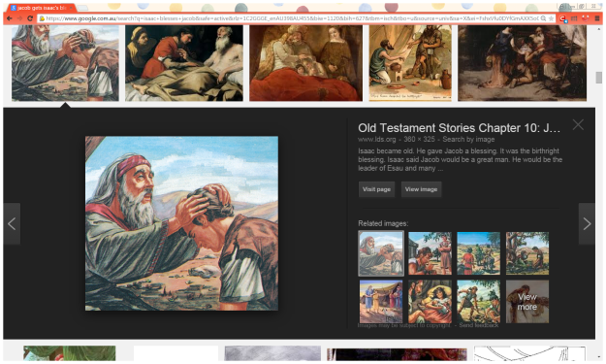*3“May God Almighty bless you,  
And make you fruitful and multiply you,  
That you may be an assembly of peoples;  
4And give you the blessing of Abraham,  
To you and your descendants with you,  
That you may inherit the land  
In which you are a stranger,  
Which God gave to Abraham.”*

*5So Isaac sent Jacob away, and he went to Padan Aram, to Laban the son of Bethuel the Syrian, the brother of Rebekah, the mother of Jacob and Esau.*

**Question 1**

Where on the map below did Isaac tell Jacob to go and find a wife?

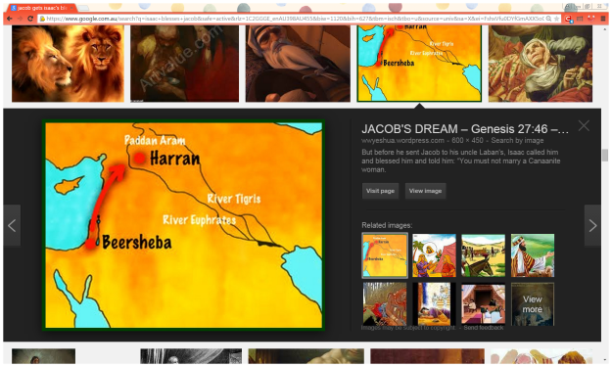

**A**

**C**

**B**

**D**

**A**

1. A
2. B
3. C
4. D

**Question 2**

How are the following people related to Jacob?

Rebekah, Bethual, Laban, Esau, Isaac

|  |  |
| --- | --- |
| **Name** | **Relation to Jacob** |
|  | Father |
|  | Mother |
|  | Brother |
|  | His mother’s father |
|  | His mother’s brother |

**Question 3**

Verses 3 & 4 are the blessing of Isaac to Jacob.

Match the lines of the actual verse with what you think they mean from the list below

* *May you become a big nation (country)*
* *God give you and your children the same blessing Abraham had*
* *God bless you*
* *May you take ownership of the land God gave to Abraham*
* *God give you many children*

|  |  |
| --- | --- |
| **Isaac’s blessing verses 3-4** | **Meanings** |
| *“May God Almighty bless you,* |  |
| *And make you fruitful and multiply you,* |  |
| *That you may be an assembly of peoples;* |  |
| *And give you the blessing of Abraham, To you and your descendants with you,* |  |
| *That you may inherit the land In which you are a stranger, Which God gave to Abraham.”* |  |

* Tuesday 26th December: Read **Genesis 28: 6-9** and answer the questions:

### Esau Marries Mahalath

*6Esau saw that Isaac had blessed Jacob and sent him away to Padan Aram to take himself a wife from there, and that as he blessed him he gave him a charge, saying, “You shall not take a wife from the daughters of Canaan,” 7and that Jacob had obeyed his father and his mother and had gone to Padan Aram. 8Also Esau saw that the daughters of Canaan did not please his father Isaac. 9So Esau went to Ishmael and took Mahalath the daughter of Ishmael, Abraham’s son, the sister of Nebajoth, to be his wife in addition to the wives he had.*

**Question 4**

How does Esau try to please his parents and perhaps make up for having just upset Rebekah by threatening to kill Jacob?

a) By killing a calf as a gift

b) By taking a wife who is not from Canaan

c) By leaving his parent’s house

**Question 5**

(i) Who is the father of the woman Esau marries?  
(ii) How is that man related to Abraham? He is:

a) Abraham's grandson

b) Abraham's nephew

c) Abraham's first born son

* 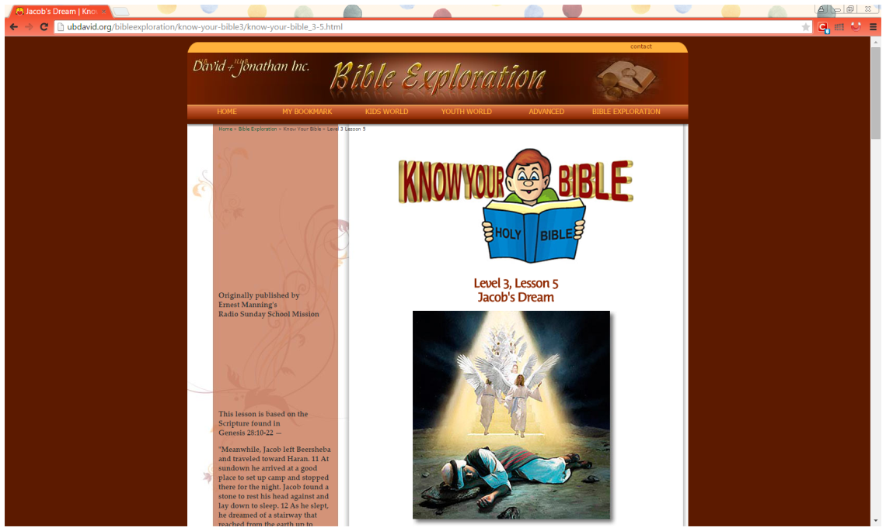Wednesday 27th December: Read **Genesis 28: 10-12** and answer the questions:

### Jacob’s Vow at Bethel

*10Now Jacob went out from Beersheba and went toward Haran. 11So he came to a certain place and stayed there all night, because the sun had set. And he took one of the stones of that place and put it at his head, and he lay down in that place to sleep. 12Then he dreamed, and behold, a ladder was set up on the earth, and its top reached to heaven; and there the angels of God were ascending and descending on it.*

**Question 6**

What did he use as a pillow to go to sleep at night?   
**Question 7**

What did he dream about when he fell asleep?

1. He saw a ladder with angels going up and down.
2. The coming day.
3. How he had wronged Esau and his father.

* Thursday 28th December: Read **Genesis 28: 13-15** and answer the questions:

**God speaks to Jacob in a dream**

*13And behold, the Lord stood above it and said: “I am the Lord God of Abraham your father and the God of Isaac; the land on which you lie I will give to you and your descendants. 14Also your descendants shall be as the dust of the earth; you shall spread abroad to the west and the east, to the north and the south; and in you and in your seed all the families of the earth shall be blessed. 15Behold, I am with you and will keep you wherever you go, and will bring you back to this land; for I will not leave you until I have done what I have spoken to you.”*

**Question 8**

In the dream, what did God promise Jacob?

a) God promised to give him this land, to guard him and bring him back safely to this  
     land, and never to leave him.

b) God promised to give him food for his journey.

* Friday 29th December: Read **Genesis 28: 16-17** and answer the questions:

**Jacob wakes up from his sleep**

*16Then Jacob awoke from his sleep and said, “Surely the Lord is in this place, and I did not know it.” 17And he was afraid and said, “How awesome is this place! This is none other than the house of God, and this is the gate of heaven!”*

**Question 9**

Why was Jacob ***afraid?***

* 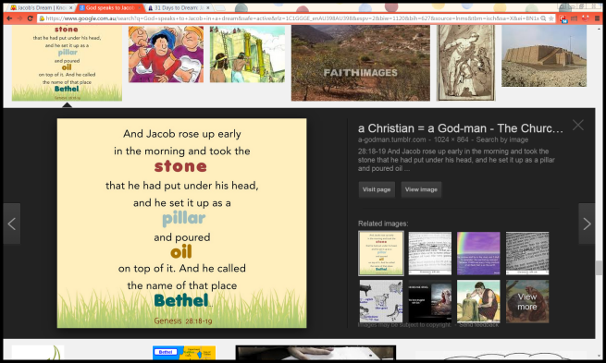Saturday 30th December: Read **Genesis 28: 18-22** and answer the questions:

**Jacob’s vow to God**

*18Then Jacob rose early in the morning, and took the stone that he had put at his head, set it up as a pillar, and poured oil on top of it. 19And he called the name of that place Bethel; but the name of that city had been Luz previously. 20Then Jacob made a vow, saying, “If God will be with me, and keep me in this way that I am going, and give me bread to eat and clothing to put on, 21so that I come back to my father’s house in peace, then the Lord shall be my God. 22And this stone which I have set as a pillar shall be God’s house, and of all that You give me I will surely give a tenth to You.”*

**Do you know what a pillar is?**

*A pillar is large post that helps to hold up something (such as a roof).*

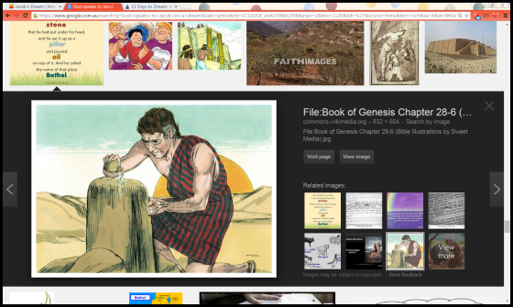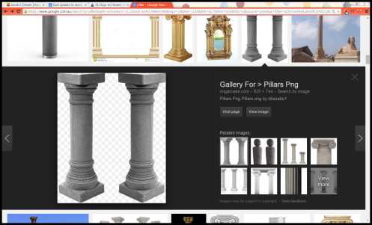

Man-made pillar

Jacob’s pillar

**Question 10**

When Jacob wakes up, he recognises how precious his dream was and instantly tries to keep up his conversation with God. What does he do with his "pillow" as a permanent reminder of God?

**Question 11**

What does Jacob name that place?  
a) Bethel

b) Luz

c) Pillar

**Question 12**

Jacob makes a vow (promise) to God - what does Jacob promise to give God?

1. I will give You my first son.
2. I will give You first salary.
3. I will give You a tenth (10%) of everything that You give me

**Question 13**

Do you believe that God watches over you wherever you are?

1. Yes.
2. No.
3. I don't know

Give reasons for your answer:

**What to do when you finish your Bible Study.**

Send it by email to your class email address or print and hand it to your servants next Sunday.

* Year 3A St Bishoy[stbishoy3a@gmail.com](mailto:stbishoy3a@gmail.com) Class Servant: Uncle Emile (0416895236)
* Year 3B St Paul[saintpaul3b@gmail.com](mailto:saintpaul3b@gmail.com) Class Servant: Aunty Marena (0433677290)
* Year 3C St Moses [stmoses3c@gmail.com](mailto:stmoses3c@gmail.com) Class Servant: Uncle Mina (0433520175)