C:\Documents and Settings\suzy\Local Settings\Temporary Internet Files\Content.IE5\3JXW24R5\MC900383922[1].wmfSunday 10th December, 2017

End Date: Saturday 16thDecember2017

Name:

Class:

**Year 4 Bible Study Psalm 24**

*This is the last week of Year 4 bible study. For this last week of bible study, we will be focused on memorisation of the Psalm 24. You will receive your Bible Study points on Sunday when you recite the Psalm to your Sunday school teacher at the beginning of the lesson.*

**Psalm 24**

* **Monday: Read and memorise Psalm 24:1-2**

**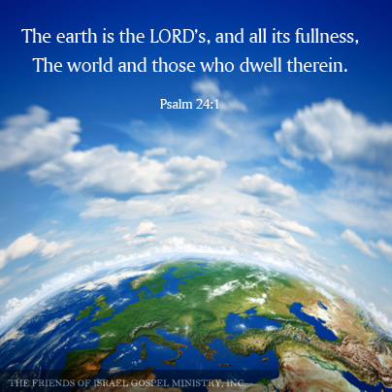*A Psalm of David.***

***24****The earth is the Lord’s, and all its fullness,  
The world and those who dwell therein.****2****For He has founded it upon the seas,  
And established it upon the waters.*

It may help you to memorise the verses by filling in the gaps:

*The _____ is the Lord’s, and all its __________,  
The ________ and those who _______ therein.****2****For He has _____________it upon the _______,  
And________________ it upon the _________.*

* **Tuesday: Read and memorise Psalm 24: 3-4**

*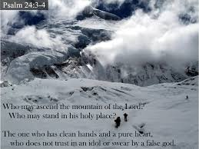****3****Who may ascend into the hill of the Lord?  
Or who may stand in His holy place?* ***4****He who has clean hands and a pure heart,  
Who has not lifted up his soul to an idol,  
Nor sworn deceitfully.*

*Fill in the gaps:*

***3****Who may __________ into the _____of the ______?  
Or who may ________ in His ______ ______?****4****He who has _________ ________ and a ______ ________,  
Who has not _________ up his ______to an _____,  
Nor _______ ______________.*

* **Wednesday: Read and memorise Psalm 24:5-6**

***5****He shall receive blessing from the Lord,  
And righteousness from the God of his salvation.****6****This is Jacob, the generation of those who seek Him,  
Who seek Your face. Selah*

*Fill in the gaps:*

***5****He _______ receive _________ from the Lord,  
And __________________ from the God of his _____________.****6****This is ______, the ___________ of those who _____ _______,  
Who _______Your _____. Selah*

* **Thursday: Read and memorise Psalm 24: 7-8**

***7****Lift up your heads, O you gates!  
And be lifted up, you everlasting doors!  
And the King of glory shall come in.****8****Who is this King of glory?  
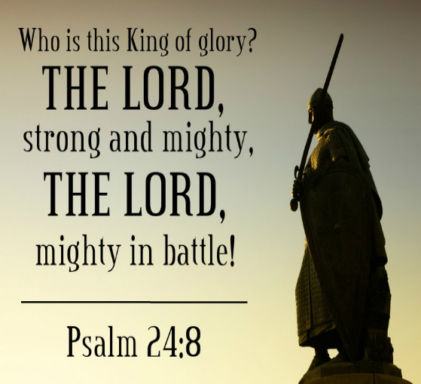The Lord strong and mighty,  
The Lord mighty in battle.*

*Fill in the gaps:*

***7****Lift up your ________, O you ________!  
And be ________up, you ___________ doors!  
And the ______ of ______ shall ____ in.****8****Who is this ________ of ________?  
The_______ strong and __________,  
The ______ mighty in _________.*

* **Friday: Read and memorise Psalm 24:9**

***9****Lift up your heads, O you gates!  
Lift up, you everlasting doors!  
And the King of glory shall come in.*

*Fill in the gaps:*

***9****_______up your _______, O you __________!  
Lift up, you ____________ doors!  
And the ______ of _______ shall come in.*

* **Saturday: Read and memorise Psalm 24:10**

***10****Who is this King of glory?  
The Lord of hosts,  
He is the King of glory. Selah*

*Fill in the gaps:*

***10****______ is this ______of _______?  
The ______of _______,  
He is the ______ of _______. Selah*

* Now that you have memorised Psalm 24, recite it to your Sunday School Teacher at the beginning of your lesson to obtain your points.
* Well done on finishing Year 4 bible study! During the holidays, try to keep up with your daily bible reading and we will continue with the bible study worksheets next year.