C:\Documents and Settings\suzy\Local Settings\Temporary Internet Files\Content.IE5\3JXW24R5\MC900383922[1].wmfSunday 3rd December, 2017

Finish Date:Saturday 9th December2017

Name:

Class:

**Year 4 Bible Study Psalm 47**

*For the end of year 4, we will be focused on memorisation of the Psalms. We will learn a Psalm each week, and you will receive your Bible Study points on Sunday when you recite the Psalm to your Sunday school teacher at the beginning of the lesson.*

**Psalm 47**



* **Monday: Read and memorise Psalm 47: 1-2**

***47****Oh, clap your hands, all you peoples!  
Shout to God with the voice of triumph!****2****For the Lord Most High is awesome;  
He is a great King over all the earth.*

*It may help you to memorise by filling in the gaps:*

***47****Oh, clap your _______, all you peoples!  
Shout to ______ with the voice of _________!****2****For the Lord Most ______ is __________;  
He is a great ______over all the __________.*

* **Tuesday: Read and memorise Psalm 47:3-4**

***3****He will subdue the peoples under us,  
And the nations under our feet.****4****He will choose our inheritance for us,  
The excellence of Jacob whom He loves. Selah*

*It may help you to memorise by filling in the gaps*

***3****He will ______ the peoples _______ us,  
And the________ under our ______.****4****He will choose our ______________for us,  
The _____________ of ________whom He________. Selah*

* **Wednesday: Read and memorise Psalm 47:5**

***5****God has gone up with a shout,  
The Lord with the sound of a trumpet.*

*It may help you to memorise by filling in the gaps*

*God has _______ up with a ________,  
The Lord with the ________ of a ___________.*

* **Thursday: Read and memorise Psalm 47:6-7**

*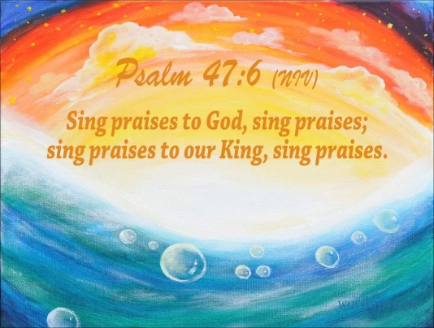****6****Sing praises to God, sing praises!  
Sing praises to our King, sing praises!****7****For God is the King of all the earth;  
Sing praises with understanding.*

*It may help you to memorise by filling in the gaps*

***6****Sing praises to _____, sing praises!  
Sing ________ to our _______, sing ______!****7****For God is the _______ of all the ________;  
Sing praises with ­­­­­_______________.*

* **Friday: Read and memorise Psalm 47:8**

***8****God reigns over the nations;  
God sits on His holy throne.*

*It may help you to memorise by filling in the gaps*

***8****God ________ over the __________;  
God _______ on His holy __________*

* **Saturday: Read and memorise Psalm 47:9*****9****The princes of the people have gathered together,  
  The people of the God of Abraham.  
  For the shields of the earth belong to God;  
  He is greatly exalted*

*It may help you to memorise by filling in the gaps*

***9****The ___________ of the __________ have gathered __________,  
The ___________ of the God of _____________.  
For the __________ of the earth ____________ to God;  
He is greatly _________*

* Now that you have memorised Psalm 47, recite it to your Sunday School Teacher at the beginning of your lesson to obtain your points.