C:\Documents and Settings\suzy\Local Settings\Temporary Internet Files\Content.IE5\3JXW24R5\MC900383922[1].wmfSunday 3rd December, 2017

Name:

Class:

Finish Date: Saturday 9th December, 2017

Completed Bible Study = 6 points

Email Homework by the due date = 12 points

**Year 4 Bible Study Genesis Chapter 25**

**For the questions below Highlight or change the font colour to choose the correct answer.**

* Monday 4th December: Read **Genesis Chapter 25:7-11** and answer the questions:

**Abraham’s Death and Burial**

*7 This is the sum of the years of Abraham’s life which he lived: one hundred and seventy-five years. 8 Then Abraham breathed his last and died in a good old age, an old man and full of years, and was gathered to his people. 9 And his sons Isaac and Ishmael buried him in the cave of Machpelah, ……….10 the field which Abraham purchased from the sons of Heth. There Abraham was buried, and Sarah his wife. 11 And it came to pass, after the death of Abraham, that God blessed his son Isaac. And Isaac dwelt at Beer Lahai Roi.*

**Question 1**

How old was Abraham when he died?

**Question 2**

Who did Abraham buy the field from?

1. Sarah
2. Ishmael
3. The sons of Heth

* Tuesday 5th December: **Read Genesis Chapter 25: 19-22** and answer the questions:

**Isaac prayed to our Lord that his wife Rebekah will have children**

*19 This*is*the genealogy of Isaac, Abraham’s son. Abraham begot Isaac. 20 Isaac was forty years old when he took Rebekah as wife, the daughter of Bethuel the Syrian of Padan Aram, the sister of Laban the Syrian. 21 Now Isaac pleaded with the Lord for his wife, because she*was*barren; and the Lord granted his plea, and Rebekah his wife conceived. 22 But the children struggled together within her; and she said, “If*all is*well, why*am I like*this?” So she went to inquire of the Lord.*

**Question 3**

What does the word ‘barren’ mean?

1. old
2. not able to have children
3. sick
4. tired

**Question** **4**

Isaac prayed to God for Rebekah to have children (**TRUE / FALSE**)

**Question 5**

What did Rebekah ask God about?

* 1. The discomfort she felt in her pregnancy
  2. Why God hadn't yet given her any children
  3. How many children she was carrying
* Wednesday 6th December: Read Genesis **Chapter 25: 23-26** and answer the questions:

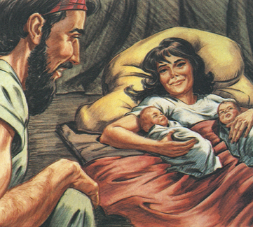**Rebekah gives birth to twins**

*23 And the Lord said to her: “Two nations*are*in your womb, Two peoples shall be separated from your body;* One*people shall be stronger than the other, And the older shall serve the younger.”*

*24 So when her days were fulfilled*for her*to give birth, indeed*there were*twins in her womb. 25 And the first came out red.*He was*like a hairy garment all over; so they called his name Esau. 26 Afterward his brother came out, and his hand took hold of Esau’s heel; so his name was called Jacob. Isaac*was *sixty years old when she bore them.*

**Question** **6**

Which of Rebekah’s twins were… (Highlight the correct answer)

|  |  |
| --- | --- |
| Hairy | Esau/ Jacob |
| Born first | Esau/ Jacob |
| Holding onto the heel of his brother | Esau/ Jacob |

* Thursday 7th December: Read **Genesis Chapter 25: 27-28** and answer the questions:

*27 So the boys grew. And Esau was a skilful hunter, a man of the field; but Jacob was a mild man, dwelling in tents. 28 And Isaac loved Esau because he ate of his game, but Rebekah loved Jacob.*

**Question 7**

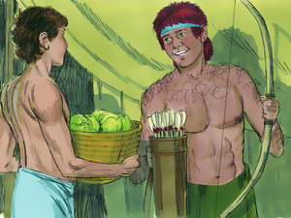

**A**

**B**

Identify each twin as shown in the picture on the right.

A is

B is

**Question 8**

Why did Isaac love Esau more?

**Question 9**

Who loved Jacob more?

* Friday 8th December: Read **Genesis Chapter 25: 29-34**  and answer the questions:

**Esau Sells His Birthright**

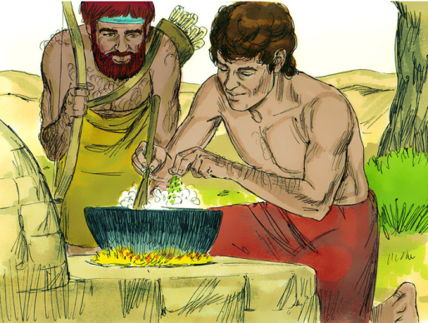*29 Now Jacob cooked a stew; and Esau came in from the field, and he*was *weary. 30 And Esau said to Jacob, “Please feed me with that same red*stew,*for I*am*weary.” Therefore his name was called Edom. 31 But Jacob said, “Sell me your birthright as of this day.”*

*32 And Esau said, “Look, I*am*about to die; so what*is*this birthright to me?” 33 Then Jacob said, “Swear to me as of this day.” So he swore to him, and sold his birthright to Jacob. 34 And Jacob gave Esau bread and stew of lentils; then he ate and drank, arose, and went his way. Thus Esau despised his birthright*

**Question 10**

Define “birthright”

**Question** **11**

Why was it wrong for Esau to sell his birthright?

**What to do when you finish your Bible Study.**

Send it by email to your class email address or print and hand it to your servants next Sunday.

* Year 3A St Bishoy[stbishoy3a@gmail.com](mailto:stbishoy3a@gmail.com) Class Servant: Uncle Emile (0416895236)
* Year 3B St Paul[saintpaul3b@gmail.com](mailto:saintpaul3b@gmail.com) Class Servant: Aunty Marena (0433677290)
* Year 3C St Moses [stmoses3c@gmail.com](mailto:stmoses3c@gmail.com) Class Servant: Uncle Mina (0433520175)