C:\Documents and Settings\suzy\Local Settings\Temporary Internet Files\Content.IE5\3JXW24R5\MC900383922[1].wmfSunday 26thNovember, 2017

Finish Date:Saturday 2nd December2017

Name:

Class:

**Year 4 Bible Study Psalm 12**

*For the end of year 4, we will be focused on memorisation of the Psalms. We will learn a Psalm each week, and you will receive your Bible Study points on Sunday when you recite the Psalm to your Sunday school teacher at the beginning of the lesson.*

**Psalm 12**



***To the Chief Musician. On an eight-stringed harp.[[a](https://www.biblegateway.com/passage/?search=psalm+12&version=NKJV" \l "fen-NKJV-14068a" \o "See footnote a)] A Psalm of David.***

* **Monday: Read Psalm 12:1-2 and memorise**

***12****Help, Lord, for the godly man ceases!  
For the faithful disappear from among the sons of men.*

***2****They speak idly everyone with his neighbour;  
With flattering lips and a double heart they speak.*

It may help to write out the verse/fill in the gaps, as you try to memorise it.

*Help, Lord, for the ______ _____ ceases!  
For the _______disappear from among the ____ __ ____.****2****They speak ____ everyone with his __________;  
With __________ _____ and a ______ _______they speak.*

* **Tuesday: Read Psalm 12:3 and memorise**

***3****May the Lord cut off all flattering lips,  
And the tongue that speaks proud things*

Fill in the gaps to help you memorise:

***3****May the _____ cut off all ________ lips,  
And the ______ that speaks ______ _______*

* **Wednesday: Read Psalm 12:4 and memorise**

***4****Who have said,  
“With our tongue we will prevail;  
Our lips are our own;  
Who is lord over us?”*

Fill in the gaps to help you memorise:

***4****Who have ____,  
“With our _______ we will _______;  
Our ____ are our ____;  
Who is____ over __?”*

* **Thursday: Read Psalm 12:5 and memorise**

***5****“For the oppression of the poor, for the sighing of the needy,  
Now I will arise,” says the Lord;  
“I will set him in the safety for which he yearns.”*

Fill in the gaps to help you memorise:

***5****“For the ___________ of the ____, for the ________of the _____,  
Now I will ______,” says the _____;  
“I will ____  ____ in the _______for which he ________.”*

* **Friday: Read Psalm 12:6-7 and memorise**

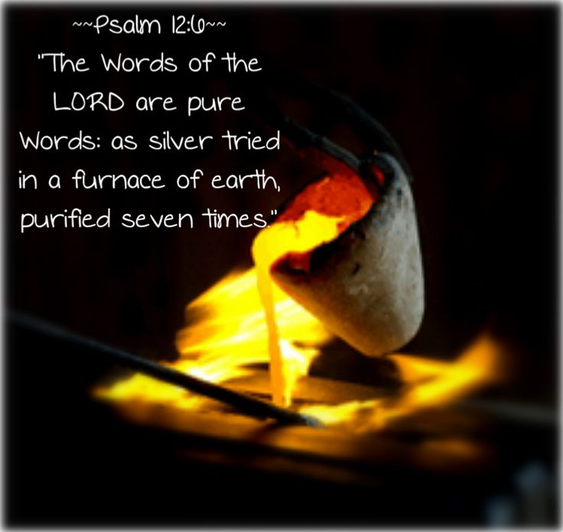

***6****The words of the Lord are pure words,  
Like silver tried in a furnace of earth,  
Purified seven times.****7****You shall keep them, O Lord,  
You shall preserve them from this generation forever.*

Fill in the gaps to help you memorise:

***6****The _______ of the Lord are ____ ______,  
Like _____ tried in a ______ of ______,  
________ seven ______.****7****You shall _____ _____, O Lord,  
You shall ________ them from this ___________ forever.*

* **Saturday: Read Psalm 12:8 and memorise**

***8****The wicked prowl on every side,  
When vileness is exalted among the sons of men.*

Fill in the gaps to help you memorise:

***8****The wicked _____ on every ____,  
When____________ is ________ among the ____ of ____.*

* Now that you have memorised Psalm 12, recite it to your Sunday School Teacher at the beginning of your lesson to obtain your points.