C:\Documents and Settings\suzy\Local Settings\Temporary Internet Files\Content.IE5\3JXW24R5\MC900383922[1].wmfSunday 12th November, 2017

Finish Date: Saturday 18th November, 2017

Name:

Class:

Completed Bible Study = 15 points

Email Homework by the due date = 5 points

**Year 4 Bible Study Psalm 91**



* **Monday: Read Psalm 91:1-2 and answer the questions**

*Safety of Abiding in the Presence of God*

***91****He who dwells in the secret place of the Most High  
Shall abide under the shadow of the Almighty.****2****I will say of the Lord, “He is my refuge and my fortress;  
My God, in Him I will trust.”*

**Question 1: Match the words to their meanings:**

Refuge Protection/Strong Residence

Fortress Safe shelter to provide rest

* **Tuesday: Read Psalm 91:3-4 and answer the questions**

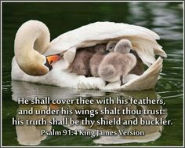

***3****Surely He shall deliver you from the snare of the fowler[*[*a*](https://www.biblegateway.com/passage/?search=psalm+91&version=NKJV#fen-NKJV-15399a)*]  
And from the perilous pestilence.****4****He shall cover you with His feathers,  
And under His wings you shall take refuge;  
His truth shall be your shield and buckler.*

**Question 2: Fill in the missing words:**

“His _ _ _ _ _ shall be your _ _ _ _ _ _ and _ _ _ _ _ _ _.

* **Wednesday: Read Psalm 91:5-6 and answer the questions**

***5****You shall not be afraid of the terror by night,  
Nor of the arrow that flies by day,****6****Nor of the pestilence that walks in darkness,  
Nor of the destruction that lays waste at noonday.*

These verses are talking about fear. We not only will be protected from evil, but also from the fear of evil. We have no reason to be afraid with faith in God.

**Question 3:** Name four things in these verses that with faith in God, we will not be afraid of:

i.

ii.

iii.

iv.

* **Thursday: Read Psalm 91-7-8 and answer the questions**

***7****A thousand may fall at your side,  
And ten thousand at your right hand;  
But it shall not come near you.****8****Only with your eyes shall you look,  
And see the reward of the wicked.*

**Question 4: True or False**

1. With God on your side, the wicked shall come near you_____________
2. With God on your side, the wicked will not come near you but you will see them fall at your side__________

* **Friday: Read Psalm 91:9-12 and answer the questions:**

***9****Because you have made the Lord, who is my refuge,  
Even the Most High, your dwelling place,****10****No evil shall befall you,  
Nor shall any plague come near your dwelling;****11****For He shall give His angels charge over you,  
To keep you in all your ways.****12****In their hands they shall bear you up,  
Lest you dash your foot against a stone.*

**The Psalmist writes how we can make our home in God, to life our life in Him, to talk with Him, enjoy Him and depend upon Him. This way we will be safe in Him and kept in perfect peace.**

**Question 5:** Which verse tells us that, when we make the Lord our refuge:

1. Whatever happens to us, nothing shall hurt us?_______
2. the Angels will be given the job to protect you______
3. the Angels shall pull you up with their hands________

* **Saturday: Read Psalm 91:13-16 and answer the questions**

*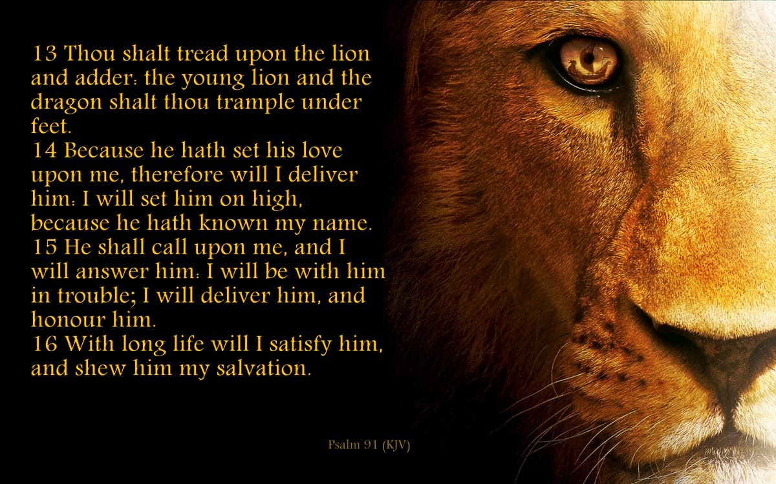****13****You shall tread upon the lion and the cobra,  
The young lion and the serpent you shall trample underfoot.*

***14****“Because he has set his love upon Me, therefore I will deliver him;  
I will set him on high, because he has known My name.****15****He shall call upon Me, and I will answer him;  
I will be with him in trouble;  
I will deliver him and honor him.****16****With long life I will satisfy him,  
And show him My salvation.”*

**Question 6:**

1. Name what you shall tread and trample on:

i.

ii.

iii.

iv.

1. Which verse states that God will answer our prayers?________

**What to do when you finish your Bible Study.**

**Send it by email to your class email address or print and hand it to your servants next Sunday.**

* **Year 4A St Makarious StMakarios4A@gmail.com Class Servant- Aunty Labiba (0421891567)**
* **Year 4B St Bakhomious StBakhomios4B@gmail.com Class Servant- Aunty Mira (0415595556)**
* **Year 4C St Anthony StAnthony4C@gmail.com Class Servant- Aunty Olivia**