C:\Documents and Settings\suzy\Local Settings\Temporary Internet Files\Content.IE5\3JXW24R5\MC900383922[1].wmfSunday 12th November, 2017

Name:

Class:

Finish Date: Saturday 18th November, 2017

Completed Bible Study = 6 points

Email Homework by the due date = 12 points

**Year 3 Bible Study Genesis Chapter 22**

**For the questions below Highlight, underline or change the font colour to choose the correct answer.**

* Monday 13th November: Read **Genesis 22: 1-5** and answer the questions:

**God tests Abraham**

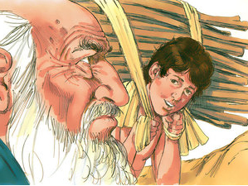 *1 Now it came to pass after these things that God tested Abraham, and said to him, “Abraham!” And he said, “Here I am.” 2 Then He said, “Take now your son, your only son Isaac, whom you love, and go to the land of Moriah, and offer him there as a burnt offering on one of the mountains of which I shall tell you.* *” 3 So Abraham rose early in the morning and saddled his donkey, and took two of his young men with him, and Isaac his son; and he split the wood for the burnt offering, and arose and went to the place of which God had told him.4 Then on the third day Abraham lifted his eyes and saw the place afar off.5 And Abraham said to his young men, “Stay here with the donkey; the lad and I will go yonder and worship, and we will come back to you.”*

**Do you know what a Burnt offering is?**

A sacrifice is burnt; therefore smoke (and a smell) goes up to the Lord so He hears our prayers.

Now we use incense when we pray.

Burnt offerings symbolized the total dedication of the offering to God (completely burned by fire so that it was available for nothing else), and the ascending (the rising smoke) of the offering to God in heaven.

***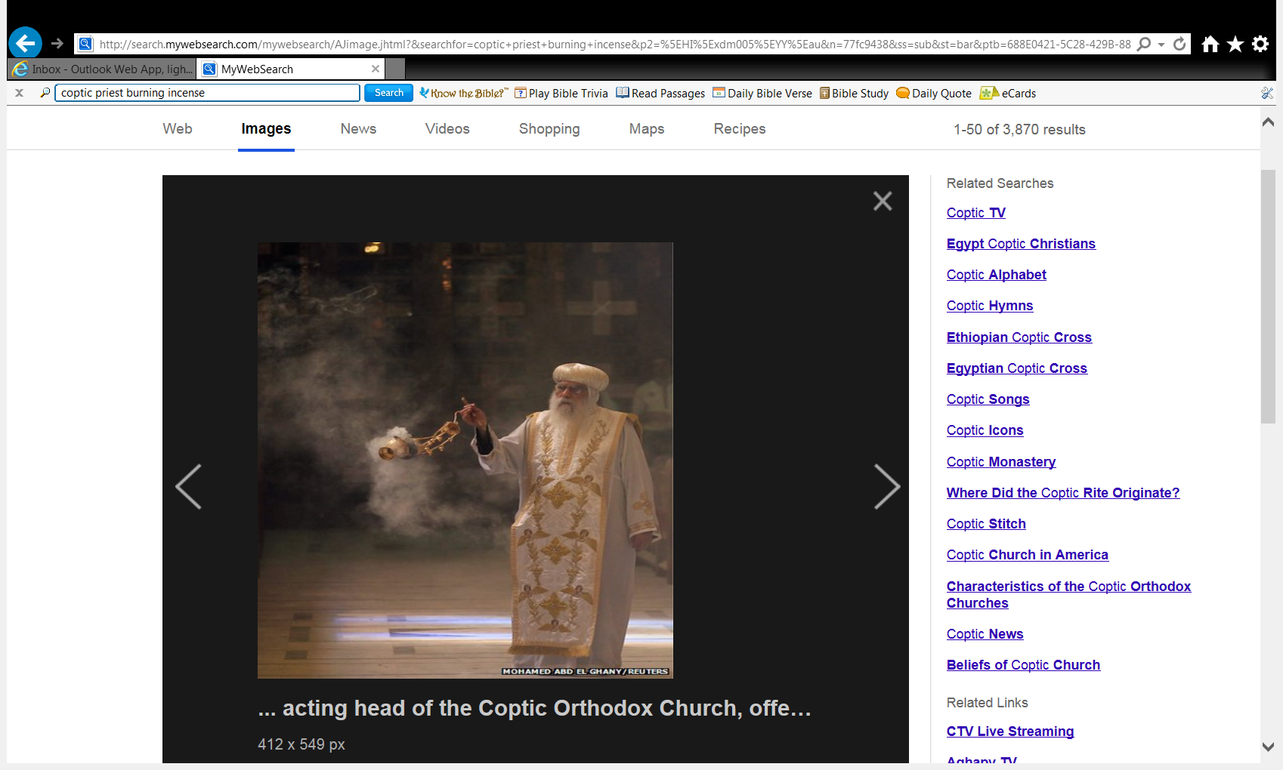*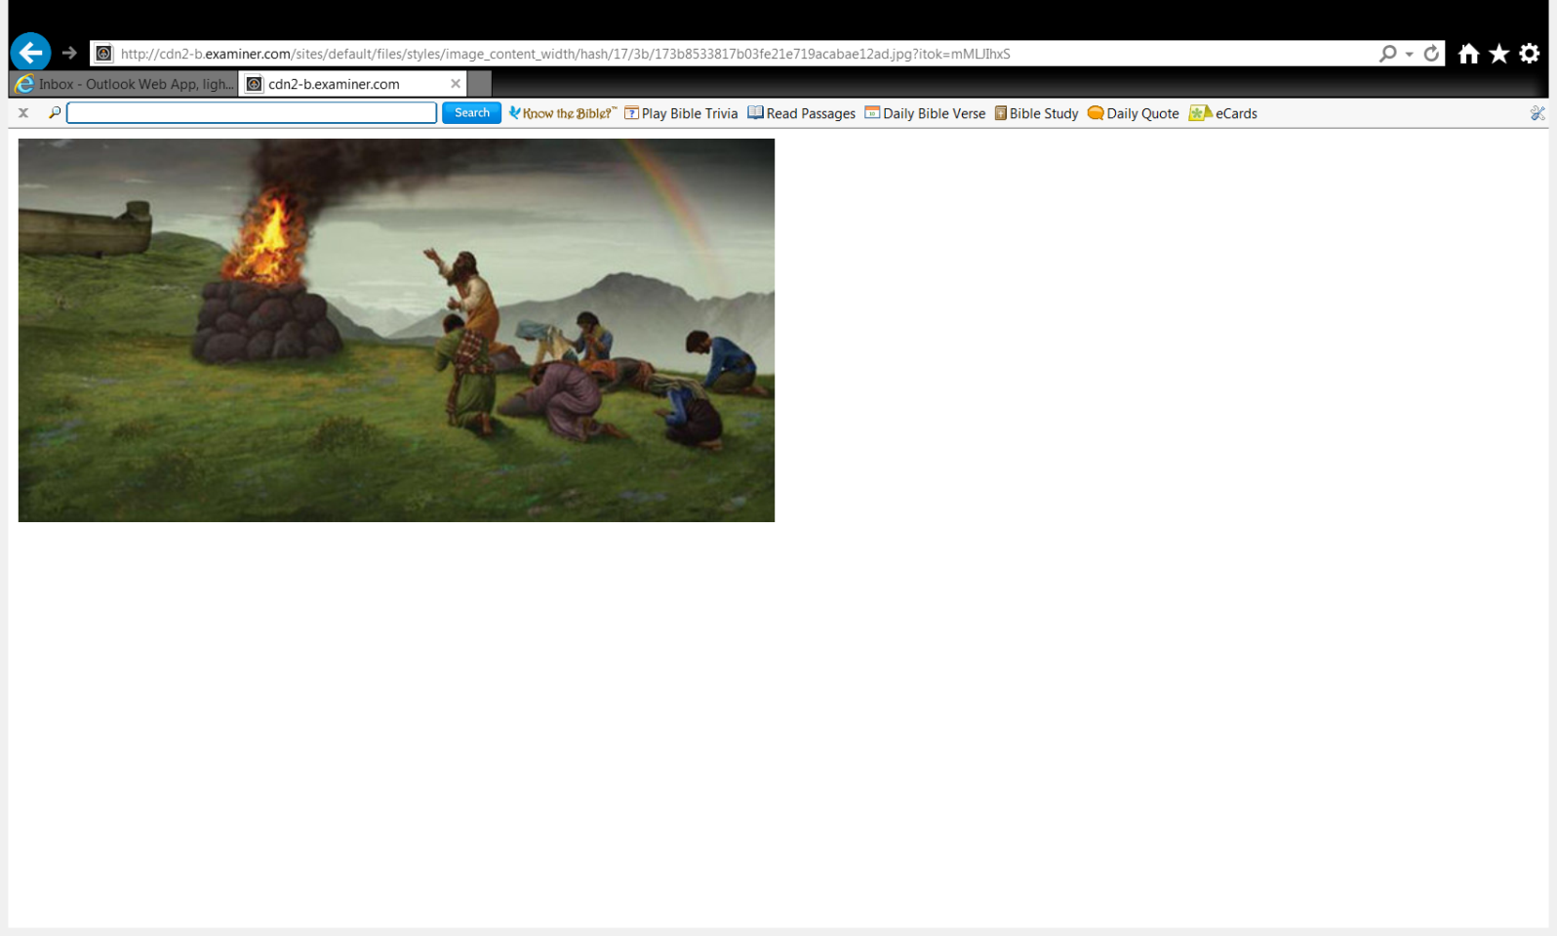**

**Question 1**

God asked Abraham to do the most difficult thing in his life, to take his son Isaac and offer him on an altar as a burnt offering. What did Abraham do?

* 1. He prayed to God and asked him not to do that.
  2. He spent two days thinking of what he should do.
  3. He immediately obeyed the voice of the Lord. He made a choice to trust in God and actively obeyed, even rising early to do so.

**Question 2**

Abraham understood God’s deep love for him, and that’s why he trusted and obeyed Him. (**TRUE / FALSE**)

* Tuesday 14th November: Read **Genesis 22: 6-8** and answer the questions:

**Abraham prepares Isaac as an offering**

*6 So Abraham took the wood of the burnt offering and laid it on Isaac his son; and he took the fire in his hand, and a knife, and the two of them went together. 7 But Isaac spoke to Abraham his father and said, “My father!” And he said, “Here I am, my son.” Then he said, “Look, the fire and the wood, but where is the lamb for a burnt offering?” 8 And Abraham said, “My son, God will provide for Himself the lamb for a burnt offering.” So the two of them went together.*

**Question 3**

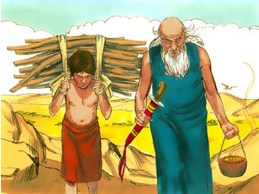

Who is this person?

Who is this young boy?

**Question 4**

a) Isaac was obedient to his father and showed his confidence in God (**TRUE / FALSE**)

1. Abraham told his son Isaac that he will offer him as a burnt offering to God (**TRUE / FALSE**)

**Question 5**

What did Isaac notice that was missing?

* Wednesday 15th November: Read **Genesis 22: 9-12** and answer the questions:

### Abraham shows God his complete obedience

*9 Then they came to the place of which God had told him. And Abraham built an* *altar there and placed the wood in order; and he bound Isaac his son and laid him on the altar, upon the wood. 10 And Abraham stretched out his hand and took the knife to slay his son. 11 But the Angel of the Lord called to him from heaven and said, “Abraham, Abraham!” So he said, “Here I am.” 12 And He said, “Do not lay your hand on the lad, or do anything to him; for now I know that you fear God, since you have not withheld your son, your only* son, *from Me.”*

**Question 6**

Who spoke to Abraham and told him not to kill his son Isaac?

**Question 7**

God wanted to test Abraham’s faith and obedience but He didn’t want to cause any harm to Isaac (**TRUE / FALSE**)

* Thursday 16th November: Read **Genesis 22: 13-14** and answer the questions:

**God provides the sacrifice**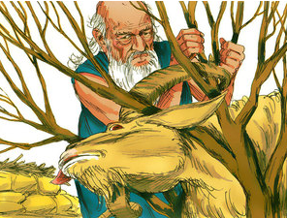

*13 Then Abraham lifted his eyes and looked, and there behind* him was *a ram caught in a thicket by its horns. So Abraham went and took the ram, and offered it up for a burnt offering instead of his son. 14 And Abraham called the name of the place, The-Lord-Will-Provide; as it is said* to *this day, “In the Mount of the Lord it shall be provided.”*

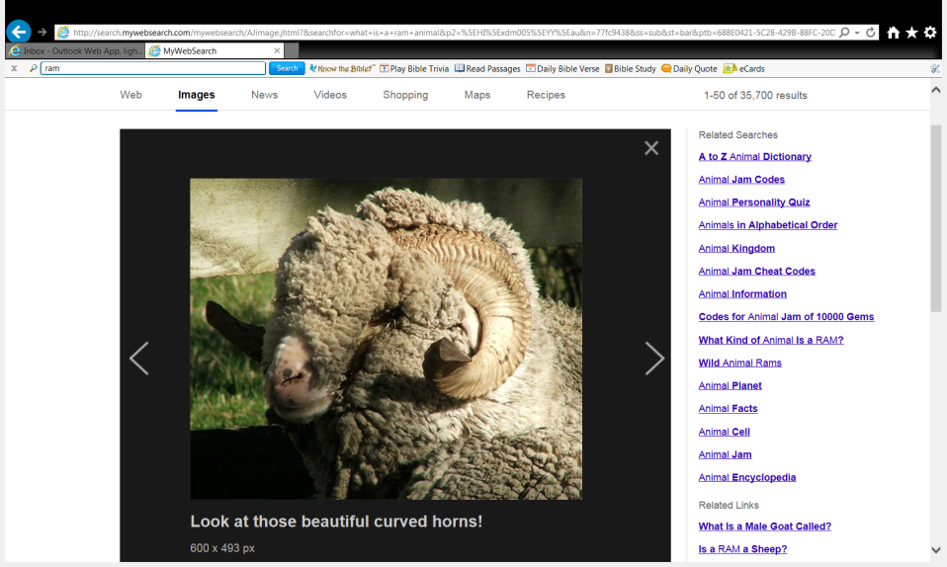

Horns

**Do you know what a ram is?**

***Ram*** *is an* ***adult male*** *sheep- it has horns.*

*A* ***ewe*** *is an* ***adult female*** *sheep- it has no horns*

*A* ***lamb*** *is a* ***baby*** *sheep*

**Question 8**

Abraham called the name of the place “The Lord will provide”.

Do you believe that when you obey God and believe in Him, He will provide all your needs? Why?

* Friday 17th November: Read **Genesis 22: 15-19** and answer the questions:

**God blesses Abraham because of his obedience**

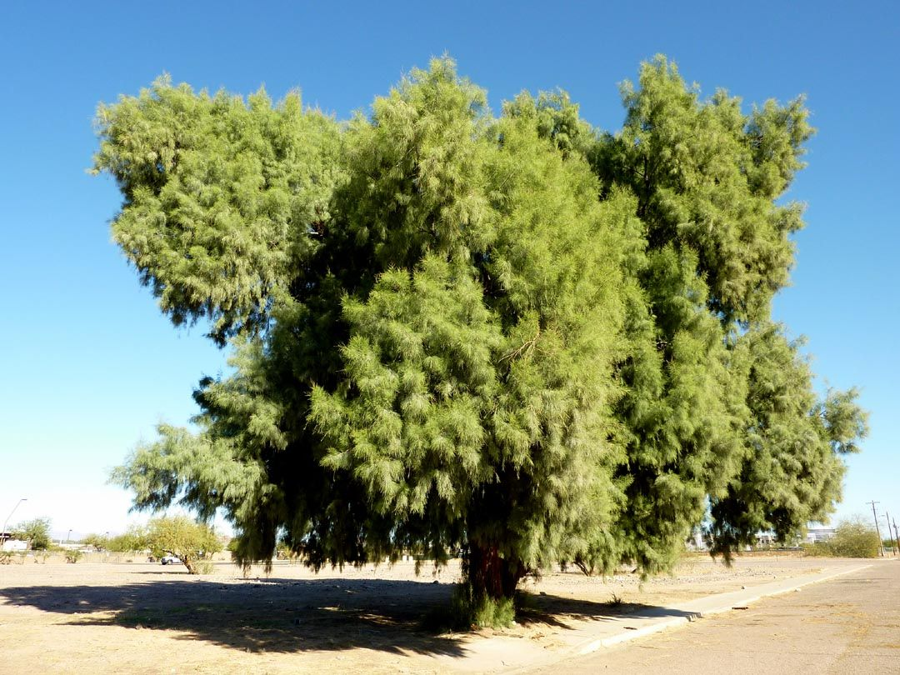*15 Then the Angel of the Lord called to Abraham a second time out of heaven, 16 and said: “By Myself I have sworn, says the Lord, because you have done this thing, and have not withheld your son, your only* son*— 17 blessing I will bless you, and multiplying I will multiply your descendants as the stars of the heaven and as the sand which* is *on the seashore; and your descendants shall possess the gate of their enemies. 18 In your seed all the nations of the earth shall be blessed, because you have obeyed My voice.” 19 So Abraham returned to his young men, and they rose and went together to Beersheba; and Abraham dwelt at Beersheba.*

**Do you know what Descendants mean?**

*It means your children, grandchildren, great grandchildren etc.*

*Remember Abraham thought he would not have any children, therefore no descendants.*

*God blessed Abraham with a child, Isaac. Isaac had twins, Jacob and Esau. Esau and Jacob had lots of children etc.*

**Question 9**

What was God’s covenant (promise) to Abraham and his descendants?

* 1. Abraham will have many descendants
  2. All the nations of the earth will be blessed because of Abraham
  3. Both (a) and (b)
* Saturday 18th November:

**Question 10**

How can we be more obedient to God in our lives?

**What to do when you finish your Bible Study.**

Send it by email to your class email address or print and hand it to your servants next Sunday.

* Year 3A St Bishoy[stbishoy3a@gmail.com](mailto:stbishoy3a@gmail.com) Class Servant: Uncle Emile (0416895236)
* Year 3B St Paul[saintpaul3b@gmail.com](mailto:saintpaul3b@gmail.com) Class Servant: Aunty Marena (0433677290)
* Year 3C St Moses [stmoses3c@gmail.com](mailto:stmoses3c@gmail.com) Class Servant: Uncle Mina (0433520175)