C:\Documents and Settings\suzy\Local Settings\Temporary Internet Files\Content.IE5\3JXW24R5\MC900383922[1].wmfSunday 5th November, 2017

Finish Date: Saturday 11th November, 2017

Name:

Class:

Completed Bible Study = 15 points

Email Homework by the due date = 5 points

**Year 4 Bible Study Jonah 3&4**

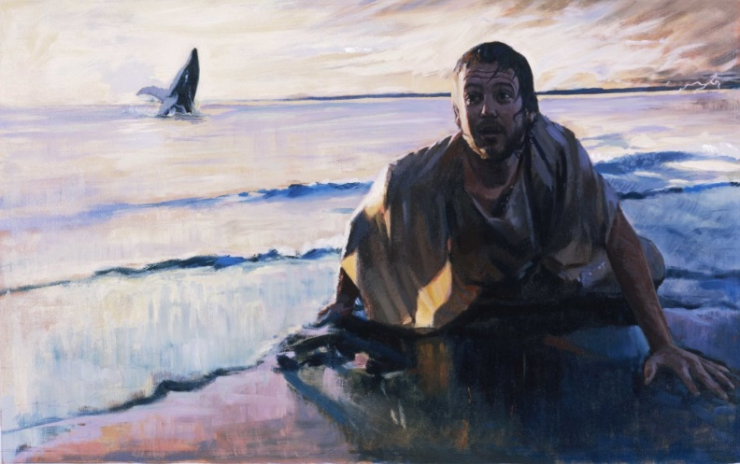

* **Monday: Read: Jonah 3:1-5 and answer the questions**

*Jonah Preaches at Nineveh*

*3 Now the word of the Lord came to Jonah the second time, saying, 2“Arise, go to Nineveh, that great city, and preach to it the message that I tell you.” 3So Jonah arose and went to Nineveh, according to the word of the Lord. Now Nineveh was an exceedingly great city, a three-day journey[*[*a*](https://www.biblegateway.com/passage/?search=jonah3&version=NKJV#fen-NKJV-22562a)*] in extent. 4And Jonah began to enter the city on the first day’s walk. Then he cried out and said, “Yet forty days, and Nineveh shall be overthrown!”*

**Question 1a**: When God forgives Jonah for his disobedience, we can see that God makes the same request to Jonah. What is that request? ______________________________________________________________________________________________________ _________________________________________________

**Question 1b**: When God asked Jonah a second time to go to Nineveh, Jonah:

1. Disputed with God
2. Showed his repentance by arising and going to Nineveh, according to the word of the Lord
3. Went to catch another boat

*The People of Nineveh Believe*

*5So the people of Nineveh believed God, proclaimed a fast, and put on sackcloth, from the greatest to the least of them.*

**Question 1c**: True or False:

1. The people of Nineveh had hope that the Lord would forgive them________________
2. Likewise, Christ’s resurrection preaches repentance and forgiveness of sins________
3. Jonah didn’t have a change of heart (repentance) in the whale, but stayed stubborn against God________

* **Tuesday : Read Jonah 3:6-10 and answer the questions**

*6Then word came to the king of Nineveh; and he arose from his throne and laid aside his robe, covered himself with sackcloth and sat in ashes. 7And he caused it to be proclaimed and published throughout Nineveh by the decree of the king and his nobles, saying,*

*Let neither man nor beast, herd nor flock, taste anything; do not let them eat, or drink water. 8But let man and beast be covered with sackcloth, and cry mightily to God; yes, let every one turn from his evil way and from the violence that is in his hands. 9Who can tell if God will turn and relent, and turn away from His fierce anger, so that we may not perish?*

**Question 2a:**

When the King of Nineveh heard that God was angry with Nineveh, what did he command his people to do? ____________________________________________________________________________________________________________________________________________________________________________________________________________________________________________________________________________________________________________

**Question2b**: True or False

1. The King commanded the people to fast from food and water
2. The King objected and argued with God that it’s not fair
3. The King commanded the people to cry to God and turn from their sins

**Question 2c**: What verse shows that they still had hope that God will relent?__________

*10Then God saw their works, that they turned from their evil way; and God relented from the disaster that He had said He would bring upon them, and He did not do it.*

**Question 2d:** What works did God see that made Him relent from the disaster that they said He would bring upon them?_______________________________________________________

Did you notice that the people of Nineveh didn’t offer sacrifices to God to ask for forgiveness but they had a broken and contrite heart, which made God relent.

* **Wednesday : Read Jonah 4:1-3 and answer the questions**

*Jonah’s Anger and God’s Kindness*



***4****But it displeased Jonah exceedingly, and he became angry.*

***2****So he prayed to the Lord, and said, “Ah, Lord, was not this what I said when I was still in my country? Therefore I fled previously to Tarshish; for I know that You are a gracious and merciful God, slow to anger and abundant in lovingkindness, One who relents from doing harm.*

***3****Therefore now, O Lord, please take my life from me, for it is better for me to die than to live!”*

**Question 3a:** Was Jonah happy that God forgave the people of Nineveh?

**Question 3b:** Name four of the characteristics of God mentioned in verse 2:

i.

ii.

iii.

iv.

* **Thursday: Read Jonah 4:4-6 and answer the questions**

***4****Then the Lord said, “Is it right for you to be angry?”*

Can you see how kindly God speaks to Jonah with soft questions. God is talking to Jonah’s conscience, as we should often ask when we are angry.

***5****So Jonah went out of the city and sat on the east side of the city. There he made himself a shelter and sat under it in the shade, till he might see what would become of the city.****6****And the Lord God prepared a plant[*[*a*](https://www.biblegateway.com/passage/?search=jonah+4&version=NKJV#fen-NKJV-22575a)*]and made it come up over Jonah, that it might be shade for his head to deliver him from his misery. So Jonah was very grateful for the plant.*

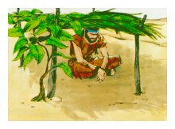

**Question 4.**

What did God do to deliver Jonah from his misery? ______________________________________________________________________________________________________________________________________________________

* **Friday : Read Jonah 4:7-9 and answer the questions**

***7****But as morning dawned the next day God prepared a worm, and it so damaged the plant that it withered.****8****And it happened, when the sun arose, that God prepared a vehement east wind; and the sun beat on Jonah’s head, so that he grew faint. Then he wished death for himself, and said, “It is better for me to die than to live.”*

***9****Then God said to Jonah, “Is it right for you to be angry about the plant?”*

*And he said, “It is right for me to be angry, even to death!”*

**Question 5:**

What question did God ask Jonah here? ____________________________________________________________________________

* **Saturday: Read Jonah 4:10 and answer the questions**

***10****But the Lord said, “You have had pity on the plant for which you have not labored, nor made it grow, which came up in a night and perished in a night.****11****And should I not pity Nineveh, that great city, in which are more than one hundred and twenty thousand persons who cannot discern between their right hand and their left—and much livestock?”*

**Question 6a:**

What lesson is God teaching Jonah about the plant? ________________________________________________________________________________________________________________________________________________________________________________________________________________________________________________________________________________________________________________

Can you see here how kind God is by showing mercy to the people of Nineveh and then justifying himself to Jonah in why he showed mercy. This shows we should never lose hope in the forgiveness and mercy of God.

**What to do when you finish your Bible Study.**

**Send it by email to your class email address or print and hand it to your servants next Sunday.**

* **Year 4A St Makarious StMakarios4A@gmail.com Class Servant- Aunty Labiba (0421891567)**
* **Year 4B St Bakhomious StBakhomios4B@gmail.com Class Servant- Aunty Mira (0415595556)**
* **Year 4C St Anthony StAnthony4C@gmail.com Class Servant- Aunty Olivia**