C:\Documents and Settings\suzy\Local Settings\Temporary Internet Files\Content.IE5\3JXW24R5\MC900383922[1].wmfSunday 5th November, 2017

Name:

Class:

Finish Date: Saturday 11th November, 2017

Completed Bible Study = 6 points

Email Homework by the due date = 12 points

**Year 3 Bible Study Genesis Chapter 21**

**For the questions below Highlight or change the font colour to choose the correct answer.**

* Monday 6th November: Read **Genesis 21: 1-7** and answer the questions:

**Sarah and Abraham have a son**

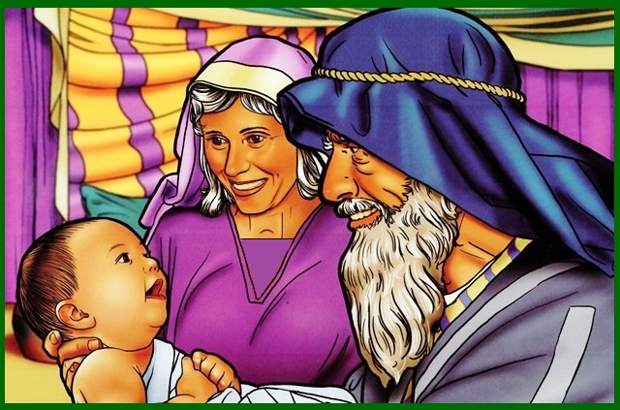*1 And the Lord visited Sarah as He had said, and the Lord did for Sarah as He had spoken. 2 For Sarah conceived and bore Abraham a son in his old age, at the set time of which God had spoken to him. 3 And Abraham called the name o* *f his son who was born to him—whom Sarah bore to him—Isaac. 4 Then Abraham circumcised his son Isaac when he was eight days old, as God had commanded him. 5 Now Abraham was one hundred years old when his son Isaac was born to him. 6 And Sarah said, “God has made me laugh,*and*all who hear will laugh with me.” 7 She also said, “Who would have said to Abraham that Sarah would nurse children? For I have borne*him*a son in his old age.”*

**Question 1**

How old was Abraham when Isaac was born?

**Question 2**

What does the name Isaac mean? (the answer is in verse 6)

1. Happiness
2. Laughter
3. Old age

* Tuesday 7th November: Read **Genesis 21: 8-13** and answer the questions:

**Sarah wants to send Ishmael away.**

*8 So the child grew and was weaned. And Abraham made a great feast on the same day that Isaac was* ***weaned****. 9 And Sarah saw the son of Hagar the Egyptian, whom she had borne to Abraham,* ***scoffing****. 10 Therefore she said to Abraham, “****Cast out*** *this* ***bondwoman*** *and her son; for the son of this bondwoman shall not be* ***heir*** *with my son,*namely*with Isaac.” 11 And the matter was very displeasing in Abraham’s sight because of his son. 12 But God said to Abraham, “Do not let it be displeasing in your sight because of the lad or because of your bondwoman. Whatever Sarah has said to you, listen to her voice; for in Isaac your* ***seed*** *shall be called. 13 Yet I will also make a nation of the son of the bondwoman, because he*is*your seed.”*

**Question 3**

Match the following words to their meaning:

weaned scoffing cast out bondwoman heir seed

|  |  |
| --- | --- |
| **Word** | **Meaning** |
|  | to inherit (receive) |
|  | making fun of |
|  | slave, servant |
|  | stop drinking milk from his mother, stop breastfeeding |
|  | descendants, children |
|  | send away |

**Question 4**

What did Abraham do on the day Isaac was weaned?

**Question 5**

God said to Abraham not to listen to what Sarah had asked him to do. (**TRUE / FALSE**)

* Wednesday 8th November: Read **Genesis 21: 14-20** and answer the questions:

### http://www.goodsalt.com/view/hagar-and-ishmael-3-GoodSalt-prcas0013.jpgHagar and Ishmael Depart

*14So Abraham rose early in the morning, and took bread and a skin of water; and putting it on her shoulder, he gave it and the boy to Hagar, and sent her away. Then she departed and wandered in the Wilderness of Beersheba. 15And the water in the skin was used up, and she placed the boy under one of the shrubs. 16Then she went and sat down across from him at a distance of about a bowshot; for she said to herself, “Let me not see the death of the boy.” So she sat opposite him, and lifted her voice and wept. 17And God heard the voice of the lad. Then the angel of God called to Hagar out of heaven, and said to her, “What ails you, Hagar? Fear not, for God has heard the voice of the lad where he is. 18Arise, lift up the lad and hold him with your hand, for I will make him a great nation.”*

*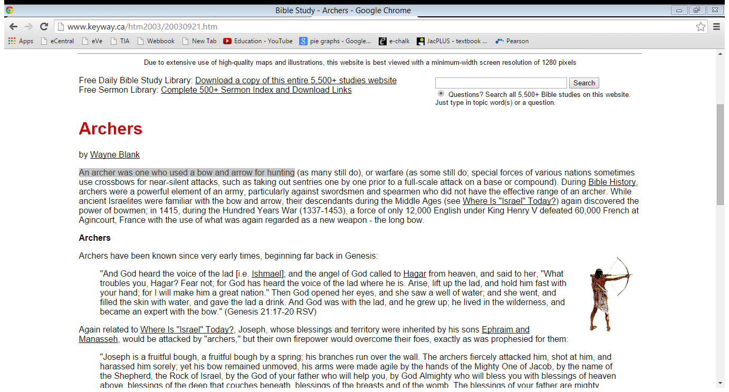19Then God opened her eyes, and she saw a well of water. And she went and filled the skin with water, and gave the lad a drink. 20So God was with the lad; and he grew and dwelt in the wilderness, and became an archer. 21He dwelt in the Wilderness of Paran; and his mother took a wife for him from the land of Egypt.*

**Do you know what an archer is?**

*An archer was one who used a bow and arrow for hunting*

**Question 6**

1. Abraham sent Hagar and Ishmael away with just bread and water (**TRUE / FALSE**)
2. Ishmael died when the water ran out (**TRUE / FALSE**)
3. God gave Hagar a well to save her and Ishmael (**TRUE / FALSE**)
4. Ishmael grew up to be a farmer (**TRUE / FALSE**)

* Thursday 9th November: Read **Genesis 21: 22-24** and answer the questions:

**Abimelech sees God is with Abraham**

*22 And it came to pass at that time that Abimelech and Phichol, the commander of his army, spoke to Abraham, saying, “God is with you in all that you do.23 Now therefore, swear to me by God that you will not deal falsely with me, with my offspring, or with my posterity; but that according to the kindness that I have done to you, you will do to me and to the land in which you have dwelt.”*

*24 And Abraham said, “I will swear.”*

**Question 7**

In the Old Testament, people used to swear as an oath (promise), but in the New Testament Jesus said “*34 But I say to you, do not swear at all ………. 37 But let your ‘Yes’ be ‘Yes,’ and your ‘No,’ ‘No.’ For whatever is more than these is from the evil one.”*

Do you think we are allowed to swear when we want people to believe what we are saying?

* Friday 10th November: Read **Genesis 21: 32-34** and answer the questions:

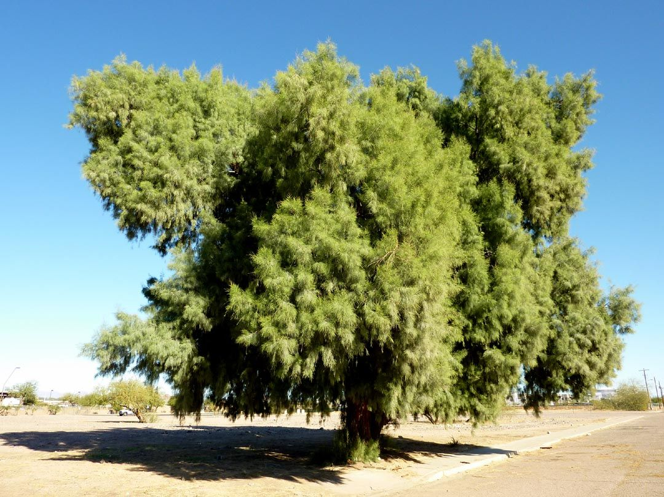

**Abraham and Abimelech make a promise in Beersheba**

*32 Thus they made a covenant at Beersheba. So Abimelech rose with Phichol, the commander of his army, and they returned to the land of the Philistines 33 Then*Abraham*planted a tamarisk tree in Beersheba, and there called on the name of the Lord, the Everlasting God. 34 And Abraham stayed in the land of the Philistines many days.*

**Question 8**

Where did Abraham plant the tamarisk tree?

**Question 9**

Where did Abraham stay?

**What to do when you finish your Bible Study.**

Send it by email to your class email address or print and hand it to your servants next Sunday.

* Year 3A St Bishoy[stbishoy3a@gmail.com](mailto:stbishoy3a@gmail.com) Class Servant: Uncle Emile (0416895236)
* Year 3B St Paul[saintpaul3b@gmail.com](mailto:saintpaul3b@gmail.com) Class Servant: Aunty Marena (0433677290)
* Year 3C St Moses [stmoses3c@gmail.com](mailto:stmoses3c@gmail.com) Class Servant: Uncle Mina (0433520175)