C:\Documents and Settings\suzy\Local Settings\Temporary Internet Files\Content.IE5\3JXW24R5\MC900383922[1].wmfSunday 22nd October, 2017

Name:

Class:

Finish Date: Saturday 28th October, 2017

Completed Bible Study = 6 points

Email Homework by the due date = 12 points

**Year 3 Bible Study Genesis Chapter 19**

* Monday 23rd October: Read **Genesis 19: 1-3** and answer the questions:

**Two Angels speak to Lot**

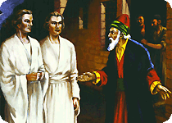*1 Now the two angels came to Sodom in the evening, and Lot was sitting in the gate of Sodom. When Lot saw*them,*he rose to meet them, and he bowed himself with his face toward the ground. 2 And he said, “Here now, my lords, please turn in to your servant’s house and spend the night, and wash your feet; then you may rise early and go on your way.” And they said, “No, but we will spend the night in the open square.”*

*3 But he insisted strongly; so they turned in to him and entered his house. Then he made them a feast, and baked unleavened bread, and they ate.*

**Question 1**

Like Abraham, Lot gave the angels a great welcome, what did he insist they do?

**Question 2**

How many angels visited Lot ?

* Tuesday 24th October: Read **Genesis 19: 12-14** and answer the questions:

**The angels warn Lot to take his family and leave sinful city of Sodom.**

*12 Then the men said to Lot, “Have you anyone else here? Son-in-law, your sons, your daughters, and whomever you have in the city—take them out of this place! 13For we will destroy this place, because the outcry against them has grown great before the face of the Lord, and the Lord has sent us to destroy it.”*

*14 So Lot went out and spoke to his sons-in-law, who had married his daughters, and said, “Get up, get out of this place; for the Lord will destroy this city!” But to his sons-in-law he seemed to be joking.*

**Question 3**

God wanted to save Lot and all his family so He sent the two angels to save them before He destroys Sodom and Gomorrah.

Do you believe that God always take care of His sons and daughters who listen and obey His words?

* Wednesday 25th October: Read **Genesis 19: 15-17** and answer the questions:

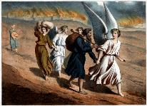**The angels take Lot and his family by their hands to hurry them to get out of the city before God destroys it**

*15 When the morning dawned, the angels urged Lot to hurry, saying, “Arise, take your wife and your two daughters who are here, lest you be consumed in the punishment of the city.” 16 And while he lingered, the men took hold of his hand, his wife’s hand, and the hands of his two daughters, the Lord being merciful to him, and they brought him out and set him outside the city. 17 So it came to pass, when they had brought them outside, that he said, “Escape for your life! Do not look behind you nor stay anywhere in the plain. Escape to the mountains, lest you be destroyed.”*

**Question 4**

The angels told Lot that it was time to leave Sodom, but Lot was hesitant to go. What did the angles do?

* 1. They left him in the city.
  2. They took hold of his hand, his wife’s hand and the hands of his daughters and they brought him out and set him outside the city.
  3. They stayed with him in the city.

**Question 5**

The angels asked Lot and his family to look behind to see how God punished the city because of their sins. (**TRUE / FALSE**)

* Thursday 26th October: Read **Genesis 19: 18-22** and answer the questions:

**Lot begs to escape to the closest city**

*18 Then Lot said to them, “Please, no, my lords! 19 Indeed now, your servant has found favor in your sight, and you have increased your mercy which you have shown me by saving my life; but I cannot escape to the mountains, lest some evil overtake me and I die. 20 See now, this city*is*near*enough*to flee to, and it*is*a little one; please let me escape there (*is*it not a little one?) and my soul shall live.”*

*21 And he said to him, “See, I have favored you concerning this thing also, in that I will not overthrow this city for which you have spoken. 22 Hurry, escape there. For I cannot do anything until you arrive there.” Therefore the name of the city was called Zoar.*

**Question 6**

What was the name of the city to which Lot escaped?

* Friday 27th October: Read **Genesis 19: 23-26** and answer the questions:

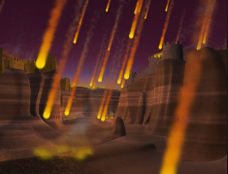

*23 The sun had risen upon the earth when Lot entered Zoar. 24 Then the Lord rained brimstone and fire on Sodom and Gomorrah, from the Lord out of the heavens. 25 So He overthrew those cities, all the plain, all the inhabitants of the cities, and what grew on the ground. 26 But his wife looked back behind him, and she became a pillar of salt.*

**Question 7**

What did the Lord rain upon Sodom and Gomorrah?

* 1. Dust
  2. Fire and brimstone
  3. hail

**Question 8**

Why do you think Lot’s wife looked back?

**Question 9**

Identify the people in the picture

A

B

C

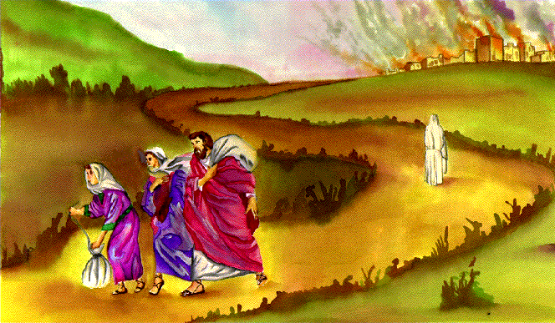

C.

B.

A

* Saturday 28th October: Read **Genesis 19: 27-29** and answer the questions

*27 And Abraham went early in the morning to the place where he had stood before the Lord. 28 Then he looked toward Sodom and Gomorrah, and toward all the land of the plain; and he saw, and behold, the smoke of the land which went up like the smoke of a furnace. 29 And it came to pass, when God destroyed the cities of the plain, that God remembered Abraham, and sent Lot out of the midst of the overthrow, when He overthrew the cities in which Lot had dwelt.*

*God remembered how Abraham pleaded for Lot to be saved and had mercy on Lot and saved him. We should follow Abraham’s example and pray for others to be saved.*

**Question 10**

What can we do to bring others closer to God?

**What to do when you finish your Bible Study.**

Send it by email to your class email address or print and hand it to your servants next Sunday.

* Year 3A St Bishoy[stbishoy3a@gmail.com](mailto:stbishoy3a@gmail.com) Class Servant: Uncle Emile (0416895236)
* Year 3B St Paul[saintpaul3b@gmail.com](mailto:saintpaul3b@gmail.com) Class Servant: Aunty Marena (0433677290)
* Year 3C St Moses [stmoses3c@gmail.com](mailto:stmoses3c@gmail.com) Class Servant: Uncle Mina (0433520175)