C:\Documents and Settings\suzy\Local Settings\Temporary Internet Files\Content.IE5\3JXW24R5\MC900383922[1].wmfSunday 15th October, 2017

Finish Date: Saturday 21st October, 2017

Name:

Class:

Completed Bible Study = 15 points

Email Homework by the due date = 5 points

**Year 4 Bible Study Psalm 23**

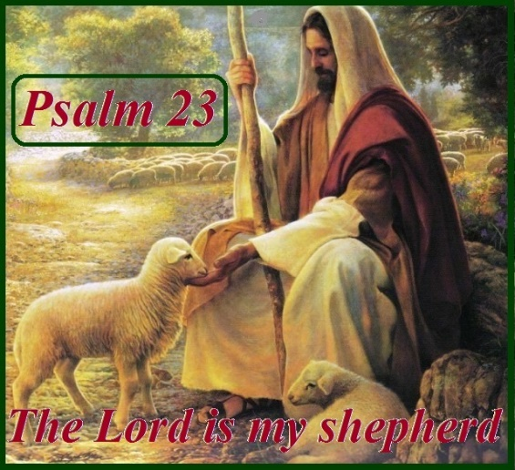

* **Monday Psalm 23:1**

*The Lord is my shepherd;  
 I shall not want.*

**Question 1a.** David wrote this psalm. Do you remember what was David’s first job when he was young? (hint: it’s in the verse)__________________________

**Question 1b**. What are some of the tasks a shepherd must do to look after his sheep?__________________________________________________________________________________________________________________________________________________________________________________________

**Question 1c.** What does “I shall not want” mean?

1. I will always be supplied with whatever I need if the Lord is my shepherd
2. If I do not have something I desire, this means it is either not good for me or I will have it in the right time
3. I need not fear or worry about anything in life
4. All of the above

* **Tuesday Psalm 23:2**

*He makes me to lie down in green pastures;  
He leads me beside the still waters.*

**Question 2:**

In verse 2 what does “lie down in green pastures” mean?

a. To be God’s people, we have to sleep in the outdoors

b.The green pasture which is food for all believers is the Word of life which causes God’s people to live quiet and content in their own minds, living at ease.

c.If we are God’s people, we never need to do any work.

**Question 3:**

He leads me beside the still waters means:

1. God always will lead us to a river
2. God is the guide, and God’s people are well led by God. When we are tired and in need of help, God will lead us to revive us.
3. David loved swimming

* **Wednesday: Psalm 23:3**

*He restores my soul;  
He leads me in the paths of righteousness  
For His name’s sake.*

**Question 4:**

This verse is talking about restoring the soul. When we go astray, like lost sheep, God will lead us back to the right way and shows us what we do wrong so that our soul will be restored. It is talking about how repentence gives us peace.

Can you remember a time when God showed David his error, and David repented? (hint: 2Samuel 12)

________________________________________________________________________________________________________________________________________________________________________________________________________________________________________________________________

* Thursday: Psalm 23:4

*Yea, though I walk through the valley of the shadow of death,  
I will fear no evil;  
For You are with me;  
Your rod and Your staff, they comfort me.*

*Did you know that a shepherd’s rod is what the shepherd used to hold up, and when the sheep passed underneath they would be counted. The staff is the tool that the shepherd used to drive away dogs and animals that would scatter or worry the sheep.*

**Question 5:**

When David is in danger, he has confidence that God will never leave him. What can separate us from the love of God?

1. Death
2. Sickness
3. Nothing

* **Friday: Psalm 23:5**

*You prepare a table before me in the presence of my enemies;  
You anoint my head with oil;  
My cup runs over.*

**Question 6:**

Does God only provide spiritual blessings, or does he also provide for our bodies?

* **Saturday Psalm 23:6**

*Surely goodness and mercy shall follow me  
All the days of my life;  
And I will dwell[*[*a*](https://www.biblegateway.com/passage/?search=psalm+23&version=NKJV#fen-NKJV-14242a)*] in the house of the Lord  
Forever*

**Question 7**

What are the mercy’s that will follow us all of our life if we are God’s people?

1. Forgiveness
2. Protection
3. Strength
4. Nourishment
5. All of the above

**Question 8**

Where is David talking about when he says “I will dwell in the house of the Lord Forever”?

1. Church
2. Heaven
3. Jerusalem

**What to do when you finish your Bible Study.**

**Send it by email to your class email address or print and hand it to your servants next Sunday.**

* **Year 4A St Makarious StMakarios4A@gmail.com Class Servant- Aunty Labiba (0421891567)**
* **Year 4B St Bakhomious StBakhomios4B@gmail.com Class Servant- Aunty Mira (0415595556)**
* **Year 4C St Anthony StAnthony4C@gmail.com Class Servant- Aunty Olivia**