C:\Documents and Settings\suzy\Local Settings\Temporary Internet Files\Content.IE5\3JXW24R5\MC900383922[1].wmfSunday 8th October, 2017

Finish Date: Saturday 14th October, 2017

Name:

Class:

Completed Bible Study = 15 points

Email Homework by the due date = 5 points

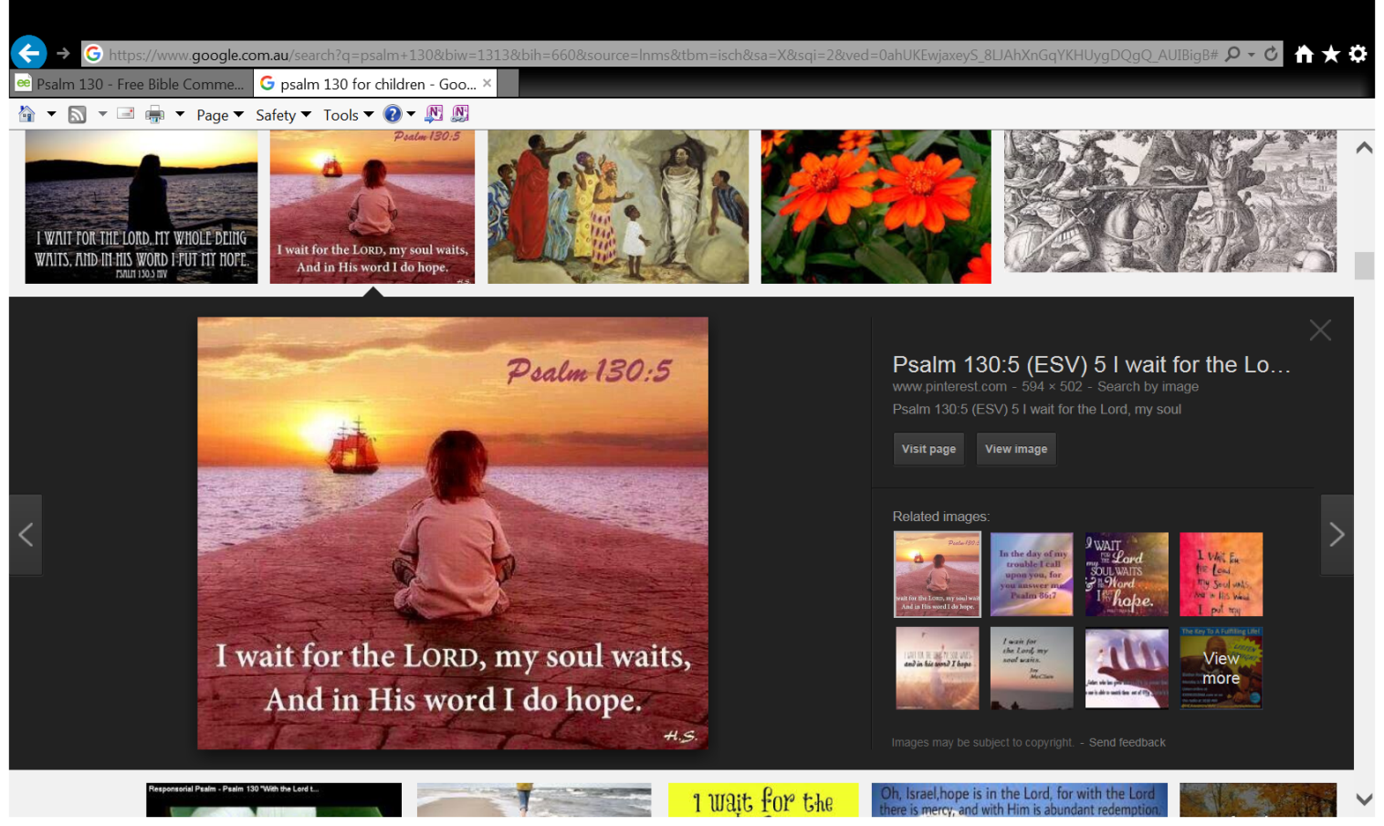**Year 4 Bible Study Psalm 130**

* Monday **Psalm 130: 1-3**:

Psalm 130 is one of the "repentance psalms". "Repentance" means to tell God that you are sorry for your sins. And you will try not to do them again. You sin when you break God’s rules.

**Question 1**

Look up Psalm 130 verse 1 Learn it and write it in the textbox below

*2Lord, hear my voice!  
Let Your ears be attentive  
To the voice of my supplications.*

**Verse 2 is saying:**

Lord, listen to my voice

Turn your ears to hear what I am saying to you.

**Question 2**

To help you memorise, fill in the missing words:

2 Lord, Listen to my !

Let your ears be

To the voice of my

*3If You,* ***LORD****, should mark iniquities,  
O* ***Lord****, who could stand?*

**Verse 3 is saying:** LORD, if you make a note of sins, who could stand?

*"Nobody will stand" because everybody sins (does wrong things)!*

*Nobody could "stand" before God. This means nobody would be able to tell God that they have not sinned.*

**Did you notice** in verse 3Lord is written as **“Lord”** and **“LORD”**? Do you know what the difference is between the two?

*They are not the same in the Hebrew Bible. The Jews wrote the psalms in the Hebrew language.* ***"LORD"*** *is a name for God that His people use. It is His covenant name. It is Yahweh in Hebrew. A covenant is when people agree to do something. Here, God agrees to give help to His people. His people agree to love and obey God. "Lord" means "master". It is Adonai in Hebrew. Here, it is another name for God.*

**Question 3**

Match the following words to their meanings:

depths, attentive, supplications, iniquities, stand.

|  |  |
| --- | --- |
| **Word** | **Meaning** |
|  | great sins |
|  | paying close attention to something |
|  | Survive and stay |
|  | Time of despair and feeling low |
|  | asking or begging for something earnestly or humbly |

***Tuesday: Psalm 130:4-5***

**Question 4**

Look up Psalm 130 verse 4, learn it and write it in the textbox below

**Question 5**

What does it mean for us “to fear God”?

* + To honour and respect Him because He has the power to forgive our sins
  + To know that He has power over the whole Universe
  + To understand that because He loves you He wants you to repent so He can forgive your sins so that one day you can come into His Holy presence.
  + All of the above.

*5I wait for the Lord, my soul waits,  
And in His word I do hope.*

**Verse 5 is saying:**

*"Wait" means "love and obey God even when he seems to do nothing".*

*"Hope" means "wait for something good to happen". While we wait, it is good to read God’s words in the Bible.*

**Question 6**

To help you memorise, fill in the missing words:

5I wait for the LORD,

And in His word

* Wednesday: **Psalm 130:6**

*6My soul waits for the Lord  
 More than those who watch for the morning—  
 Yes, more than those who watch for the morning.*

**Verse 6 is saying:**

*People who are sad or ill want the morning to come. They want the morning to come when it is still night. The psalmist wants the Lord (God) more than people who are sad or ill.*

**Question 7**

Match the following words or phrases to their meanings

|  |  |
| --- | --- |
| **Words/Phrase** | **Meaning** |
|  | wait for something good to happen |
|  | the person who wrote a psalm (or psalms). |
|  | In awe (love, respect, in reverence) of God. |
|  | love and obey God even when he seems to do nothing |
|  | excuse; God excused us when he gave our sins to Jesus. God did this when Jesus died. |
|  | Want the morning |

Psalmist, forgives, fear of God, hope, wait, “watch for the morning”

* Thursday: Review **Psalm 130: 4-6**

**Question 8**

Who is an example of someone in the Bible who waited patiently on God?

**Hint:** My nephew’s name is Lot, my wife’s name is Sarah. I have a son named Isaac.

**Question 9**

Try to recite verses 4-6 tonight. To help you remember fill in the missing words.

|  |  |  |  |  |  |
| --- | --- | --- | --- | --- | --- |
| But |  |  | forgiveness |  | You |
| That |  |  |  | feared. |
| I | wait |  |  | Lord |
| And | in |  |  |  | do | Hope. |
| My | soul |  |  |  | Lord |
| More | than |  |  |  |  |  |  |
| Yes |  |  |  |  |  |  |  |  |

* Friday: **Psalm 130: 7-8**

**Question 10**

Look up Psalm 130 verse 7. Learn it and write it in the textbox below

**Question 11**

Match the words to their definition:

Words: **Mercy, Redemption**

|  |  |
| --- | --- |
| **Word** | **Definition** |
|  | the action of saving or being saved from sin, error, or evil |
|  | compassion or forgiveness shown towards someone who has done the wrong thing, and deserves to be punished |

**What is Verse 7 saying?**

*People of Israel, place all of your hope in the Lord,*

*Because He will forgive you even if you have done the wrong thing,*

*And in Him there is the chance to be saved*

**Question 12**

Use your Bible to help you complete each line of Psalm 130 Verse 8

|  |  |
| --- | --- |
| And He shall |  |
|  | his iniquities |

**Remember:** *Iniquites means great sins*

**What is Verse 8 saying?**

The Lord shall provide salvation to the people of Israel for their many sins

* Saturday : Review **Psalm 130:7-8**

**Question 13**

To help you memorise the psalm, fill in the spaces using the words in the box:

**many salvation hope mercy abundant**

**Verse 7**

h

All people should place all of their in the Lord

For he has on our many sins and forgives us

m

In addition to the great mercy He has, He also has redemption

a

**Verse 8**

The Lord shall give us

s

m

From our sins

**Question 14**

**Can you recite the psalm now? Try to practice it and recite it to your Sunday school teacher tomorrow.**

**What to do when you finish your Bible Study.**

**Send it by email to your class email address or print and hand it to your servants next Sunday.**

* **Year 4A St Makarious StMakarios4A@gmail.com Class Servant- Aunty Labiba (0421891567)**
* **Year 4B St Bakhomious StBakhomios4B@gmail.com Class Servant- Aunty Mira (0415595556)**
* **Year 4C St Anthony StAnthony4C@gmail.com Class Servant- Aunty Olivia**