C:\Documents and Settings\suzy\Local Settings\Temporary Internet Files\Content.IE5\3JXW24R5\MC900383922[1].wmfSunday 8th October, 2017

Name:

Class:

Finish Date: Saturday 14th October 2017

Completed Bible Study = 6 points

Email Homework by the due date = 12 points

**Year 3 Bible Study Genesis Chapter 17**

**For the questions below Highlight or change the font colour to choose the correct answer.**

* Monday 9th October: Read **Genesis 17: 1-8** and answer the questions:

### The Sign of the Covenant

*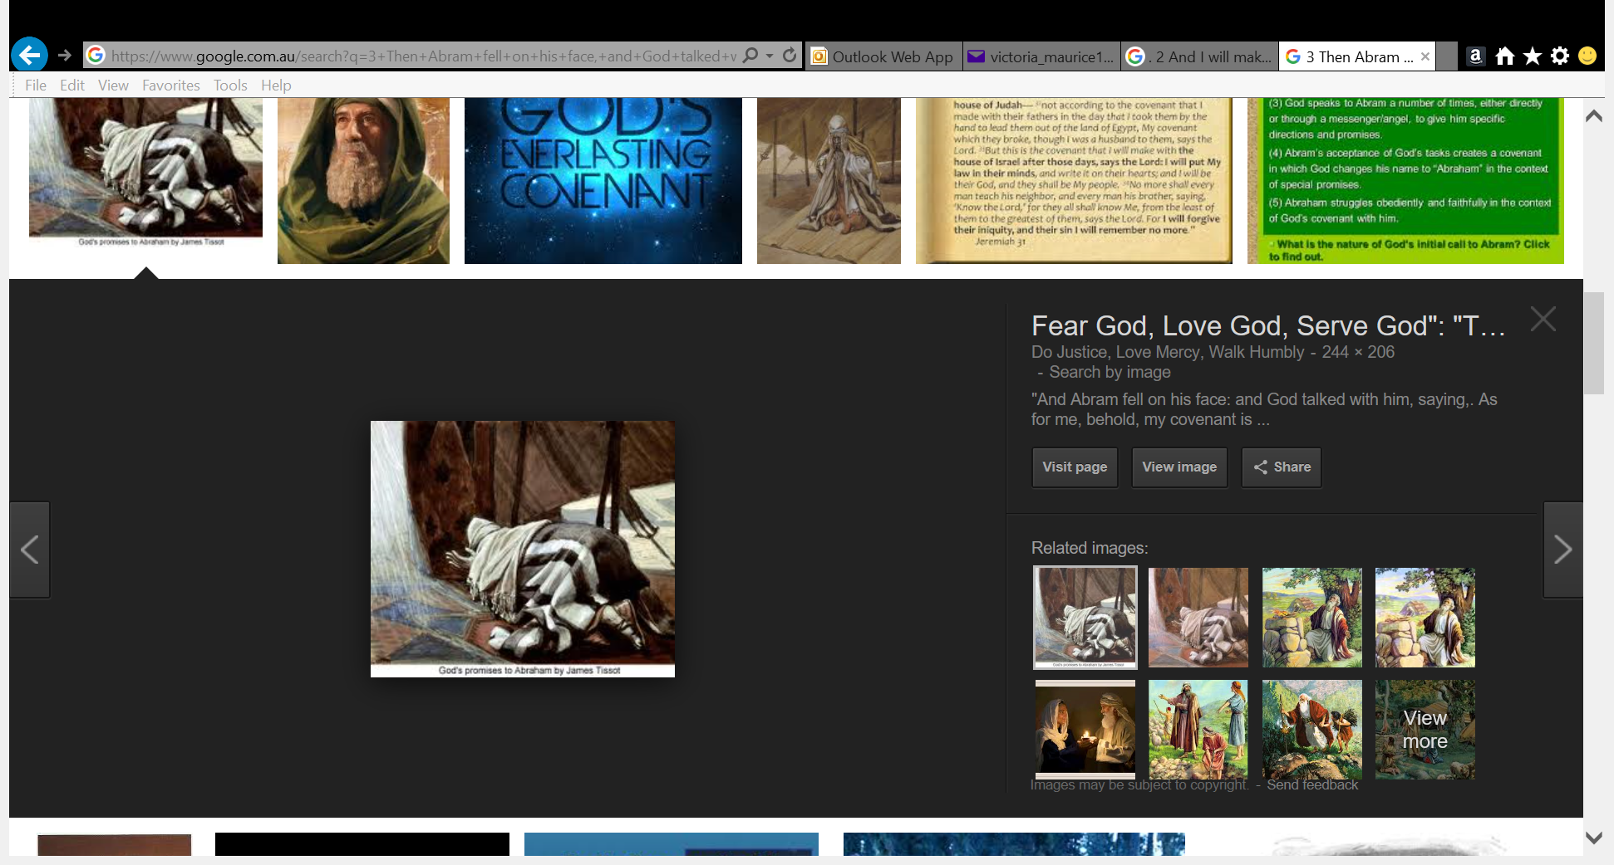1 When Abram was ninety-nine years old, the Lord appeared to Abram and said to him, “I am Almighty God; walk before Me and be blameless. 2And I will make My covenant between Me and you, and will multiply you exceedingly.” 3Then Abram fell on his face, and God talked with him, saying: 4“As for Me, behold, My covenant is with you, and you shall be a father of many nations. 5No longer shall your name be called Abram, but your name shall be Abraham; for I have made you a father of many nations. 6I will make you exceedingly fruitful; and I will make nations of you, and kings shall come from you. 7And I will establish My covenant between Me and you and your descendants after you in their generations, for an everlasting covenant, to be God to you and your descendants after you. 8Also I give to you and your descendants after you the land in which you are a stranger, all the land of Canaan, as an everlasting possession; and I will be their God.”*

**Question 1**

Who was the covenant between?

(A) You and God

(B) God and Abram

(C) Sarah and Abram

(D) Joseph and Noah

**Question 2**

What was the covenant ?

**Question 3**

God changed Abram’s name when he made a covenant with him. What was his new name?

* Tuesday 10th October: Read **Genesis 17: 9-10** and answer the questions:

*9And God said to Abraham: “As for you, you shall keep My covenant, you and your descendants after you throughout their generations. 10This is My covenant which you shall keep, between Me and you and your descendants after you:*

**Question 4**

Who was the covenant also given to? Circle all the correct answers.

1. Abraham’s friends.
2. Abraham’s children.
3. Abraham’s grandchildren.
4. Abraham’s neighbours.
5. Abraham’s great grand children.
6. Abraham’s grandchildren’s grandchildren.

* Wednesday 11th October: Read **Genesis 17: 15-16** and answer the questions:

**Sarai also becomes mother of nations**

*15Then God said to Abraham, “As for Sarai your wife, you shall not call her name Sarai, but Sarah shall be her name. 16And I will bless her and also give you a son by her; then I will bless her, and she shall be a mother of nations; kings of peoples shall be from her.”*

**Question 5**

What did Sarai’s name become?

**Question 6**

1. God made a promise to Abraham as we read above but did He also make a promise to Sarah?
2. What was the promise God made to Sarah?

* Thursday 12th October: Read **Genesis 17: 17-18** and answer the questions:

**Abraham could not believe that Sarah would have a baby at 90.**

*17Then Abraham fell on his face and laughed, and said in his heart, “Shall a child be born to a man who is one hundred years old? And shall Sarah, who is ninety years old, bear a child?” 18And Abraham said to God, “Oh, that Ishmael might live before You!”*

**Question 7**

Why did Abraham laugh at the promise from God?

1. because his wife Sarah was too old
2. because he was too old
3. because he couldn’t imagine becoming a father at his age
4. all of the above

* Friday 13th October: Read **Genesis 17: 19-20** and answer the questions:

*19Then God said: “No, Sarah your wife shall bear you a son, and you shall call his name Isaac; I will establish My covenant with him for an everlasting covenant, and with his descendants after him. 20And as for Ishmael, I have heard you. Behold, I have blessed him, and will make him fruitful, and will multiply him exceedingly. He shall beget twelve princes, and I will make him a great nation.*

**Question 8**

Ishmael was also the son of Abraham but from another wife. That is why Abraham thinks that God is saying that Ishmael will have many sons but then God clarifies: ‘No Sarah your wife shall bear YOU a son’. What was the name of Sarah’s son?

**Question 9**

Which of Abraham’s sons will God make a covenent with?

* Saturday 14th October: **Read Genesis 17:21-22**

*21But My covenant I will establish with Isaac, whom Sarah shall bear to you at this set time next year.” 22Then He finished talking with him, and God went up from Abraham.*

**Question 10**

What can you tell us about Abraham from this passage? If God appeared to him personally and spoke with him, what sort of man was Abraham?

**What to do when you finish your Bible Study.**

Send it by email to your class email address or print and hand it to your servants next Sunday.

* Year 3A St Bishoy[stbishoy3a@gmail.com](mailto:stbishoy3a@gmail.com) Class Servant: Uncle Emile (0416895236)
* Year 3B St Paul[saintpaul3b@gmail.com](mailto:saintpaul3b@gmail.com) Class Servant: Aunty Marena (0433677290)
* Year 3C St Moses [stmoses3c@gmail.com](mailto:stmoses3c@gmail.com) Class Servant: Uncle Mina (0433520175)