C:\Documents and Settings\suzy\Local Settings\Temporary Internet Files\Content.IE5\3JXW24R5\MC900383922[1].wmfSunday 1st October, 2017

Name:

Class:

Finish Date: Saturday 7th October, 2017

Completed Bible Study = 6 points

Email Homework by the due date = 12 points

**Year 3 Bible Study Genesis Chapter 16**

**For the questions below Highlight, underline or change the font colour to choose the correct answer.**

* Monday 2nd October: Read **Genesis 16: 1-4** and answer the questions:

**Sarai gives Abram a wife to have children**

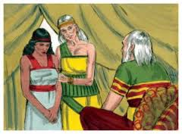*1 Now Sarai, Abram’s wife, had borne him no children. And she had an Egyptian maidservant whose name was Hagar. 2So Sarai said to Abram, “See now, the Lord has restrained me from bearing children. Please, go in to my maid; perhaps I shall obtain children by her.” And Abram heeded the voice of Sarai. 3Then Sarai, Abram’s wife, took Hagar her maid, the Egyptian, and gave her to her husband Abram to be his wife, after Abram had dwelt ten years in the land of Canaan. And when she saw that she had conceived, her mistress became despised in her eyes.*

**Question 1**

Match the words below to their meaning:

restrained, bearing children, heeded the voice, conceived, despised

|  |  |
| --- | --- |
| **Word** | **Meaning** |
|  | hated |
|  | listened to/obeyed |
|  | stopped |
|  | became pregnant |
|  | giving birth to children |

**Question 2**

Why did Sarai give Hagar, her maidservant, to be a wife for Abram?

*In Abraham’s day, Old Testament, it was common for men to marry maidservants in order to have children. This not acceptable any more in the New Testament. A man is allowed to marry only one woman whether they are able or not to have children.*

* Tuesday 3rd October: Read **Genesis 16: 5-6** and answer the questions:

**Sarai deals harshly with Hagar**

*5Then Sarai said to Abram, ………she saw that she had conceived, I became despised in her eyes. The Lord judge between you and me.”*

*6So Abram said to Sarai, “Indeed your maid is in your hand; do to her as you please.” And when Sarai dealt harshly with her, she fled from her presence.*

**Question 3**

What does Hagar do after Sarai treats her harshly?

* Wednesday 4th October: Read **Genesis 16: 7-8** and answer the questions:

**Angel of the Lord finds Hagar**

*Now the Angel of the Lord found her by a spring of water in the wilderness, by the spring on the way to Shur. 8And He said, “Hagar, Sarai’s maid, where have you come from, and where are you going?”*

*She said, “I am fleeing from the presence of my mistress Sarai.”*

**Question 4**

Who appears to Hagar to comfort her in her pain?

* Thursday 5th October: Read **Genesis 16: 10-13** and answer the questions:

**Angel of the Lord speaks to Hagar**

*9The Angel of the Lord said to her, “Return to your mistress, and submit yourself under her hand.” 10Then the Angel of the Lord said to her, “I will multiply your descendants exceedingly, so that they shall not be counted for multitude.”*

**Question 5**

What does God promise to Hagar if she returns to work for Sarai?

1. Land
2. More children and grandchildren than she could count
3. Wealth and money

* Friday 6th October: Read **Genesis 16: 11-12** and answer the questions:

*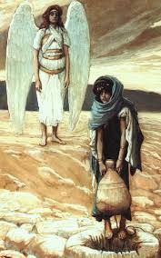***Angel of the Lord tells Hagar she will have a son.**

*11And the Angel of the Lord said to her:*

*“Behold, you are with child,  
And you shall bear a son.  
You shall call his name Ishmael,  
Because the Lord has heard your affliction.  
12He shall be a wild man;  
His hand shall be against every man,  
And every man’s hand against him.  
And he shall dwell in the presence of all his brethren.”*

**Question 6**

Based on the following verse, what do you guess that the name “Ishmael” might mean?

*“And you shall bear a son. You shall call his name Ishmael, because the Lord has* ***heard*** *your affliction [suffering].”*

1. God is with us
2. God saves
3. God hears

* Saturday 7th October:  **Read Genesis 16:13-16**

**Hagar bears Ishmael**

*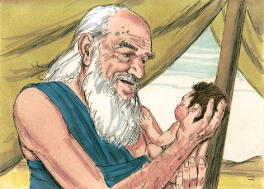13Then she called the name of the Lord who spoke to her, You-Are-the-God-Who-Sees; for she said, “Have I also here seen Him who sees me?” 14Therefore the well was called Beer Lahai Roi; observe, it is between Kadesh and Bered. 15So Hagar bore Abram a son; and Abram named his son, whom Hagar bore, Ishmael. 16Abram was eighty-six years old when Hagar bore Ishmael to Abram.*

**Question 7**

How old was Abram when he had his first son?

1. 89 years old
2. 88 years old
3. 86 years old

**Question 8**

What was the name of Abram’s first son?

1. Isaac
2. Ishmael
3. Hagar

**What to do when you finish your Bible Study.**

Send it by email to your class email address or print and hand it to your servants next Sunday.

* Year 3A St Bishoy[stbishoy3a@gmail.com](mailto:stbishoy3a@gmail.com) Class Servant: Uncle Emile (0416895236)
* Year 3B St Paul[saintpaul3b@gmail.com](mailto:saintpaul3b@gmail.com) Class Servant: Aunty Marena (0433677290)
* Year 3C St Moses [stmoses3c@gmail.com](mailto:stmoses3c@gmail.com) Class Servant: Uncle Mina (0433520175)