C:\Documents and Settings\suzy\Local Settings\Temporary Internet Files\Content.IE5\3JXW24R5\MC900383922[1].wmfSunday 24th September, 2017

Name:

Class:

Finish Date: Saturday 30th September, 2017

Completed Bible Study = 15 points

Email Homework by the due date = 5 points

**Year 4 Bible Study Genesis Chapter 48, 49, 50**

**For the questions below Highlight or change the font colour to choose the correct answer.**

* Monday 25th September :Read **Genesis 48: 1-14** and answer the questions:

**Joseph unites with his father Jacob(Israel)**

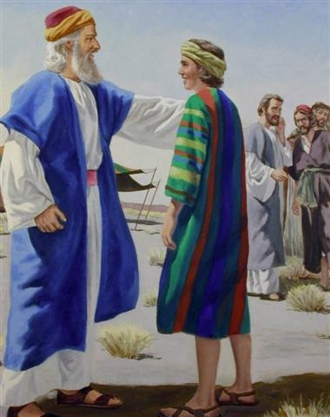*1 Now it came to pass after these things that Joseph was told, “Indeed your father is sick”; and he took with him his two sons, Manasseh and Ephraim. 2And Jacob was told, “Look, your son Joseph is coming to you”; and Israel strengthened himself and sat up on the bed. 3Then Jacob said to Joseph: “God Almighty appeared to me at Luz in the land of Canaan and blessed me, 4and said to me, ‘Behold, I will make you fruitful and multiply you, and I will make of you a multitude of people, and give this land to your descendants after you as an everlasting possession.’ 5And now your two sons, Ephraim and Manasseh, who were born to you in the land of Egypt before I came to you in Egypt, are mine; as Reuben and Simeon, they shall be mine. 6Your offspring whom you beget after them shall be yours; they will be called by the name of their brothers in their inheritance. 7But as for me, when I came from Padan, Rachel died beside me in the land of Canaan on the way, when there was but a little distance to go to Ephrath; and I buried her there on the way to Ephrath (that is, Bethlehem).”*

**Joseph introduces his sons to his father**

*8Then Israel saw Joseph’s sons, and said, “Who are these?”9And Joseph said to his father, “They are my sons, whom God has given me in this place.”And he said, “Please bring them to me, and I will bless them.” 10Now the eyes of Israel were dim with age, so that he could not see. Then Joseph brought them near him, and he kissed them and embraced them. 11And Israel said to Joseph, “I had not thought to see your face; but in fact, God has also shown me your offspring!”*

**Israel blesses Joseph**

*12So Joseph brought them from beside his knees, and he bowed down with his face to the earth. 13And Joseph took them both, Ephraim with his right hand toward Israel’s left hand, and Manasseh with his left hand toward Israel’s right hand, and brought them near him. 14Then Israel stretched out his right hand and laid it on Ephraim’s head, who was the younger, and his left hand on Manasseh’s head, guiding his hands knowingly, for Manasseh was the firstborn.*

**Question 1**

Identify the people in the picture using the following names:

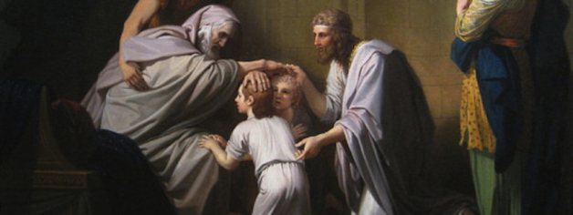

Joseph

Israel

Ephraim

Manasseh

* Tuesday 26th September: Read **Genesis 48: 15-22** and answer the questions:

**Israel’s blesses Joseph’s sons**

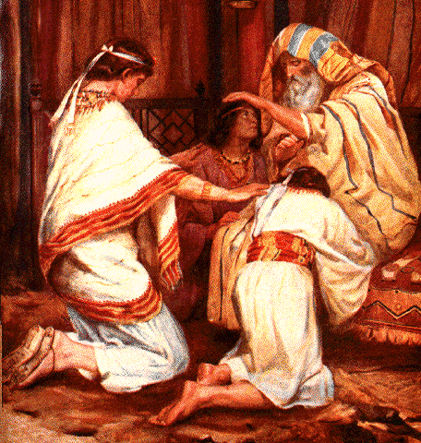

*15And he blessed Joseph, and said:*

*“God, before whom my fathers Abraham and Isaac walked,  
The God who has fed me all my life long to this day,  
16The Angel who has redeemed me from all evil,  
Bless the lads;  
Let my name be named upon them,  
And the name of my fathers Abraham and Isaac;  
And let them grow into a multitude in the midst of the earth.”*

**Question 2**

Match the words below with their meaning:

Redeemed, lads, multitude.

|  |  |
| --- | --- |
| **Word** | **Meaning** |
|  | A large number of people |
|  | To save |
|  | Another word for boys |

**Israel gives the firstborn blessing to Joseph’s younger son**

*17Now when Joseph saw that his father laid his right hand on the head of Ephraim, it displeased him; so he took hold of his father’s hand to remove it from Ephraim’s head to Manasseh’s head. 18And Joseph said to his father, “Not so, my father, for this one is the firstborn; put your right hand on his head.”*

*19But his father refused and said, “I know, my son, I know. He also shall become a people, and he also shall be great; but truly his younger brother shall be greater than he, and his descendants shall become a multitude of nations.”*

**Question 3**

Why was Joseph upset when Israel put his right hand on the head of Ephraim?

1. Manasseh was older and it was custom for the older son to receive blessing from the right
2. Israel was blind and couldn’t see what he was doing
3. Israel was meant to put his hand on Joseph’s head

**Question 4**

Look up Genesis 48 verses 21-22 and copy it in the textbox below

* Wednesday 27th September :Read **Genesis 49: 1-21** and answer the questions:

**Jacob’s Last Words to His Sons**

*1And Jacob called his sons and said, “Gather together, that I may tell you what shall befall you in the last days:*

*2“Gather together and hear, you sons of Jacob, And listen to Israel your father.*

**Jacob’s last words to Reuben.**

*3“Reuben, you are my firstborn, My might and the beginning of my strength,  
The excellency of dignity and the excellency of power.  
4Unstable as water, you shall not excel, Because you went up to your father’s bed;  
Then you defiled it— He went up to my couch.*

**Jacob’s last words to Simeon and Levi**

*5“Simeon and Levi are brothers; Instruments of cruelty are in their dwelling place.  
6Let not my soul enter their council; Let not my honor be united to their assembly;  
For in their anger they slew a man, And in their self-will they hamstrung an ox.  
7Cursed be their anger, for it is fierce; And their wrath, for it is cruel!  
I will divide them in Jacob And scatter them in Israel.*

**Question 5**

Match the following words to their correct meaning: excel, defiled, unstable, cruelty, slew

|  |  |
| --- | --- |
| **Word** | **Meaning** |
|  | Outshine and surpass |
|  | Killed |
|  | Unsteady |
|  | Nastiness |
|  | Dishonoured |

**Jacob’s last words to Judah.**

*“Judah, you are he whom your brothers shall praise; Your hand shall be on the neck of your enemies; Your father’s children shall bow down before you.  
9Judah is a lion’s whelp; From the prey, my son, you have gone up.  
He bows down, he lies down as a lion; And as a lion, who shall rouse him?  
10The scepter shall not depart from Judah, Nor a lawgiver from between his feet,  
Until Shiloh comes; And to Him shall be the obedience of the people.  
11Binding his donkey to the vine, And his donkey’s colt to the choice vine,  
He washed his garments in wine, And his clothes in the blood of grapes.  
12His eyes are darker than wine, And his teeth whiter than milk.*

**Jacob’s last words to Zebulun.**

*13“Zebulun shall dwell by the haven of the sea;  
He shall become a haven for ships,  
And his border shall adjoin Sidon*

**Jacob’s last words to Issachar.**

*14“Issachar is a strong donkey, Lying down between two burdens; 15He saw that rest was good,  
And that the land was pleasant; He bowed his shoulder to bear a burden, And became a band of slaves*

**Jacob’s last words to Dan.**

*“Dan shall judge his people As one of the tribes of Israel. 17Dan shall be a serpent by the way,  
A viper by the path, That bites the horse’s heels So that its rider shall fall backward.  
18I have waited for your salvation, O Lord!*

**Jacob’s last words to Gad.**

*19“Gad, a troop shall tramp upon him, But he shall triumph at last.*

**Jacob’s last words to Asher.**

*20“Bread from Asher shall be rich, And he shall yield royal dainties.*

**Jacob’s last words to Naphtali**

*21“Naphtali is a deer let loose; He uses beautiful words*

**Question 6a**

Who is described as a strong donkey?

**Question 6b**

Who is described as a ‘deer let loose’?

* Thursday 28th September: Read **Genesis 49: 22-33** and answer the questions:

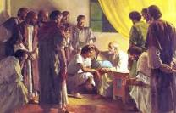**Jacob’s last words to Joseph.**

*22“Joseph is a fruitful bough [branch], A fruitful bough by a well; His branches run over the wall.  
23The archers have bitterly grieved him, Shot at him and hated him. 24But his bow remained in strength, And the arms of his hands were made strong By the hands of the Mighty God of Jacob  
(From there is the Shepherd, the Stone of Israel),  
25By the God of your father who will help you, And by the Almighty who will bless you  
With blessings of heaven above, Blessings of the deep that lies beneath, Blessings of the breasts and of the womb. 26The blessings of your father Have excelled the blessings of my ancestors,  
Up to the utmost bound of the everlasting hills. They shall be on the head of Joseph,  
And on the crown of the head of him who was separate from his brothers*

**Question 7a**

Jacob says that Joseph’s strength came from one sourse/ what or who does Joseph get his strength from?

**Question 7b**

Benjamin was Jacob’s youngest son. Look up Genesis 49 verse 27 to find out what Jacob’s last words to Benjamin were. Write it in the text box below.

*28All these are the twelve tribes of Israel, and this is what their father spoke to them. And he blessed them; he blessed each one according to his own blessing.*

### Jacob’s Death and Burial

*29Then he charged them and said to them: “I am to be gathered to my people; bury me with my fathers in the cave that is in the field of Ephron the Hittite, 30in the cave that is in the field of Machpelah, which is before Mamre in the land of Canaan, which Abraham bought with the field of Ephron the Hittite as a possession for a burial place. 31There they buried Abraham and Sarah his wife, there they buried Isaac and Rebekah his wife, and there I buried Leah. 32The field and the cave that is there were purchased from the sons of Heth.” 33And when Jacob had finished commanding his sons, he drew his feet up into the bed and breathed his last, and was gathered to his people.*

**Question 8a**

In which field does Jacob wish to be buried?

**Question 8b**

Who else was buried in that spot? **True or False**

|  |  |
| --- | --- |
| Abraham | **True / False** |
| Sarah | **True / False** |
| Isaac | **True/ False** |
| Rebekah | **True/ False** |
| Esau | **True/ False** |
| Leah | **True/ False** |

* **Friday 29th September: Read Genesis 50: 1-14 and answer the questions:**

**Joseph mourns for his father**

**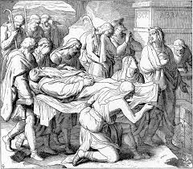***1 Then Joseph fell on his father’s face, and wept over him, and kissed him. 2And Joseph commanded his servants the physicians to embalm his father. So the physicians embalmed Israel. 3Forty days were required for him, for such are the days required for those who are embalmed; and the Egyptians mourned for him seventy days.*

*4Now when the days of his mourning were past, Joseph spoke to the household of Pharaoh, saying, “If now I have found favor in your eyes, please speak in the hearing of Pharaoh, saying, 5‘My father made me swear, saying, “Behold, I am dying; in my grave which I dug for myself in the land of Canaan, there you shall bury me.” Now therefore, please let me go up and bury my father, and I will come back.’”*

*6And Pharaoh said, “Go up and bury your father, as he made you swear.”*

**Question 9**

Jacob had asked Joseph to bury him when he died in a particular place.

1. What was the name of this place?
2. Did Joseph obey his father in what he was asked?

**Joseph buries his father to Canaan**

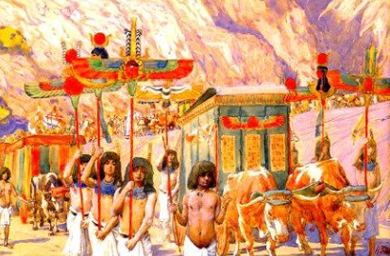*7So Joseph went up to bury his father; and with him went up all the servants of Pharaoh, the elders of his house, and all the elders of the land of Egypt, 8as well as all the house of Joseph, his brothers, and his father’s house. Only their little ones, their flocks, and their herds they left in the land of Goshen. 9And there went up with him both chariots and horsemen, and it was a very great gathering.*

*10Then they came to the threshing floor of Atad, which is beyond the Jordan, and they mourned there with a great and very solemn lamentation. He observed seven days of mourning for his father. 11And when the inhabitants of the land, the Canaanites, saw the mourning at the threshing floor of Atad, they said, “This is a deep mourning of the Egyptians.” Therefore its name was called Abel Mizraim, which is beyond the Jordan.*

**Question 10a**

Which of the following groups did NOT attend the burial of Jacob?

1. the elders
2. the little children
3. the servants of Pharoah
4. Josephs 11 brothers

**Question10 b**

The family came to a place in Canaan and wept and mourned for many days. Even the neighbours commented on how much they mourned. How many days did they mourn?

**Joseph returns to Egypt after he buries his father.**

*12So his sons did for him just as he had commanded them. 13For his sons carried him to the land of Canaan, and buried him in the cave of the field of Machpelah, before Mamre, which Abraham bought with the field from Ephron the Hittite as property for a burial place. 14And after he had buried his father, Joseph returned to Egypt, he and his brothers and all who went up with him to bury his father.*

**Question 11**

Here we see an example of OBEDIENCE from Joseph and his brothers because the Bible tells us that they did exactly as their father Jacob had told them. This is very special and meaningful and we should learn from this because their father was not even around to see them and reward them for their obedience.

Can you think of a way you could better obey your parents this week?

* **Saturday 30th September: Read Genesis 50: 15-26 and answer the questions:**

### Joseph Reassures His Brothers

*15When Joseph’s brothers saw that their father was dead, they said, “Perhaps Joseph will hate us, and may actually repay us for all the evil which we did to him.” 16So they sent messengers to Joseph, saying, “Before your father died he commanded, saying, 17‘Thus you shall say to Joseph: “I beg you, please forgive the trespass of your brothers and their sin; for they did evil to you.”’ Now, please, forgive the trespass of the servants of the God of your father.” And Joseph wept.*

**Joseph shows his trust in God to his brothers**

*18Then his brothers also went and fell down before his face, and they said, “Behold, we are your servants.”19Joseph said to them, “Do not be afraid, for am I in the place of God? 20But as for you, you meant evil against me; but God meant it for good, in order to bring it about as it is this day, to save many people alive. 21Now therefore, do not be afraid; I will provide for you and your little ones.” And he comforted them and spoke kindly to them.*

**Question 12**

1. So the brothers of Joseph were still so afraid they came and fell before him as servants would. Did they have faith like Joseph that God would treat them well?
2. What was Joseph’s response to his brothers?
3. He forgave them and explained it was all in God’s will
4. He was upset and left
5. He shouted at them to get up
6. He didn’t want to know them anymore

### Death of Joseph

*22So Joseph dwelt in Egypt, he and his father’s household. And Joseph lived one hundred and ten years. 23Joseph saw Ephraim’s children to the third generation. The children of Machir, the son of Manasseh, were also brought up on Joseph’s knees.*

*24And Joseph said to his brethren, “I am dying; but God will surely visit you, and bring you out of this land to the land of which He swore to Abraham, to Isaac, and to Jacob.” 25Then Joseph took an oath from the children of Israel, saying, “God will surely visit you, and you shall carry up my bones from here.” 26So Joseph died, being one hundred and ten years old; and they embalmed him, and he was put in a coffin in Egypt.*

**Question 13**

What have you learnt about faith from the life and story of Joseph?

1. When things are tough just trust God will work it out
2. Be honest and true to your faith in EVERY situation
3. Work hard and you will be rewarded
4. Love and forgive unconditionally
5. All of the above

**What to do when you finish your Bible Study.**

**Send it by email to your class email address or print and hand it to your servants next Sunday.**

* **Year 4A St Makarious StMakarios4A@gmail.com Class Servant- Aunty Labiba (0421891567)**
* **Year 4B St Bakhomious StBakhomios4B@gmail.com Class Servant- Aunty Mira (0415595556)**
* **Year 4C St Anthony StAnthony4C@gmail.com Class Servant- Aunty Olivia**