C:\Documents and Settings\suzy\Local Settings\Temporary Internet Files\Content.IE5\3JXW24R5\MC900383922[1].wmfSunday 3rd September, 2017

Name:

Class:

Finish Date: Saturday 9th September, 2017

Completed Bible Study = 15 points

Email Homework by the due date = 5 points

**Year 4 Bible Study Genesis Chapter 42&43**

**For the questions below Highlight or change the font colour to choose the correct answer.**

Monday 4th September :Read **Genesis 42: 1-12** and answer the questions:

**Joseph’s Brothers Go to Egypt**

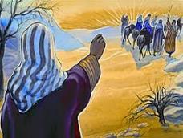*1 When Jacob saw that there was grain in Egypt, Jacob said to his sons, “Why do you look at one another?” 2And he said, “Indeed I have heard that there is grain in Egypt; go down to that place and buy for us there, that we may live and not die.”*

*3So Joseph’s ten brothers went down to buy grain in Egypt. 4But Jacob did not send Joseph’s brother Benjamin with his brothers, for he said, “Lest some calamity befall him.” 5And the sons of Israel went to buy grain among those who journeyed, for the famine was in the land of Canaan.*

**Question1**

Why did Jacob sends his sons to Egypt?

**Question 2**

Which of Jacob’s sons does NOT travel to Egypt?

**Joseph recognises his brothers but they don’t recognise him.**

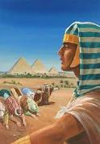*6Now Joseph was governor over the land; and it was he who sold to all the people of the land. And Joseph’s brothers came and bowed down before him with their faces to the earth. 7Joseph saw his brothers and recognized them, but he acted as a stranger to them and spoke roughly to them. Then he said to them, “Where do you come from?”*

*And they said, “From the land of Canaan to buy food.”*

*8So Joseph recognized his brothers, but they did not recognize him. 9Then Joseph remembered the dreams which he had dreamed about them, and said to them, “You are spies! You have come to see the nakedness of the land!”*

*10And they said to him, “No, my lord, but your servants have come to buy food. 11We are all one man’s sons; we are honest men; your servants are not spies.”*

*12But he said to them, “No, but you have come to see the nakedness of the land.”*

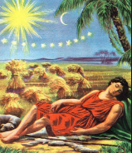

**Question 3**

Do you remember back in Genesis 37 Joseph dreamt that all the sheaths, stars & moon bowed down to him, and when he told his brothers they replied with anger *“Do you intend to reign over us? Will you actually rule us?”*  Which verse in the above passage tells us that Joseph’s dream came true?

**Question 4**

1. Did Joseph recognise his brothers? **YES/NO**
2. Did Joseph’s brothers recognise Joseph? **YES/NO**

* Tuesday 5th September: Read **Genesis 42: 13-24** and answer the questions:

**Joseph accuses his brothers of being ‘spies’**

*13And they said, “Your servants are twelve brothers, the sons of one man in the land of Canaan; and in fact, the youngest is with our father today, and one is no more.”*

*14But Joseph said to them, “It is as I spoke to you, saying, ‘You are spies!’ 15In this manner you shall be tested: By the life of Pharaoh, you shall not leave this place unless your youngest brother comes here. 16Send one of you, and let him bring your brother; and you shall be kept in prison, that your words may be tested to see whether there is any truth in you; or else, by the life of Pharaoh, surely you are spies!” 17So he put them all together in prison three days.*

**Joseph weeps for his brothers**

*18Then Joseph said to them the third day, “Do this and live, for I fear God: 19If you are honest men, let one of your brothers be confined to your prison house; but you, go and carry grain for the famine of your houses. 20And bring your youngest brother to me; so your words will be verified, and you shall not die.”*

*And they did so. 21Then they said to one another, “We are truly guilty concerning our brother, for we saw the anguish of his soul when he pleaded with us, and we would not hear; therefore this distress has come upon us.”*

*22And Reuben answered them, saying, “Did I not speak to you, saying, ‘Do not sin against the boy’; and you would not listen? Therefore behold, his blood is now required of us.” 23But they did not know that Joseph understood them, for he spoke to them through an interpreter. 24And he turned himself away from them and wept. Then he returned to them again, and talked with them. And he took Simeon from them and bound him before their eye.*

*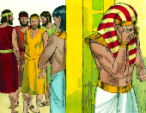***Question 5**

Which verse in the above passage is describes what you see in the picture?

* Wednesday 6th September: Read **Genesis 42: 25-38** and answer the questions:

### The Brothers Return to Canaan

*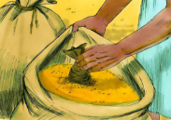25Then Joseph gave a command to fill their sacks with grain, to restore every man’s money to his sack, and to give them provisions for the journey. Thus he did for them. 26So they loaded their donkeys with the grain and departed from there. 27But as one of them opened his sack to give his donkey feed at the encampment, he saw his money; and there it was, in the mouth of his sack. 28So he said to his brothers, “My money has been restored, and there it is, in my sack!” Then their hearts failed them and they were afraid, saying to one another, “What is this that God has done to us?”*

*29Then they went to Jacob their father in the land of Canaan and told him all that had happened to them, saying: 30“The man who is lord of the land spoke roughly to us, and took us for spies of the country. 31But we said to him, ‘We are honest men; we are not spies. 32We are twelve brothers, sons of our father; one is no more, and the youngest is with our father this day in the land of Canaan.’ 33Then the man, the lord of the country, said to us, ‘By this I will know that you are honest men: Leave one of your brothers here with me, take food for the famine of your households, and be gone. 34And bring your youngest brother to me; so I shall know that you are not spies, but that you are honest men. I will grant your brother to you, and you may trade in the land.’”*

**Question 6**

What does Joseph order his men to put into the men’s sacks along with the grain?

**Question 7**

When the brothers return home to Canaan, to whom do they tell all that has happened?

### The Brothers Return to Canaan

*35Then it happened as they emptied their sacks, that surprisingly each man’s bundle of money was in his sack; and when they and their father saw the bundles of money, they were afraid. 36And Jacob their father said to them, “You have bereaved me: Joseph is no more, Simeon is no more, and you want to take Benjamin. All these things are against me.”*

*37Then Reuben spoke to his father, saying, “Kill my two sons if I do not bring him back to you; put him in my hands, and I will bring him back to you.”*

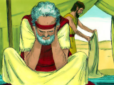*38But he said, “My son shall not go down with you, for his brother is dead, and he is left alone. If any calamity should befall him along the way in which you go, then you would bring down my gray hair with sorrow to the grave.”*

**Question 8**

Why is Jacob afraid to send Benjamin back with the brothers to Egypt?

* Thursday 7th September :Read **Genesis 43: 1-10** and answer the questions:

### Joseph’s Brothers Return with Benjamin

*1 Now the famine was severe in the land. 2And it came to pass, when they had eaten up the grain which they had brought from Egypt, that their father said to them, “Go back, buy us a little food.”*

*3But Judah spoke to him, saying, “The man solemnly warned us, saying, ‘You shall not see my face unless your brother is with you.’ 4If you send our brother with us, we will go down and buy you food. 5But if you will not send him, we will not go down; for the man said to us, ‘You shall not see my face unless your brother is with you.’”*

**Question 9**

Why do you think Joseph in Egypt asked his brothers to bring the youngest brother with them?

**Judah reassures Israel that Benjamin will return with them.**

**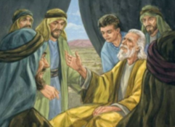***6And Israel said, “Why did you deal so wrongfully with me as to tell the man whether you had still another brother?”*

*7But they said, “The man asked us pointedly about ourselves and our family, saying, ‘Is your father still alive? Have you another brother?’ And we told him according to these words. Could we possibly have known that he would say, ‘Bring your brother down’?”*

*8Then Judah said to Israel his father, “Send the lad with me, and we will arise and go, that we may live and not die, both we and you and also our little ones. 9I myself will be surety for him; from my hand you shall require him. If I do not bring him back to you and set him before you, then let me bear the blame forever. 10For if we had not lingered, surely by now we would have returned this second time.”*

**Question 10**

At this stage we read that the brothers are afraid to return to Egypt for food without their brother Benjamin as they had been warned by Joseph that they should only return with their youngest brother.

1. How do you think Jacob felt about letting his youngest son go on the journey?
2. Do you think he was thinking of what happened to his beloved Joseph?

* Friday 8thSeptember: Read **Genesis 43: 11-23** and answer the questions:

*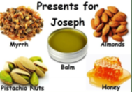***Joseph’s brothers return to Egypt to buy more grain**

*11And their father Israel said to them, “If it must be so, then do this: Take some of the best fruits of the land in your vessels and carry down a present for the man—a little balm and a little honey, spices and myrrh, pistachio nuts and almonds. 12Take double money in your hand, and take back in your hand the money that was returned in the mouth of your sacks; perhaps it was an oversight. 13Take your brother also, and arise, go back to the man. 14And may God Almighty give you mercy before the man, that he may release your other brother and Benjamin. If I am bereaved, I am bereaved!”*

*15So the men took that present and Benjamin, and they took double money in their hand, and arose and went down to Egypt; and they stood before Joseph. 16When Joseph saw Benjamin with them, he said to the steward of his house, “Take these men to my home, and slaughter an animal and make ready; for these men will dine with me at noon.” 17Then the man did as Joseph ordered, and the man brought the men into Joseph’s house.*

*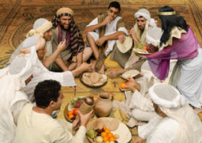18Now the men were afraid because they were brought into Joseph’s house; and they said, “It is because of the money, which was returned in our sacks the first time, that we are brought in, so that he may make a case against us and seize us, to take us as slaves with our donkeys.”*

**Question 11a**

Does Jacob allow Benjamin to go to Egypt with his brothers? **YES/NO**

**Question 11b**

What sort of gifts did Jacob send with his sons to Egypt? Highlight the one that is NOT correct:

Balm, Honey, Spices, Myrrh, Pistachio nuts, Peanuts, and Almonds.

*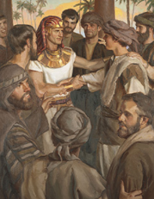***Joseph speaks to his brothers**

*19When they drew near to the steward of Joseph’s house, they talked with him at the door of the house, 20and said, “O sir, we indeed came down the first time to buy food; 21but it happened, when we came to the encampment, that we opened our sacks, and there, each man’s money was in the mouth of his sack, our money in full weight; so we have brought it back in our hand. 22And we have brought down other money in our hands to buy food. We do not know who put our money in our sacks.”*

*23But he said, “Peace be with you, do not be afraid. Your God and the God of your father has given you treasure in your sacks; I had your money.” Then he brought Simeon out to them.*

* Saturday 9th September: Read **Genesis 43: 24-34** and answer the questions:

**Joseph enquires about his father**

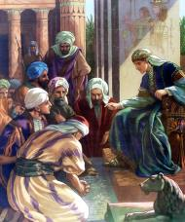*24So the man brought the men into Joseph’s house and gave them water, and they washed their feet; and he gave their donkeys feed. 25Then they made the present ready for Joseph’s coming at noon, for they heard that they would eat bread there.*

*26And when Joseph came home, they brought him the present which was in their hand into the house, and bowed down before him to the earth. 27Then he asked them about their well-being, and said, “Is your father well, the old man of whom you spoke? Is he still alive?”*

*28And they answered, “Your servant our father is in good health; he is still alive.” And they bowed their heads down and prostrated themselves*

**Question 12**

Here we see that Joseph meets his brothers and what a special time it must have been. The brothers are invited to wash their feet and dine with Joseph and they present their gifts to him. (i) What is the first thing that Joseph asks of his brothers?

1. And what was their response?

**Joseph weeps when he sees Benjamin**

*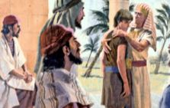29Then he lifted his eyes and saw his brother Benjamin, his mother’s son, and said, “Is this your younger brother of whom you spoke to me?” And he said, “God be gracious to you, my son.” 30Now his heart yearned for his brother; so Joseph made haste and sought somewhere to weep. And he went into his chamber and wept there. 31Then he washed his face and came out; and he restrained himself, and said, “Serve the bread.”*

*32So they set him a place by himself, and them by themselves, and the Egyptians who ate with him by themselves; because the Egyptians could not eat food with the Hebrews, for that is an abomination to the Egyptians. 33And they sat before him, the firstborn according to his birthright and the youngest according to his youth; and the men looked in astonishment at one another. 34Then he took servings to them from before him, but Benjamin’s serving was five times as much as any of theirs. So they drank and were merry with him.*

**Question 13**

Identify the people listed below as shown by their actions. You can use the same word more than once.

Joseph, Egyptians, Benjamin.

|  |  |
| --- | --- |
| Person/persons | Action |
|  | Were not allowed to eat with the Hebrews |
|  | Received 5 times as much food as his brothers |
|  | Cried when he saw Benjamin |
|  | He ate by himself. |
|  | Yearned (longed) to see his brother |

**What to do when you finish your Bible Study.**

**Send it by email to your class email address or print and hand it to your servants next Sunday.**

* **Year 4A St Makarious StMakarios4A@gmail.com Class Servant- Aunty Labiba (0421891567)**
* **Year 4B St Bakhomious StBakhomios4B@gmail.com Class Servant- Aunty Mira (0415595556)**
* **Year 4C St Anthony StAnthony4C@gmail.com Class Servant- Aunty Olivia**