C:\Documents and Settings\suzy\Local Settings\Temporary Internet Files\Content.IE5\3JXW24R5\MC900383922[1].wmfSunday 13th August, 2017

Name:

Class:

Finish Date: Saturday 19th October, 2017

Completed Bible Study = 15 points

Email Homework by the due date = 5 points

**Year 3 Bible Study Genesis Chapter 6 and 7**

**For the questions below Highlight, underline or change the font colour to choose the correct answer.**

# Monday: Read Genesis Chapter 6:1-8 and answer the questions:

### The Wickedness and Judgment of Man

*When human beings began to increase in number on the earth and daughters were born to them, 2the sons of God saw that the daughters of humans were beautiful, and they married any of them they chose. 3Then the Lord said, “My Spirit will not contend with humans forever, for they are mortal; their days will be a hundred and twenty years.”*

*4The Nephilim were on the earth in those days—and also afterward—when the sons of God went to the daughters of humans and had children by them. They were the heroes of old, men of renown.*

*5The Lord saw how great the wickedness of the human race had become on the earth, and that every inclination of the thoughts of the human heart was only evil all the time. 6The Lord regretted that he had made human beings on the earth, and his heart was deeply troubled. 7So the Lord said, “I will wipe from the face of the earth the human race I have created—and with them the animals, the birds and the creatures that move along the ground—for I regret that I have made them.” 8But Noah found favor in the eyes of the Lord.*

**Question 1:**

Explain in your own words why God decided to destroy man? Hint: verses 5-7

**Question 2:**

Who found favour in God’s eyes?

# Tuesday: Read Genesis Chapter 6:9-12 and answer the questions:

### Noah Pleases God

*9This is the account of Noah and his family.*

*Noah was a righteous man, blameless among the people of his time, and he walked faithfully with God. 10Noah had three sons: Shem, Ham and Japheth.*

*11Now the earth was corrupt in God’s sight and was full of violence. 12God saw how corrupt the earth had become, for all the people on earth had corrupted their ways.*

**Question 3**

What were the names of Noah’s three sons?

|  |
| --- |
| (i) |
| (ii) |
| (iii) |

**Question 4**

What do YOU think this verse means: *“Noah walked with God”?*

*There is NO right or wrong answer. It’s a beautiful image for us to think about and also possibly consider in our lives how we can walk with God.*

1. [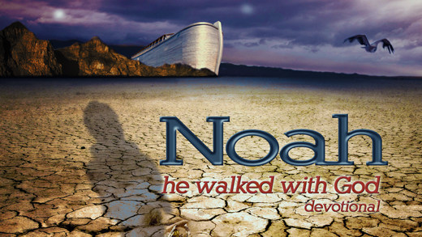](http://www.google.com.au/url?sa=i&rct=j&q=&esrc=s&source=images&cd=&cad=rja&uact=8&ved=0CAcQjRxqFQoTCOrdqdqer8cCFSEjpgodhu0N9g&url=http://www.ica.tv/noah-walked-with-god&ei=p13RVaruE6HGmAWG27ewDw&bvm=bv.99804247,d.dGY&psig=AFQjCNHpocfSpaiKTeFBhiIhfS4k2Cck6w&ust=1439870715673873)That Noah physically took strolls with God.
2. That Noah was faithful and honest with God.
3. That Noah had a genuine friendship with God.
4. That Noah feared God and honoured Him in his life.
5. That Noah made all of his decisions based on what he believed God wanted for him.

**Question 5**

Verse 11 explains that when God looked upon the earth He saw that it was filled with violence and corruption. When God looks to the earth now, what do you think He sees?

*Again there is no right or wrong answer but it is important for us to stop and think about our ways and what God would like us to be. Think about the whole world and then also think about your own personal life.*

*You can just type a few words or thoughts about this.*

# Wednesday: Read Genesis Chapter 6:13-22 and answer the questions:

### The Ark Prepared

[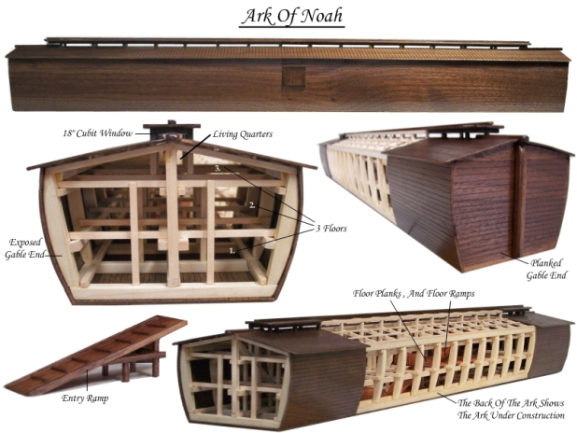](http://www.google.com.au/url?sa=i&rct=j&q=&esrc=s&source=images&cd=&cad=rja&uact=8&ved=0CAcQjRxqFQoTCIHb75eQsccCFQQWpgodpjUNJQ&url=http://www.ancient-code.com/the-mysterious-descriptions-of-noahs-ark/&ei=3VrSVcH4FISsmAWm67SoAg&bvm=bv.99804247,d.dGY&psig=AFQjCNG2M06wifvrfWOfK1eAW8BhyMAklQ&ust=1439935572422619)*13So God said to Noah, “I am going to put an end to all people, for the earth is filled with violence because of them. I am surely going to destroy both them and the earth. 14So make yourself an ark of cypresswood; make rooms in it and coat it with pitch inside and out. 15This is how you are to build it: The ark is to be three hundred cubits long, fifty cubits wide and thirty cubits high. 16Make a roof for it, leaving below the roof an opening one cubit[*[*e*](https://www.biblegateway.com/passage/?search=Genesis+6&version=NIV#fen-NIV-154e)*] high all around.[*[*f*](https://www.biblegateway.com/passage/?search=Genesis+6&version=NIV#fen-NIV-154f)*] Put a door in the side of the ark and make lower, middle and upper decks. 17I am going to bring floodwaters on the earth to destroy all life under the heavens, every creature that has the breath of life in it. Everything on earth will perish. 18But I will establish my covenant with you, and you will enter the ark—you and your sons and your wife and your sons’ wives with you. 19You are to bring into the ark two of all living creatures, male and female, to keep them alive with you. 20Two of every kind of bird, of every kind of animal and of every kind of creature that moves along the ground will come to you to be kept alive. 21You are to take every kind of food that is to be eaten and store it away as food for you and for them.”*

**Do you know how much a cubit measures?**

*1 cubit is approximately = 50cm*

*22Noah did everything just as God commanded him.*

**Question 6**

God gave Noah very specific instructions about how to build the ark. Fill in the missing words below to complete the description.

*Make yourself an ark of*

*make* *in the ark, and cover it inside and*

*outside with*

*The length of the ark shall be*

*Its width****,*** *and its height*

*You shall make a**for the ark, and you*

*shall finish it to a* *from above; and set the door*

*of the ark in its* *You shall make it with lower,*

***,*** *and* *decks.*

* Thirty cubits
* Second
* Cubit
* Window
* third
* Gopherwood
* Three hundred cubits
* Side
* rooms
* Fifty cubits
* Pitch

**Question 7:**

God instructed Noah who and what to take on the ark with him. Lets imagine that as Noah listened to God that he wrote a list of everything God asked him to take. After reading the passage can you write that list? Hint: read verses 18 -21

**Noah’s List of what to take on the ark…**

[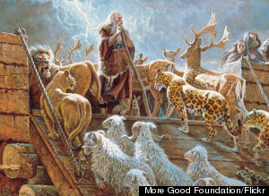](http://www.google.com.au/url?sa=i&rct=j&q=&esrc=s&source=images&cd=&cad=rja&uact=8&ved=0CAcQjRxqFQoTCI_LqKGkr8cCFYcbpgod07oDOQ&url=http://www.huffingtonpost.com/dr-joel-hoffman/quiz-how-well-do-you-know_b_5042884.html&ei=emPRVY-mF4e3mAXT9Y7IAw&bvm=bv.99804247,d.dGY&psig=AFQjCNFfcE7ItviZRtOhxX9RIG6lhqqIaw&ust=1439872222894189)

# Thursday: Read Genesis Chapter 7:1-12 and answer the questions:

### The Great Flood

[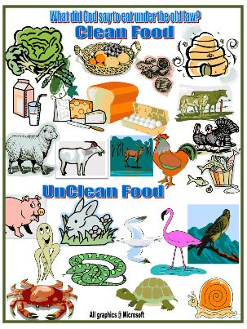](http://www.google.com.au/url?sa=i&rct=j&q=&esrc=s&source=images&cd=&cad=rja&uact=8&ved=0CAcQjRxqFQoTCKb54cWNsccCFQIfpgodqpgIpQ&url=http://www.biblefunforkids.com/2012/10/cornelius-peters-vision.html&ei=GFjSVaaNEYK-mAWqsaKoCg&bvm=bv.99804247,d.dGY&psig=AFQjCNFe2nHmGKBsgzKgZgKz1qwBFmVzGw&ust=1439934845904524)*1 The Lord then said to Noah, “Go into the ark, you and your whole family, because I have found you righteous in this generation. 2Take with you seven pairs of every kind of clean animal, a male and its mate, and one pair of every kind of unclean animal, a male and its mate, 3and also seven pairs of every kind of bird, male and female, to keep their various kinds alive throughout the earth. 4Seven days from now I will send rain on the earth for forty days and forty nights, and I will wipe from the face of the earth every living creature I have made.”*

*5And Noah did all that the Lord commanded him.*

*6Noah was six hundred years old when the floodwaters came on the earth. 7And Noah and his sons and his wife and his sons’ wives entered the ark to escape the waters of the flood. 8Pairs of clean and unclean animals, of birds and of all creatures that move along the ground, 9male and female, came to Noah and entered the ark, as God had commanded Noah. 10And after the seven days the floodwaters came on the earth.*

*11In the six hundredth year of Noah’s life, on the seventeenth day of the second month—on that day all the springs of the great deep burst forth, and the floodgates of the heavens were opened. 12And rain fell on the earth forty days and forty nights.*

**Question 8**

How long did God explain that it would rain for?

**Question 9**

How old was Noah when the floods came onto the earth?

**Question 10**

How many days before the rains began to come did Noah and

his family enter the ark?

# Friday: Read Genesis Chapter 7:13-16 and answer the questions:

### [http://www.christart.com/IMAGES-art9ab/books/richard_gunther/a/animal_tales/noah_and_the_open_door/noahs-family-go-on-the-ark.gif](http://www.google.com.au/url?sa=i&rct=j&q=&esrc=s&source=images&cd=&cad=rja&uact=8&ved=0CAcQjRxqFQoTCNGuwsmpr8cCFYHdpgodB3MN8Q&url=http://www.christart.com/christianbooks/read/4661/7&ei=DGnRVdH4NIG7mwWH5rWIDw&bvm=bv.99804247,d.dGY&psig=AFQjCNE90h_aqgvSzs1QU_gIok-UaY6P0g&ust=1439873653999617)Noah’s family enter the ark

[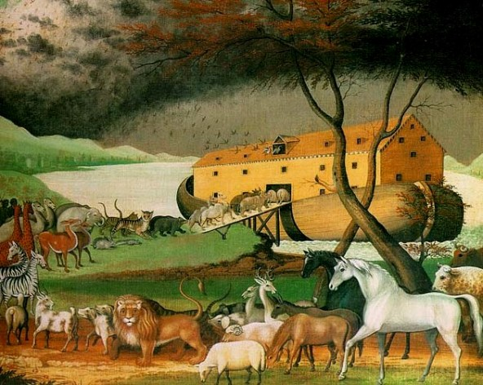](http://www.google.com.au/url?sa=i&rct=j&q=&esrc=s&source=images&cd=&cad=rja&uact=8&ved=0CAcQjRxqFQoTCMfYmu6NsccCFUcdpgodZC0G_g&url=http://www.womeninthebible.net/paintings_noah.htm&ei=bVjSVYfuBce6mAXk2pjwDw&bvm=bv.99804247,d.dGY&psig=AFQjCNHbLzL1T7D64pVZrEBzLLpsq8rMow&ust=1439934952886704)*13On the very same day Noah and Noah’s sons, Shem, Ham, and Japheth, and Noah’s wife and the three wives of his sons with them, entered the ark— 14they and every beast after its kind, all cattle after their kind, every creeping thing that creeps on the earth after its kind, and every bird after its kind, every bird of every sort. 15And they went into the ark to Noah, two by two, of all flesh in which is the breath of life. 16So those that entered, male and female of all flesh, went in as God had commanded him; and the Lord shut him in.*

**Question 11**

Who shut the door of the ark?

**Question 12:**

How did the animals enter the ark?

# Saturday: Read Genesis Chapter 7:17-24 and answer the questions:

**The flood**

*17For forty days the flood kept coming on the earth, and as the waters increased they lifted the ark high above the earth. 18The waters rose and increased greatly on the earth, and the ark floated on the surface of the water. 19They rose greatly on the earth, and all the high mountains under the entire heavens were covered. 20The waters rose and covered the mountains to a depth of more than fifteen cubits. 21Every living thing that moved on land perished—birds, livestock, wild animals, all the creatures that swarm over the earth, and all mankind. 22Everything on dry land that had the breath of life in its nostrils died. 23Every living thing on the face of the earth was wiped out; people and animals and the creatures that move along the ground and the birds were wiped from the earth. Only Noah was left, and those with him in the ark.24The waters flooded the earth for a hundred and fifty days.*

**Question 13:**

How high did the waters of the flood reach?

*God was so upset with the state of mankind that in chapter 6 we read that God was sorry that He had made man. It is very sad that mankind fell so far from God’s will and command that He wished He never created those whom He loved.*

**Something to think about…..**

Do we think about our actions every day and how they make God feel? Do I consider God’s commandments when I make decisions, talk with other people and live my everyday life? God promised to never send another flood to destroy the earth but we will each face God at the end of our lives. Will God be pleased with me or will He be disappointed? Think about something in your life/behaviour that you would like to change in order to be more pleasing and faithful to God.

[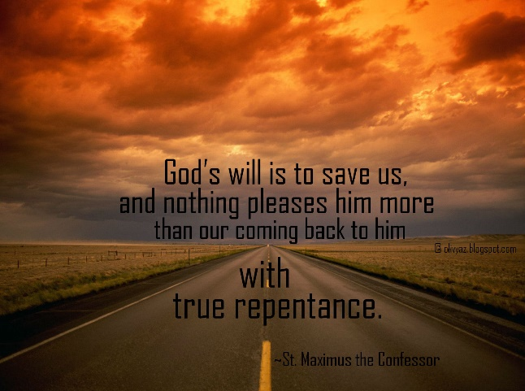](http://www.google.com.au/url?sa=i&rct=j&q=&esrc=s&source=images&cd=&cad=rja&uact=8&ved=0CAcQjRxqFQoTCJP--6GOsccCFSPbpgodztwGdw&url=http://www.suggestkeyword.com/cmVwZW50YW5jZSBxdW90ZXM/&ei=2VjSVdOtJ6O2mwXOuZu4Bw&bvm=bv.99804247,d.dGY&psig=AFQjCNEjStiYyf9pkbg5j5qeMAWkTrSQgg&ust=1439935045853094)

**What to do when you finish your Bible Study.**

Send it by email to your class email address or print and hand it to your servants next Sunday.

* Year 3A St Bishoy[stbishoy3a@gmail.com](mailto:stbishoy3a@gmail.com) Class Servant: Uncle Emile (0416895236)
* Year 3B St Paul[saintpaul3b@gmail.com](mailto:saintpaul3b@gmail.com) Class Servant: Aunty Marena (0433677290)
* Year 3C St Moses [stmoses3c@gmail.com](mailto:stmoses3c@gmail.com) Class Servant: Uncle Mina (0433520175)