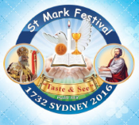Sunday 6th August 2017

Name:

Class:

Finish Date: Saturday 11th August 2017

Completed Bible Study = 15 points

Homework handed in by the due date = 5 points

**Year 5 & 6 St Marks Festival Homework Week 3**

Bible study homework leading up to the theory exam will help you with all the things you need to know. We will continue with our regular Bible study after the Festival.

**Stick to the Teaching of Your Saviour**

* **Monday: Read Spiritual book pages 35 and 36**

1. Please write the following in coptic

Good Morning

Abouna

1. Please translate the following



Good Night

1. Please write in coptic, the feminie noun for ‘The heaven’

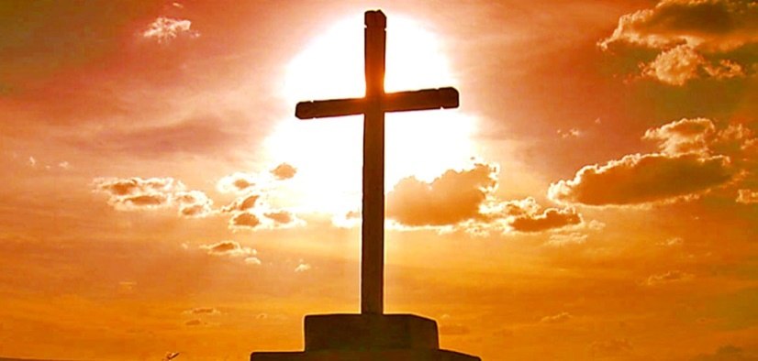

* **Tuesday: Read Spiritual Book page 37**

1. Please translate the following words

The Mothers

God

Angel





* **Wednesday: Read Spiritual Book pages 38 and 39**

1. Practice the Our Father in Coptic.



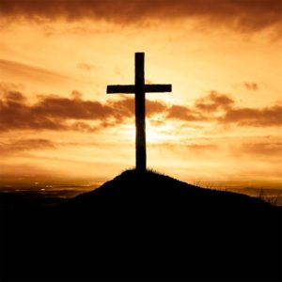

* 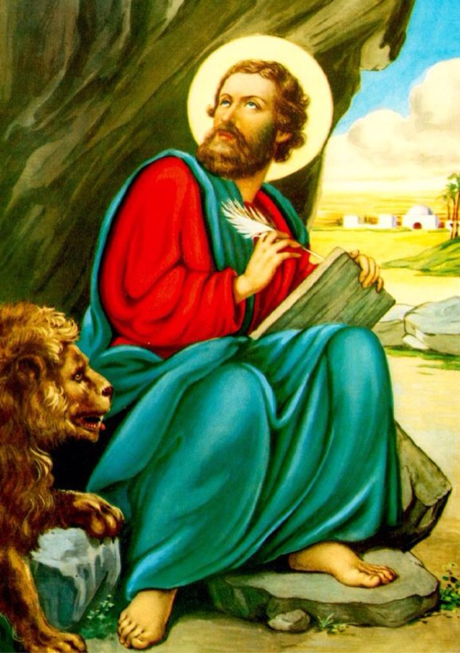**Thursday: Read Spiritual Book pages 17-18**

St Mark's Shoes tore upon arriving in Egypt. He Went to a shoemaker, Annianus to repair it. While fixing St Mark's Shoes, Annianus hurt his finger with his tool, screaming saying, "Eith Theos" (Meaning "One & Only God). St Mark was surprised, but took the opportunity to talk about the one and only God. Whilst doing that, he spat on somedirt, took the mud, rubbed Annianus' finger,praying, healing it. He kept talking about the divinty of Jesus Christ, His Incarnation, death, resurecction, our salvation & His ascention to heaven to prepare a place for us. Annianus then invited St Mark to his house, where he continued preaching about Jesus Christ until they all believed. He baptised them all, becoming the first fruit of preaching in Egypt. Christianity then spread all over egypt andering idol worshippers causing them to try & kill St Mark. toprotect him, the Christians asked him to leave Egypt & return to the five western cities. Before leaving Egypt, St Mark anointed Annianus as the first Bishop of Alexandria, three priests and seven deacons to help him. St Mark stayed there for 2 years then went to St Paul in Rome, Staying until his Martyrdom.

After the martyrdom of St Paul, St Mark came back to Alexandria and found out that the number of Christians had increased. So they built a church and the number of believers increased each day. St Mark cared so much about education and spreading information that he used to visit believers and preach in all Egyptian cities. That is why our church calls him the Idol's damager. One day, the idol worshippers attacked the church and the believer during prayers on the eve of the feast. They arrested St Mark and dragged him through the roads of Alexandria, with his blood being shed everywhere. Then they threw him in prison, where Jesus appeared to him at midnight & encouraged him, promising him the crown of martyrdom. The next day, the idol worshippers repeated their actions, until he was martyred on 30 Baramudah 68 AD. The idol worshippers then set his body on fire to try and burn it, but heavy rain fell and out the fire out. The Christians took his body with all honours and put it in shrouds.

1. What did Annianus scream after hurting his finger? And what does it mean?

|  |
| --- |
|  |

1. Who was the first Bishop of Alexandria?

|  |
| --- |
|  |

1. What does the church call St Mark and Why?

|  |
| --- |
|  |

* **Friday: Read Spiritual Book pages 19-20**

1. What where the 3 things were lasting evidence for St Mark preaching?

|  |
| --- |
| 1.  2.  3. |

1. Pick and write 2 of the names St Mark is known by and why we use that title?

|  |
| --- |
| 1.  2. |

1. What does Nesetia mean?

|  |
| --- |
|  |

* **Saturday: Read Spiritual Book pages 21-22**

1. What are the 3 most important things we should focus on while fasting?

|  |
| --- |
| 1.  2.  3. |

1. Jesus said that food of the soul is more important than the food of the body. Write the verse that Jesus said to indicate this?

|  |
| --- |
|  |

**PARENTS SECTION:**

We kindly ask you as a parent to read (a little each day) in the Holy Bible with your family.

**Now email your answers to your teacher, choose ONE of the email addresses below.**

**What to do when you finish your Bible Study.**

Send it by email to your class email address or print and hand it to your servants next Sunday.

* Year 5B1 St Thomas[stthomas5b@gmail.com](mailto:stthomas5b@gmail.com) Class Servant- Uncle Andrew **(**0416744100)
* Year 5B2 St Philip[saintphilip5g@gmail.com](mailto:saintphilip5g@gmail.com) Class Servant- Uncle Mark (0413495921)
* Year 5G St Matthew [stmatthew5g@gmail.com](mailto:stmatthew5g@gmail.com) Class Servant – Aunty Dina (0404604507)

**What to do when you finish your Bible Study.**

Send it by email to your class email address or print and hand it to your servants next Sunday.

* Year 6B1 St Mark [stmark6b1@gmail.com](mailto:stmark6b1@gmail.com) Class Servant- Uncle Adel (0422884699)
* Year 6B2 St Luke [stluke6b2@gmail.com](mailto:stluke6b2@gmail.com) Class Servant- Uncle Fady (0424740775)
* Year 6G St John[stjohn6g@gmail.com](mailto:stjohn6g@gmail.com) Class Servant- Aunty Nancy (0400212921)