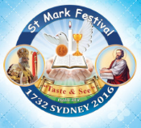Sunday 23rd July 2017

Name:

Class:

Finish Date: Saturday 29th July 2017

Completed Bible Study = 15 points

Homework handed in by the due date = 5 points

**Year 5 & 6 St Marks Festival Homework Week 2**

Bible study homework leading up to the theory exam will help you with all the things you need to know. We will continue with our regular Bible study after the Festival.

**Stick to the Teaching of Your Saviour**

* **Monday: Read Spiritual book pages 9 and 10**

1. How did God create us? (Gen 1:27)
2. What did God say would happen the day human ate from the tree of knowledge? (Gen 2:16-17)
3. What does St. Paul say in Romans 5:12?

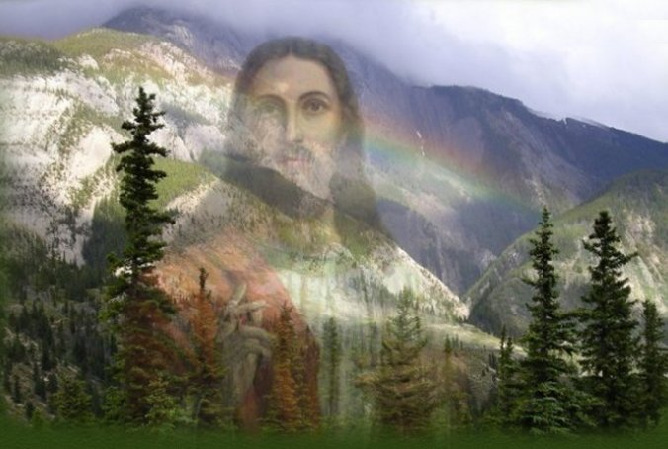

* **Tuesday: Read Spiritual Book pages 11 and 12**

1. What are the characteristics of the Saviour?
2. How does St. Peter describe us as being saved? (1 Peter 1:18-19)

* **Wednesday: Read Spiritual Book pages 13 and 14**

1. Match the reference to the prophecy.

|  |  |  |
| --- | --- | --- |
| **“For dogs have surrounded Me; The congregation of the wicked has enclosed Me. They pierced[**[**a**](https://www.biblegateway.com/passage/?search=Psalm+22%3A16-18&version=NKJV#fen-NKJV-14221a)**] My hands and My feet; I can count all My bones. They look *and* stare at Me. They divide My garments among them, And for My clothing they cast lots.” (Psalm 22:16-18)** |  | **Then one of the twelve, called Judas Iscariot, went to the chief priests 15and said, “What are you willing to give me if I deliver Him to you?” And they counted out to him thirty pieces of silver. (Matthew 26:14-15)** |
| **Then I said to them, “If it is agreeable to you, give *me* my wages; and if not, refrain.” So, they weighed out for my wages thirty *pieces* of silver. (Zechariah 11:12)** | **…Now the tunic was without seam, woven from the top in one piece. 24They said therefore among themselves, “Let us not tear it, but cast lots for it, whose it shall be,” that the Scripture might be fulfilled which says: “They divided My garments among them, And for My clothing they cast lots.” Therefore, the soldiers did these things. (John 19:23-24)** |

1. Which character in the Old Testament symbolised Jesus’offering on the cross?

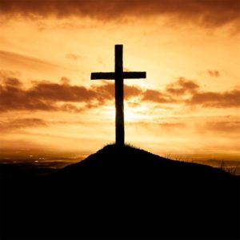

**Do Not Look Back**

* **Thursday: Read Spiritual Book pages 15 and 16**

Story of St Mark:

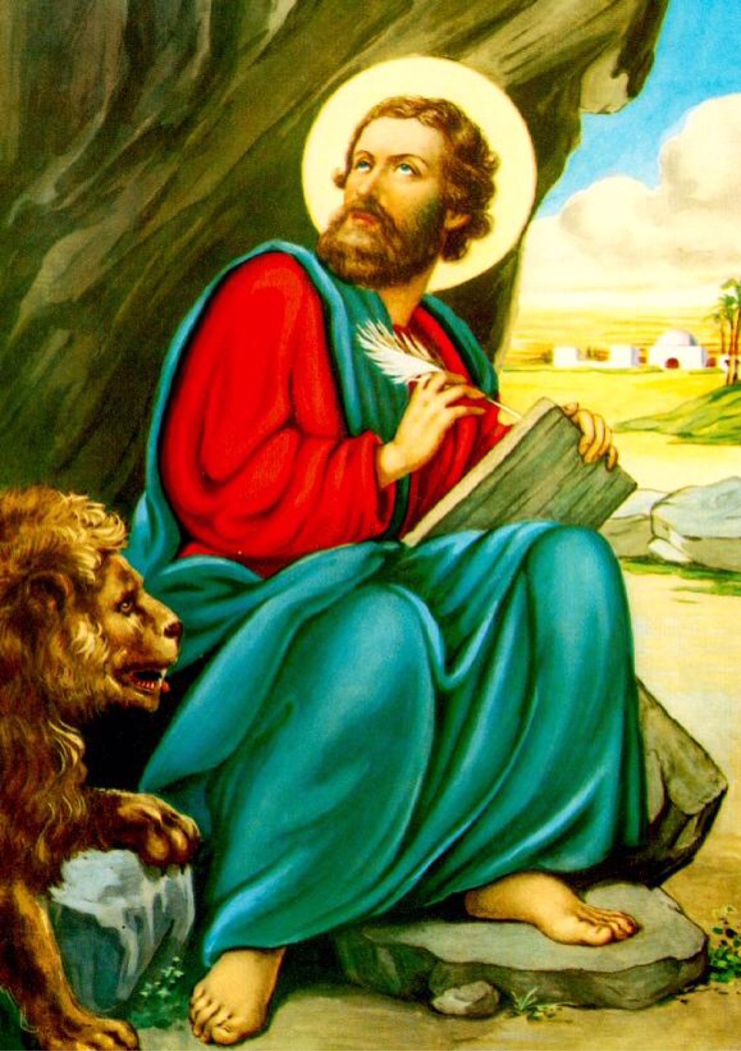St Mark was born in Cyrene, one of the five western cities (currently Libya). He was born to a rich Jewish family. His father, Aristopolous, and his mother, Mariam, raised him in the fear of God. They taught him the Torah and the Jewish traditions. He spoke many languages: Greek, Latin and Hebrew. St Mark had two names, the Jewish name of ‘John’ which means ‘ ‘Jehovah is Gracious’, and a Roman name, Mark, which means ‘hammer’. Their properties were attacked by some of the tribes there, so the family escaped to Jerusalem.

They had a house in Jerusalem around the same time that Jesus began His service. That’s how St Mark knew Jesus and became one of his disciples. St Mark was one of the 70 apostles, chosen by Jesus Himself. Mariam, St Mark’s mother, was one of the women who served Jesus and hosted Him in her house. Her house was one of the most important houses in Christianity. The house of St Mariam, the mother of St Mark, was the first Christian Church in the world, since it is where Jesus instituted the Sacrament of Holy Communion. During all these events, St Mark was learning from Jesus and becoming His disciple.

1. Name the events which happened in St Mark’s house.

1.

2.

3.

4.

5.

1. Name the different preaching stages which St Mark performed during his life.

1.

2.

3.

4.

5.

* **Friday: Read Spiritual Book pages 29 and 30**

Practise reading the Coptic Alphabet.





* **Saturday: Read Spiritual Book pages 33 and 34**

1. Write “In the Name of the Father, the Son and the Holy Spirit, One God Amen” in Coptic.
2. Write, my father, my mother, my brother and my sister in Coptic.

**PARENTS SECTION:**

We kindly ask you as a parent to read (a little each day) in the Holy Bible with your family.

**Now email your answers to your teacher, choose ONE of the email addresses below.**

**What to do when you finish your Bible Study.**

Send it by email to your class email address or print and hand it to your servants next Sunday.

* Year 5B1 St Thomas[stthomas5b@gmail.com](mailto:stthomas5b@gmail.com) Class Servant- Uncle Andrew **(**0416744100)
* Year 5B2 St Philip[saintphilip5g@gmail.com](mailto:saintphilip5g@gmail.com) Class Servant- Uncle Mark (0413495921)
* Year 5G St Matthew [stmatthew5g@gmail.com](mailto:stmatthew5g@gmail.com) Class Servant – Aunty Dina (0404604507)

**What to do when you finish your Bible Study.**

Send it by email to your class email address or print and hand it to your servants next Sunday.

* Year 6B1 St Mark [stmark6b1@gmail.com](mailto:stmark6b1@gmail.com) Class Servant- Uncle Adel (0422884699)
* Year 6B2 St Luke [stluke6b2@gmail.com](mailto:stluke6b2@gmail.com) Class Servant- Uncle Fady (0424740775)
* Year 6G St John[stjohn6g@gmail.com](mailto:stjohn6g@gmail.com) Class Servant- Aunty Nancy (0400212921)