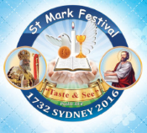
Sunday 23th July, 2017
Name:
Class:
Finish Date: Saturday 29th July, 2017
Year 3 & 4 St Marks Festival Homework Worksheet 2
The Holy Trinity
- Monday: Read Spiritual book page 8
Qu1. True or False:
- Christian’s believe the Holy Trinity are three Gods___________
- Christian’s believe the Holy Trinity is one God_______________
- The Sun’s Orb, light and heat all come from the same Sun_______
- The Holy Trinity is made up of three persons _________________

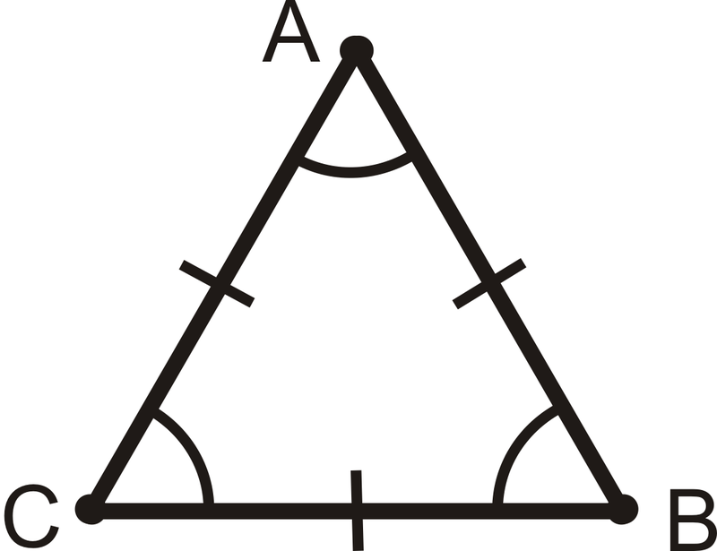
- Tuesday: Read St Marks Festival book page 9

Qu2. Match the similarities of an equilateral triangle a to d with the Holy Trinity e to h

- An equilateral triangle has all angles of equal value______
- All angles are not separated_________
- All angles are different________
- We can name it after any of the angles_______

- The Father is not separated from the Son or the Holy Spirit
- Father is different from the Son and they are both different from the Holy Spirit
- Father, Son and Holy Spirit are of the same substance
- The Father, Son and Holy Spirit are all equal

- Wednesday: Read St Marks Festival book page 10

Qu3) Name 3 times we use the names of the Holy Trinity during prayers
1.
2.
3.

Qu4) Name the event in the bible that was a clear demonstration of the Holy Trinity (hint: Matt 3:16-17)
_______________________________________________________________

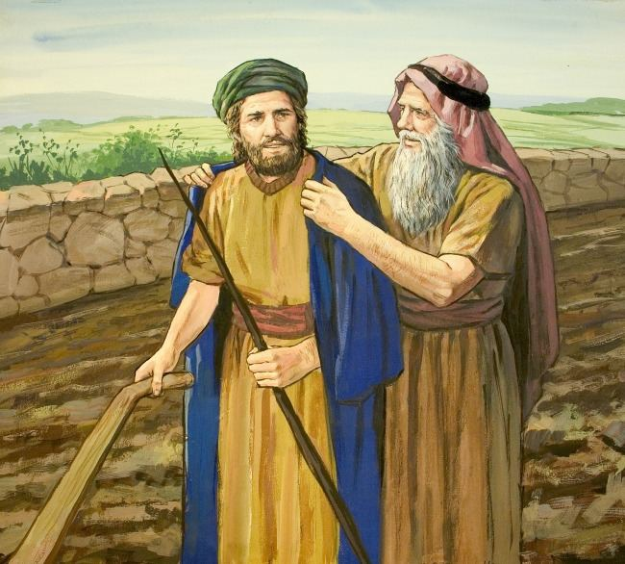
Elisha
- Thursday: Read St Marks Festival book page 12-13
Qu5) What does the name Elisha mean?______________________________
Qu6) Who was Elisha’s teacher?_____________________________________
Qu7) What does prophet mean?_____________________________________
Qu8) Why did Elijah throw his robe on Elisha? _______________________________________________________________
Qu9) What did Elisha say to Elijah when Elijah said he would go on without him
(hint: 2 Kings 2:2)_________________________________________________

- Friday : Read St Marks Festival book 14
Qu10) What did Elisha ask Elijah for before Elijah left to heaven?_______________________________________________________
Qu11) What was the sign that God accepted Elisha’s request?______________________________________________________
Qu12) What did Elisha see when Elijah went up to heaven?_______________________________________________________
Qu13) What fell on the ground when Elijah went up to heaven?________________________________________________________
- Saturday: Read St Marks Festival book page 15
Qu14) Describe the miracle of Elisha and the Widow’s oil (2 Kings 4:1-7) ______________________________________________________________________________________________________________________________________________
Qu15) What two miracles happened to the Shunammite woman by the prayers of Elisha (2 Kings 4:8-35)
a)______________________________________________________________________
b)______________________________________________________________________

Qu16)How was Namaan healed from leprosy (22Kings 5:1-15) _____________________________________________________________________________________________________________________________________________________________________________________________________________________

What to do when you finish your Bible Study.
Send it by email to your class email address or print and hand it to your servants next Sunday.
Yr3
- Year 3A St Bishoy stbishoy3a@gmail.com Class Servant: Uncle Emile (0416895236)
- Year 3B St Paul saintpaul3b@gmail.com Class Servant: Aunty Marena (0433677290)
- Year 3C St Moses stmoses3c@gmail.com Class Servant: Uncle Mina (0433520175)
Yr4
- Year 4A St Makarious StMakarios4A@gmail.com Class Servant- Aunty Labiba (0421891567)
- Year 4B St Bakhomious StBakhomios4B@gmail.com Class Servant- Aunty Mira (0415595556)
- Year 4C St Anthony StAnthony4C@gmail.com Class Servant- Aunty Olivia

