Sunday 9th July 2017

Name:

Class:

Due Date: Saturday 15th July 2017

Description: Description: Description: Description: Description: Description: Description: Description: http://www.timshen.truepath.com/christian/goldcrosswhite.gifCompleted Bible Study = 15 points,

Handed in by the due date = 5 points

**ACTS of the Apostles**

Year 5 – Bible Study 23 (Chapters 15 & 16)

**Monday** **10th July Read Chapter 15 verses 1 – 21**

### Conflict over Circumcision

*And certain men came down from Judea and taught the brethren, “Unless you are circumcised according to the custom of Moses, you cannot be saved.” 2Therefore, when Paul and Barnabas had no small dissension and dispute with them, they determined that Paul and Barnabas and certain others of them should go up to Jerusalem, to the apostles and elders, about this question.*

*3So, being sent on their way by the church, they passed through Phoenicia and Samaria, describing the conversion of the Gentiles; and they caused great joy to all the brethren. 4And when they had come to Jerusalem, they were received by the church and the apostles and the elders; and they reported all things that God had done with them. 5But some of the sect of the Pharisees who believed rose up, saying, “It is necessary to circumcise them, and to command them to keep the law of Moses.”*

### The Jerusalem Council

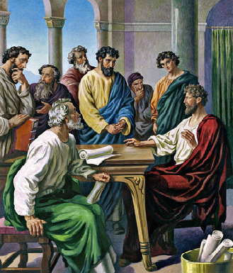*6Now the apostles and elders came together to consider this matter. 7And when there had been much dispute, Peter rose up and said to them: “Men and brethren, you know that a good while ago God chose among us, that by my mouth the Gentiles should hear the word of the gospel and believe. 8So God, who knows the heart, acknowledged them by giving them the Holy Spirit, just as He did to us, 9and made no distinction between us and them, purifying their hearts by faith. 10Now therefore, why do you test God by putting a yoke on the neck of the disciples which neither our fathers nor we were able to bear? 11But we believe that through the grace of the Lord Jesus Christ[*[*a*](https://www.biblegateway.com/passage/?search=Acts+15&version=NKJV#fen-NKJV-27454a)*] we shall be saved in the same manner as they.”*

*12Then all the multitude kept silent and listened to Barnabas and Paul declaring how many miracles and wonders God had worked through them among the Gentiles. 13And after they had become silent, James answered, saying, “Men and brethren, listen to me: 14Simon has declared how God at the first visited the Gentiles to take out of them a people for His name. 15And with this the words of the prophets agree, just as it is written: 16‘After this I will return And will rebuild the tabernacle of David, which has fallen down; I will rebuild its ruins, And I will set it up; 17So that the rest of mankind may seek the Lord, Even all the Gentiles who are called by My name, Says the Lord who does all these things.’ 18“Known to God from eternity are all His works. 19Therefore I judge that we should not trouble those from among the Gentiles who are turning to God, 20but that we write to them to abstain from things polluted by idols, from sexual immorality] from things strangled, and from blood. 21For Moses has had throughout many generations those who preach him in every city, being read in the synagogues every Sabbath.”*

### To be honest, chapter 15 is a little confusing. What was the big controversy?? Why did priests and apostles from all over the world come back to Jerusalem to sort it out? To understand, we need to go back to the Old Testament…

### From the time of Abraham, God’s chosen people were the Israelites (or Jews) while everyone else was considered a gentile. The Jews were the people God communicated with, the people He looked after, the people He sent prophets to and so on. Why did He go to all this trouble? So that one day, He could send His son to be born from one of these people (St Mary!)

### Now in order to make it clear that the Israelites were God’s people and to ensure that they were a holy people worthy of having Jesus come from one of them, they had to carry out certain customs and obey certain laws (e.g. circumcision).

### But after Jesus came, there were many gentiles that wanted to enter the church. The question was – should they be accepted? And if yes, do they need to be circumcised? DO they need to follow all those rules that the Jews followed in the Old Testament?

### And these are the questions that the council of Jerusalem answered? What was the answer? Read chapter 15 and find out!

### What did the elders have a problem with?

**Tuesday 11th July Read Chapter 15 verses 22 – 35**

### The Jerusalem Decree

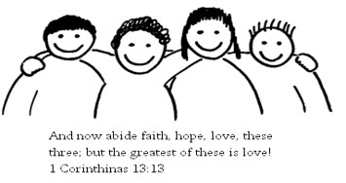*22Then it pleased the apostles and elders, with the whole church, to send chosen men of their own company to Antioch with Paul and Barnabas, namely, Judas who was also named Barsabas,[*[*e*](https://www.biblegateway.com/passage/?search=Acts+15&version=NKJV#fen-NKJV-27465e)*] and Silas, leading men among the brethren. 23They wrote this letter by them: The apostles, the elders, and the brethren, To the brethren who are of the Gentiles in Antioch, Syria, and Cilicia: Greetings. 24Since we have heard that some who went out from us have troubled you with words, unsettling your souls, saying, “You must be circumcised and keep the law”[*[*f*](https://www.biblegateway.com/passage/?search=Acts+15&version=NKJV#fen-NKJV-27467f)*] —to whom we gave no such commandment— 25it seemed good to us, being assembled with one accord, to send chosen men to you with our beloved Barnabas and Paul, 26men who have risked their lives for the name of our Lord Jesus Christ. 27We have therefore sent Judas and Silas, who will also report the same things by word of mouth. 28For it seemed good to the Holy Spirit, and to us, to lay upon you no greater burden than these necessary things: 29that you abstain from things offered to idols, from blood, from things strangled, and from sexual immorality. If you keep yourselves from these, you will do well.*

*Farewell.*

### Continuing Ministry in Syria

*30So when they were sent off, they came to Antioch; and when they had gathered the multitude together, they delivered the letter. 31When they had read it, they rejoiced over its encouragement. 32Now Judas and Silas, themselves being prophets also, exhorted and strengthened the brethren with many words. 33And after they had stayed there for a time, they were sent back with greetings from the brethren to the apostles.34However, it seemed good to Silas to remain there. 35Paul and Barnabas also remained in Antioch, teaching and preaching the word of the Lord, with many others also.*

1. What was the outcome of the Jerusalem Council? (Hint: it was something about accepting gentiles into the church and circumcision)

**Wednesday 12th July Read Chapter 15 verses 36 – 41**

### Division over John Mark

*36Then after some days Paul said to Barnabas, “Let us now go back and visit our brethren in every city where we have preached the word of the Lord, and see how they are doing.” 37Now Barnabas was determined to take with them John called Mark. 38But Paul insisted that they should not take with them the one who had departed from them in Pamphylia, and had not gone with them to the work. 39Then the contention became so sharp that they parted from one another. And so Barnabas took Mark and sailed to Cyprus; 40but Paul chose Silas and departed, being commended by the brethren to the grace of God. 41And he went through Syria and Cilicia, strengthening the churches.*

1. Whom did Barnabas want to take on the next trip? Why did Paul not want to take him with them? What was the result of the contention?

**Thursday 13th July Read Chapter 16 verses 1 – 10**

### Timothy Joins Paul and Silas

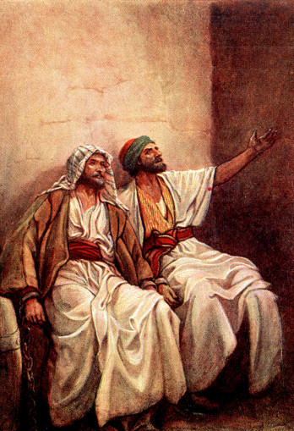*Then he came to Derbe and Lystra. And behold, a certain disciple was there, named Timothy, the son of a certain Jewish woman who believed, but his father was Greek. 2He was well spoken of by the brethren who were at Lystra and Iconium. 3Paul wanted to have him go on with him. And he took him and circumcised him because of the Jews who were in that region, for they all knew that his father was Greek. 4And as they went through the cities, they delivered to them the decrees to keep, which were determined by the apostles and elders at Jerusalem. 5So the churches were strengthened in the faith, and increased in number daily.*

### The Macedonian Call

*6Now when they had gone through Phrygia and the region of Galatia, they were forbidden by the Holy Spirit to preach the word in Asia. 7After they had come to Mysia, they tried to go into Bithynia, but the Spirit[*[*a*](https://www.biblegateway.com/passage/?search=Acts+16&version=NKJV#fen-NKJV-27491a)*] did not permit them. 8So passing by Mysia, they came down to Troas. 9And a vision appeared to Paul in the night. A man of Macedonia stood and pleaded with him, saying, “Come over to Macedonia and help us.” 10Now after he had seen the vision, immediately we sought to go to Macedonia, concluding that the Lord had called us to preach the gospel to them.*

1. Who were with Paul during his travels to Mysia?
2. Peter and Timothy
3. Silas and Saul
4. Barnabas and Peter
5. Timothy and Silas
6. What did Paul see in a vison at Troas?

**Friday 14th July Read Chapter 16 verses 11 – 24**

### Lydia Baptized at Philippi

*11Therefore, sailing from Troas, we ran a straight course to Samothrace, and the next day came to Neapolis, 12and from there to Philippi, which is the foremost city of that part of Macedonia, a colony. And we were staying in that city for some days. 13And on the Sabbath day we went out of the city to the riverside, where prayer was customarily made; and we sat down and spoke to the women who met there. 14Now a certain woman named Lydia heard us. She was a seller of purple from the city of Thyatira, who worshiped God. The Lord opened her heart to heed the things spoken by Paul. 15And when she and her household were baptized, she begged us, saying, “If you have judged me to be faithful to the Lord, come to my house and stay.” So she persuaded us.*

### Paul and Silas Imprisoned

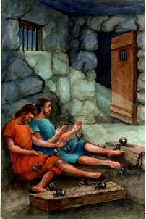*16Now it happened, as we went to prayer, that a certain slave girl possessed with a spirit of divination met us, who brought her masters much profit by fortune-telling. 17This girl followed Paul and us, and cried out, saying, “These men are the servants of the Most High God, who proclaim to us the way of salvation.” 18And this she did for many days.*

*But Paul, greatly annoyed, turned and said to the spirit, “I command you in the name of Jesus Christ to come out of her.” And he came out that very hour. 19But when her masters saw that their hope of profit was gone, they seized Paul and Silas and dragged them into the marketplace to the authorities.*

*20And they brought them to the magistrates, and said, “These men, being Jews, exceedingly trouble our city; 21and they teach customs which are not lawful for us, being Romans, to receive or observe.” 22Then the multitude rose up together against them; and the magistrates tore off their clothes and commanded them to be beaten with rods. 23And when they had laid many stripes on them, they threw them into prison, commanding the jailer to keep them securely. 24Having received such a charge, he put them into the inner prison and fastened their feet in the stocks.*

1. **True or false.** Highlight the correct answer.
2. Lydia worshiped idols. True or false
3. Lydia was a seller of purple. True or false
4. Lydia was baptized because the Lord opened her heart. True or false.
5. Highlight the verse(s) that say why Paul and Silas were imprisoned.

**Saturday 15th July Read Chapter 16 verses 25 – 40**

### The Philippian Jailer Saved

*25But at midnight Paul and Silas were praying and singing hymns to God, and the prisoners were listening to them. 26Suddenly there was a great earthquake, so that the foundations of the prison were shaken; and immediately all the doors were opened and everyone’s chains were loosed. 27And the keeper of the prison, awaking from sleep and seeing the prison doors open, supposing the prisoners had fled, drew his sword and was about to kill himself. 28But Paul called with a loud voice, saying, “Do yourself no harm, for we are all here.” 29Then he called for a light, ran in, and fell down trembling before Paul and Silas. 30And he brought them out and said, “Sirs, what must I do to be saved?” 31So they said, “Believe on the Lord Jesus Christ, and you will be saved, you and your household.” 32Then they spoke the word of the Lord to him and to all who were in his house. 33And he took them the same hour of the night and washed their stripes. And immediately he and all his family were baptized. 34Now when he had brought them into his house, he set food before them; and he rejoiced, having believed in God with all his household.*

### Paul Refuses to Depart Secretly

*35And when it was day, the magistrates sent the officers, saying, “Let those men go.” 36So the keeper of the prison reported these words to Paul, saying, “The magistrates have sent to let you go. Now therefore depart, and go in peace.” 37But Paul said to them, “They have beaten us openly, uncondemned Romans, and have thrown us into prison. And now do they put us out secretly? No indeed! Let them come themselves and get us out.” 38And the officers told these words to the magistrates, and they were afraid when they heard that they were Romans. 39Then they came and pleaded with them and brought them out, and asked them to depart from the city. 40So they went out of the prison and entered the house of Lydia; and when they had seen the brethren, they encouraged them and departed.*

St Chrysostom says, “If Paul had been freed and had shaken that building, the event would not have been so wonderful. This is what amazed the jailer, that Paul, held in such constraints, was able, through prayer alone, to shake the foundations, open the doors of the prison and free all who were in chains.”

1. What were Paul and Silas doing will in prison? How can we apply this example to our lives?
2. What did the local magistrates decide to do the next day?

**PARENTS SECTION:**

We kindly ask you as a parent to read (a little each day) in the Holy Bible with your family.

**Now email your answers to your teacher, choose ONE of the email addresses below.**

**What to do when you finish your Bible Study.**

Send it by email to your class email address or print and hand it to your servants next Sunday.

* Year 5B1 St Thomas[stthomas5b@gmail.com](mailto:stthomas5b@gmail.com) Class Servant- Uncle Andrew

(0416744100)

* Year 5B2 St Philip[saintphilip5g@gmail.com](mailto:saintphilip5g@gmail.com) Class Servant- Uncle Mark

(0413495921)

* Year 5G St Matthew [stmatthew5g@gmail.com](mailto:stmatthew5g@gmail.com) Class Servant – Aunty Dina

(0404604507)