C:\Documents and Settings\suzy\Local Settings\Temporary Internet Files\Content.IE5\3JXW24R5\MC900383922[1].wmfSunday 2 July

Name:

Class:

Completion Date: Saturday 8 July

Completed Bible Study = 15 points

Email Homework by the due date = 5 points

**Year 6 Bible Study Joshua Chapter 7**

**For the questions below Highlight, underline or change the font colour to choose the correct answer.**

* MONDAY Read **Joshua Chapter 7: 1-15** and answer the questions:

### Defeat at Ai

*2Now Joshua sent men from Jericho to Ai, which is beside Beth Aven, on the east side of Bethel, and spoke to them, saying, “Go up and spy out the country.” So the men went up and spied out Ai. 3And they returned to Joshua and said to him, “Do not let all the people go up, but let about two or three thousand men go up and attack Ai. Do not weary all the people there, for the people of Ai are few.” 4So about three thousand men went up there from the people, but they fled before the men of Ai. 5And the men of Ai struck down about thirty-six men, for they chased them from before the gate as far as Shebarim, and struck them down on the descent; therefore the hearts of the people melted and became like water.*

*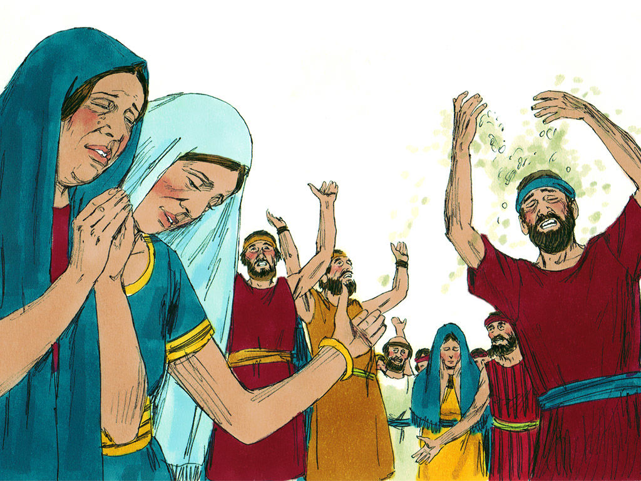***Joshua grieves over the defeat**

*6Then Joshua tore his clothes, and fell to the earth on his face before the ark of the Lord until evening, he and the elders of Israel; and they put dust on their heads. 7And Joshua said, “Alas, Lord God, why have You brought this people over the Jordan at all—to deliver us into the hand of the Amorites, to destroy us? Oh, that we had been content, and dwelt on the other side of the Jordan! 8O Lord, what shall I say when Israel turns its back before its enemies? 9For the Canaanites and all the inhabitants of the land will hear it, and surround us, and cut off our name from the earth. Then what will You do for Your great name?”*

*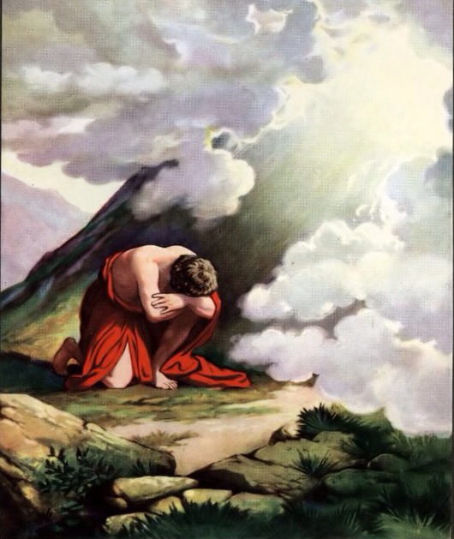***Israelites defeated because of their sin**

*10So the Lord said to Joshua: “Get up! Why do you lie thus on your face? 11Israel has sinned, and they have also transgressed My covenant which I commanded them. For they have even taken some of the accursed things, and have both stolen and deceived; and they have also put it among their own stuff. 12Therefore the children of Israel could not stand before their enemies, but turned their backs before their enemies, because they have become doomed to destruction. Neither will I be with you anymore, unless you destroy the accursed from among you. 13Get up, sanctify the people, and say, ‘Sanctify yourselves for tomorrow, because thus says the Lord God of Israel: “There is an accursed thing in your midst, O Israel; you cannot stand before your enemies until you take away the accursed thing from among you.” 14In the morning therefore you shall be brought according to your tribes. And it shall be that the tribe which the Lord takes shall come according to families; and the family which the Lord takes shall come by households; and the household which the Lord takes shall come man by man. 15Then it shall be that he who is taken with the accursed thing shall be burned with fire, he and all that he has, because he has transgressed the covenant of the Lord, and because he has done a disgraceful thing in Israel.’”*

**Question 1**

Start this week’s Bible study by opening up your Bible to Joshua Chapter 7, and finding Verse 1. Write it out in the space below. (Ask a friend or family member to help you find it)

But the children of Israel….

**Question 2**

Fill in the blanks by using the pictures to help you- Lord, Ark of the Covenant, cried

Joshua was feeling very sad that he lost 36 members of his army. So

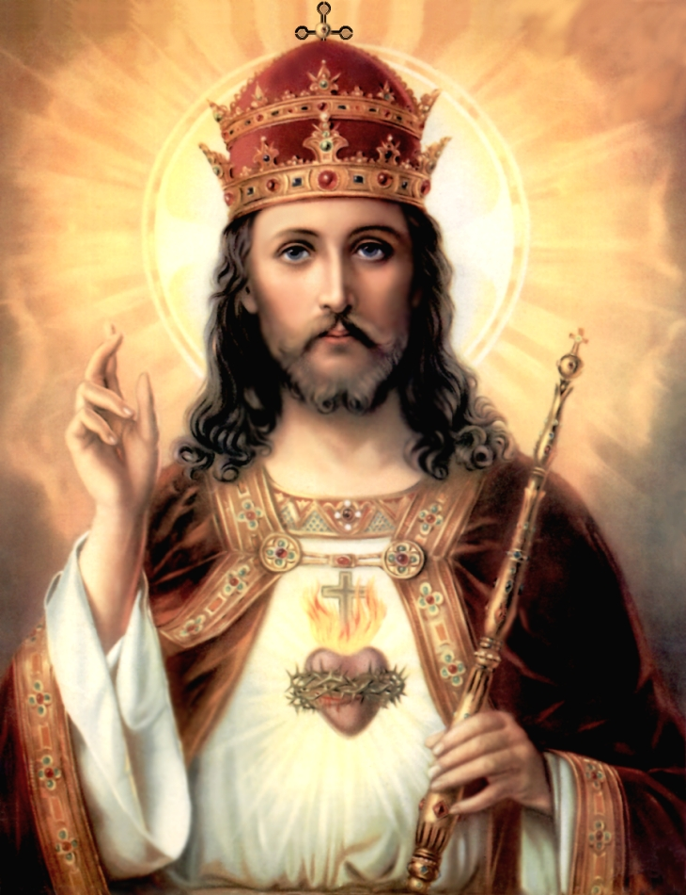

he went and to the

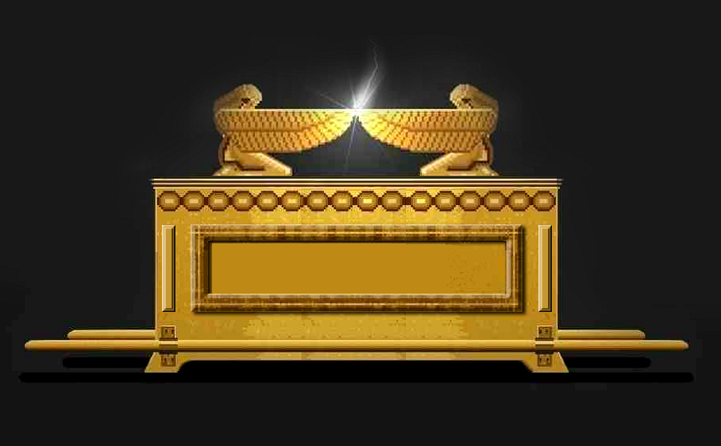

in front of the

* TUESDAY Read **Joshua Chapter 7: 16-20** and answer the questions:

### The Sin of Achan

*16So Joshua rose early in the morning and brought Israel by their tribes, and the tribe of Judah was taken. 17He brought the clan of Judah, and he took the family of the Zarhites; and he brought the family of the Zarhites man by man, and Zabdi was taken. 18Then he brought his household man by man, and Achan the son of Carmi, the son of Zabdi, the son of Zerah, of the tribe of Judah, was taken.*

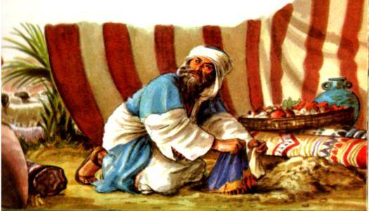

*19Now Joshua said to Achan, “My son, I beg you, give glory to the Lord God of Israel, and make confession to Him, and tell me now what you have done; do not hide it from me.”*

*20And Achan answered Joshua and said, “Indeed I have sinned against the Lord God of Israel, and this is what I have done: 21When I saw among the spoils a beautiful Babylonian garment, two hundred shekels of silver, and a wedge of gold weighing fifty shekels, I coveted them and took them. And there they are, hidden in the earth in the midst of my tent, with the silver under it.”*

**Question 3**

1. Achan was from the Tribe of Judah .True/False
2. Achan did NOT admit to his sin. True/ False
3. Carmi was Achan’s father.True/ False
4. Achan stole 200 shekels of gold.True/ False
5. Achan stole a wedge of silver worth 50 shekels. True/ False
6. The silver and gold was hidden in the ground under the tent of Achan.True/ False

**Question 4**

What message does the story of Achan teach you?

(Think of things such as: the consequences your sins have- not just on you, but also on others around you, having a close relationship with God (Like Joshua) etc.) Write at least 3 sentences!

* WEDNESDAY: Read **Joshua Chapter 8: 1-17** and answer the questions:

**The Lord commands Joshua to be ready for war**

*1 Now the Lord said to Joshua: “Do not be afraid, nor be dismayed; take all the people of war with you, and arise, go up to Ai. See, I have given into your hand the king of Ai, his people, his city, and his land. 2And you shall do to Ai and its king as you did to Jericho and its king. Only its spoil and its cattle you shall take for yourselves. Lay an ambush for the city behind it.”*

*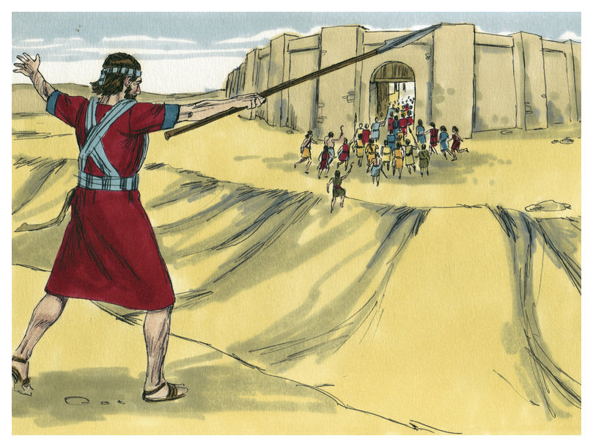3So Joshua arose, and all the people of war, to go up against Ai; and Joshua chose thirty thousand mighty men of valor and sent them away by night. 4And he commanded them, saying: “Behold, you shall lie in ambush against the city, behind the city. Do not go very far from the city, but all of you be ready. 5Then I and all the people who are with me will approach the city; and it will come about, when they come out against us as at the first, that we shall flee before them. 6For they will come out after us till we have drawn them from the city, for they will say, ‘They are fleeing before us as at the first.’ Therefore we will flee before them. 7Then you shall rise from the ambush and seize the city, for the Lord your God will deliver it into your hand. 8And it will be, when you have taken the city, that you shall set the city on fire. According to the commandment of the Lord you shall do. See, I have commanded you.”*

**Joshua instructs the people where to position themselves to get ready for war**

*9Joshua therefore sent them out; and they went to lie in ambush, and stayed between Bethel and Ai, on the west side of Ai; but Joshua lodged that night among the people. 10Then Joshua rose up early in the morning and mustered the people, and went up, he and the elders of Israel, before the people to Ai. 11And all the people of war who were with him went up and drew near; and they came before the city and camped on the north side of Ai. Now a valley lay between them and Ai. 12So he took about five thousand men and set them in ambush between Bethel and Ai, on the west side of the city. 13And when they had set the people, all the army that was on the north of the city, and its rear guard on the west of the city, Joshua went that night into the midst of the valley.*

*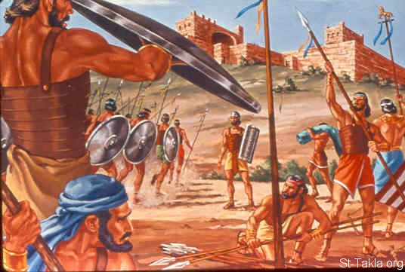***People of Ai go after Israel**

*14Now it happened, when the king of Ai saw it, that the men of the city hurried and rose early and went out against Israel to battle, he and all his people, at an appointed place before the plain. But he did not know that there was an ambush against him behind the city. 15And Joshua and all Israel made as if they were beaten before them, and fled by the way of the wilderness. 16So all the people who were in Ai were called together to pursue them. And they pursued Joshua and were drawn away from the city. 17There was not a man left in Ai or Bethel who did not go out after Israel. So they left the city open and pursued Israel.*

**What does it mean to pursue?**

*To pursue is to chase somebody or something consistently*

**So what was Joshua’s plan?**

*Joshua split the army into 2 parts. The first part was to stay with him, and attack the city of Ai as though they would any other city- straight away from the front, and then pretend to be defeated.*

*The second half of the army was to sneak to the back of the city of Ai, and wait until all the people of Ai went to attack the first half of the army of Israel, and then the Israelites would destroy Ai.*

**Question 5**

What did the Lord ask the people of Israel to keep after they defeated Ai?

a) Everything

b) Spoil and cattle

c) Fire

d) The men of the city

**Question 6**

Identify the valley that Joshua and his army hid in on the night before they attacked Ai (Read Verse 9)

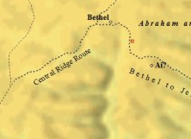

A

B

C

D

1. A
2. B
3. C
4. D

* THURSDAY: Read **Joshua Chapter 8: 18-35** and answer the questions:

**Lord tells Joshua what to do in order to defeat Ai**

*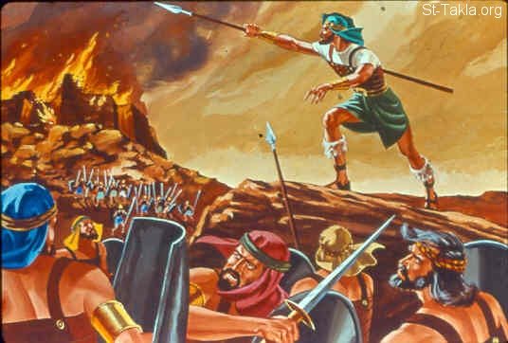18Then the Lord said to Joshua, “Stretch out the spear that is in your hand toward Ai, for I will give it into your hand.” And Joshua stretched out the spear that was in his hand toward the city. 19So those in ambush arose quickly out of their place; they ran as soon as he had stretched out his hand, and they entered the city and took it, and hurried to set the city on fire. 20And when the men of Ai looked behind them, they saw, and behold, the smoke of the city ascended to heaven. So they had no power to flee this way or that way, and the people who had fled to the wilderness turned back on the pursuers.*

*21Now when Joshua and all Israel saw that the ambush had taken the city and that the smoke of the city ascended, they turned back and struck down the men of Ai. 22Then the others came out of the city against them; so they were caught in the midst of Israel, some on this side and some on that side. And they struck them down, so that they let none of them remain or escape. 23But the king of Ai they took alive, and brought him to Joshua. 24And it came to pass when Israel had made an end of slaying all the inhabitants of Ai in the field, in the wilderness where they pursued them, and when they all had fallen by the edge of the sword until they were consumed, that all the Israelites returned to Ai and struck it with the edge of the sword.*

**Ai is destroyed**

*25So it was that all who fell that day, both men and women, were twelve thousand—all the people of Ai. 26For Joshua did not draw back his hand, with which he stretched out the spear, until he had utterly destroyed all the inhabitants of Ai. 27Only the livestock and the spoil of that city Israel took as booty for themselves, according to the word of the Lord which He had commanded Joshua. 28So Joshua burned Ai and made it a heap forever, a desolation to this day.*

### Joshua Renews the Covenant

*30Now Joshua built an altar to the Lord God of Israel in Mount Ebal, 31as Moses the servant of the Lord had commanded the children of Israel, as it is written in the Book of the Law of Moses: “an altar of whole stones over which no man has wielded an iron tool.”And they offered on it burnt offerings to the Lord, and sacrificed peace offerings. 32And there, in the presence of the children of Israel, he wrote on the stones a copy of the law of Moses, which he had written. 33Then all Israel, with their elders and officers and judges, stood on either side of the ark before the priests, the Levites, who bore the ark of the covenant of the Lord, the stranger as well as he who was born among them. Half of them were in front of Mount Gerizim and half of them in front of Mount Ebal, as Moses the servant of the Lord had commanded before, that they should bless the people of Israel. 34And afterward he read all the words of the law, the blessings and the cursings, according to all that is written in the Book of the Law. 35There was not a word of all that Moses had commanded which Joshua did not read before all the assembly of Israel, with the women, the little ones, and the strangers who were living among them.*

**Question 7**

Match the person or city to their role/ event

**Joshua, King of Ai, Israel, Ai**

|  |  |
| --- | --- |
| The army that was split in two |  |
| The person that spoke with the Lord |  |
| The city that was set on fire to be destroyed |  |
| The only person to remain alive after their city was destroyed |  |

**Question 8**

What was the sign that Joshua was to give the men of Israel in order to ambush the city of Ai?

**Question 9**

List the three main things that Joshua did after the defeat of Ai (HINTS: Verse 30, Verse 31 and Verse 32)

1)

2)

3)

* FRIDAY Read **Joshua Chapter 9: 1-13** and answer the questions:

**The treaty with the Gibeonites**

***1****And it came to pass when all the kings who were on this side of the Jordan, in the hills and in the lowland and in all the coasts of the Great Sea toward Lebanon—the Hittite, the Amorite, the Canaanite, the Perizzite, the Hivite, and the Jebusite—heard about it,****2****that they gathered together to fight with Joshua and Israel with one accord.*

***3****But when the inhabitants of Gibeon heard what Joshua had done to Jericho and Ai,****4****they worked craftily, and went and pretended to be ambassadors. And they took old sacks on their donkeys, old wineskins torn and mended,****5****old and patched sandals on their feet, and old garments on themselves; and all the bread of their provision was dry and moldy.****6****And they went to Joshua, to the camp at Gilgal, and said to him and to the men of Israel, “We have come from a far country; now therefore, make a covenant with us.”*

***7****Then the men of Israel said to the Hivites, “Perhaps you dwell among us; so how can we make a covenant with you?”*

***8****But they said to Joshua, “We are your servants.”*

*And Joshua said to them, “Who are you, and where do you come from?”*

***9****So they said to him: “From a very far country your servants have come, because of the name of the Lord your God; for we have heard of His fame, and all that He did in Egypt,****10****and all that He did to the two kings of the Amorites who were beyond the Jordan—to Sihon king of Heshbon, and Og king of Bashan, who was at Ashtaroth.****11****Therefore our elders and all the inhabitants of our country spoke to us, saying, ‘Take provisions with you for the journey, and go to meet them, and say to them, “We are your servants; now therefore, make a covenant with us.”’****12****This bread of ours we took hot for our provision from our houses on the day we departed to come to you. But now look, it is dry and moldy.****13****And these wineskins which we filled were new, and see, they are torn; and these our garments and our sandals have become old because of the very long journey.”*

**Question 10**

How did the people of Gibeon fool Israel?

1. By wearing old clothes and shoes
2. By bringing mouldy and dry bread
3. By pretending to be ambassadors from a far country
4. All the above

* SATURDAY Read **Joshua Chapter 9: 14-24** and answer the questions:

***14****Then the men of Israel took some of their provisions; but they did not ask counsel of the Lord.****15****So Joshua made peace with them, and made a covenant with them to let them live; and the rulers of the congregation swore to them.*

***16****And it happened at the end of three days, after they had made a covenant with them, that they heard that they were their neighbors who dwelt near them.****17****Then the children of Israel journeyed and came to their cities on the third day. Now their cities were Gibeon, Chephirah, Beeroth, and Kirjath Jearim.****18****But the children of Israel did not attack them, because the rulers of the congregation had sworn to them by the Lord God of Israel. And all the congregation complained against the rulers.*

***19****Then all the rulers said to all the congregation, “We have sworn to them by the Lord God of Israel; now therefore, we may not touch them.****20****This we will do to them: We will let them live, lest wrath be upon us because of the oath which we swore to them.”****21****And the rulers said to them, “Let them live, but let them be woodcutters and water carriers for all the congregation, as the rulers had promised them.”*

***22****Then Joshua called for them, and he spoke to them, saying, “Why have you deceived us, saying, ‘We are very far from you,’ when you dwell near us?****23****Now therefore, you are cursed, and none of you shall be freed from being slaves—woodcutters and water carriers for the house of my God.”*

***24****So they answered Joshua and said, “Because your servants were clearly told that the Lord your God commanded His servant Moses to give you all the land, and to destroy all the inhabitants of the land from before you; therefore we were very much afraid for our lives because of you, and have done this thing.****25****And now, here we are, in your hands; do with us as it seems good and right to do to us.”****26****So he did to them, and delivered them out of the hand of the children of Israel, so that they did not kill them.****27****And that day Joshua made them woodcutters and water carriers for the congregation and for the altar of the Lord, in the place which He would choose, even to this day.*

**Question 11**

What did the men of Israel fail to do?

**What to do when you finish your Bible Study.**

Send it by email to your class email address or print and hand it to your servants next Sunday.

* Year 6B1 St Mark [stmark6b1@gmail.com](mailto:stmark6b1@gmail.com) Class Servant- Uncle Fady (0424740775)
* Year 6B2 St Luke [stluke6b2@gmail.com](mailto:stluke6b2@gmail.com) Class Servant- Uncle Adel (0422884699)
* Year 6G St John[stjohn6g@gmail.com](mailto:stjohn6g@gmail.com) Class Servant- Aunty Nancy (0400212921)