C:\Documents and Settings\suzy\Local Settings\Temporary Internet Files\Content.IE5\3JXW24R5\MC900383922[1].wmfSunday 16th October, 2016

Name:

Class:

Finish Date: Saturday 22nd October, 2016

Completed Bible Study = 15 points

Email Homework by the due date = 5 points

**Year 3 Bible Study Genesis Chapter 5**

**For the questions below Highlight or change the font colour to choose the correct answer.**

* **Monday 17th October:Read Genesis 5: 1-5 and answer the questions:**

### The Family of Adam

*This is the written account of Adam’s family line.*

*When God created mankind, he made them in the likeness of God. 2He created them male and female and blessed them. And he named them “Mankind” when they were created.*

*3When Adam had lived 130 years, he had a son in his own likeness, in his own image; and he named him Seth. 4After Seth was born, Adam lived 800 years and had other sons and daughters. 5Altogether, Adam lived a total of 930 years, and then he died.*

**Question 1**

What was the name of the first man God created?

**Question 2**

What name did God give the males and females that he created?

1. Mankind
2. Humans
3. Species
4. People

**Question 3**

Choose the number 130, 800 or 930 that matches the statement in the table below:

|  |  |
| --- | --- |
| **Number** | **Statement** |
|  | How old was Adam when he died? |
|  | How old was Adam when he had Seth? |
|  | How old was Adam when he had more children? |

* **Tuesday 18th October: Read Genesis 5: 6-11 and answer the questions:**

**Adams grandchildren**

*6When Seth had lived 105 years, he became the father of Enosh. 7After he became the father of Enosh, Seth lived 807 years and had other sons and daughters. 8Altogether, Seth lived a total of 912 years, and then he died.*

*9When Enosh had lived 90 years, he became the father of Kenan. 10After he became the father of Kenan, Enosh lived 815 years and had other sons and daughters. 11Altogether, Enosh lived a total of 905 years, and then he died.*

**Question 3**

What was the name of the first son of Seth?

**Question 4**

How old was Seth when he died?

**Question 5**

Who was Kenan’s father?

* **Wednesday 19th October: Read Genesis 5: 12-17 and answer the questions:**

**Adam’s grandchildren have children**

*12When Kenan had lived 70 years, he became the father of Mahalalel. 13After he became the father of Mahalalel, Kenan lived 840 years and had other sons and daughters. 14Altogether, Kenan lived a total of 910 years, and then he died.*

*15When Mahalalel had lived 65 years, he became the father of Jared. 16After he became the father of Jared, Mahalalel lived 830 years and had other sons and daughters. 17Altogether, Mahalalel lived a total of 895 years, and then he died.*

**Question 6**

What was the name of Kenan’s first son?

1. Jared
2. Mahalalel
3. Enosh
4. Mahalel

**Question 7**

1. Kenan begot both sons and daughters. **(True/False)**
2. Mahalalel only had daughters. **(True/False)**

* **Thursday 20th October: Read Genesis 5: 18-24 and answer the questions:**

**Adam’s family tree continues to grow**

*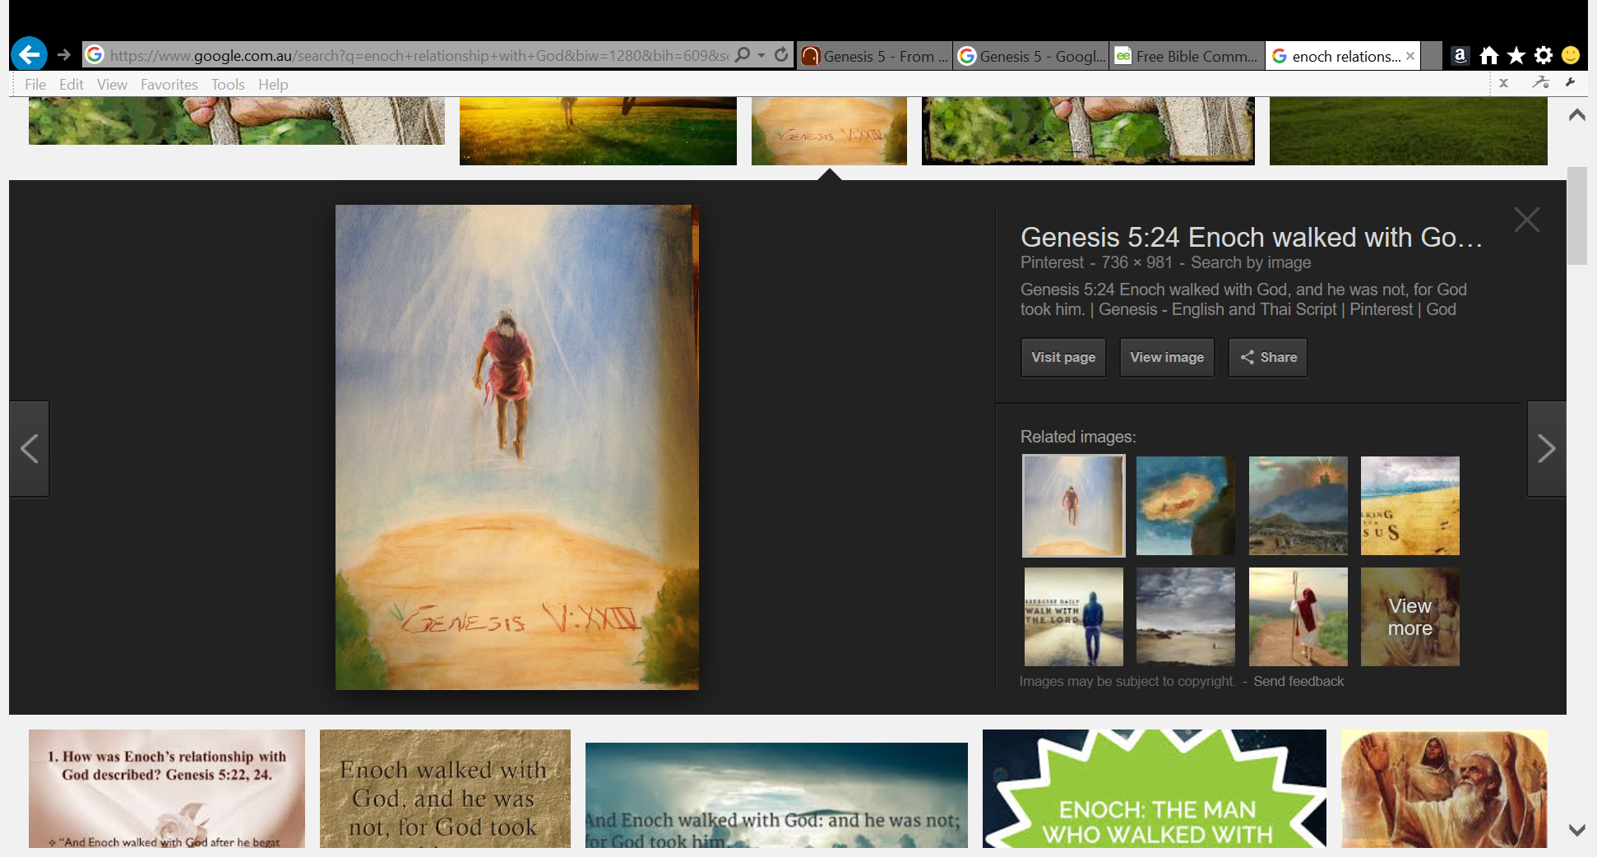18When Jared had lived 162 years, he became the father of Enoch. 19After he became the father of Enoch, Jared lived 800 years and had other sons and daughters. 20Altogether, Jared lived a total of 962 years, and then he died.*

*21When Enoch had lived 65 years, he became the father of Methuselah. 22After he became the father of Methuselah, Enoch walked faithfully with God 300 years and had other sons and daughters. 23Altogether, Enoch lived a total of 365 years. 24Enoch walked faithfully with God; then he was no more, because God took him away.*

**Question 8**

Enoch loved Gd very much and he had a very close relationship with God.

1. Find the verse from the passage above that tells us this.
2. Write in the textbox below the four words used to describe this special relationship.
3. When Enoch was 365 years old did he die? HINT verse 24
4. How did Enoch disappear?

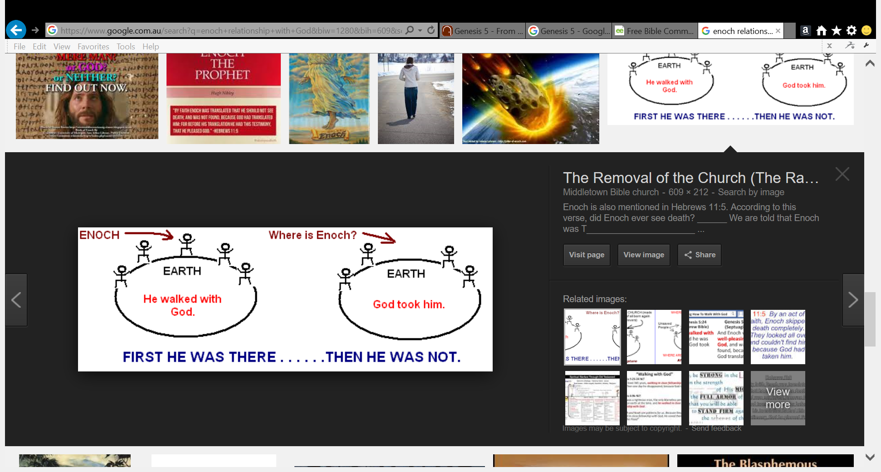

* Friday 21st October: Read **Genesis 5: 25-32** and answer the questions:

**Noah is born**

*25When Methuselah had lived 187 years, he became the father of Lamech. 26After he became the father of Lamech, Methuselah lived 782 years and had other sons and daughters. 27Altogether, Methuselah lived a total of 969 years, and then he died.*

*28When Lamech had lived 182 years, he had a son. 29He named him Noah and said, “He will comfort us in the labor and painful toil of our hands caused by the ground the Lord has cursed.” 30After Noah was born, Lamech lived 595 years and had other sons and daughters. 31Altogether, Lamech lived a total of 777 years, and then he died.*

**Question 9**

Who was the father of Noah?

**Question 10**

Noah was given this name because his father believed that his son will bring rest from hard work. It is hard work to farm the ground because God has cursed the ground. **TRUE/FALSE**

* Saturday 22nd October:

**Question 11**

Look up Genesis Chapter 5 Verse 32.

1. How old was Noah when he became the father of 3 boys?
2. What were the names of his three sons?

i.

ii.

iii.

**What to do when you finish your Bible Study.**

Send it by email to your class email address or print and hand it to your servants next Sunday.

* Year 3A St Bishoy[stbishoy3a@gmail.com](mailto:stbishoy3a@gmail.com) Bible Study Servant- Auntie Rola
* Year 3B St Paul[saintpaul3b@gmail.com](mailto:saintpaul3b@gmail.com) Bible Study Servant- Uncle Victor
* Year 3C St Moses [stmoses3c@gmail.com](mailto:stmoses3c@gmail.com) Bible Study Servant- Uncle Shady

**OR**

Print your Bible study homework and hand it to your servants on Sunday.

**What to do if you would like to see how many points you have for completed Bible Studies.**

Go to the link for your class.

* Year 3A <https://docs.google.com/spreadsheets/d/1FWXUHEz64NtabysgPQR5moCL9kRbqQjCM0wRR6yF4s/edit?usp=sharing>
* Year 3B <https://docs.google.com/spreadsheets/d/1H_Q9z53af4H3B-LoUZrHiWRBDAXR0z52wPP3xY7ZmX4/edit?usp=sharing>
* Year 3C <https://docs.google.com/spreadsheets/d/1s_PZE3OHz2Jp-6D0-2lI5qTUFjCwuEgoC-C5JhaEuUk/edit?usp=sharing>