C:\Documents and Settings\suzy\Local Settings\Temporary Internet Files\Content.IE5\3JXW24R5\MC900383922[1].wmfSunday 2nd July, 2017

Name:

Class:

Finish Date: Saturday 8th July, 2017

Completed Bible Study = 15 points

Email Homework by the due date = 5 points

**Year 4 Bible Study Genesis Chapter 28 & 29**

**For the questions below Highlight, or change the font colour to choose the correct answer.**

* Monday 3rd July : Read **Genesis 28: 1-9** and answer the questions:

**Isaac blesses Jacob**

*1 Then Isaac called Jacob and blessed him, and charged him, and said to him: “You shall not take a wife from the daughters of Canaan. 2Arise, go to Padan Aram, to the house of Bethuel your mother’s father; and take yourself a wife from there of the daughters of Laban your mother’s brother.*

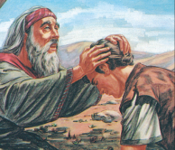*3“May God Almighty bless you,  
And make you fruitful and multiply you,  
That you may be an assembly of peoples;  
4And give you the blessing of Abraham,  
To you and your descendants with you,  
That you may inherit the land  
In which you are a stranger,  
Which God gave to Abraham.”*

*5So Isaac sent Jacob away, and he went to Padan Aram, to Laban the son of Bethuel the Syrian, the brother of Rebekah, the mother of Jacob and Esau.*

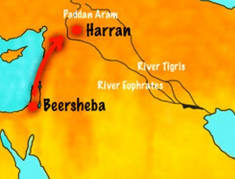

**A**

**C**

**B**

**D**

**Question 1**

Where on the map below did Isaac tell Jacob to go and find a wife?

1. A
2. B
3. C
4. D

**Question 2**

**Isaac is now given 2 blessings from Jacob**

**Blessing 1: Genesis 27:27-29**

*“Surely, the smell of my son  
Is like the smell of a field  
Which the Lord has blessed.  
28Therefore may God give you  
Of the dew of heaven,  
Of the fatness of the earth,  
And plenty of grain and wine.  
29Let peoples serve you,  
And nations bow down to you.  
Be master over your brethren,  
And let your mother’s sons bow down to you.  
Cursed be everyone who curses you,  
And blessed be those who bless you!”*

**Blessing 2: Genesis 28: 3-4**

*3“May God Almighty bless you,  
And make you fruitful and multiply you,  
That you may be an assembly of peoples;  
4And give you the blessing of Abraham,  
To you and your descendants with you,  
That you may inherit the land  
In which you are a stranger,  
Which God gave to Abraham.”*

1. Which Blessing did Jacob receive by pretending to be his bother Esau?
2. Which blessing did Isaac give Jacob knowing *who* he is blessing, it is more complete.

**Question 3**

Verses 3 & 4 are the blessing of Isaac to Jacob.

Match the lines of the actual verse with what you think they mean from the list below

* *May you become a big nation (country)*
* *God give you and your children the same blessing Abraham had*
* *God bless you*
* *May you take ownership of the land God gave to Abraham*
* *God give you many children*

|  |  |
| --- | --- |
| **Isaac’s blessing verses 3-4** | **Meanings** |
| *“May God Almighty bless you,* |  |
| *And make you fruitful and multiply you,* |  |
| *That you may be an assembly of peoples;* |  |
| *And give you the blessing of Abraham, To you and your descendants with you,* |  |
| *That you may inherit the land In which you are a stranger, Which God gave to Abraham.”* |  |

### Esau Marries Mahalath

*6Esau saw that Isaac had blessed Jacob and sent him away to Padan Aram to take himself a wife from there, and that as he blessed him he gave him a charge, saying, “You shall not take a wife from the daughters of Canaan,” 7and that Jacob had obeyed his father and his mother and had gone to Padan Aram. 8Also Esau saw that the daughters of Canaan did not please his father Isaac. 9So Esau went to Ishmael and took Mahalath the daughter of Ishmael, Abraham’s son, the sister of Nebajoth, to be his wife in addition to the wives he had.*

**Question 4**

(i) Who is the father of the woman Esau marries?  
(ii) How is that man related to Abraham? He is:

a) Abraham's grandson

b) Abraham's nephew

c) Abraham's first born son

* 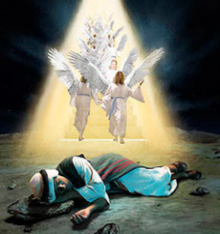Tuesday 4th July: Read **Genesis 28: 10-15** and answer the questions:

### Jacob’s Vow at Bethel

*10Now Jacob went out from Beersheba and went toward Haran. 11So he came to a certain place and stayed there all night, because the sun had set. And he took one of the stones of that place and put it at his head, and he lay down in that place to sleep. 12Then he dreamed, and behold, a ladder was set up on the earth, and its top reached to heaven; and there the angels of God were ascending and descending on it.*

**Question 5**

What did he dream about when he fell asleep?

1. He saw a ladder with angels going up and down, and God was speaking to him.
2. The coming day.
3. How he had wronged Esau and his father.

**God speaks to Jacob in a dream**

*13And behold, the Lord stood above it and said: “I am the Lord God of Abraham your father and the God of Isaac; the land on which you lie I will give to you and your descendants. 14Also your descendants shall be as the dust of the earth; you shall spread abroad to the west and the east, to the north and the south; and in you and in your seed all the families of the earth shall be blessed. 15Behold, I am with you and will keep you wherever you go, and will bring you back to this land; for I will not leave you until I have done what I have spoken to you.”*

**Question 6**

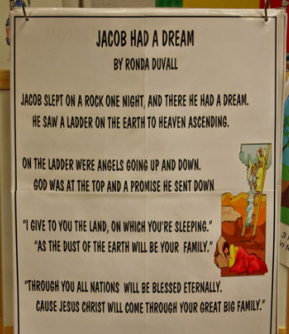

Verse:

Verse:

Verse:

Verse:

Verse:

Identify the verse number

* Wednesday 5th July: Read **Genesis 28: 16-22** and answer the questions:

**Jacob wakes up from his sleep**

*16Then Jacob awoke from his sleep and said, “Surely the Lord is in this place, and I did not know it.” 17And he was afraid and said, “How awesome is this place! This is none other than the house of God, and this is the gate of heaven!”*

**Question 7**

Why was Jacob ***afraid?***

1. Because he was scard from God. **TRUE/FALSE**
2. Because he thought God was going to punish him. **TRUE/FALSE**
3. Because Of God’s amazing Grace and goodness, especially after deceiving his father and dishonestly taking Esau’s blessing. **TRUE/FALSE**
4. Because he felt he was unworthy to receive God’s promise. **TRUE/FALSE**
5. He woke in AWE (amazement) of The LORD and His promise to be with Jacob. **TRUE/FALSE**
6. Because he was in the middle of the wilderness all alone. **TRUE/FALSE**

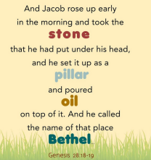

**Jacob’s vow to God**

*18Then Jacob rose early in the morning, and took the stone that he had put at his head, set it up as a pillar, and poured oil on top of it. 19And he called the name of that place Bethel; but the name of that city had been Luz previously. 20Then Jacob made a vow, saying, “If God will be with me, and keep me in this way that I am going, and give me bread to eat and clothing to put on, 21so that I come back to my father’s house in peace, then the Lord shall be my God. 22And this stone which I have set as a pillar shall be God’s house, and of all that You give me I will surely give a tenth to You.”*

**Do you know what a pillar is?**

*A pillar is large post that helps to hold up something (such as a roof).*

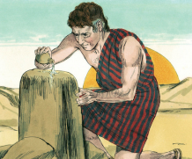

Man-made pillar

Jacob’s pillar

**Question 8a**

As Jacob took the stone, which he had used as a pillow, and set it up as a memorial, what promise did he make?

a) That he would always save that stone.

b) That he would always worship God and obey His laws.

**Question 8b**

Jacob makes a vow (promise) to God - what does Jacob promise to give God?

1. I will give You my first son.
2. I will give You first salary.
3. I will give you a tenth (10%) of everything that You give me

* Thursday 6th July: Read **Genesis 29: 1-12** and answer the questions:

Jacob arrives at the well

**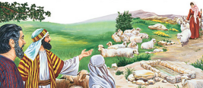***1 So Jacob went on his journey and came to the land of the people of the East. 2And he looked, and saw a well in the field; and behold, there were three flocks of sheep lying by it; for out of that well they watered the flocks. A large stone was on the well’s mouth. 3Now all the flocks would be gathered there; and they would roll the stone from the well’s mouth, water the sheep, and put the stone back in its place on the well’s mouth.*

*4And Jacob said to them, “My brethren, where are you from?”*

*And they said, “We are from Haran.”*

*5Then he said to them, “Do you know Laban the son of Nahor?”*

*And they said, “We know him.”*

*6So he said to them, “Is he well?”*

*And they said, “He is well. And look, his daughter Rachel is coming with the sheep.”*

**Jacob Meets Rachel**

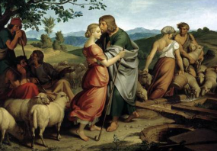*9Now while he was still speaking with them, Rachel came with her father’s sheep, for she was a shepherdess. 10And it came to pass, when Jacob saw Rachel the daughter of Laban his mother’s brother, and the sheep of Laban his mother’s brother, that Jacob went near and rolled the stone from the well’s mouth, and watered the flock of Laban his mother’s brother. 11Then Jacob kissed Rachel, and lifted up his voice and wept. 12And Jacob told Rachel that he was her father’s relative and that he was Rebekah’s son. So she ran and told her father.*

*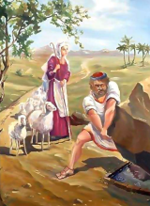***Question 9a**

Identify the verse in the passage that describes what you see in the picture.

Verse:

**Question 9b**

What did Jacob do for Rachel when he saw her?  
 a) rolled the stone from the well’s mouth

b) watered the flock of Laban his mother’s brother

c) all of the above

* Friday 7th July: Read **Genesis 29: 13-20** and answer the questions:

**Question 10**

For this question I would like you to open a Bible you have at home and find the verse Genesis Chapter 29 verse 13**-14**

1. Copy verses 13-14 into the textbox below.
2. List the 4 things Laban did to welcome Jacob to his home.

### Jacob loves and wants to marry Rachel

*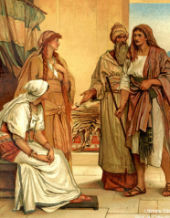15Then Laban said to Jacob, “Because you are my relative, should you therefore serve me for nothing? Tell me, what should your wages be?” 16Now Laban had two daughters: the name of the elder was Leah, and the name of the younger was Rachel. 17Leah’s eyes were delicate, but Rachel was beautiful of form and appearance.*

*18Now Jacob loved Rachel; so he said, “I will serve you seven years for Rachel your younger daughter.”*

*19And Laban said, “It is better that I give her to you than that I should give her to another man. Stay with me.” 20So Jacob served seven years for Rachel, and they seemed only a few days to him because of the love he had for her.*

**Question 11**

How many years Jacob had to work for Laban in order to marry Rachel?

1. 5
2. 7
3. 12

* Saturday 8th July: Read **Genesis 29: 21-35** and answer the questions:

**Laban deceives Jacob**

*21Then Jacob said to Laban, “Give me my wife, for my days are fulfilled, that I may go in to her.” 22And Laban gathered together all the men of the place and made a feast. 23Now it came to pass in the evening, that he took Leah his daughter and brought her to Jacob; and he went in to her. 24And Laban gave his maid Zilpah to his daughter Leah as a maid. 25So it came to pass in the morning, that behold, it was Leah. And he said to Laban, “What is this you have done to me? Was it not for Rachel that I served you? Why then have you deceived me?”*

*26And Laban said, “It must not be done so in our country, to give the younger before the firstborn. 27Fulfill her week, and we will give you this one also for the service which you will serve with me still another seven years.”*

*28Then Jacob did so and fulfilled her week. So he gave him his daughter Rachel as wife also. 29And Laban gave his maid Bilhah to his daughter Rachel as a maid. 30Then Jacob also went in to Rachel, and he also loved Rachel more than Leah. And he served with Laban still another seven years.*

**Question 12**

How did Laban trick Jacob?

1. Laban gave him a maid instead of Rachel
2. He gave him Leah instead of Rachel
3. Neither of the above

**Question 13**

Fill in the table below by naming Leah or Rachael to answer the question

|  |  |
| --- | --- |
| Question | Leah or Rachel |
| Who did Jacob love more? |  |
| Who did Jacob marry first? |  |
| For whom did Jacob serve Laban for? |  |
| Who was older? |  |
| Who’s maid was Bilhah? |  |
| Who’s maid was Zilpah? |  |

**The Children of Jacob**

*31When the Lord saw that Leah was unloved, He opened her womb; but Rachel was barren. 32So Leah conceived and bore a son, and she called his name Reuben;for she said, “The Lord has surely looked on my affliction. Now therefore, my husband will love me.” 33Then she conceived again and bore a son, and said, “Because the Lord has heard that I am unloved, He has therefore given me this son also.” And she called his name Simeon. 34She conceived again and bore a son, and said, “Now this time my husband will become attached to me, because I have borne him three sons.” Therefore his name was called Levi. 35And she conceived again and bore a son, and said, “Now I will praise the Lord.” Therefore she called his name Judah. Then she stopped bearing.*

**Question 14**

Jacob had many children, you will learn about the other children in the next Bible Study.

Below is a picture of 4 women that will bear children for Jacob.

Write down the names of the 4 sons Leah gave birth to in this passage.

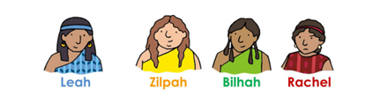

**Question 15**

Each of the names of the sons you identified in question 18 has a meaning. Match the name to its meaning. The reason for the meaning is a hint to help you identify the name.

|  |  |  |
| --- | --- | --- |
| **Name** | **Meaning** | **Reason for the meaning** |
|  | Behold, a son. | This was her statement to Jacob and all others that the Lord had looked upon my affliction. |
|  | Attachment. | Leah still lives in the hope her husband Jacob would love her and become attached to her through the birth of these sons. |
|  | Praise. | Leah stopped naming her children to reflect the pain and longing in her heart. At this point she focused on God and could praise Him. |
|  | Hearing. | Leah hoped all would notice that the Lord has heard her. |

**What to do when you finish your Bible Study.**

**Send it by email to your class email address or print and hand it to your servants next Sunday.**

* **Year 4A St Makarious StMakarios4A@gmail.com Class Servant- Aunty Labiba (0421891567)**
* **Year 4B St Bakhomious StBakhomios4B@gmail.com Class Servant- Aunty Mira (0415595556)**
* **Year 4C St Anthony StAnthony4C@gmail.com Class Servant- Aunty Olivia**