C:\Documents and Settings\suzy\Local Settings\Temporary Internet Files\Content.IE5\3JXW24R5\MC900383922[1].wmfSunday 18 JUNE

Name:

Class:

Finish Date: Saturday 24 June

Completed Bible Study = 15 points

Email Homework by the due date = 5 points

**Year 6 Bible Study Joshua Chapters 1-3**

**For the questions below Highlight, underline or change the font colour to choose the correct answer.**

* SUNDAY: Read **Joshua Chapter 1: 1-9** and answer the questions:

### God’s Commission to Joshua

*After the death of Moses the servant of the Lord, it came to pass that the Lord spoke to Joshua the son of Nun, Moses’ assistant, saying: 2“Moses My servant is dead. Now therefore, arise, go over this Jordan, you and all this people, to the land which I am giving to them—the children of Israel. 3Every place that the sole of your foot will tread upon I have given you, as I said to Moses. 4From the wilderness and this Lebanon as far as the great river, the River Euphrates, all the land of the Hittites, and to the Great Sea toward the going down of the sun, shall be your territory.*

****God tells Joshua He will never leave him**

*5No man shall be able to stand before you all the days of your life; as I was with Moses, so I will be with you. I will not leave you nor forsake you. 6Be strong and of good courage, for to this people you shall divide as an inheritance the land which I swore to their fathers to give them. 7Only be strong and very courageous, that you may observe to do according to all the law which Moses My servant commanded you; do not turn from it to the right hand or to the left, that you may prosper wherever you go.*

**

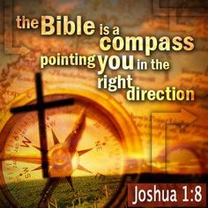

**God encourages Joshua**

*8This Book of the Law shall not depart from your mouth, but you shall meditate in it day and night, that you may observe to do according to all that is written in it. For then you will make your way prosperous, and then you will have good success.*

*9Have I not commanded you? Be strong and of good courage; do not be afraid, nor be dismayed, for the Lord your God is with you wherever you go.”*

**Where is the Promised Land?**

This map reveals the 7 nations mentioned in the Bible that existed in the land of Canaan before God gave the land to the Israelites. The ***Canaanites*** dwelt in the plains, the ***Amorites*** lived in the hills, some of the other nations were the ***Perizzites***, the ***Hivites***, the ***Hittites***, the ***Jebusites***, the ***Moabites***, the ***Edomites***, the ***Philistines***, and the ***Girgashites***. These nations were descendants of ***Canaan, the fourth son of Ham*** who was cursed by Noah. Some of them were ***Giants***.

**Question 1**

Looking at the map on the right, identify which two tribes the Camp of the Israelites was between.

a) Edomites and Hitites

b) Moabites and Amorites

c) Moabites and Canaanites

d) Philistines and Girgashites

**Question 2**

Is God’s promise in verse 5, exclusively to Joshua? Yes/ No

What does this verse mean to you?

**Question 3**

Why do we feel this strength, courage and trust through all these times? Complete from verse 9

The LORD your God is

* MONDAY Read **Joshua Chapter 1: 10-18** and answer the questions:

**The Order to Cross the Jordan**

*Then Joshua commanded the officers of the people, saying, 11“Pass through the camp and command the people, saying, ‘Prepare provisions for yourselves, for within three days you will cross over this Jordan, to go in to possess the land which the Lord your God is giving you to possess.’”*

*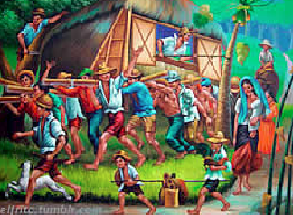12And to the Reubenites, the Gadites, and half the tribe of Manasseh Joshua spoke, saying, 13“Remember the word which Moses the servant of the Lord commanded you, saying, ‘The Lord your God is giving you rest and is giving you this land.’ 14Your wives, your little ones, and your livestock shall remain in the land which Moses gave you on this side of the Jordan. But you shall pass before your brethren armed, all your mighty men of valor, and help them, 15until the Lord has given your brethren rest, as He gave you, and they also have taken possession of the land which the Lord your God is giving them. Then you shall return to the land of your possession and enjoy it, which Moses the Lord’s servant gave you on this side of the Jordan toward the sunrise.”*

*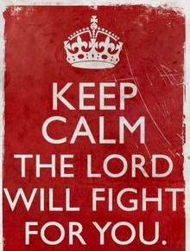***The Israelites support Joshua**

*16So they answered Joshua, saying, “All that you command us we will do, and wherever you send us we will go. 17Just as we heeded Moses in all things, so we will heed you. Only the Lord your God be with you, as He was with Moses. 18Whoever rebels against your command and does not heed your words, in all that you command him, shall be put to death. Only be strong and of good courage.”*

**Question 4**

Before the Rubenites, Gadites and half the tribe of Manasseh were able to rest on the side of the Jordan (their land and home) that they were already on, what did they have to do to the rest of the Israel?

a) Sing for them

b) Rest with them

c) Help them move

d) Make fun of them for having to cross the river

**Question 5**

The main message of the chapter is repeated here once again, and this time it’s by the people of Israel, rather than from God.

There are TWO parts to this message! What are they?

1) The Lord your God is

2) Be strong and

* TUESDAY: Read **Joshua Chapter 2: 1-3** and answer the questions:

**Rahab Hides the Two Men**

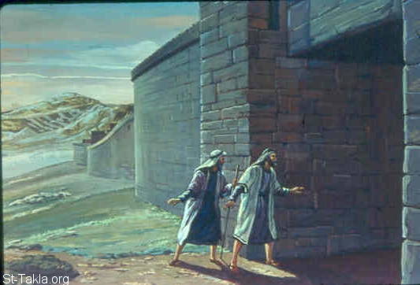*1Now Joshua the son of Nun sent out two men from Acacia Grove to spy secretly, saying, “Go, view the land, especially Jericho.” So they went, and came to the house of a harlot named Rahab, and lodged there. 2And it was told the king of Jericho, saying, “Behold, men have come here tonight from the children of Israel to search out the country.”*

*3So the king of Jericho sent to Rahab, saying, “Bring out the men who have come to you, who have entered your house, for they have come to search out all the country.”*

*4Then the woman took the two men and hid them. So she said, “Yes, the men came to me, but I did not know where they were from. 5And it happened as the gate was being shut, when it was dark, that the men went out. Where the men went I do not know; pursue them quickly, for you may overtake them.”*

*6(But she had brought them up to the roof and hidden them with the stalks of flax, which she had laid in order on the roof.) 7Then the men pursued them by the road to the Jordan, to the fords. And as soon as those who pursued them had gone out, they shut the gate.*

***What is Flax?***

*Flax is a type of wheat or crop, used to make linen (fabric)*

**Question 6**

Identify the following people or items in the picture on the right, by writing one of the following answers in each box.

**Rahab, Two Spies, Flax, Rooftop**

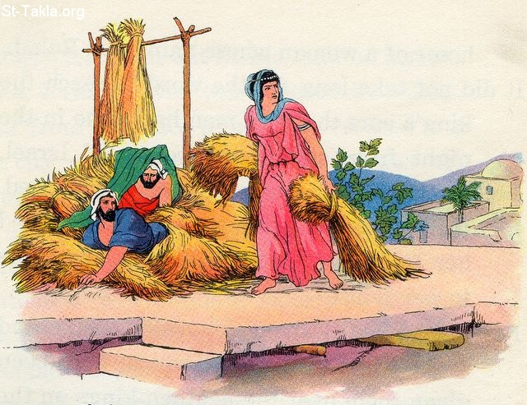

**Question 7**

Where did Rahab hide the two men?

a) In her bed

b) Outside the gate

c) Under some flax on her roof

d) Near the river

* WEDNESDAY: Read **Joshua Chapter 2: 8-13** and answer the questions:

**Rahab begs God to save her and her family**

*8Now before they lay down, she came up to them on the roof, 9and said to the men: “I know that the Lord has given you the land, that the terror of you has fallen on us, and that all the inhabitants of the land are fainthearted because of you. 10For we have heard how the Lord dried up the water of the Red Sea for you when you came out of Egypt, and what you did to the two kings of the Amorites who were on the other side of the Jordan, Sihon and Og, whom you utterly destroyed.*

*11And as soon as we heard these things, our hearts melted; neither did there remain any more courage in anyone because of you, for the Lord your God, He is God in heaven above and on earth beneath. 12Now therefore, I beg you, swear to me by the Lord, since I have shown you 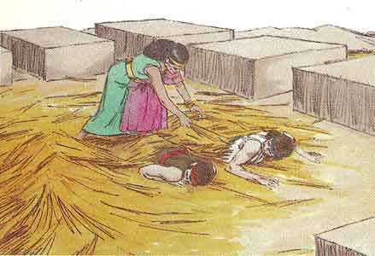kindness, that you also will show kindness to my father’s house, and give me a true token, 13and spare my father, my mother, my brothers, my sisters, and all that they have, and deliver our lives from death.”*

**Question 8**

Fill in the blanks for the follow verse, and write down the verse number in the box below it.

For the your God, He is in heaven above, and on

beneath. (Joshua Chapter 2, Verse )

**Question 9**

List the 2 events, accoridng to verse 10, that allowed Rahab, and the people of Jericho, know that the God of the Israelites was a powerful God, and made them lose courage in themselves.

1.

2.

* THURSDAY Read **Joshua Chapter 2: 14-24** and answer the questions:

**A plan to save the two men**

*14So the men answered her, “Our lives for yours, if none of you tell this business of ours. And it shall be, when the Lord has given us the land, that we will deal kindly and truly with you.”*

*15Then she let them down by a rope through the window, for her house was on the city wall; she dwelt on the wall. 16And she said to them, “Get to the mountain, lest the pursuers meet you. Hide there three days, until the pursuers have returned. Afterward you may go your way.”*

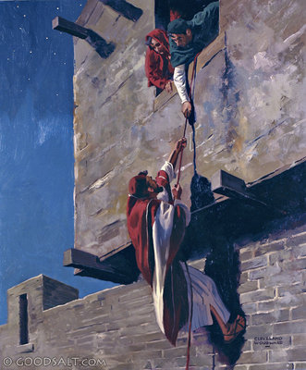**The Scarlet Cord**

*17So the men said to her: “We will be blameless of this oath of yours which you have made us swear, 18unless, when we come into the land, you bind this line of scarlet cord in the window through which you let us down, and unless you bring your father, your mother, your brothers, and all your father’s household to your own home. 19So it shall be that whoever goes outside the doors of your house into the street, his blood shall be on his own head, and we will be guiltless. And whoever is with you in the house, his blood shall be on our head if a hand is laid on him. 20And if you tell this business of ours, then we will be free from your oath which you made us swear.”*

*21Then she said, “According to your words, so be it.” And she sent them away, and they departed. And she bound the scarlet cord in the window.*

**The two men return to Joshua safely**

*22They departed and went to the mountain, and stayed there three days until the pursuers returned. The pursuers sought them all along the way, but did not find them. 23So the two men returned, descended from the mountain, and crossed over; and they came to Joshua the son of Nun, and told him all that had befallen them*

*.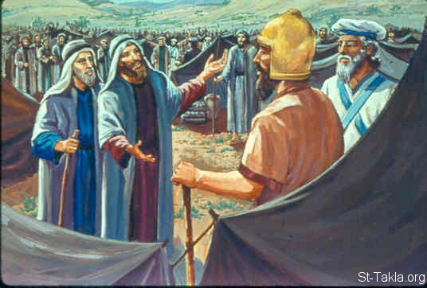*

*24And they said to Joshua, “Truly the Lord has delivered all the land into our hands, for indeed all the inhabitants of the country are fainthearted because of us.”*

**Question 10**

Yes/ No

Did the spies agree to help Rahab? Yes/ No

Did Rahab live in the middle of the city? Yes/ No

The men had to hide in the mountains for 3 days? Yes/No

The men walked out of the city doors? es/ No

**Question 11**

Why did Rahab have to tie the scarlet (red) cord in her window until the Israelites came back?

* FRIDAY Read **Joshua Chapter 3: 1-8** and answer the questions:

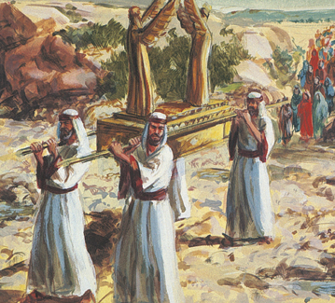*1 Then Joshua rose early in the morning; and they set out from Acacia Grove and came to the Jordan, he and all the children of Israel, and lodged there before they crossed over. 2So it was, after three days, that the officers went through the camp; 3and they commanded the people, saying, “When you see the ark of the covenant of the Lord your God, and the priests, the Levites, bearing it, then you shall set out from your place and go after it. 4Yet there shall be a space between you and it, about two thousand cubits by measure. Do not come near it, that you may know the way by which you must go, for you have not passed this way before.”*

**What is a cubit?**

*A cubit is an ancient measure of length, approximately equal to 44 cm.*

*So 2000 cubits = 915 metres*

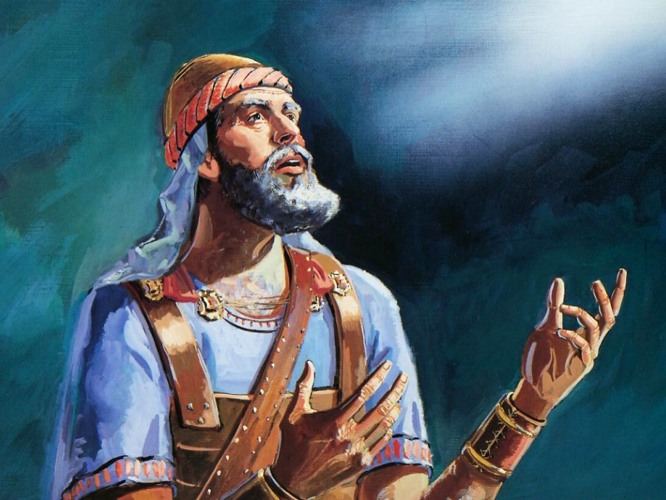**Israelites reaches the Jordan River**

*5And Joshua said to the people, “Sanctify yourselves, for tomorrow the Lord will do wonders among you.” 6Then Joshua spoke to the priests, saying, “Take up the Ark of the Covenant and cross over before the people.”*

*So they took up the Ark of the Covenant and went before the people.*

*7And the Lord said to Joshua, “This day I will begin to exalt you in the sight of all Israel, that they may know that, as I was with Moses, so I will be with you. 8You shall command the priests who bear the ark of the covenant, saying, ‘When you have come to the edge of the water of the Jordan, you shall stand in the Jordan.’”*

**What is the Jordan?**

The Jordan is a river that separated the Israelites from the Promised Land

**Question 12**

Which tribe was to be “bearing” (carrying) the Ark?

1. Judah
2. Israel
3. Levites
4. Acacia

**Question 13**

How far behind did Joshua tell the Israelites they must be when they follow the Ark?

* SATURDAY Read **Joshua Chapter 3: 9-17** and answer the questions:

**Joshua instructs Israelites how to cross the Jordan River**

*9So Joshua said to the children of Israel, “Come here, and hear the words of the Lord your God.” 10And Joshua said, “By this you shall know that the living God is among you, and that He will without fail drive out from before you the Canaanites and the Hittites and the Hivites and the Perizzites and the Girgashites and the Amorites and the Jebusites: 11Behold, the ark of the covenant of the Lord of all the earth is crossing over before you into the Jordan.*

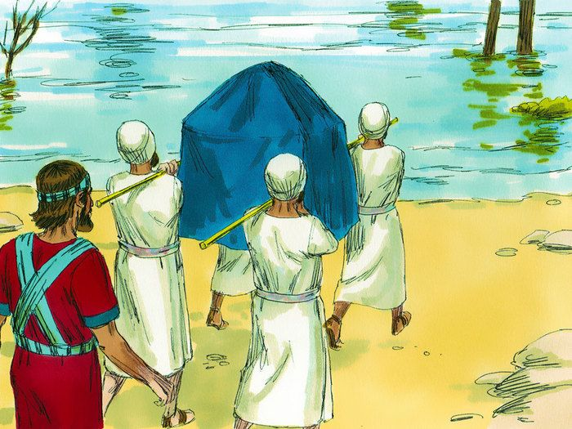 *12Now therefore, take for yourselves twelve men from the tribes of Israel, one man from every tribe. 13And it shall come to pass, as soon as the soles of the feet of the priests who bear the ark of the Lord, the Lord of all the earth, shall rest in the waters of the Jordan, that the waters of the Jordan shall be cut off, the waters that come down from upstream, and they shall stand as a heap.”*

### Israel Crosses the Jordan

*14So it was, when the people set out from their camp to cross over the Jordan, with the priests bearing the ark of the covenant before the people, 15and as those who bore the ark came to the Jordan, and the feet of the priests who bore the ark dipped in the edge of the water (for the Jordan overflows all its banks during the whole time of harvest), 16that the waters which came down from upstream stood still, and rose in a heap very far away at Adam, the city that is beside Zaretan. So the waters that went down into the Sea of the Arabah, the Salt Sea, failed, and were cut off; and the people crossed over opposite Jericho. 17Then the priests who bore the ark of the covenant of the Lord stood firm on dry ground in the midst of the Jordan; and all Israel crossed over on dry ground, until all the people had crossed completely over the Jordan.*

**Question 14**

Number the events in the order that they happened. The first one has been done for you

|  |  |
| --- | --- |
|  | A small part of the Ark of the Covenant touched the water because the Jordan was overflowing during the time of harvest |
|  | All of the Israelites crossed over on dry land |
|  | The water was cut off, and stood still allowing the priests to cross on dry land |
| 1 | The priests led the way to the Jordan, and the Israelites followed |

**Question 15**

Identify the following characters/ things/ places in the image below.

Israelites , Joshua , Jordan River , Ark of the Covenant, Levite Priests

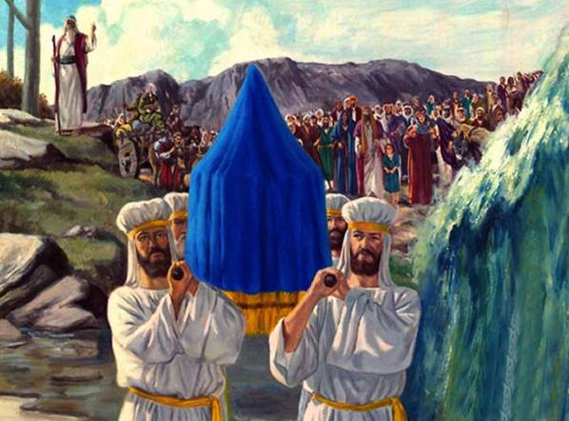

**What 4 lessons we learn from crossing the Jordan River to the Promised Land**

*The children of Israel had spent 40 years in the wilderness and now they were about to enter into the Promised Land. The Jordan River was the barrier keeping them out, so they had to cross the Jordan to get there. Sometimes we need to leave the past behind and enter new territory. Usually we will encounter a barrier that keeps us from the new land, and we must break through that barrier to get to what God has for us.*

1. ***You must believe that God has given you the land.*** *God had promised their fathers that He would give them their own land (Josh. 1:6).  Many of those people died in the wilderness and could not enter it due to unbelief (Heb. 3:19).  Before you can enter any new territory, you must believe that it's God's will and that He has given it to you.*
2. ***You must believe that the Promised Land is better than the wilderness.****Why would you go into the land, unless you believed it was better than the wilderness?  The 12 men that Moses had sent to spy out the land said that it was "an exceedingly good land" (Num. 14:7).  Some people probably said, "I kind of like it here in the wilderness.  This is what I'm used to. I like all the sand, rocks, and dirt out here. I'm not sure I want to go into a land full of green grass and fruit trees."  It's easy to stay with what you're familiar with instead of doing something new. But then you miss out on the blessings God has for you.*
3. ***You must believe that God is with you.****Joshua said, "Be strong and courageous...for the Lord your God is with you wherever you go" (Josh. 1:9).  To leave your comfort zone and tread into new territory, you must believe that God is with you and that you're not on your own. "God is with you" means that He is there to help and guide you through all situations, both good and bad.*
4. ***You must take a step of faith into the Jordan.*** *Imagine standing at the Jordan River, and you don't know how you're going to get an entire nation across it.  There isn't a bridge over the river. There aren't any boats. But God told them to take a step of faith and He would open the way.  As soon as the priests put their feet in the river, the Lord stopped the water and they crossed over (Josh. 3:13).  Sometimes God wants us to take the step of faith first, and then He will come through.*

**What to do when you finish your Bible Study.**

Send it by email to your class email address or print and hand it to your servants next Sunday.

* Year 6B1 St Mark [stmark6b1@gmail.com](mailto:stmark6b1@gmail.com) Class Servant- Uncle Fady (0424740775)
* Year 6B2 St Luke [stluke6b2@gmail.com](mailto:stluke6b2@gmail.com) Class Servant- Uncle Adel (0422884699)
* Year 6G St John[stjohn6g@gmail.com](mailto:stjohn6g@gmail.com) Class Servant- Aunty Nancy (0400212921)