C:\Documents and Settings\suzy\Local Settings\Temporary Internet Files\Content.IE5\3JXW24R5\MC900383922[1].wmfSunday 18th June, 2017

Name:

Class:

Finish Date: Saturday 24th June, 2017

Completed Bible Study = 15 points

Email Homework by due date = 5 extra points

**Year 3 Bible Study Genesis Chapter 1**

**For the questions below Highlight, underline or change the font colour to choose the correct answer.**

# Monday: Read Genesis Chapter 1:1-5 and answer the questions:

### The History of Creation- Day 1

*1 In the beginning God created the heavens and the earth. 2The earth was without form, and void; and darkness was on the face of the deep. And the Spirit of God was hovering over the face of the waters.*

*3Then God said, “Let there be light”; and there was light. 4And God saw the light, that it was good; and God divided the light from the darkness. 5God called the light Day, and the darkness He called Night. So the evening and the morning were the first day.*

**Question 1**

On Day 1, God said, “Let there be

**Question 2**

1. What did God call the light?
2. What did God call the darkness?

# Tuesday: Read Genesis Chapter 1:6-8 and answer the questions:

### The History of Creation- Day 2

*6Then God said, “Let there be a firmament in the midst of the waters, and let it divide the waters from the waters.” 7Thus God made the firmament, and divided the waters which were under the firmament from the waters which were above the firmament; and it was so. 8And God called the firmament Heaven. So the evening and the morning were the second day.*

***On Day 2, God separated the waters of the nothingness into the moisture and clouds of the sky above, and the drops and waves of the oceans below. God named the sky “Heaven”***

**Question 3**

On Day 2, what did God call the firmament (*hint: verse 8*)?

# Wednesday: Read Genesis Chapter 1:9-13 and answer the questions:

### The History of Creation- Day 3

[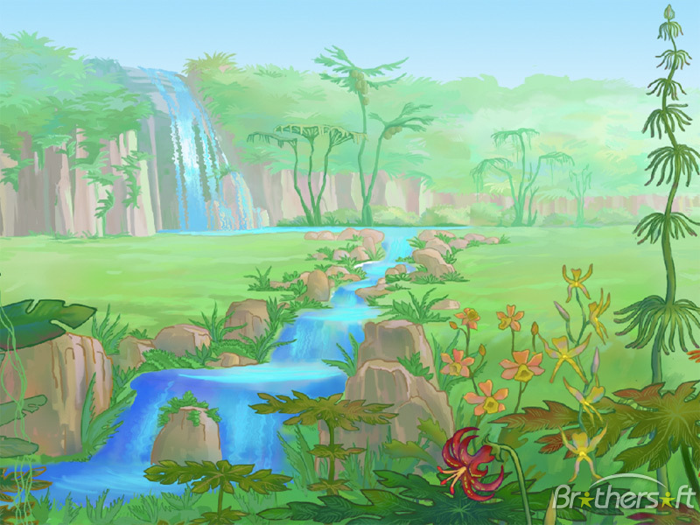](https://www.google.com.au/url?sa=i&rct=j&q=&esrc=s&source=images&cd=&cad=rja&uact=8&ved=0ahUKEwjn2aKny8fUAhWGnJQKHR80BcsQjRwIBw&url=http%3A%2F%2Fmac.brothersoft.com%2Fsecret-land-screensaver.html&psig=AFQjCNHxHZYQkvyxJiprrIgFcyEEfkyNNw&ust=1497881881756231)*9Then God said, “Let the waters under the heavens be gathered together into one place, and let the dry land appear”; and it was so. 10And God called the dry land Earth, and the gathering together of the waters He called Seas. And God saw that it was good.*

*11Then God said, “Let the earth bring forth grass, the herb that yields seed, and the fruit tree that yields fruit according to its kind, whose seed is in itself, on the earth”; and it was so. 12And the earth brought forth grass, the herb that yields seed according to its kind, and the tree that yields fruit, whose seed is in itself according to its kind. And God saw that it was good. 13So the evening and the morning were the third day.*

***God created trees, plants and flowers with seeds so they could keep growing more trees, plants and flowers just like they still do today.***

**Question 4 - On Day 3:**

1. God gathered together the waters under heaven and called these waters Seas?

**True/ False**

1. God let dry land appear and called it Earth? **True/ False**
2. On the dry land, God created grass, trees and fruit? **True/ False**

# Thursday: Read Genesis Chapter 1:14-19 and answer the questions:

### The History of Creation- Day 4

*14Then God said, “Let there be lights in the firmament of the heavens to divide the day from the night; and let them be for signs and seasons, and for days and years; 15and let them be for lights in the firmament of the heavens to give light on the earth”; and it was so. 16Then God made two great lights: the greater light to rule the day, and the lesser light to rule the night. He made the stars also. 17God set them in the firmament of the heavens to give light on the earth, 18and to rule over the day and over the night, and to divide the light from the darkness. And God saw that it was good. 19So the evening and the morning were the fourth day.*

**Question 5**

On day 4, God made:

1. To light the Earth by day, a great light called the
2. To light the Earth by night, a lesser light called the as well as the

# Friday: Read Genesis Chapter 1:20-23 and answer the questions:

### The History of Creation- Day 5

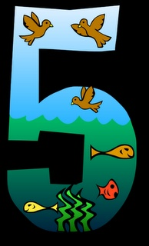*20Then God said, “Let the waters abound with an abundance of living creatures, and let birds fly above the earth across the face of the firmament of the heavens.” 21So God created great sea creatures and every living thing that moves, with which the waters abounded, according to their kind, and every winged bird according to its kind. And God saw that it was good. 22And God blessed them, saying, “Be fruitful and multiply, and fill the waters in the seas, and let birds multiply on the earth.” 23So the evening and the morning were the fifth day.*

**Question 6**

What does the word “abundance” mean?

(A) Very little (B) Some (C) Plenty

**Question 7**

On Day 5, God created:

1. Birds
2. Animals
3. Sea Creatures
4. Birds and Animals
5. Birds and Sea Creatures
6. Animals and Sea Creatures
7. Birds, Animals and Sea Creatures

# Saturday: Read Genesis Chapter 1:24-31 and answer the questions:

### The History of Creation- Day 6

*24Then God said, “Let the earth bring forth the living creature according to its kind: cattle and creeping thing and beast of the earth, each according to its kind”; and it was so. 25And God made the beast of the earth according to its kind, cattle according to its kind, and everything that creeps on the earth according to its kind. And God saw that it was good.*

**Question 8**

God created which of the following on Day 6?

1. Animals (B) Insects (C) Fish (D) Lizards (E) Snakes (F) Birds

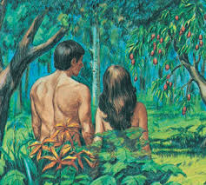*26Then God said, “Let Us make man in Our image, according to Our likeness; let them have dominion over the fish of the sea, over the birds of the air, and over the cattle, over all the earth and over every creeping thing that creeps on the earth.” 27So God created man in His own image; in the image of God He created him; male and female He created them. 28Then God blessed them, and God said to them, “Be fruitful and multiply; fill the earth and subdue it; have dominion over the fish of the sea, over the birds of the air, and over every living thing that moves on the earth.”*

*29And God said, “See, I have given you every herb that yields seed which is on the face of all the earth, and every tree whose fruit yields seed; to you it shall be for food. 30Also, to every beast of the earth, to every bird of the air, and to everything that creeps on the earth, in which there is life, I have given every green herb for food”; and it was so. 31Then God saw everything that He had made, and indeed it was very good. So the evening and the morning were the sixth day.*

**Question 9**

Number the following things that God did in the correct order that they happened (*the first one has been done for you.)*

|  |  |
| --- | --- |
|  | God gave humans control over fish, birds, and every living creature |
|  | God provided food for humans and all living creatures |
| 1 (verse 27) | God made man in His own image … male and female He created them |
|  | God blessed them (male and female) and told them to multiply (have children) |

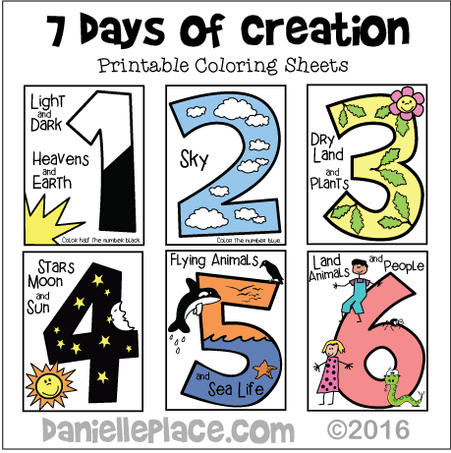

**What to do when you finish your Bible Study.**

Send it by email to your class email address or print and hand it to your servants next Sunday.

* Year 3A St Bishoy[stbishoy3a@gmail.com](mailto:stbishoy3a@gmail.com) Class Servant: Uncle Emile (0416895236)
* Year 3B St Paul[saintpaul3b@gmail.com](mailto:saintpaul3b@gmail.com) Class Servant: Aunty Marena (0433677290)
* Year 3C St Moses [stmoses3c@gmail.com](mailto:stmoses3c@gmail.com) Class Servant: Uncle Mina (0433520175)