1,2 Peter, 1,2 Timothy & Ephesians Revision

**Revision for 1,2 Peter**

**Chapter 1**

1. Who wrote 1 & 2 Peter?
2. To whom were 1 & 2 Peter written to? *(Teachers - Explain term ‘elect pilgrims’ & that region circled below was part of Roman Empire)*

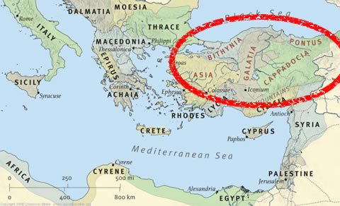

1. Peter describes a person’s faith as being more precious than what? (1 Peter 1:7)
2. Complete the missing words from 1 Peter 1:16.

“…because it is written, “Be , for I am

**Chapter 3**

1. In 1 Peter 3, he was writing this letter to Christians who were being persecuted for their faith, encouraging them to stand firm in Christ. He reminds them of someone else who suffered for us first – who is that?
2. Complete the missing words from 1 Peter 4:1:

|  |  |  |  |  |  |
| --- | --- | --- | --- | --- | --- |
| *Therefore, since Christ suffered for* |  | | *in the flesh, arm yourselves also with the same* | |  |
| *for he who has suffered in the* | |  | | *has ceased from* |  |

**Chapter 4**

1. Who wrote that we should love one another without complaining? St Peter or St Paul?

**Chapter 5**

1. The devil is likened to a roaring tiger TRUE or FALSE

**2 Peter Chapter 1**

1. What are the 8 virtues Peter writes we should ‘put on’? (1 & 2 are done for you)

|  |  |
| --- | --- |
| 1 | Faith |
| 2 | Virtue |
| 3 |  |
| 4 |  |
| 5 |  |
| 6 |  |
| 7 |  |
| 8 |  |

**2 Peter 2**

1. What does God promise He can ALWAYS save us from?
2. To God, 1000 years equates to how long?

**2 Peter 3**

1. In verse 10 St Peter explains that the Day of the Lord will come suddenly, with no notice. What does he compare this to? (Underline/ highlight/ bold the correct answer).
2. A lightening bolt
3. A thief in the night
4. A shooting star.

**Revision for 1,2 Timothy**

1. Who wrote Timothy?
2. Complete the missing words from 1 Timothy 1:5:

|  |  |  |  |
| --- | --- | --- | --- |
| *Now the purpose of the commandment is* |  | *from a pure* |  |
| *from a good* |  | *& from a sincere* |  |

1. True or False

|  |  |
| --- | --- |
| St Paul calls on Timothy to pray for all men, kings and people in authority so that we can live peaceful lives. |  |
| God wants only good men to come to the knowledge of the truth. |  |
| The truth = Jesus Christ |  |
| St Paul calls on men and women everywhere to pray. |  |
| He tells women to wear pearls and gold and expensive clothes, not living simply. |  |

1. Why does St Paul say that if a man does not have control over his own house, he cannot be fit to be a bishop?
2. What is described as the root of all kinds of evil?
3. We are called to fight the good fight of……..?
4. Fill in the missing words from 2 Tim 1 verse 13:

*Hold the pattern of sound words which you have heard from me, in*

*and which are in Christ Jesus.*

1. St Paul warns of ‘perilous times’ to come when men will not believe in Christ… in verse 5 what does he say we should do if we meet such people?
2. Who does St Paul strengthened him so that he could preach even after being in prison?

Ephesians

1. Ephesians 1 verse 11

*11 In Him also we have obtained an inheritance, being predestined according to the purpose of Him who works all things according to the counsel of His will*

In verse 11 above, what does it say we have gained through Christ?

1. Are we saved by our works or by God’s grace, according to this passage? (verses 8-9)
2. St Paul describes all believers as members of one house (verse 19). What are the foundations of this house and what is the chief cornerstone?
3. Where in the Agpia do we read verses Ephesians 4:1-4 on unity?
4. Who is instructed to love their spouse as their own flesh? Wives or husbands?
5. Who are children instructed to obey?
6. Besides having the sword of truth, write 6 more ways we can dress as Christian soldiers.

|  |  |
| --- | --- |
| 1 |  |
| 2 |  |
| 3 |  |
| 4 |  |
| 5 |  |
| 6 |  |

