C:\Documents and Settings\suzy\Local Settings\Temporary Internet Files\Content.IE5\3JXW24R5\MC900383922[1].wmfSunday 4th June, 2017

Name:

Class:

Finish Date: Saturday 10th June, 2017

Completed Bible Study = 15 points

Email Homework by due date = 5 extra points

**Year 3 Bible Study Mark Chapters 15 & 16**

**For the questions below Highlight, or change the font colour to choose the correct answer.**

# Monday: Read Mark Chapter 15:1-15 and answer the questions:

### Jesus Faces Pilate

*1 Immediately, in the morning, the chief priests held a consultation with the elders and scribes and the whole council; and they bound Jesus, led Him away, and delivered Him to Pilate. 2Then Pilate asked Him, “Are You the King of the Jews?”*

*He answered and said to him, “It is as you say.”*

*3And the chief priests accused Him of many things, but He answered nothing. 4Then Pilate asked Him again, saying, “Do You answer nothing? See how many things they testify against You!” 5But Jesus still answered nothing, so that Pilate marveled.*

### Taking the Place of Barabbas

*6Now at the feast he was accustomed to releasing one prisoner to them, whomever they requested. 7And there was one named Barabbas, who was chained with his fellow rebels; they had committed murder in the rebellion. 8Then the multitude, crying aloud, began to ask him to do just as he had always done for them. 9But Pilate answered them, saying, “Do you want me to release to you the King of the Jews?” 10For he knew that the chief priests had handed Him over because of envy.*

*11But the chief priests stirred up the crowd, so that he should rather release Barabbas to them. 12Pilate answered and said to them again, “What then do you want me to do with Him whom you call the King of the Jews?”*

*13So they cried out again, “Crucify Him!”*

*14Then Pilate said to them, “Why, what evil has He done?”*

*But they cried out all the more, “Crucify Him!”*

*15So Pilate, wanting to gratify the crowd, released Barabbas to them; and he delivered Jesus, after he had scourged Him, to be crucified.*

**Question 1**

How many prisoners was Pilate accustomed to releasing at the Passover feast (*hint: verse 6*)?

**Question 2**

Who did the crowd choose to release? **Barabbas/ Jesus**

# Tuesday: Read Mark Chapter 15:16-32 and answer the questions:

### The Soldiers Mock Jesus

*16Then the soldiers led Him away into the hall called Praetorium, and they called together the whole garrison. 17And they clothed Him with purple; and they twisted a crown of thorns, put it on His head, 18and began to salute Him, “Hail, King of the Jews!” 19Then they struck Him on the head with a reed and spat on Him; and bowing the knee, they worshiped Him. 20And when they had mocked Him, they took the purple off Him, put His own clothes on Him, and led Him out to crucify Him.*

**Question 3**

What is the name of the hall that Christ was taken to by the soldiers?

### The King on a Cross

*21Then they compelled a certain man, Simon a Cyrenian, the father of Alexander and Rufus, as he was coming out of the country and passing by, to bear His cross. 22And they brought Him to the place Golgotha, which is translated, Place of a Skull. 23Then they gave Him wine mingled with myrrh to drink, but He did not take it. 24And when they crucified Him, they divided His garments, casting lots for them to determine what every man should take.*

*25Now it was the third hour, and they crucified Him. 26And the inscription of His accusation was written above: THE KING OF THE JEWS.*

*27With Him they also crucified two robbers, one on His right and the other on His left. 28So the Scripture was fulfilled which says, “And He was numbered with the transgressors.”*

*29And those who passed by blasphemed Him, wagging their heads and saying, “Aha! You who destroy the temple and build it in three days, 30save Yourself, and come down from the cross!”*

*31Likewise the chief priests also, mocking among themselves with the scribes, said, “He saved others; Himself He cannot save. 32Let the Christ, the King of Israel, descend now from the cross, that we may see and believe.” Even those who were crucified with Him reviled Him.*

# [http://www.middlewall.co.uk/photos/jesus_l.jpg](http://www.google.com.au/url?sa=i&rct=j&q=&esrc=s&source=images&cd=&cad=rja&uact=8&ved=0CAcQjRw&url=http://www.middlewall.co.uk/jesus.html&ei=Ov2DVcTQL8TXmAW375yYAQ&bvm=bv.96042044,d.dGY&psig=AFQjCNF0tHwYjicGuRbqW8Nte5znSb_3qQ&ust=1434799780892669)

*.*

**Question 4**

Who was asked to carry Jesus’ cross?

***CARRY YOUR CROSS***

***“When He had called the people to Himself, with His disciples also, He said to them, “Whoever desires to come after Me, let him deny himself, and take up his cross, and follow Me.”***

***Mark 8:34***

**Question 5**

We are asked to carry our cross every day. What does that mean – “to carry your cross”

1. Wear a cross around your neck
2. Choose to do the right thing even when it’s difficult as well as always accepting and being thankfull for what God gives us

**Do you know what the Stations of the Cross are?**

*These were the 14 steps that we remember that Christ went through from the time Pilate condemned Jesus to death, until Christ’s burial.*

[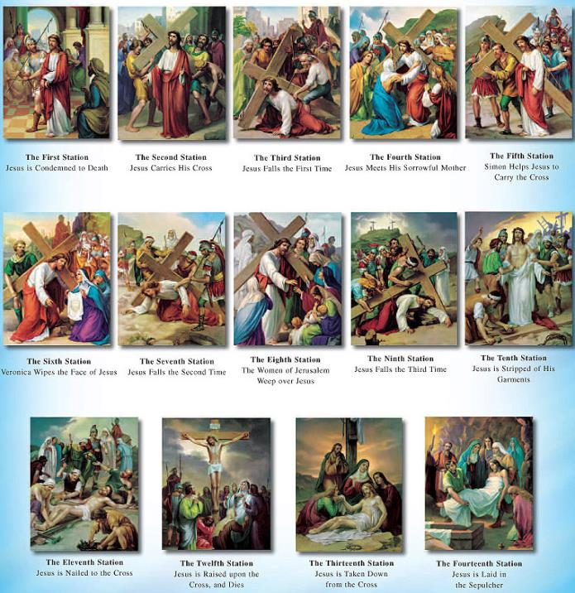](http://www.google.com.au/url?sa=i&rct=j&q=&esrc=s&source=images&cd=&cad=rja&uact=8&ved=0CAcQjRw&url=http://www.discountcatholicstore.com/catholic_posters.htm&ei=I3R2VZXZGMO9mgXCwIOQAQ&bvm=bv.95039771,d.dGY&psig=AFQjCNHjlRGMn9D3AwS3etq1BCcD0hp2Ug&ust=1433912632586983)

# Wednesday: Read Mark Chapter 15:33-47 and answer the questions:

### Jesus Dies on the Cross

*33Now when the sixth hour had come, there was darkness over the whole land until the ninth hour. 34And at the ninth hour Jesus cried out with a loud voice, saying, “Eloi, Eloi, lama sabachthani?” which is translated, “My God, My God, why have You forsaken Me?”*

*35Some of those who stood by, when they heard that, said, “Look, He is calling for Elijah!” 36Then someone ran and filled a sponge full of sour wine, put it on a reed, and offered it to Him to drink, saying, “Let Him alone; let us see if Elijah will come to take Him down.”*

*37And Jesus cried out with a loud voice, and breathed His last.*

*38Then the veil of the temple was torn in two from top to bottom. 39So when the centurion, who stood opposite Him, saw that He cried out like this and breathed His last, he said, “Truly this Man was the Son of God!”*

*40There were also women looking on from afar, among whom were Mary Magdalene, Mary the mother of James the Less and of Joses, and Salome, 41who also followed Him and ministered to Him when He was in Galilee, and many other women who came up with Him to Jerusalem.*

**Question 6**

At what hour was there “darkness over the whole land”?

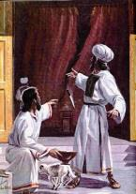

**Question 7**

What is happening in this picture? Hint Read verse 38

### Jesus Buried in Joseph’s Tomb

*42Now when evening had come, because it was the Preparation Day, that is, the day before the Sabbath, 43Joseph of Arimathea, a prominent council member, who was himself waiting for the kingdom of God, coming and taking courage, went in to Pilate and asked for the body of Jesus. 44Pilate marveled that He was already dead; and summoning the centurion, he asked him if He had been dead for some time. 45So when he found out from the centurion, he granted the body to Joseph. 46Then he bought fine linen, took Him down, and wrapped Him in the linen. And he laid Him in a tomb which had been hewn out of the rock, and rolled a stone against the door of the tomb. 47And Mary Magdalene and Mary the mother of Joses observed where He was laid.*

**Question 8**

Who took away, prepared and laid Jesus’ body in a tomb?

**DID YOU KNOW?**

*It would usually take a long time for people who were crucified to die so it was common that the soldiers would break the legs of those who were crucified so that they would die quicker.*

*Jesus however died quickly and therefore his legs were not broken fulfilling the Old Testament prophecy saying that none of Jesus’ bones would be broken.*

# Thursday: Read Mark Chapter 16:1-11 and answer the questions:

### He Is Risen

*1Now when the Sabbath was past, Mary Magdalene, Mary the mother of James, and Salome bought spices, that they might come and anoint Him. 2Very early in the morning, on the first day of the week, they came to the tomb when the sun had risen. 3And they said among themselves, “Who will roll away the stone from the door of the tomb for us?” 4But when they looked up, they saw that the stone had been rolled away—for it was very large. 5And entering the tomb, they saw a young man clothed in a long white robe sitting on the right side; and they were alarmed.*

*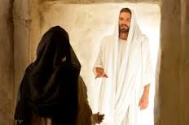6But he said to them, “Do not be alarmed. You seek Jesus of Nazareth, who was crucified. He is risen! He is not here. See the place where they laid Him. 7But go, tell His disciples—and Peter—that He is going before you into Galilee; there you will see Him, as He said to you.”*

*8So they went out quickly and fled from the tomb, for they trembled and were amazed. And they said nothing to anyone, for they were afraid.*

### Mary Magdalene Sees the Risen Lord

*9Now when He rose early on the first day of the week, He appeared first to Mary Magdalene, out of whom He had cast seven demons. 10She went and told those who had been with Him, as they mourned and wept. 11And when they heard that He was alive and had been seen by her, they did not believe.*

**Question 9**

Mary and the other women brought spices to the tomb of Jesus to anoint His Body. **TRUE/FALSE**

**Question 10**

Where did the Angel tell Mary and the others to go to meet Jesus?

# Friday: Read Mark Chapter 16:12-20 and answer the questions:

### Jesus Appears to Two Disciples

### *12After that, He appeared in another form to two of them as they walked and went into the country. 13And they went and told it to the rest, but they did not believe them either.*

### The Great Commission

*14Later He appeared to the eleven as they sat at the table; and He rebuked their unbelief and hardness of heart, because they did not believe those who had seen Him after He had risen. 15And He said to them, “Go into all the world and preach the gospel to every creature. 16He who believes and is baptized will be saved; but he who does not believe will be condemned. 17And these signs will follow those who believe: In My name they will cast out demons; they will speak with new tongues; 18they will take up serpents; and if they drink anything deadly, it will by no means hurt them; they will lay hands on the sick, and they will recover.”*

**Question 11**

What did Jesus ask them to do (hint: verse 15)

### Christ Ascends to God’s Right Hand

*19So then, after the Lord had spoken to them, He was received up into heaven, and sat down at the right hand of God. 20And they went out and preached everywhere, the Lord working with them and confirming the word through the accompanying signs. Amen.*

**Question 12**

Put the following events in order from 1 to 6 as they happened:

Jesus received up in to Heaven Disciples go preach to the world

Jesus appeared to Mary Magdalene Jesus appeared to a few disciples

Jesus sitting at the right hand of the Father Jesus appeared to all the disciples

**What to do when you finish your Bible Study.**

Send it by email to your class email address or print and hand it to your servants next Sunday.

* Year 3A St Bishoy[stbishoy3a@gmail.com](mailto:stbishoy3a@gmail.com) Class Servant: Uncle Emile (0416895236)
* Year 3B St Paul[saintpaul3b@gmail.com](mailto:saintpaul3b@gmail.com) Class Servant: Aunty Marena (0433677290)
* Year 3C St Moses [stmoses3c@gmail.com](mailto:stmoses3c@gmail.com) Class Servant: Uncle Mina (0433520175)