Sunday 4th June 2017

Name:

Class:

Due Date: Saturday 10th June 2017

Description: Description: Description: Description: Description: Description: Description: Description: http://www.timshen.truepath.com/christian/goldcrosswhite.gifCompleted Bible Study = 15 points,

Handed in by the due date = 5 points

**ACTS of the Apostles**

Year 5 – Bible Study 18 (Chapters 7 & 8)

**Monday** **5th June Read Chapter 7 verses 1 – 16**

### Stephen’s Address: The Call of Abraham

*1 Then the high priest said, “Are these things so? 2And he said, “Brethren and fathers, listen: The God of glory appeared to our father Abraham when he was in Mesopotamia, before he dwelt in Haran, 3and said to him, ‘Get out of your country and from your relatives, and come to a land that I will show you.’ 4Then he came out of the land of the Chaldeans and dwelt in Haran. And from there, when his father was dead, He moved him to this land in which you now dwell. 5And God gave him no inheritance in it, not even enough to set his foot on. But even when Abraham had no child, He promised to give it to him for a possession, and to his descendants after him. 6But God spoke in this way: that his descendants would dwell in a foreign land, and that they would bring them into bondage and oppress them four hundred years. 7‘And the nation to whom they will be in bondage I will judge,’[*[*b*](https://www.biblegateway.com/passage/?search=Acts+7&version=NKJV#fen-NKJV-27124b)*] said God, ‘and after that they shall come out and serve Me in this place.’ 8Then He gave him the covenant of circumcision; and so Abraham begot Isaac and circumcised him on the eighth day; and Isaac begot Jacob, and Jacob begot the twelve patriarchs.*

### The Patriarchs in Egypt

*9“And the patriarchs, becoming envious, sold Joseph into Egypt. But God was with him 10and delivered him out of all his troubles, and gave him favor and wisdom in the presence of Pharaoh, king of Egypt; and he made him governor over Egypt and all his house. 11Now a famine and great trouble came over all the land of Egypt and Canaan, and our fathers found no sustenance. 12But when Jacob heard that there was grain in Egypt, he sent out our fathers first. 13And the second time Joseph was made known to his brothers, and Joseph’s family became known to the Pharaoh. 14Then Joseph sent and called his father Jacob and all his relatives to him, seventy-five[*[*d*](https://www.biblegateway.com/passage/?search=Acts+7&version=NKJV#fen-NKJV-27131d)*] people. 15So Jacob went down to Egypt; and he died, he and our fathers. 16And they were carried back to Shechem and laid in the tomb that Abraham bought for a sum of money from the sons of Hamor, the father of Shechem.*

**Remember: Stephen is on trial for apparently speaking incorrect things about Moses and God!**

*In this passage Stephen is explaining to the High Priests the history of Abraham and how God was so good to Abraham even though Abraham had nothing to begin with. Stephen was telling them about Abraham trusting the Lord and moving cities after God told him to without even questioning it, and because he was a righteous and obedient man the Lord blessed him with being the leader of the nation of Israel. This blessing was sealed with the covenant (promise) of circumcision.*

1. Verse 5, “*And God gave him no inheritance in it, not even enough to set his foot on. But even when Abraham had no child, He promised to give it to him for a possession, and to his descendants after him”* means:

a) God abandoned Abraham in this new land

b) God made promises to Abraham that were not kept

c) Even when there is nothing to begin with, God will keep his promises

d) We must have descendants to please God

1. How many relatives did Joseph have come and visit him in Egypt?

a) 73

b) 174

c) 75

d) 176

**Tuesday 6th June Read Chapter 7 verses 17 – 43**

### God Delivers Israel by Moses

*17“But when the time of the promise drew near which God had sworn to Abraham, the people grew and multiplied in Egypt 18till another king arose who did not know Joseph. 19This man dealt treacherously with our people, and oppressed our forefathers, making them expose their babies, so that they might not live. 20At this time Moses was born, and was well pleasing to God; and he was brought up in his father’s house for three months. 21But when he was set out, Pharaoh’s daughter took him away and brought him up as her own son. 22And Moses was learned in all the wisdom of the Egyptians, and was mighty in words and deeds. 23“Now when he was forty years old, it came into his heart to visit his brethren, the children of Israel. 24And seeing one of them suffer wrong, he defended and avenged him who was oppressed, and struck down the Egyptian. 25For he supposed that his brethren would have understood that God would deliver them by his hand, but they did not understand. 26And the next day he appeared to two of them as they were fighting, and tried to reconcile them, saying, ‘Men, you are brethren; why do you wrong one another?’ 27But he who did his neighbor wrong pushed him away, saying, ‘Who made you a ruler and a judge over us? 28Do you want to kill me as you did the Egyptian yesterday?’ [*[*e*](https://www.biblegateway.com/passage/?search=Acts+7&version=NKJV#fen-NKJV-27145e)*] 29Then, at this saying, Moses fled and became a dweller in the land of Midian, where he had two sons. 30“And when forty years had passed, an Angel of the Lord[*[*f*](https://www.biblegateway.com/passage/?search=Acts+7&version=NKJV#fen-NKJV-27147f)*] appeared to him in a flame of fire in a bush, in the wilderness of Mount Sinai. 31When Moses saw it, he marveled at the sight; and as he drew near to observe, the voice of the Lord came to him, 32saying, ‘I am the God of your fathers—the God of Abraham, the God of Isaac, and the God of Jacob.’ [*[*g*](https://www.biblegateway.com/passage/?search=Acts+7&version=NKJV#fen-NKJV-27149g)*] And Moses trembled and dared not look. 33‘Then the Lord said to him, “Take your sandals off your feet, for the place where you stand is holy ground. 34I have surely seen the oppression of My people who are in Egypt; I have heard their groaning and have come down to deliver them. And now come, I will send you to Egypt.”’ 35“This Moses whom they rejected, saying, ‘Who made you a ruler and a judge?’ [[i](https://www.biblegateway.com/passage/?search=Acts+7&version=NKJV" \l "fen-NKJV-27152i" \o "See footnote i)] is the one God sent to be a ruler and a deliverer by the hand of the Angel who appeared to him in the bush. 36He brought them out, after he had shown wonders and signs in the land of Egypt, and in the Red Sea, and in the wilderness forty years.*

### Israel Rebels Against God

*37“This is that Moses who said to the children of Israel, ‘The Lord your God will raise up for you a* ***Prophet*** *like* ***me*** *from your brethren.* ***Him*** *you shall hear.’ 38“This is* ***he*** *who was in the congregation in the wilderness with the Angel who spoke to him on Mount Sinai, and with our* ***fathers****, the* ***one*** *who received the living oracles to give to us, 39whom our fathers would not obey, but rejected. And in their hearts they turned back to Egypt, 40saying to Aaron, ‘Make us gods to go before us; as for this Moses who brought us out of the land of Egypt, we do not know what has become of him.’ 41And they made a calf in those days, offered sacrifices to the idol, and rejoiced in the works of their own hands. 42Then God turned and gave them up to worship the host of heaven, as it is written in the book of the Prophets: ‘Did you offer Me slaughtered animals and sacrifices during forty years in the wilderness, O house of Israel? 43You also took up the tabernacle of Moloch, And the star of your god Remphan, Images which you made to worship; And I will carry you away beyond Babylon.’*

**Do you know what “star of your god Remphan” is?**

*Verses 42-43 includes the book by the prophet Amos (Old Testament). The verses that Stephen uses here are from Amos 5:25-27. These verses show how the Israelites worshipped many false gods. Remphan is one of the false gods they worshipped. Moloch and Remphan are names for the star god, Saturn (a planet in our universe).*

1. **True/ False**
2. A while after the time of Joseph the rulers of Egypt still liked the people of Israel? **True/False**
3. Moses was found by the daughter of Pharoh when he was three months old. **True/False**
4. Moses was not mighty or smart. **True/False**
5. The first time Moses visited the Israelites in Egypt he was forty years old. **True/False**
6. The first time Moses visited the Israelites he killed one of them. **True/False**
7. When Moses was eighty years old God called him to save His people. **True/False**
8. Where the Lord was, in the tree, was Holy ground. **True/False**
9. Moses obeyed the Lord and brought the Israelites out of Egypt. **True/False**
10. Identify the person(s) underlined in bold in the passage above. Use the names below to help you identify the person(s): Jesus, Israelites, Moses.

|  |  |
| --- | --- |
| **Person undelined in passage** | **Who is this person (s)?** |
| Prophet |  |
| me |  |
| Him |  |
| He |  |
| Fathers |  |
| one |  |

**Wednesday 7th June Read Chapter 7 verses 44 – 59**

### God’s True Tabernacle

*44“Our fathers had the tabernacle of witness in the wilderness, as He appointed, instructing Moses to make it according to the pattern that he had seen, 45which our fathers, having received it in turn, also brought with Joshua into the land possessed by the Gentiles, whom God drove out before the face of our fathers until the days of David, 46who found favor before God and asked to find a dwelling for the God of Jacob. 47But Solomon built Him a house.*

*48“However, the Most High does not dwell in temples made with hands, as the prophet says: 49‘Heaven is My throne,  
And earth is My footstool. What house will you build for Me? says the Lord, Or what is the place of My rest? 50Has My hand not made all these things?’*

### Israel Resists the Holy Spirit

*51“You stiff-necked and uncircumcised in heart and ears! You always resist the Holy Spirit; as your fathers did, so do you. 52Which of the prophets did your fathers not persecute? And they killed those who foretold the coming of the Just One, of whom you now have become the betrayers and murderers, 53who have received the law by the direction of angels and have not kept it.”*

### Stephen the Martyr

*54When they heard these things they were cut to the heart, and they gnashed at him with their teeth. 55But he, being full of the Holy Spirit, gazed into heaven and saw the glory of God, and Jesus standing at the right hand of God, 56and said, “Look! I see the heavens opened and the Son of Man standing at the right hand of God!”*

*57Then they cried out with a loud voice, stopped their ears, and ran at him with one accord; 58and they cast him out of the city and stoned him. And the witnesses laid down their clothes at the feet of a young man named Saul. 59And they stoned Stephen as he was calling on God and saying, “Lord Jesus, receive my spirit.” 60Then he knelt down and cried out with a loud voice, “Lord, do not charge them with this sin.” And when he had said this, he fell asleep.*

**People who do not obey**

*Today’s passage is Part 4 of Stephen’s speech. He reminded the Jews that God was bigger than any tabernacle (Temple). Stephen said some words from the book by the prophet Isaiah quoted in verses 49-50 (Isaiah 66:1-2). God is bigger than heaven and earth. He made all things. He cannot stay in one place only. Both the Law and the Tabernacle were very important to the Jews. Stephen showed that although the Law and the Tabernacle were important, God was more important.*

**Do you know why the High priests were angry with Stephen?**

*The High Priests were offended and angry with Stephen because he pointed out to them that there were many signs pointing to Jesus Christ as the true saviour, yet they murdered him. They were so enraged that they decided then and there to kill Stephen (who became the first martyr)*

1. What do you think *51“You stiff-necked and uncircumcised in heart and ears! You always resist the Holy Spirit; as your fathers did, so do you”* means*?*
2. You stubborn people, you think like pagans. And you do not hear God’s message. You are exactly like your ancestors. You always fight against the Holy Spirit!
3. You stubborn people, you think like non-believers. And you hear God’s message. You are exactly like your ancestors. You always accept the guidance of the Holy Spirit!
4. You faithful people, you think like your ancestors. And you hear God’s message. You always fight against the Holy Spirit!
5. You faithful people, you think like pagans. And you do not hear God’s message. You are not like your ancestors. You always fight against the Holy Spirit!
6. Highlight or underline the TWO things that Stephen said in the passage below that are VERY SIMILAR to what Christ said on the cross…

*“And they stoned Stephen as he was calling on God and saying, “Lord Jesus, receive my spirit.” 60Then he knelt down and cried out with a loud voice, “Lord, do not charge them with this sin.”*

**Thursday 8th June Read Chapter 8 verses 1 – 8**

### Saul Persecutes the Church

*1 Now Saul was consenting to his death. At that time a great persecution arose against the church which was at Jerusalem; and they were all scattered throughout the regions of Judea and Samaria, except the apostles. 2And devout men carried Stephen to his burial, and made great lamentation over him. 3As for Saul, he made havoc of the church, entering every house, and dragging off men and women, committing them to prison.*

### Christ Is Preached in Samaria

*4Therefore those who were scattered went everywhere preaching the word. 5Then Philip went down to the city of Samaria and preached Christ to them. 6And the multitudes with one accord heeded the things spoken by Philip, hearing and seeing the miracles which he did. 7For unclean spirits, crying with a loud voice, came out of many who were possessed; and many who were paralyzed and lame were healed. 8And there was great joy in that city.*

**Do you remember who Philip is?**

*Philip was one of the 7 helpers (Acts 6:5). The apostles had chosen them to distribute food to the poorer believers. So, then, because the helpers distributed the food, the apostles did not have to do it any longer. Therefore, the apostles had much more time to preach. Philip had worked with Stephen. The apostles had chosen them to do practical work. But God also used them to preach. Stephen had preached to the Sanhedrin. Now Philip was preaching to the people in Samaria. This was a brave thing to do.*

1. Whose death was Saul consenting (approving) to?

_______________________________________________________________________________________________________________________________________________________________________________________________________________________________________________________________________________________________________________________________________________________________

1. List the things Philip did in Samaria?

____________________________________________________________________________________________________________________________________________________________________________________________________________________________________________________________________________________________________________________________________________________________________________________________________________________________________________________________________________________

**Friday 9th June Read Chapter 8 verses 9 – 25**

### The Sorcerer’s Profession of Faith

*9But there was a certain man called Simon, who previously practiced sorcery in the city and astonished the people of Samaria, claiming that he was someone great, 10to whom they all gave heed, from the least to the greatest, saying, “This man is the great power of God.” 11And they heeded him because he had astonished them with his sorceries for a long time. 12But when they believed Philip as he preached the things concerning the kingdom of God and the name of Jesus Christ, both men and women were baptized. 13Then Simon himself also believed; and when he was baptized he continued with Philip, and was amazed, seeing the miracles and signs which were done.*

### The Sorcerer’s Sin

*14Now when the apostles who were at Jerusalem heard that Samaria had received the word of God, they sent Peter and John to them, 15who, when they had come down, prayed for them that they might receive the Holy Spirit. 16For as yet He had fallen upon none of them. They had only been baptized in the name of the Lord Jesus. 17Then they laid hands on them, and they received the Holy Spirit. 18And when Simon saw that through the laying on of the apostles’ hands the Holy Spirit was given, he offered them money, 19saying, “Give me this power also, that anyone on whom I lay hands may receive the Holy Spirit.” 20But Peter said to him, “Your money perish with you, because you thought that the gift of God could be purchased with money! 21You have neither part nor portion in this matter, for your heart is not right in the sight of God. 22Repent therefore of this your wickedness, and pray God if perhaps the thought of your heart may be forgiven you. 23For I see that you are poisoned by bitterness and bound by iniquity.” 24Then Simon answered and said, “Pray to the Lord for me, that none of the things which you have spoken may come upon me.” 25So when they had testified and preached the word of the Lord, they returned to Jerusalem, preaching the gospel in many villages of the Samaritans.*

**Do you know what sorcery is?**

*It is the use of magical powers that are obtained through evil spirits not God. Sorcery is a sin and is clearly condemned in the Bible. The common forms of sorcery used in today’s society are things like palm reading, predicting horoscope, zodiac signs. These predictions do not come from God but from evil spirits. This is why the church tells you to keep away from these practises.*

**Do you remember who Peter and John were?**

*They were both Jesus’ disciples – Peter is the one who denied Jesus when He was arrested. John was the disciple who was at the foot of the cross with Mary when Jesus was crucified.*

1. Who am I?

* I once practised sorcery
* I claimed I was someone great in Samaria
* People used to say I was the great power of God, but this was not true. I had power from the evil spirits.

I am _____________________________

1. Who am I?

* People believed me when I preached the things concerning the kingdom of God
* I preached in the name of Jesus
* People believed what I taught them about Jesus and they were baptized.
* I performed miracles using power of God
* Simon came to believe in Jesus when I taught him, and he no longer practised evil practices.

I am _____________________________

**Saturday 10th June Read Chapter 8 verses 26 – 15**

### Christ Is Preached to an Ethiopian

*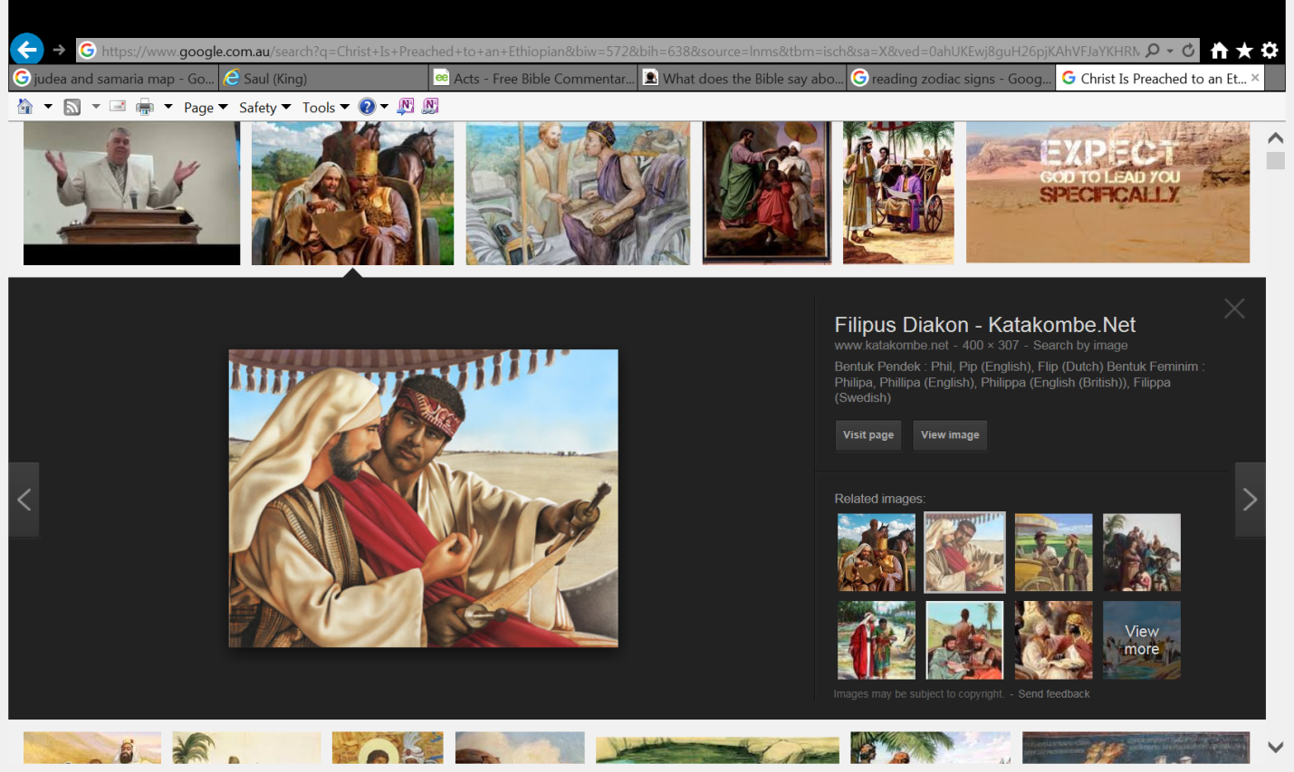26Now an angel of the Lord spoke to Philip, saying, “Arise and go toward the south along the road which goes down from Jerusalem to Gaza.” This is desert. 27So he arose and went. And behold, a man of Ethiopia, a eunuch of great authority under Candace the queen of the Ethiopians, who had charge of all her treasury, and had come to Jerusalem to worship, 28was returning. And sitting in his chariot, he was reading Isaiah the prophet. 29Then the Spirit said to Philip, “Go near and overtake this chariot.” 30So Philip ran to him, and heard him reading the prophet Isaiah, and said, “Do you understand what you are reading?” 31And he said, “How can I, unless someone guides me?” And he asked Philip to come up and sit with him. 32The place in the Scripture which he read was this: “He was led as a sheep to the slaughter; And as a lamb before its shearer is silent, So He opened not His mouth. 33In His humiliation His justice was taken away, And who will declare His generation? For His life is taken from the earth.”*

**Phillip baptizes the Ethiopian**

*34So the eunuch answered Philip and said, “I ask you, of whom does the prophet say this, of himself or of some other man?” 35Then Philip opened his mouth, and beginning at this Scripture, preached Jesus to him. 36Now as they went down the road, they came to some water. And the eunuch said, “See, here is water. What hinders me from being baptized?” 37Then Philip said, “If you believe with all your heart, you may.” And he answered and said, “I believe that Jesus Christ is the Son of God.” 38So he commanded the chariot to stand still. And both Philip and the eunuch went down into the water, and he baptized him. 39Now when they came up out of the water, the Spirit of the Lord caught Philip away, so that the eunuch saw him no more; and he went on his way rejoicing. 40But Philip was found at Azotus. And passing through, he preached in all the cities till he came to Caesarea.*

1. 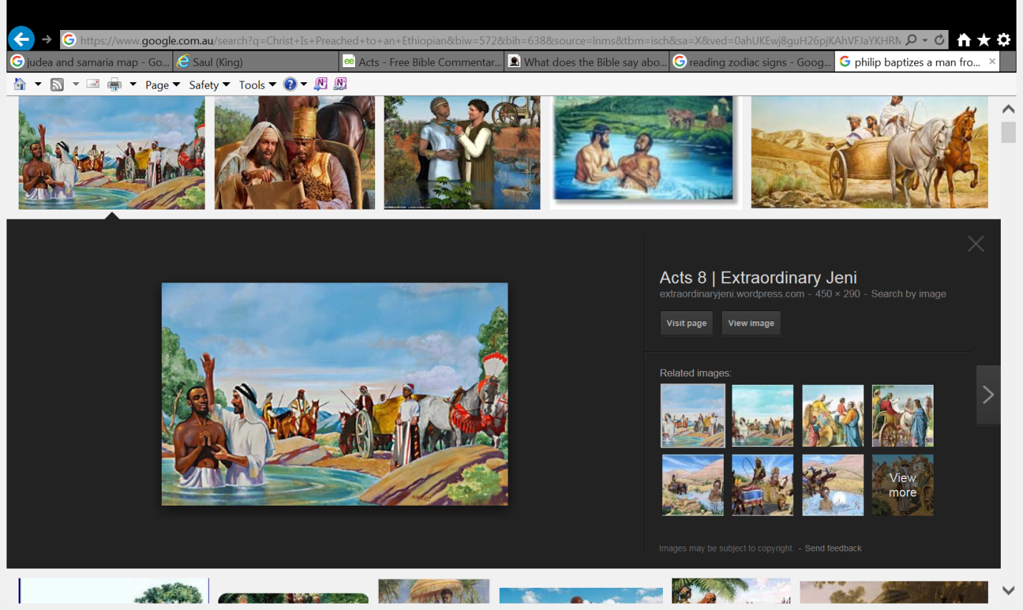The Ethipian was reading the prophecy of the Messiah when Philip met him. Why do you think that God planned for Philip to meet him at this time?
2. So Philip and the Ethiopian could read the Bible together
3. So that the Ethipian could explain to Philip what the prohecy meant.
4. So that they have a converstaion piece so they can be friends.
5. This was an opportunity for Philip to talk about Jesus.
6. Describe the miracle that happened after the eunuch was baptized?

____________________________________________________________________________________________________________________________________________________________________________________________________________________________________________________________________________________________________________________________________________________________________________________________________________________________________________________________________________________

**PARENTS SECTION:**

We kindly ask you as a parent to read (a little each day) in the Holy Bible with your family.

**Now email your answers to your teacher, choose ONE of the email addresses below.**

**What to do when you finish your Bible Study.**

Send it by email to your class email address or print and hand it to your servants next Sunday.

* Year 5B1 St Thomas[stthomas5b@gmail.com](mailto:stthomas5b@gmail.com) Class Servant- Uncle Andrew

(0416744100)

* Year 5B2 St Philip[saintphilip5g@gmail.com](mailto:saintphilip5g@gmail.com) Class Servant- Uncle Mark

(0413495921)

* Year 5G St Matthew [stmatthew5g@gmail.com](mailto:stmatthew5g@gmail.com) Class Servant – Aunty Dina

(0404604507)