C:\Documents and Settings\suzy\Local Settings\Temporary Internet Files\Content.IE5\3JXW24R5\MC900383922[1].wmfSunday 21st May, 2017

Name:

Class:

Finish Date: Saturday 27th May, 2017

Completed Bible Study = 15 points

Email Homework by due date = 5 extra points

**Year 4 Bible Study Luke Chapter 22**

**For the questions below Highlight or change the font colour to choose the correct answer.**

* Monday 22nd May: Read **Luke 22: 1-13** and answer the questions:

### The Plot to Kill Jesus

*1Now the Feast of Unleavened Bread drew near, which is called Passover. 2And the chief priests and the scribes sought how they might kill Him, for they feared the people.*

*3Then Satan entered Judas, surnamed Iscariot, who was numbered among the twelve. 4So he went his way and conferred with the chief priests and captains, how he might betray Him to them. 5And they were glad, and agreed to give him money. 6So he promised and sought opportunity to betray Him to them in the absence of the multitude.*

### Jesus and His Disciples Prepare the Passover

*7Then came the Day of Unleavened Bread, when the Passover must be killed. 8And He sent Peter and John, saying, “Go and prepare the Passover for us, that we may eat.”*

*9So they said to Him, “Where do You want us to prepare?”*

*10And He said to them, “Behold, when you have entered the city, a man will meet you carrying a pitcher of water; follow him into the house which he enters. 11Then you shall say to the master of the house, ‘The Teacher says to you, “Where is the guest room where I may eat the Passover with My disciples?”’ 12Then he will show you a large, furnished upper room; there make ready.”*

*13So they went and found it just as He had said to them, and they prepared the Passover.*

**Question 1**

Which two of the disciples did Jesus send to prepare the Passover?

1. Matthew and Paul
2. James and John
3. Peter and John
4. Matthew and Bartholomew

* Tuesday 24th May: Read **Luke 22: 14-30** and answer the questions:

### Jesus Institutes the Lord’s Supper

*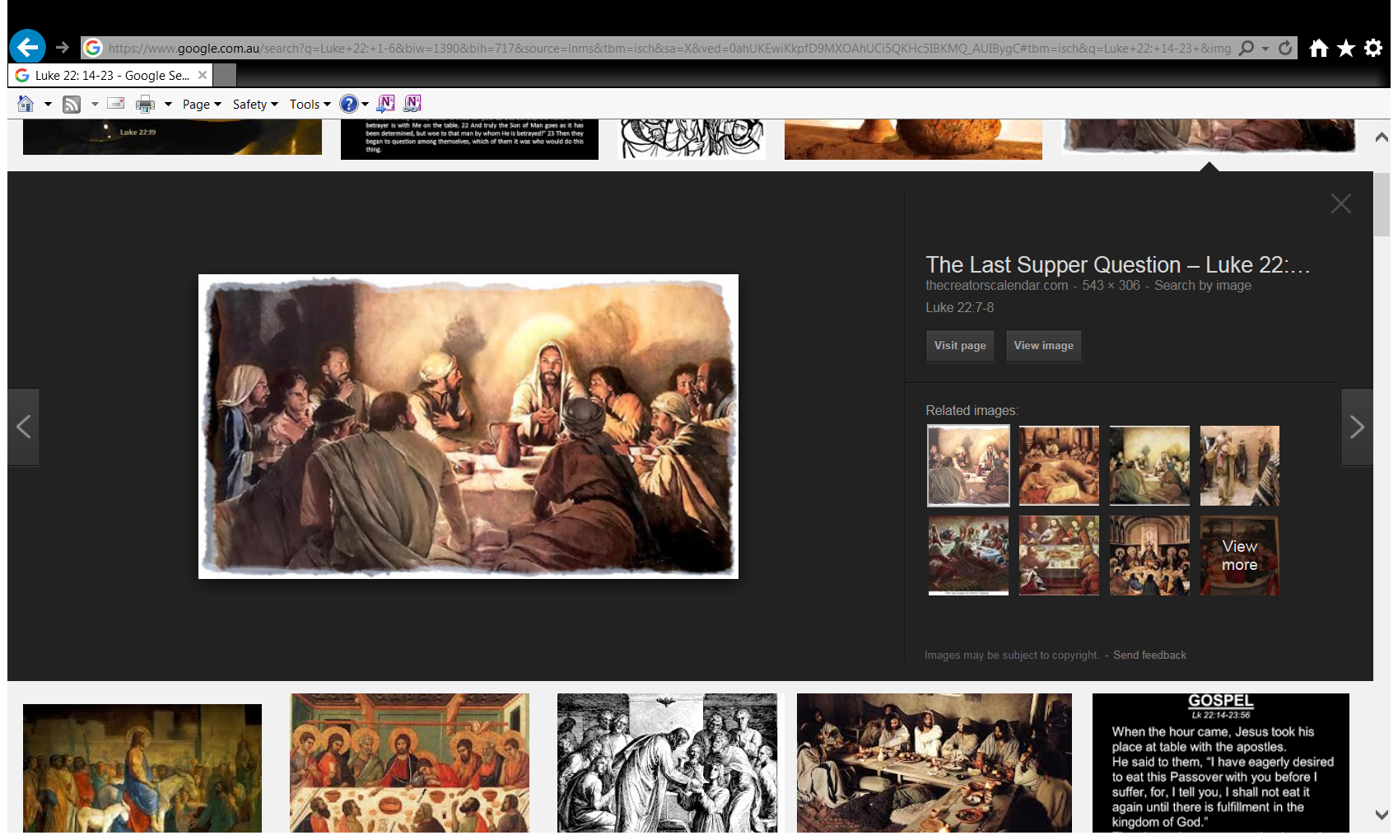14When the hour had come, He sat down, and the twelveapostles with Him. 15Then He said to them, “With fervent desire I have desired to eat this Passover with you before I suffer; 16for I say to you, I will no longer eat of it until it is fulfilled in the kingdom of God.”*

*17Then He took the cup, and gave thanks, and said, “Take this and divide it among yourselves; 18for I say to you, I will not drink of the fruit of the vine until the kingdom of God comes.”*

*19And He took bread, gave thanks and broke it, and gave it to them, saying, “This is My body which is given for you; do this in remembrance of Me.”*

*20Likewise He also took the cup after supper, saying, “This cup is the new covenant in My blood, which is shed for you. 21But behold, the hand of My betrayer is with Me on the table. 22And truly the Son of Man goes as it has been determined, but woe to that man by whom He is betrayed!”*

*23Then they began to question among themselves, which of them it was who would do this thing.*

**Question 2**

Sequence the events listed below in the correct order of when they happened. Number them 1 to 5.

|  |  |
| --- | --- |
| **Event** | **Number** |
| He gave thanks |  |
| He took the bread |  |
| He broke the bread and gave it to the disciples |  |
| He gave the blood to the disciples |  |
| He took the cup and gave thanks |  |

### The Disciples Argue About Greatness

*24Now there was also a dispute among them, as to which of them should be considered the greatest. 25And He said to them, “The kings of the Gentiles exercise lordship over them, and those who exercise authority over them are called ‘benefactors.’ 26But not so among you; on the contrary, he who is greatest among you, let him be as the younger, and he who governs as he who serves. 27For who is greater, he who sits at the table, or he who serves? Is it not he who sits at the table? Yet I am among you as the One who serves.*

*28“But you are those who have continued with Me in My trials. 29And I bestow upon you a kingdom, just as My Father bestowed one upon Me, 30that you may eat and drink at My table in My kingdom, and sit on thrones judging the twelve tribes of Israel.”*

**Question 3**

Match the statement with the verse. The first has been done for you.

|  |  |  |
| --- | --- | --- |
| **Statement** |  | **Verse** |
| **A.** But you should not behave like that. Rather, the most important one among you must be like the least important. The leader must be like the servant. | **C** | **24** |
| **B** Who is more important? The person who eats at the table or the person who serves him? The person who eats at the table is more important. But I am like the servant. |  | **25** |
| **C** The apostles began to argue among themselves. They wondered which one of them was the most important person |  | **26** |
| **D** My Father has given me the right to rule. So, I will give you the same right. |  | **27** |
| **E** Jesus said to them, ‘The kings of the Gentiles have power over their people. The rulers tell their people to call them “Friends of the People”. |  | **28** |
| **F** You will eat and drink at my table in my kingdom. You will sit on royal seats, and rule over the 12 tribes of Israel’. |  | **29** |
| **G** You have remained loyal to me through all my difficulties. |  | **30** |

* Wednesday 25th May: **Luke 22: 31-38** and answer the questions:

### Jesus Predicts Peter’s Denial

*31And the Lord said, “Simon, Simon! Indeed, Satan has asked for you, that he may sift you as wheat. 32But I have prayed for you, that your faith should not fail; and when you have returned to Me, strengthen your brethren.”*

*33But he said to Him, “Lord, I am ready to go with You, both to prison and to death.”*

*34Then He said, “I tell you, Peter, the rooster shall not crow this day before you will deny three times that you know Me.”*

**Question 4**

Why does the Lord tell Simon Peter that Satan has asked for him?

1. Because Jesus and Satan spoke all the time
2. Because Jesus knew that Peter would betray Him
3. Jesus wanted to warn Peter of what was to come and reassure him that he would repent and return to strengthen the other disciples
4. B and C

### Supplies for the Road

*35And He said to them, “When I sent you without money bag, knapsack, and sandals, did you lack anything?”*

*So they said, “Nothing.”*

*36Then He said to them, “But now, he who has a money bag, let him take it, and likewise a knapsack; and he who has no sword, let him sell his garment and buy one. 37For I say to you that this which is written must still be accomplished in Me: ‘And He was numbered with the transgressors.’ For the things concerning Me have an end.”*

*38So they said, “Lord, look, here are two swords.”*

*And He said to them, “It is enough.”*

**Question 5a**

What were the disciples lacking when He sent them out on their ministry?

**Question 5b**

Now Jesus is saying that the disciples need to be prepared for what was to happen next, as though it was a new calling for them. What was He referring to?

1. His coming Death
2. His Ascension
3. His Resurrection
4. His last Supper

* Thursday 26th May: Read **Luke 22: 39-53** and answer the questions:

### The Prayer in the Garden

*39Coming out, He went to the Mount of Olives, as He was accustomed, and His disciples also followed Him. 40When He came to the place, He said to them, “Pray that you may not enter into temptation.”*

*41And He was withdrawn from them about a stone’s throw, and He knelt down and prayed, 42saying, “Father, if it is Your will, take this cup away from Me; nevertheless not My will, but Yours, be done.” 43Then an angel appeared to Him from heaven, strengthening Him. 44And being in agony, He prayed more earnestly. Then His sweat became like great drops of blood falling down to the ground.*

*45When He rose up from prayer, and had come to His disciples, He found them sleeping from sorrow. 46Then He said to them, “Why do you sleep? Rise and pray, lest you enter into temptation.”*

**Question 6**

In today’s passage we read the prayer that Christ prayed to His Father just before He was about to endure His passion – the crucifixion. Let us take a close look at our Lord’s Prayer so that we can learn also how to pray. Move each prayer lesson into the correct space in the table below.

|  |  |
| --- | --- |
| **HOW AND WHAT CHRIST PRAYED** | **WHAT WE LEARN ABOUT PRAYER** |
| *And He was withdrawn from them about a stone’s throw,* |  |
| *He knelt down and prayed* |  |
| *take this cup away from Me* |  |
| *nevertheless not My will, but Yours, be done* |  |
| *being in agony, He prayed more earnestly* |  |
| *Rise and pray, lest you enter into temptation* |  |

**Prayer lessons:**

We should pray, even when we find it hard.

In prayer we make our requests known to God.

When we pray we are protected from temptations.

In prayer our bodies should be reverent towards God when we pray

We should pray in a private and quiet place.

In prayer we ask that God’s will be done, before our own.

**Question 2**

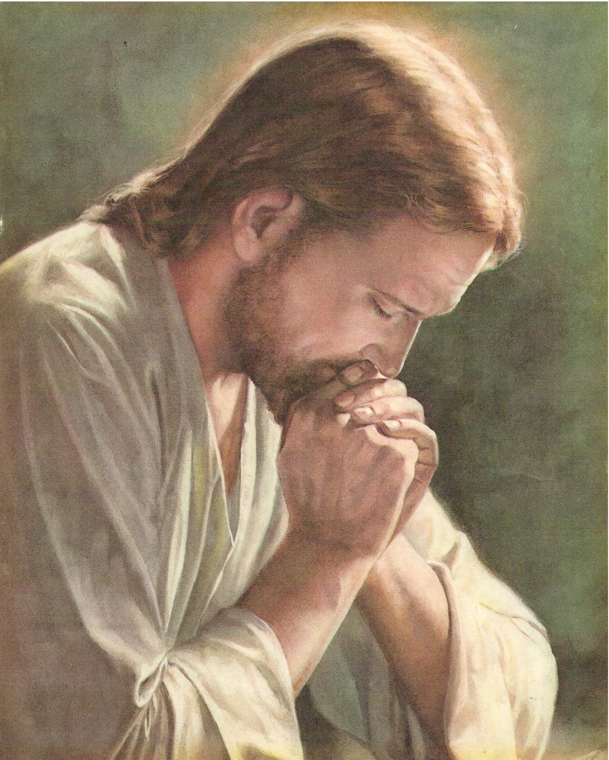

It is important for us to remember to pray like Christ prayed. To help you remember create a poster to put in your room (even if it is just on a normal sized paper) with the 6 points that we have learned from question 1, about prayer. Put it up in your room and make sure each morning and night when you pray, that you pray as Christ prayed.

### Betrayal and Arrest in Gethsemane

*47And while He was still speaking, behold, a multitude; and he who was called Judas, one of the twelve, went before them and drew near to Jesus to kiss Him. 48But Jesus said to him, “Judas, are you betraying the Son of Man with a kiss?”*

*49When those around Him saw what was going to happen, they said to Him, “Lord, shall we strike with the sword?” 50And one of them struck the servant of the high priest and cut off his right ear.*

*51But Jesus answered and said, “Permit even this.” And He touched his ear and healed him.*

*52Then Jesus said to the chief priests, captains of the temple, and the elders who had come to Him, “Have you come out, as against a robber, with swords and clubs? 53When I was with you daily in the temple, you did not try to seize Me. But this is your hour, and the power of darkness.”*

**Question 7**

At the time of Christ’s passion there were many different people who betrayed and disappointed Christ in His hour of need. In the table below identify who each person/group were and explain why this would have hurt Christ. (pto)

|  |  |  |
| --- | --- | --- |
| **EVENT** | **PERSON/PEOPLE**  *(choose 1,2,or 3 from the table below)* | **WHY THIS HURT CHRIST**  *(Choose A, B, or C from the table below)* |
| *one of the twelve, went before them and drew near to Jesus to kiss Him* |  |  |
| *And one of them struck the servant of the high priest and cut off his right ear.* |  |  |
| *“Have you come out, as against a robber, with swords and clubs?* |  |  |

|  |  |
| --- | --- |
| **PERSON/PEOPLE** | **WHY THIS HURT CHRIST** |
| 1. ST. PETER | 1. He was one of Christ’s close friends and he betrayed him to the Jews. |
| 1. CHIEF PRIESTS AND CAPTAINS OF THE TEMPLE | 1. Because Christ came to teach us to be peaceful, even when others do the wrong thing. |
| 1. JUDAS | 1. Because the Jews were the people who Christ came for and who listened to Him teach in the temple. |

* Friday 27th May : Read **Luke 22: 54-64** and answer the questions:

### Peter Denies Jesus, and Weeps Bitterly

*54Having arrested Him, they led Him and brought Him into the high priest’s house. But Peter followed at a distance. 55Now when they had kindled a fire in the midst of the courtyard and sat down together, Peter sat among them. 56And a certain servant girl, seeing him as he sat by the fire, looked intently at him and said, “This man was also with Him.”*

*57But he denied Him, saying, “Woman, I do not know Him.”*

*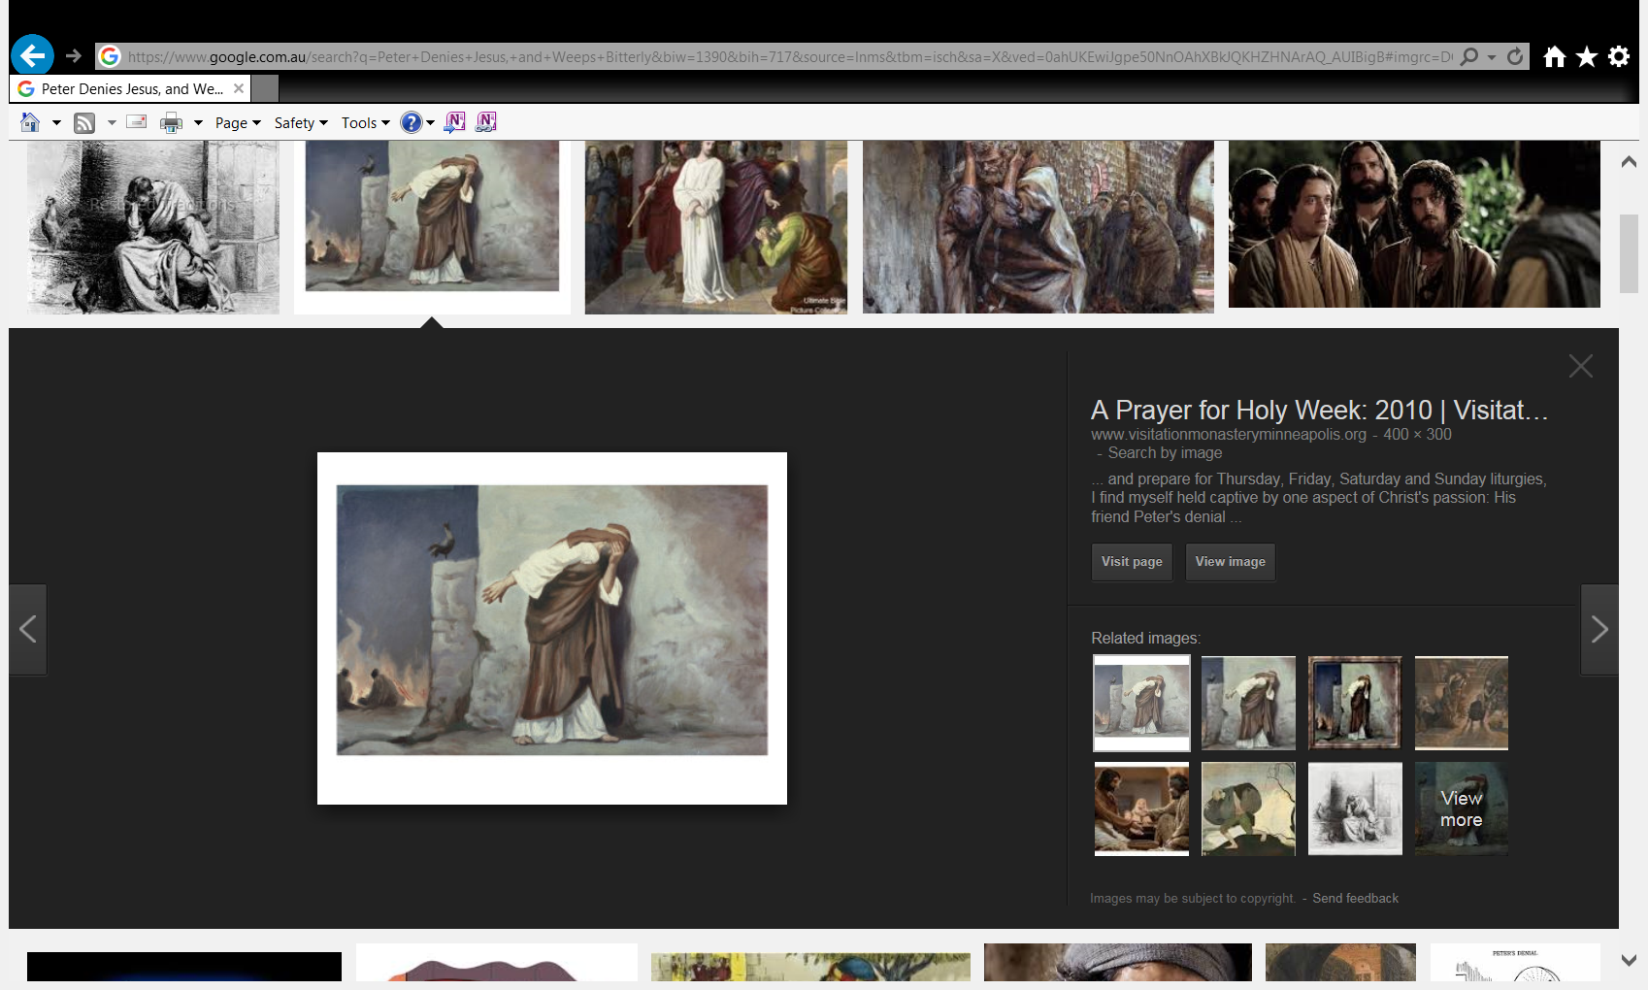58And after a little while another saw him and said, “You also are of them.”*

*But Peter said, “Man, I am not!”*

*59Then after about an hour had passed, another confidently affirmed, saying, “Surely this fellow also was with Him, for he is a Galilean.”*

*60But Peter said, “Man, I do not know what you are saying!”*

*Immediately, while he was still speaking, the rooster crowed. 61And the Lord turned and looked at Peter. Then Peter remembered the word of the Lord, how He had said to him, “Before the rooster crows, you will deny Me three times.” 62So Peter went out and wept bitterly.*

**Question 8a**

How many times did St Peter deny Christ?

**Question 8b**

What happened after St Peter denied Jesus the last time?

**Question 8c**

After St. Peter remembered that Christ warned him that he would Deny Jesus, He wept bitterly. St. Peter wept because he…

1. Was embarrassed that he was the only one who denied Christ.
2. Was sorry and repentant.
3. Was scared that the soldiers would find him and crucify him also.
4. Was scared that one day Christ would deny him.

**Question 9**

Open your Bible to Luke Chapter 22 Verses 63-64.

1. What did the men who arrested Jesus do to Him?
2. What did they ask Jesus to do?

* Saturday 28th May: **Luke 22:65-71**

**Question 10:**

Look up Verse Luke 22:65.

1. What sin did the men who arrested Jesus commit?
2. What sin against the Holy Spirit will not be forgiven?

(HINT: Look up Matthew 12:30-32 to help you answer this question.)

1. Blasphemy against the Holy Spirit does **NOT** mean:
2. Insults the Holy spirit
3. Disrespects the Holy Spirit
4. Ignores the Holy Spirit
5. Equal with God

### Jesus Faces the Sanhedrin

*66As soon as it was day, the elders of the people, both chief priests and scribes, came together and led Him into their council, saying, 67“If You are the Christ, tell us.”*

*But He said to them, “If I tell you, you will by no means believe. 68And if I also ask you, you will by no means answer Me or let Me go. [*[*j*](https://www.biblegateway.com/passage/?search=Luke+22&version=NKJV#fen-NKJV-25933j)*] 69Hereafter the Son of Man will sit on the right hand of the power of God.”*

*70Then they all said, “Are You then the Son of God?”*

*So He said to them, “You rightly say that I am.”*

*71And they said, “What further testimony do we need? For we have heard it ourselves from His own mouth.”*

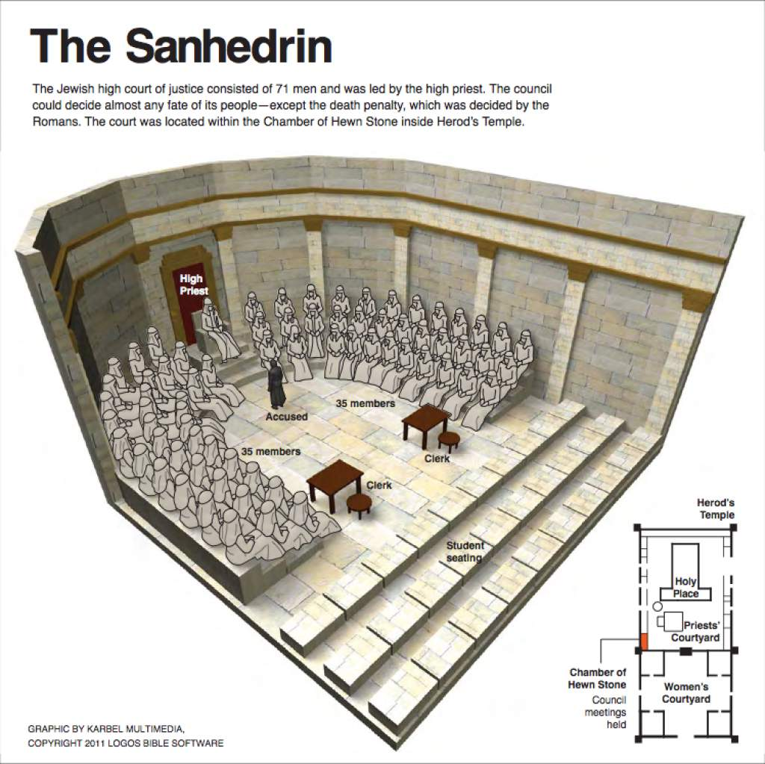**Question 11a**

What was the Sanhedrin?

1. All of the Jewish Priests.
2. The Roman legal council – made up of Pontius Pilate and his officials.
3. The Jewish legal council – made up of the Chief priests and scribes.
4. The elders of the Temple.

**Question 11b**

What was the role of the Sanhedrin?

1. To make the final judgements on the Jewish law (like the Supreme courts)
2. To explain the Jewish laws.
3. To make final judgements on disputes among Jewish people.
4. All of the above.

**Question 12**

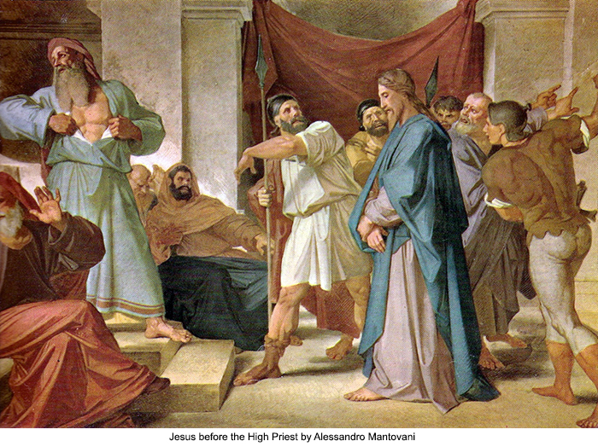When Jesus answered, before the Sanhedrin, that He was the Son of God, what sin did they believe Jesus was guilty of?

1. Blasphemy
2. Pride
3. Bearing false witness
4. Treason

* **What to do when you finish your Bible Study.**

**Send it by email to your class email address or print and hand it to your servants next Sunday.**

**• Year 4A St Makarious StMakarios4A@gmail.com Class Servant- Aunty Labiba (0421891567)**

**• Year 4B St Bakhomious StBakhomios4B@gmail.com Class Servant- Aunty Mira (0415595556)**

**• Year 4C St Anthony StAnthony4C@gmail.com Class Servant- Aunty Olivia**