Sunday 21st May 2017

Name:

Class:

Due Date: Saturday 27th May 2017

Description: Description: Description: Description: Description: Description: Description: Description: http://www.timshen.truepath.com/christian/goldcrosswhite.gifCompleted Bible Study = 15 points,

Handed in by the due date = 5 points

**ACTS of the Apostles**

Year 5 – Bible Study 16 (Chapters 3 & 4)

**Monday** **22nd May Read Chapter 3 verses 1 – 10**

**Peter and John have compassion for a man born lame**

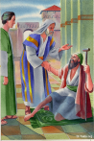*1 Now Peter and John went up together to the temple at the hour of prayer, the ninth hour. 2And a certain man lame from his mother’s womb was carried, whom they laid daily at the gate of the temple which is called Beautiful, to ask alms from those who entered the temple; 3who, seeing Peter and John about to go into the temple, asked for alms. 4And fixing his eyes on him, with John, Peter said, “Look at us.” 5So he gave them his attention, expecting to receive something from them. 6Then Peter said, “Silver and gold I do not have, but what I do have I give you: In the name of Jesus Christ of Nazareth, rise up and walk.”*

### A Lame Man Healed

*7And he took him by the right hand and lifted him up, and immediately his feet and ankle bones received strength. 8So he, leaping up, stood and walked and entered the temple with them—walking, leaping, and praising God. 9And all the people saw him walking and praising God. 10Then they knew that it was he who sat begging alms at the Beautiful Gate of the temple; and they were filled with wonder and amazement at what had happened to him.*

1. Select True or False for the following statements:
2. Peter and John went to the temple at 9am. TRUE / FALSE
3. The gate of the temple was called Beautiful. TRUE / FALSE
4. The lame man was asking for someone’s arm to help him stand up. TRUE / FALSE
5. Peter was able to heal the man in the name of Jesus Christ. TRUE / FALSE



1. Did Peter have to use Christ’s name to perform the miracle? YES / NO Explain your answer in the box below.

**Tuesday 23rd May Read Chapter 3 verses 11 – 18**

### Preaching in Solomon’s Portico

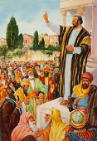*11Now as the lame man who was healed held on to Peter and John, all the people ran together to them in the porch which is called Solomon’s, greatly amazed. 12So when Peter saw it, he responded to the people: “Men of Israel, why do you marvel at this? Or why look so intently at us, as though by our own power or godliness we had made this man walk?*

**Faith heals lame man**

*13The God of Abraham, Isaac, and Jacob, the God of our fathers, glorified His Servant Jesus, whom you delivered up and denied in the presence of Pilate, when he was determined to let Him go. 14But you denied the Holy One and the Just, and asked for a murderer to be granted to you, 15and killed the Prince of life, whom God raised from the dead, of which we are witnesses. 16And His name, through faith in His name, has made this man strong, whom you see and know. Yes, the faith which comes through Him has given him this perfect soundness in the presence of you all.**17“Yet now, brethren, I know that you did it in ignorance, as did also your rulers. 18But those things which God foretold by the mouth of all His prophets, that the Christ would suffer, He has thus fulfilled.*

1. Match the words below with their meaning. lame, porch, marvel, intently, Godliness.

|  |  |
| --- | --- |
| **Word** | **Meaning** |
|  | a covered shelter projecting in front of the entrance of a building |
|  | being holy or pure |
|  | to focus strongly on something |
|  | not being able to walk without difficulty because of an injury or illness in the leg or foot |
|  | to be filled with wonder or astonishment |

1. What did the non believing Jews do out of ignorance?

**Wednesday 24th May Read Chapter 3 verses 19 – 26**

**Peter urges non believing Jews to repent**

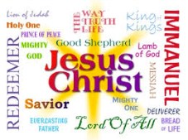*19Repent therefore and be converted, that your sins may be blotted out, so that times of refreshing may come from the presence of the Lord, 20and that He may send Jesus Christ, who was preached to you before, 21whom heaven must receive until the times of restoration of all things, which God has spoken by the mouth of all His holy prophets since the world began. 22For Moses truly said to the fathers, ‘The Lord your God will raise up for you a Prophet like me from your brethren. Him you shall hear in all things, whatever He says to you. 23And it shall be that every soul who will not hear that Prophet shall be utterly destroyed from among the people.’ 24Yes, and all the prophets, from Samuel and those who follow, as many as have spoken, have also foretoldthese days. 25You are sons of the prophets, and of the covenant which God made with our fathers, saying to Abraham, ‘And in your seed all the families of the earth shall be blessed.’ 26To you first, God, having raised up His Servant Jesus, sent Him to bless you, in turning away every one of you from your iniquities.”*

1. Peter’s main message to the Jews was to repent. Despite all they did to Jesus, Peter was trying to explain to them that God would always forgive them if they repent and ask for forgiveness. Repentance and confession are part of the 7 sacraments of the church. Can you list the other 6 sacraments below?



B

Repentance and confession

H

R

M

P

Unction of the s

**Thursday 25th May Read Chapter 2 verses 1 – 12**

### Peter and John Arrested

*1Now as they spoke to the people, the priests, the captain of the temple, and the Sadducees came upon them, 2being greatly disturbed that they taught the people and preached in Jesus the resurrection from the dead. 3And they laid hands on them, and put them in custody until the next day, for it was already evening. 4However, many of those who heard the word believed; and the number of the men came to be about five thousand.*

### Addressing the Sanhedrin

*5And it came to pass, on the next day, that their rulers, elders, and scribes, 6as well as Annas the high priest, Caiaphas, John, and Alexander, and as many as were of the family of the high priest, were gathered together at Jerusalem. 7And when they had set them in the midst, they asked, “By what power or by what name have you done this?” 8Then Peter, filled with the Holy Spirit, said to them, “Rulers of the people and elders of Israel: 9If we this day are judged for a good deed done to a helpless man, by what means he has been made well, 10let it be known to you all, and to all the people of Israel, that by the name of Jesus Christ of Nazareth, whom you crucified, whom God raised from the dead, by Him this man stands here before you whole. 11This is the ‘stone which was rejected by you builders, which has become the chief cornerstone.’ 12Nor is there salvation in any other, for there is no other name under heaven given among men by which we must be saved.”*

1. Who came “upon” St. Peter and St. John, to arrest them? ­­____________________________
2. St. Peter and St. John were being tried by the Sanhedrin. Where did this gathering take place? ____________________________

**Friday 26th May Read Chapter 16 verses 13 – 222**

### The Name of Jesus Forbidden

*13Now when they saw the boldness of Peter and John, and perceived that they were uneducated and untrained men, they marveled. And they realized that they had been with Jesus. 14And seeing the man who had been healed standing with them, they could say nothing against it. 15But when they had commanded them to go aside out of the council, they conferred among themselves, 16saying, “What shall we do to these men? For, indeed, that a notable miracle has been done through them is evident to all who dwell in Jerusalem, and we cannot deny it. 17But so that it spreads no further among the people, let us severely threaten them, that from now on they speak to no man in this name.” 18So they called them and commanded them not to speak at all nor teach in the name of Jesus. 19But Peter and John answered and said to them, “Whether it is right in the sight of God to listen to you more than to God, you judge. 20For we cannot but speak the things which we have seen and heard.” 21So when they had further threatened them, they let them go, finding no way of punishing them, because of the people, since they all glorified God for what had been done. 22For the man was over forty years old on whom this miracle of healing had been performed.*

1. The Sanhedrin marvelled because although St. Peter and St. John were uneducated and untrained, they were able to speak well before them, and they also preached to masses of people. What lesson can we learn from this?
2. That our education is not important.
3. That it is through our weakness that God can shine His strength.
4. That in order to preach we need to be unprepared.
5. That Jesus only asks the uneducated to serve Him.
6. What was St. Peter and St. John’s response when they were commanded to not speak in the Name of Jesus? ____________________________________________________________________________________

***Read the following verses and take a moment to contemplate on the power of the Name of Jesus. Then your challenge and blessing this week will be to exercise the power of the Lord’s Name in your life.***

### Therefore God has highly exalted him and bestowed on him the name that is above every name, so that at the name of Jesus every knee should bow, in heaven and on earth and under the earth, and every tongue confess that Jesus Christ is Lord, to the glory of God the Father. [*Philippians 2:9-11*](https://www.biblegateway.com/passage/?search=Philippians+2%3A9-11&version=ESV)

### 

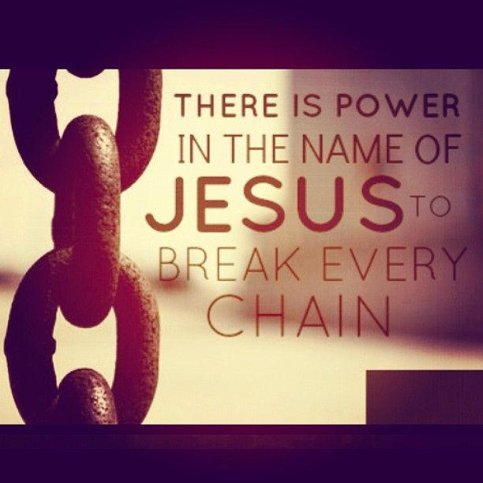

### Whatever you ask in my name, this I will do, that the Father may be glorified in the Son. [*John 14:13*](https://www.biblegateway.com/passage/?search=John+14%3A13&version=ESV)

### While you stretch out your hand to heal, and signs and wonders are performed through the name of your holy servant Jesus.” [*Acts 4:30*](https://www.biblegateway.com/passage/?search=Acts+4%3A30&version=ESV)

### For “everyone who calls on the name of the Lord will be saved.” [*Romans 10:13*](https://www.biblegateway.com/passage/?search=Romans+10%3A13&version=ESV)

There is none like you, O Lord; you are great, and **your name is great in might**. [*Jeremiah 10:6*](https://www.biblegateway.com/passage/?search=Jeremiah+10%3A6&version=ESV)

**Saturday 27th May Read Chapter 2 verses 29 – 47**

### Prayer for Boldness

*23And being let go, they went to their own companions and reported all that the chief priests and elders had said to them. 24So when they heard that, they raised their voice to God with one accord and said: “Lord, You are God, who made heaven and earth and the sea, and all that is in them, 25who by the mouth of Your servant David have said: ‘Why did the nations rage, And the people plot vain things? 26The kings of the earth took their stand, And the rulers were gathered together Against the Lord and against His Christ.’ 27“For truly against Your holy Servant Jesus, whom You anointed, both Herod and Pontius Pilate, with the Gentiles and the people of Israel, were gathered together 28to do whatever Your hand and Your purpose determined before to be done. 29Now, Lord, look on their threats, and grant to Your servants that with all boldness they may speak Your word, 30by stretching out Your hand to heal, and that signs and wonders may be done through the name of Your holy Servant Jesus.” 31And when they had prayed, the place where they were assembled together was shaken; and they were all filled with the Holy Spirit, and they spoke the word of God with boldness.*

### Sharing in All Things

*32Now the multitude of those who believed were of one heart and one soul; neither did anyone say that any of the things he possessed was his own, but they had all things in common. 33And with great power the apostles gave witness to the resurrection of the Lord Jesus. And great grace was upon them all. 34Nor was there anyone among them who lacked; for all who were possessors of lands or houses sold them, and brought the proceeds of the things that were sold, 35and laid them at the apostles’ feet; and they distributed to each as anyone had need. 36And Joses, who was also named Barnabas by the apostles (which is translated Son of Encouragement), a Levite of the country of Cyprus, 37having land, sold it, and brought the money and laid it at the apostles’ feet.*

1. Which psalm did the apostles quote in their prayer for boldness (verses 25-26)?

Hint: You may need to look up Psalms 1 and 2 to help you find the answer to this question.

1. Psalm 1
2. Psalm 2
3. What does Joses mean? ________________________________________________________

**PARENTS SECTION:**

We kindly ask you as a parent to read (a little each day) in the Holy Bible with your family.

**Now email your answers to your teacher, choose ONE of the email addresses below.**

**What to do when you finish your Bible Study.**

Send it by email to your class email address or print and hand it to your servants next Sunday.

* Year 5B1 St Thomas[stthomas5b@gmail.com](mailto:stthomas5b@gmail.com) Class Servant- Uncle Andrew

(0416744100)

* Year 5B2 St Philip[saintphilip5g@gmail.com](mailto:saintphilip5g@gmail.com) Class Servant- Uncle Mark

(0413495921)

* Year 5G St Matthew [stmatthew5g@gmail.com](mailto:stmatthew5g@gmail.com) Class Servant – Aunty Dina

(0404604507)