C:\Documents and Settings\suzy\Local Settings\Temporary Internet Files\Content.IE5\3JXW24R5\MC900383922[1].wmfSunday 14th May 2017

Name:

Class:

Finish Date: Saturday 20th May, 2017

Completed Bible Study = 15 points

Email Homework by the due date = 5 points

**Year 4 Bible Study Luke Chapter 20 & 21**

**For the questions below Highlight or change the font colour to choose the correct answer.**

* Monday 15th May :Read **Luke 20: 1-19** and answer the questions:

### Jesus’ Authority Questioned

*1 Now it happened on one of those days, as He taught the people in the temple and preached the gospel, that the chief priests and the scribes, together with the elders, confronted Him 2and spoke to Him, saying, “Tell us, by what authority are You doing these things? Or who is he who gave You this authority?”*

*3But He answered and said to them, “I also will ask you one thing, and answer Me: 4The baptism of John—was it from heaven or from men?”*

*5And they reasoned among themselves, saying, “If we say, ‘From heaven,’ He will say, ‘Why then did you not believe him?’ 6But if we say, ‘From men,’ all the people will stone us, for they are persuaded that John was a prophet.” 7So they answered that they did not know where it was from.*

*8And Jesus said to them, “Neither will I tell you by what authority I do these things.”*

**Question 1**

The chief priests and scribes always wanted to find something wrong with what Jesus said or did. In the passage above, they questioned His authority (which means His power). We know Jesus is powerful. Look at the image below and explain how it shows Jesus’ power.

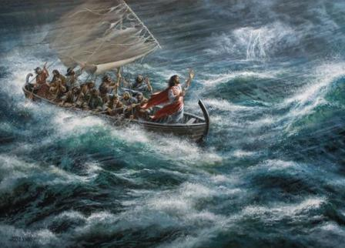

### The Parable of the Wicked Vinedressers

*9Then He began to tell the people this parable: “A certain man planted a vineyard, leased it to vinedressers, and went into a far country for a long time. 10Now at vintage-time he sent a servant to the vinedressers, that they might give him some of the fruit of the vineyard. But the vinedressers beat him and sent him away empty-handed. 11Again he sent another servant; and they beat him also, treated him shamefully, and sent him away empty-handed. 12And again he sent a third; and they wounded him also and cast him out.*

*13“Then the owner of the vineyard said, ‘What shall I do? I will send my beloved son. Probably they will respect him when they see him.’ 14But when the vinedressers saw him, they reasoned among themselves, saying, ‘This is the heir. Come, let us kill him, that the inheritance may be ours.’ 15So they cast him out of the vineyard and killed him. Therefore what will the owner of the vineyard do to them? 16He will come and destroy those vinedressers and give the vineyard to others.”And when they heard it they said, “Certainly not!”*

*17Then He looked at them and said, “What then is this that is written:*

*‘The stone which the builders rejected  
Has become the chief cornerstone’?*

*****18Whoever falls on that stone will be broken; but on whomever it falls, it will grind him to powder.”*

*19And the chief priests and the scribes that very hour sought to lay hands on Him, but they feared the people —for they knew He had spoken this parable against them.*

**Question 2**

Match the part of the parable on the left with it’s meaning on the right. The first one has been done for you.

|  |  |  |
| --- | --- | --- |
| **Parable** | **Match** | **Meaning** |
| The owner of the vineyard | **C** | **A** Jesus |
| The three servants that he sent to bring back fruit from the vineyard. |  | **B** When Jesus was crucifed by people that were jealous of Him |
| The son of the owner |  | **C** God |
| When the vinedressers kill the only son of the owner |  | **D** The prophets sent before Jesus came to change the hearts of the people. |

* Tuesday 16th May: Read **Luke 20: 20-40** and answer the questions:

### The Pharisees: Is It Lawful to Pay Taxes to Caesar?

*20So they watched Him, and sent spies who pretended to be righteous, that they might seize on His words, in order to deliver Him to the power and the authority of the governor.*

*21Then they asked Him, saying, “Teacher, we know that You say and teach rightly, and You do not show personal favoritism, but teach the way of God in truth: 22Is it lawful for us to pay taxes to Caesar or not?”*

*23But He perceived their craftiness, and said to them, “Why do you test Me? 24Show Me a denarius. Whose image and inscription does it have?”*

*They answered and said, “Caesar’s.”*

*25And He said to them, “Render therefore to Caesar the things that are Caesar’s, and to God the things that are God’s.”*

*26But they could not catch Him in His words in the presence of the people. And they marveled at His answer and kept silent.*

**Question 3**

Which picture below shows an image of a denarius? HINT: Verse 24 will help you choose the correct coin.

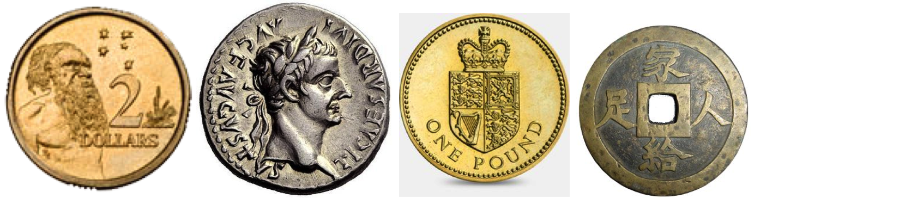

(A) (B) (C) (D)

### The Sadducees: What About the Resurrection?

*27Then some of the Sadducees, who deny that there is a resurrection, came to Him and asked Him, 28saying: “Teacher, Moses wrote to us that if a man’s brother dies, having a wife, and he dies without children, his brother should take his wife and raise up offspring for his brother. 29Now there were seven brothers. And the first took a wife, and died without children. 30And the second[*[*e*](https://www.biblegateway.com/passage/?search=Luke+20&version=NKJV#fen-NKJV-25810e)*] took her as wife, and he died childless. 31Then the third took her, and in like manner the seven also; and they left no children,[[f](https://www.biblegateway.com/passage/?search=Luke+20&version=NKJV" \l "fen-NKJV-25811f" \o "See footnote f)] and died. 32Last of all the woman died also. 33Therefore, in the resurrection, whose wife does she become? For all seven had her as wife.”*

*34Jesus answered and said to them, “The sons of this age marry and are given in marriage. 35But those who are counted worthy to attain that age, and the resurrection from the dead, neither marry nor are given in marriage; 36nor can they die anymore, for they are equal to the angels and are sons of God, being sons of the resurrection. 37But even Moses showed in the burning bush passage that the dead are raised, when he called the Lord ‘the God of Abraham, the God of Isaac, and the God of Jacob.’ 38For He is not the God of the dead but of the living, for all live to Him.”*

*39Then some of the scribes answered and said, “Teacher, You have spoken well.” 40But after that they dared not question Him anymore.*

**Question 4**

When Jesus resurrected from the dead, we say that He raised us up with Him in to a new life. This is shown in verse 38. Copy verse 38 below and memorise it by heart.

* Wednesday 17th May: **Luke 20: 41-48** and answer the questions:

### Jesus: How Can David Call His Descendant Lord?

*41And He said to them, “How can they say that the Christ is the Son of David? 42Now David himself said in the Book of Psalms:*

*‘The Lord said to my Lord,  
“Sit at My right hand,  
43Till I make Your enemies Your footstool.”’*

*44Therefore David calls Him ‘Lord’; how is He then his Son?”*

**Question 5**

Open your Bible to Luke Chapter 20 verses 45-48. These verses warn us to beware of the Scribes (Teachers of the Law).

Jesus describes the Scribes in much detail in this passage.

1. What do the Scribes like wearing?
2. Where do they love people to greet them with respect?
3. Where do they like to sit in the synagogue?
4. Where do they like to celebrate Feasts?
5. What did Jesus say will they will receive because of their ways?

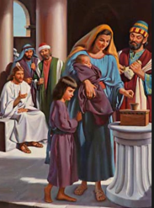

* Thursday 18th May: Read **Luke 21: 1-19** and answer the questions:

### The Widow’s Two Mites

*1And He looked up and saw the rich putting their gifts into the treasury, 2and He saw also a certain poor widow putting in two mites. 3So He said, “Truly I say to you that this poor widow has put in more than all; 4for all these out of their abundance have put in offerings for God, but she out of her poverty put in all the livelihood that she had.”*

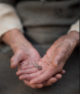**Do you know what a mite is?**

*It is simply another name for a smallest and least valuable coin circulating in Judea at the time of Christ. In the story, a widow donates two small coins, while wealthy people donate much more. Jesus explains to his disciples that the small sacrifices of the poor mean more to God than the extravagant, but proportionately lesser, donations of the rich*

**Question 6a**

Proportionately, who gave the most money?

1. the rich
2. the widow
3. woman
4. men

**Question 6b**

What does this tell us about what God wants from us?

The link below is a short video of Jesus telling the story of the widow’s two mites

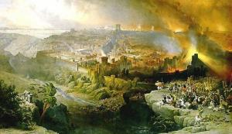<https://www.lds.org/bible-videos/videos/jesus-teaches-about-the-widows-mites?lang=eng>

### Jesus Predicts the Destruction of the Temple

*5Then, as some spoke of the temple, how it was adorned with beautiful stones and donations, He said, 6“These things which you see—the days will come in which not one stone shall be left upon another that shall not be thrown down.”*

### The Signs of the Times and the End of the Age

*7So they asked Him, saying, “Teacher, but when will these things be? And what sign will there be when these things are about to take place?”*

*8And He said: “Take heed that you not be deceived. For many will come in My name, saying, ‘I am He,’ and, ‘The time has drawn near.’ Therefore[*[*b*](https://www.biblegateway.com/passage/?search=Luke+21#fen-NKJV-25835b)*] do not go after them. 9But when you hear of wars and commotions, do not be terrified; for these things must come to pass first, but the end will not come immediately.”*

*10Then He said to them, “Nation will rise against nation, and kingdom against kingdom. 11And there will be great earthquakes in various places, and famines and pestilences; and there will be fearful sights and great signs from heaven. 12But before all these things, they will lay their hands on you and persecute you, delivering you up to the synagogues and prisons. You will be brought before kings and rulers for My name’s sake. 13But it will turn out for you as an occasion for testimony. 14Therefore settle it in your hearts not to meditate beforehand on what you will answer; 15for I will give you a mouth and wisdom which all your adversaries will not be able to contradict or resist. 16You will be betrayed even by parents and brothers, relatives and friends; and they will put some of you to death. 17And you will be hated by all for My name’s sake. 18But not a hair of your head shall be lost. 19By your patience possess your souls.*

**Question 7**

Fill in the table below:

|  |  |
| --- | --- |
| **Jesus warns the people of:** | **TRUE/FALSE** |
| People claiming to be Christ |  |
| People claiming the end of the world is now |  |
| Wars meaning the end of the world has come |  |
| Persecution for the Christians |  |

* Friday 19th May: Read **Luke 21: 20-28** and answer the questions:

### The Destruction of Jerusalem

*20“But when you see Jerusalem surrounded by armies, then know that its desolation is near. 21Then let those who are in Judea flee to the mountains, let those who are in the midst of her depart, and let not those who are in the country enter her. 22For these are the days of vengeance, that all things which are written may be fulfilled. 23But woe to those who are pregnant and to those who are nursing babies in those days! For there will be great distress in the land and wrath upon this people. 24And they will fall by the edge of the sword, and be led away captive into all nations. And Jerusalem will be trampled by Gentiles until the times of the Gentiles are fulfilled.*

**Question 8**

Match the statement on the left with the Bible verse

|  |  |  |
| --- | --- | --- |
| **Statement** |  | **Verse** |
| **A** For those are days of punishment. Then all that is written in the Bible will come true. |  | *20“But when you see Jerusalem surrounded by armies, then know that its desolation is near.* |
| **B** When armies surround Jerusalem; you will know that they will soon destroy it. |  | *21Then let those who are in Judea flee to the mountains, let those who are in the midst of her depart, and let not those who are in the country enter her.* |
| **C** Then those people who are in Judea must escape to the hills. The people who are in the city of Jerusalem must leave. The people who are out in the country must not return to the city. |  | *22For these are the days of vengeance, that all things which are written may be fulfilled.* |
| **D** Some Jews will die in the battle. Other Jews will go to prison in all countries. The Gentiles will rule Jerusalem until their time is over. |  | *23But woe to those who are pregnant and to those who are nursing babies in those days! For there will be great distress in the land and wrath upon this people.* |
| **E** How terrible it will be in those days for women who are expecting babies! And for mothers with little children! Terrible suffering will come upon this land, and God will punish these people. |  | *24And they will fall by the edge of the sword, and be led away captive into all nations. And Jerusalem will be trampled by Gentiles until the times of the Gentiles are fulfilled.* |

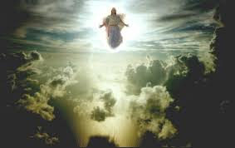

The Coming of the Son of Man

*25“And there will be signs in the sun, in the moon, and in the stars; and on the earth distress of nations, with perplexity, the sea and the waves roaring; 26men’s hearts failing them from fear and the expectation of those things which are coming on the earth, for the powers of the heavens will be shaken. 27Then they will see the Son of Man coming in a cloud with power and great glory. 28Now when these things begin to happen, look up and lift up your heads, because your redemption draws near.”*

**Question 9**

List three of the signs we will see before the coming of the Son of Man.

i)

ii)

iii)

* Saturday 20th May: **Luke 21: 29-38** and answer the questions:

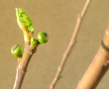The Parable of the Fig Tree

*29Then He spoke to them a parable: “Look at the fig tree, and all the trees. 30When they are already budding, you see and know for yourselves that summer is now near. 31So you also, when you see these things happening, know that the kingdom of God is near. 32Assuredly, I say to you, this generation will by no means pass away till all things take place. 33Heaven and earth will pass away, but My words will by no means pass away.*

### The Importance of Watching

*34“But take heed to yourselves, lest your hearts be weighed down with carousing, drunkenness, and cares of this life, and that Day come on you unexpectedly. 35For it will come as a snare on all those who dwell on the face of the whole earth. 36Watch therefore, and pray always that you may be counted worthy to escape all these things that will come to pass, and to stand before the Son of Man.”*

*37And in the daytime He was teaching in the temple, but at night He went out and stayed on the mountain called Olivet. 38Then early in the morning all the people came to Him in the temple to hear Him.*

**Question 10**

Christ warns us of ‘sleeping the sleep of death’. The world is a big distraction but he wants us to focus on His words and: _ _ _ _

* **What to do when you finish your Bible Study.**

**Send it by email to your class email address or print and hand it to your servants next Sunday.**

**• Year 4A St Makarious StMakarios4A@gmail.com Class Servant- Aunty Labiba (0421891567)**

**• Year 4B St Bakhomious StBakhomios4B@gmail.com Class Servant- Aunty Mira (0415595556)**

**• Year 4C St Anthony StAnthony4C@gmail.com Class Servant- Aunty Olivia**