Sunday 7th May 2017

Name:

Class:

Due Date: Saturday 13th May 2017

Description: Description: Description: Description: Description: Description: Description: Description: http://www.timshen.truepath.com/christian/goldcrosswhite.gifCompleted Bible Study = 15 points,

Handed in by the due date = 5 points

**The GOSPEL according to ST. Matthew**

Year 5 – Bible Study 14 (Chapters 27 & 28)

**Monday 8th May Read Chapter 27 verses 1 – 21**

### Judas Hangs Himself

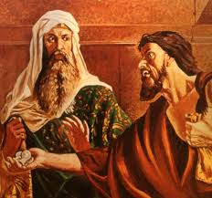***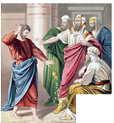****1 When morning came, all the chief priests and elders of the people plotted against Jesus to put Him to death.****2****And when they had bound Him, they led Him away and delivered Him to Pontius Pilate the governor.****3****Then Judas, His betrayer, seeing that He had been condemned, was remorseful and brought back the thirty pieces of silver to the chief priests and elders,****4****saying, “I have sinned by betraying innocent blood.” And they said, “What is that to us? You see to it!”* ***5****Then he threw down the pieces of silver in the temple and departed, and went and hanged himself.* ***6****But the chief priests took the silver pieces and said; “It is not lawful to put them into the treasury, because they are the price of blood.”****7****And they consulted together and bought with them the potter’s field, to bury strangers in.****8****Therefore that field has been called the Field of Blood to this day.* ***9****Then was fulfilled what was spoken by Jeremiah the prophet, saying, “And they took the thirty pieces of silver, the value of Him who was priced, whom they of the children of Israel priced,****10****and gave them for the potter’s field, as the Lord directed me.”*

### Jesus faces Pilate and takes the place of Barabbas

*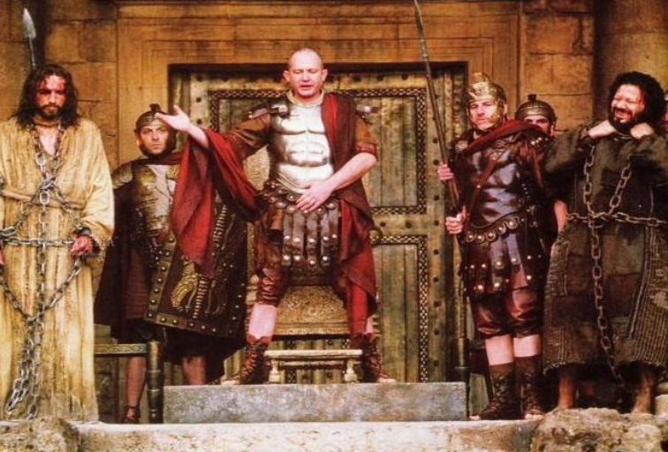****11****Now Jesus stood before the governor. And the governor asked Him, saying, “Are You the King of the Jews?” Jesus said to him, “It is as you say.”****12****And while He was being accused by the chief priests and elders, He answered nothing.* ***13****Then Pilate said to Him, “Do You not hear how many things they testify against You?”****14****But He answered him not one word, so that the governor marveled greatly.* ***15****Now at the feast the governor was accustomed to releasing to the multitude one prisoner whom they wished.****16****And at that time they had a notorious prisoner called Barabbas.****17****Therefore, when they had gathered together, Pilate said to them, “Whom do you want me to release to you? Barabbas, or Jesus who is called Christ?”****18****For he knew that they had handed Him over because of envy.* ***19****While he was sitting on the judgment seat, his wife sent to him, saying, “Have nothing to do with that just Man, for I have suffered many things today in a dream because of Him.”* ***20****But the chief priests and elders persuaded the multitudes that they should ask for Barabbas and destroy Jesus.****21****The governor answered and said to them, “Which of the two do you want me to release to you?” They said, “Barabbas!”*

1. What did the chief priests do with the 30 pieces of silver returned to them by Judas?
2. Name the prisoner the crowd chose to be released to them?

**Tuesday 9th May Read Chapter 27 verses 22 – 44**

### Soldiers Mock Jesus

*Pilate said to them, “What then shall I do with Jesus who is called Christ?” They all said to him, “Let Him be crucified!”* ***23****Then the governor said, “Why, what evil has He done?” But they cried out all the more, saying, “Let Him be crucified!”* ***24****When Pilate saw that he could not prevail at all, but rather that a tumult was rising, he took water and washed his hands before the multitude, saying, “I am innocent of the blood of this just Person. You see to it.”* ***25****And all the people answered and said, “His blood be on us and on our children.”* ***26****Then he released Barabbas to them; and when he had scourged Jesus, he delivered Him to be crucified.* ***27****Then the soldiers of the governor took Jesus into the Praetorium and gathered the whole garrison around Him.****28****And they stripped Him and put a scarlet robe on Him.****29****When they had twisted a crown of thorns, they put it on His head, and a reed in His right hand. And they bowed the knee before Him and mocked Him, saying, “Hail, King of the Jews!”****30****Then they spat on Him, and took the reed and struck Him on the head.****31****And when they had mocked Him, they took the robe off Him, put His own clothes on Him, and led Him away to be crucified.*

### King on a Cross

***32****Now as they came out, they found a man of Cyrene, Simon by name. Him they compelled to bear His cross.****33****And when they had come to a place called Golgotha, that is to say, Place of a Skull,****34****they gave Him sourwine mingled with gall to drink. But when He had tasted it, He would not drink.* ***35****Then they crucified Him, and divided His garments, casting lots that it might be fulfilled which the prophet spoke: “They divided My garments among them, And for My clothing they cast lots.”* ***36****Sitting down, they kept watch over Him there.****37****And they put up over His head the accusation written against Him:*

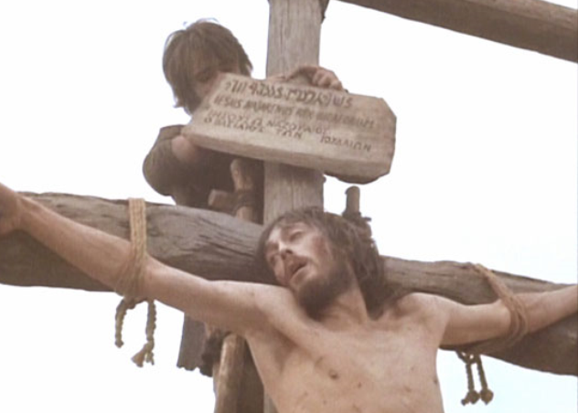

*THIS IS JESUS THE KING OF THE JEWS.*

***38****Then two robbers were crucified with Him, one on the right and another on the left.*

***39****And those who passed by blasphemed Him, wagging their heads****40****and saying, “You who destroy the temple and build it in three days, save Yourself! If You are the Son of God, come down from the cross.”* ***41****Likewise the chief priests also, mocking with the scribes and elders, said,****42****“He saved others; Himself He cannot save. If He is the King of Israel, let Him now come down from the cross, and we will believe Him.* ***43****He trusted in God; let Him deliver Him now if He will have Him; for He said, ‘I am the Son of God.’”* ***44****Even the robbers who were crucified with Him reviled Him with the same thing.*

1. What did Pilate do in front of the crowd and what was he trying to show?

|  |  |
| --- | --- |
| **ACTION** | **WHAT IT SHOWS** |
|  |  |

1. Who helped Jesus carry the cross and where was he from?

**Wednesday 10th May Read Chapter 27 verses 45 – 66**

**Jesus dies on the Cross**

***45****Now from the sixth hour until the ninth hour there was darkness over all the land.****46****And about the ninth hour Jesus cried out with a loud voice, saying, “Eli, Eli, lama sabachthani?” that is, “My God, My God, why have You forsaken Me?”* ***47****Some of those who stood there, when they heard that, said, “This Man is calling for Elijah!”****48****Immediately one of them ran and took a sponge, filled it with sour wine and put it on a reed, and offered it to Him to drink.*

*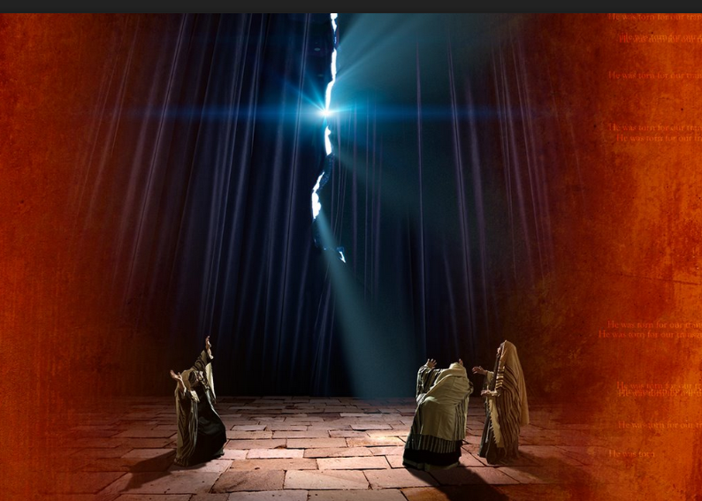****49****The rest said, “Let Him alone; let us see if Elijah will come to save Him.”* ***50****And Jesus cried out again with a loud voice, and yielded up His spirit.* ***51****Then, behold, the veil of the temple was torn in two from top to bottom; and the earth quaked, and the rocks were split,****52****and the graves were opened; and many bodies of the saints who had fallen asleep were raised;* ***53****and coming out of the graves after His resurrection, they went into the holy city and appeared to many.* ***54****So when the centurion and those with him, who were guarding Jesus, saw the earthquake and the things that had happened, they feared greatly, saying, “Truly this was the Son of God!”* ***55****And many women who followed Jesus from Galilee, ministering to Him, were there looking on from afar,* ***56****among whom were Mary Magdalene, Mary the mother of James and Joses, and the mother of Zebedee’s sons.*

**Jesus burried in Joseph’s Tomb**

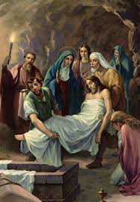***57****Now when evening had come, there came a rich man from Arimathea, named Joseph, who himself had also become a disciple of Jesus.****58****This man went to Pilate and asked for the body of Jesus. Then Pilate commanded the body to be given to him.****59****When Joseph had taken the body, he wrapped it in a clean linen cloth,****60****and laid it in his new tomb, which he had hewn out of the rock; and he rolled a large stone against the door of the tomb, and departed.****61****And Mary Magdalene was there, and the other Mary, sitting opposite the tomb.* ***62****On the next day, which followed the Day of Preparation, the chief priests and Pharisees gathered together to Pilate,****63****saying, “Sir, we remember, while He was still alive, how that deceiver said, ‘After three days I will rise.’****64****Therefore command that the tomb be made secure until the third day, lest His disciples come by night and steal Him away, and say to the people, ‘He has risen from the dead.’ So the last deception will be worse than the first.”* ***65****Pilate said to them, “You have a guard; go your way, make it as secure as you know how.”****66****So they went and made the tomb secure, sealing the stone and setting the guard.*

1. Choose TRUE or FALSE for the following statements:
2. From the seventh hour until the ninth, there was darkness over all the land. TRUE / FALSE
3. The veil of the temple was torn in two, from top to bottom. TRUE / FALSE
4. The centurion and those who were guarding Jesus believed when they saw the earthquake and the things that had happened TRUE / FALSE
5. Jesus called out to Elijah for help TRUE / FALSE
6. Many bodies of saints who had fallen asleep were raised TRUE / FALSE
7. What did Joseph do with the body of Christ?

**Thursday 11th May Read Chapter 28 verses 1 – 8**

### He Is Risen

*1 Now after the Sabbath, as the first day of the week began to dawn, Mary Magdalene and the other Mary came to see the tomb. 2And behold, there was a great earthquake; for an angel of the Lord descended from heaven, and came and rolled back the stone from the door, and sat on it. 3His countenance was like lightning, and his clothing as white as snow. 4And the guards shook for fear of him, and became like dead men.*

### The Angel of the Lord speaks to Mary Magdalene and the other Mary

*5But the angel answered and said to the women, “Do not be afraid, for I know that you seek Jesus who was crucified. 6He is not here; for He is risen, as He said. Come, see the place where the Lord lay. 7And go quickly and tell His disciples that He is risen from the dead, and indeed He is going before you into Galilee; there you will see Him. Behold, I have told you.” 8So they went out quickly from the tomb with fear and great joy, and ran to bring His disciples word.*

1. Write down the correct order of what happened on Easter day in the boxes below.

A – The guards were very afraid

B – Mary Magdalene and the other Mary went to the tomb were Jesus was laid

C – An angel rolled away the stone from the tomb’s entrance

|  |  |  |
| --- | --- | --- |
|  |  |  |

**Friday 12th May Read Chapter 28 verses 9 – 15**

### The Women Worship the Risen Lord

*9And as they went to tell His disciples, behold, Jesus met them, saying, “Rejoice!” So they came and held Him by the feet and worshiped Him. 10Then Jesus said to them, “Do not be afraid. Go and tell My brethren to go to Galilee, and there they will see Me.”*

### The Soldiers Are Bribed

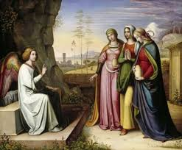*11Now while they were going, behold, some of the guard came into the city and reported to the chief priests all the things that had happened. 12When they had assembled with the elders and consulted together, they gave a large sum of money to the soldiers, 13saying, “Tell them, ‘His disciples came at night and stole Him away while we slept.’ 14And if this comes to the governor’s ears, we will appease him and make you secure.” 15So they took the money and did as they were instructed; and this saying is commonly reported among the Jews until this day.*

1. Who was Jesus talking about when he asked the women to tell His *brethren*?
2. The apostles and disciples
3. The soldiers guarding the tomb where He was buried
4. Mary His mother and John the beloved
5. 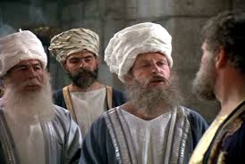Who said the following verse? *“Tell them, ‘His disciples came at night and stole Him away while we slept.’*
6. The guards
7. The chief priests
8. The disciples

**Saturday 13th May Read Chapter 28 verses 16 – 20**

### The Great Commission

*16Then the eleven disciples went away into Galilee, to the mountain which Jesus had appointed for them. 17When they saw Him, they worshiped Him; but some doubted.*

*18And Jesus came and spoke to them, saying, “All authority has been given to Me in heaven and on earth. 19Go therefore and make disciples of all the nations, baptizing them in the name of the Father and of the Son and of the Holy Spirit, 20teaching them to observe all things that I have commanded you; and lo, I am with you always, even to the end of the age.” Amen.*

1. 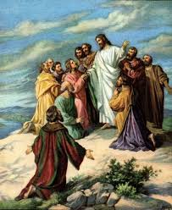Verse 16 says that only 11 disciples went to Galilee but Jesus originally had 12 disciples. Which disciple was missing?
2. Re-read the bible readings of Friday and complete the following verse:

‘… I am with you ______________, even to the _________ of age. Amen’

**PARENTS SECTION:**

We kindly ask you as a parent to read (a little each day) in the Holy Bible with your family.

**Now email your answers to your teacher, choose ONE of the email addresses below.**

**What to do when you finish your Bible Study.**

Send it by email to your class email address or print and hand it to your servants next Sunday.

* Year 5B1 St Thomas[stthomas5b@gmail.com](mailto:stthomas5b@gmail.com) Class Servant- Uncle Andrew

(0416744100)

* Year 5B2 St Philip[saintphilip5g@gmail.com](mailto:saintphilip5g@gmail.com) Class Servant- Uncle Mark

(0413495921)

* Year 5G St Matthew [stmatthew5g@gmail.com](mailto:stmatthew5g@gmail.com) Class Servant – Aunty Dina

(0404604507)