C:\Documents and Settings\suzy\Local Settings\Temporary Internet Files\Content.IE5\3JXW24R5\MC900383922[1].wmfSunday 7 May, 2017

Name:

Class:

Finish Date: Saturday 13 May, 2017

Completed Bible Study = 15 points

Email Homework by the due date = 5 points

**Year 6 Bible Study 1 Timothy Chapters 1-4**

**For the questions below Highlight or change the font colour to choose the correct answer.**

* MONDAY: Read 1 Timothy Chapter 1:1-11 and answer the questions:

***Greeting***

*Paul, an apostle of Jesus Christ, by the commandment of God our Savior and the Lord Jesus Christ, our hope,*

***2****To Timothy, a true son in the faith:*

*Grace, mercy, and peace from God our Father and Jesus Christ our Lord.*

***No Other Doctrine***

***3****As I urged you when I went into Macedonia—remain in Ephesus that you may charge some that they teach no other doctrine,****4****nor give heed to fables and endless genealogies, which cause disputes rather than godly edification which is in faith.****5****Now the purpose of the commandment is love from a pure heart, from a good conscience, and from sincere faith,****6****from which some, having strayed, have turned aside to idle talk,****7****desiring to be teachers of the law, understanding neither what they say nor the things which they affirm.*

***8****But we know that the law is good if one uses it lawfully,****9****knowing this: that the law is not made for a righteous person, but for the lawless and insubordinate, for the ungodly and for sinners, for the unholy and profane, for murderers of fathers and murderers of mothers, for manslayers,****10****for fornicators, for sodomites, for kidnappers, for liars, for perjurers, and if there is any other thing that is contrary to sound doctrine,****11****according to the glorious gospel of the blessed God which was committed to my trust.*

**Question 1**

Complete the missing words from 1 Timothy 1:5:

|  |  |  |  |
| --- | --- | --- | --- |
| *Now the purpose of the commandment is* |  | *from a pure* |  |
| *from a good* |  | *& from a sincere* |  |

**Question 2**

Who is St Paul writing this letter to?

* TUESDAY: Read 1 Timothy Chapter 1:12-20 and answer the questions:

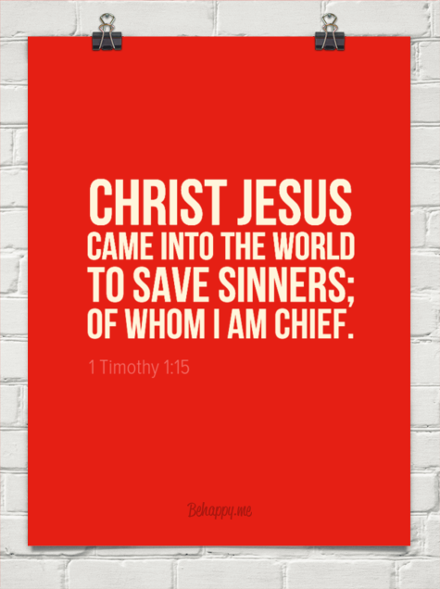***Glory to God for His Grace***

***12****And I thank Christ Jesus our Lord who has enabled me, because He counted me faithful, putting me into the ministry,****13****although I was formerly a blasphemer, a persecutor, and an insolent man; but I obtained mercy because I did it ignorantly in unbelief.****14****And the grace of our Lord was exceedingly abundant, with faith and love which are in Christ Jesus.****15****This is a faithful saying and worthy of all acceptance, that Christ Jesus came into the world to save sinners, of whom I am chief.****16****However, for this reason I obtained mercy, that in me first Jesus Christ might show all longsuffering, as a pattern to those who are going to believe on Him for everlasting life.****17****Now to the King eternal, immortal, invisible, to God who alone is wise,[[a](https://www.biblegateway.com/passage/?search=1+Timothy+1&version=NKJV" \l "fen-NKJV-29714a" \o "See footnote a)] be honor and glory forever and ever. Amen.*

***Fight the Good Fight***

***18****This charge I commit to you, son Timothy, according to the prophecies previously made concerning you, that by them you may wage the good warfare,****19****having faith and a good conscience, which some having rejected, concerning the faith have suffered shipwreck,****20****of whom are Hymenaeus and Alexander, whom I delivered to Satan that they may learn not to blaspheme.*

**Question 3**

What did our Lord have that St Paul says was “exceedingly abundant,” allowing St Paul himself to be transformed from a blasphemer to a preacher? Hint: verse 14.

* WEDNESDAY: Read 1 Timothy Chapter 2:1-15 and answer the questions:

***1 Timothy 2***

***Pray for All Men***

*Therefore I exhort first of all that supplications, prayers, intercessions, and giving of thanks be made for all men,****2****for kings and all who are in authority, that we may lead a quiet and peaceable life in all godliness and reverence.****3****For this is good and acceptable in the sight of God our Saviour,****4****who desires all men to be saved and to come to the knowledge of the truth.****5****For there is one God and one Mediator between God and men, the Man Christ Jesus,****6****who gave Himself a ransom for all, to be testified in due time,****7****for which I was appointed a preacher and an apostle—I am speaking the truth in Christ[[a](https://www.biblegateway.com/passage/?search=1%20Timothy+2&version=NKJV" \l "fen-NKJV-29724a" \o "See footnote a)] and not lying—a teacher of the Gentiles in faith and truth.*

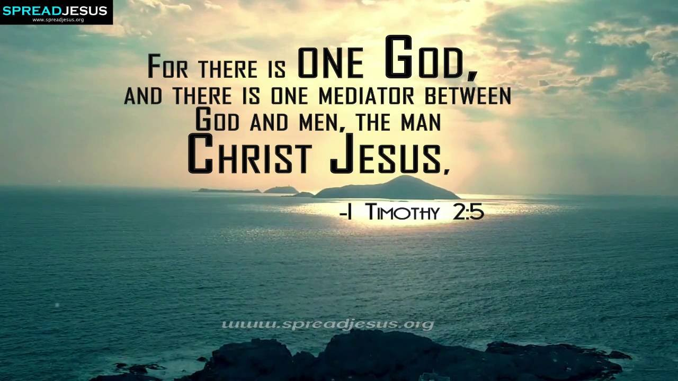

***Men and Women in the Church***

***8****I desire therefore that the men pray everywhere, lifting up holy hands, without wrath and doubting;****9****in like manner also, that the women adorn themselves in modest apparel, with propriety and moderation, not with braided hair or gold or pearls or costly clothing,****10****but, which is proper for women professing godliness, with good works.****11****Let a woman learn in silence with all submission.****12****And I do not permit a woman to teach or to have authority over a man, but to be in silence.****13****For Adam was formed first, then Eve.****14****And Adam was not deceived, but the woman being deceived, fell into transgression.****15****Nevertheless she will be saved in childbearing if they continue in faith, love, and holiness, with self-control.*

**Question 4**

True or False

|  |  |
| --- | --- |
| St Paul calls on Timothy to pray for all men, kings and people in authority so that we can live peaceful lives. |  |
| God wants only good men to come to the knowledge of the truth. |  |
| The truth = Jesus Christ |  |
| St Paul calls on men and women everywhere to pray. |  |
| He tells women to wear pearls and gold and expensive clothes, not living simply. |  |

* THURSDAY: Read 1 Timothy Chapter 3:1-16 and answer the questions:

***Qualifications of Overseers***

*3 This is a faithful saying: If a man desires the position of a bishop,[[a](https://www.biblegateway.com/passage/?search=1%20Timothy+3&version=NKJV" \l "fen-NKJV-29733a" \o "See footnote a)] he desires a good work. 2A bishop then must be blameless, the husband of one wife, temperate, sober-minded, of good behaviour, hospitable, able to teach; 3not given to wine, not violent, not greedy for money,[[b](https://www.biblegateway.com/passage/?search=1%20Timothy+3&version=NKJV" \l "fen-NKJV-29735b" \o "See footnote b)] but gentle, not quarrelsome, not covetous; 4one who rules his own house well, having his children in submission with all reverence 5(for if a man does not know how to rule his own house, how will he take care of the church of God?); 6not a novice, lest being puffed up with pride he fall into the same condemnation as the devil. 7Moreover he must have a good testimony among those who are outside, lest he fall into reproach and the snare of the devil.*

***Qualifications of Deacons***

*8Likewise deacons must be reverent, not double-tongued, not given to much wine, not greedy for money, 9holding the mystery of the faith with a pure conscience. 10But let these also first be tested; then let them serve as deacons, being found blameless. 11Likewise, their wives must be reverent, not slanderers, temperate, faithful in all things. 12Let deacons be the husbands of one wife, ruling their children and their own houses well. 13For those who have served well as deacons obtain for themselves a good standing and great boldness in the faith which is in Christ Jesus.*

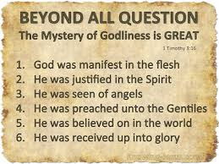***The Great Mystery***

*14These things I write to you, though I hope to come to you shortly; 15but if I am delayed, I write so that you may know how you ought to conduct yourself in the house of God, which is the church of the living God, the pillar and ground of the truth. 16And without controversy great is the mystery of godliness:*

*God[[c](https://www.biblegateway.com/passage/?search=1%20Timothy+3&version=NKJV" \l "fen-NKJV-29748c" \o "See footnote c)] was manifested in the flesh,  
Justified in the Spirit,  
Seen by angels,  
Preached among the Gentiles,  
Believed on in the world,  
Received up in glory.*

**Question 5**

Why does St Paul say that if a man does not have control over his own house, he cannot be fit to be a bishop?

**Question 6**

What does St Paul describe the church as (verse 15)?

* FRIDAY: Read 1 Timothy Chapter 4:1- 16 and answer the questions:

***The Great Apostasy***

*Now the Spirit expressly says that in latter times some will depart from the faith, giving heed to deceiving spirits and doctrines of demons, 2 speaking lies in hypocrisy, having their own conscience seared with a hot iron, 3 forbidding to marry, and commanding to abstain from foods which God created to be received with thanksgiving by those who believe and know the truth. 4 For every creature of God is good, and nothing is to be refused if it is received with thanksgiving; 5 for it is sanctified by the word of God and prayer.*

***A Good Servant of Jesus Christ***

*6 If you instruct the brethren in these things, you will be a good minister of Jesus Christ, nourished in the words of faith and of the good doctrine which you have carefully followed. 7 But reject profane and old wives’ fables, and exercise yourself toward godliness. 8 For bodily exercise profits a little, but godliness is profitable for all things, having promise of the life that now is and of that which is to come. 9 This is a faithful saying and worthy of all acceptance. 10 For to this end we both labour and suffer reproach,[*[a](https://www.biblegateway.com/passage/?search=1%20Timothy+4&version=NKJV" \l "fen-NKJV-29758a" \o "See footnote a)*] because we trust in the living God, who is the Saviour of all men, especially of those who believe. 11 These things command and teach.*

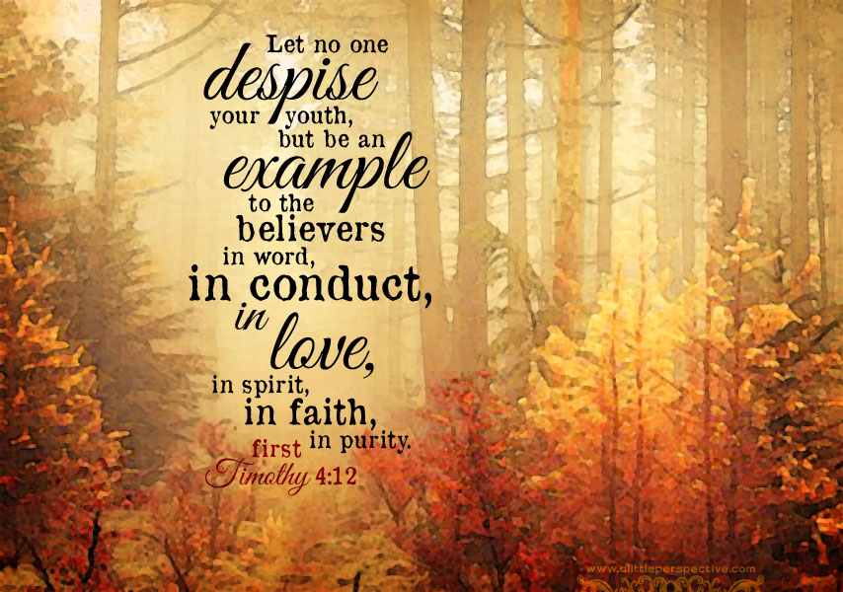***Take Heed to Your Ministry***

*12 Let no one despise your youth, but be an example to the believers in word, in conduct, in love, in spirit,[*[b](https://www.biblegateway.com/passage/?search=1%20Timothy+4&version=NKJV" \l "fen-NKJV-29760b" \o "See footnote b)*] in faith, in purity. 13 Till I come, give attention to reading, to exhortation, to doctrine. 14 Do not neglect the gift that is in you, which was given to you by prophecy with the laying on of the hands of the eldership. 15 Meditate on these things; give yourself entirely to them, that your progress may be evident to all. 16 Take heed to yourself and to the doctrine. Continue in them, for in doing this you will save both yourself and those who hear you.*

**Question 7**

What virtues should we have to be an example to all believers (verse 12)?

* SATURDAY: Memorise this verse:



**What to do when you finish your Bible Study.**

Send it by email to your class email address or print and hand it to your servants next Sunday.

* Year 6B1 St Mark [stmark6b1@gmail.com](mailto:stmark6b1@gmail.com) Class Servant- Uncle Adel (0422884699)
* Year 6B2 St Luke [stluke6b2@gmail.com](mailto:stluke6b2@gmail.com) Class Servant- Uncle Fady (0424740775)
* Year 6G St John[stjohn6g@gmail.com](mailto:stjohn6g@gmail.com) Class Servant- Aunty Nancy (0400212921)