Sunday 30th April 2017

Name:

Class:

Due Date: Saturday 6th May 2017

Description: Description: Description: Description: Description: Description: Description: Description: http://www.timshen.truepath.com/christian/goldcrosswhite.gifCompleted Bible Study = 15 points,

Handed in by the due date = 5 points

**The GOSPEL according to ST. Matthew**

Year 5 – Bible Study 13 (Chapters 25 & 26)

**Monday 1st May Read Chapter 25 verses 1 – 9**

### The Parable of the Wise and Foolish Virgins

*1“Then the kingdom of heaven shall be likened to ten virgins who took their lamps and went out to meet the bridegroom. 2Now five of them were wise, and five were foolish. 3Those who were foolish took their lamps and took no oil with them, 4but the wise took oil in their vessels with their lamps. 5But while the bridegroom was delayed, they all slumbered and slept. 6“And at midnight a cry was heard: ‘Behold, the bridegroom is coming; go out to meet him!’ 7Then all those virgins arose and trimmed their lamps. 8And the foolish said to the wise, ‘Give us some of your oil, for our lamps are going out.’ 9But the wise answered, saying, ‘No, lest there should not be enough for us and you; but go rather to those who sell, and buy for yourselves.’ 10And while they went to buy, the bridegroom came, and those who were ready went in with him to the wedding; and the door was shut. 11“Afterward the other virgins came also, saying, ‘Lord, Lord, open to us!’ 12But he answered and said, ‘Assuredly, I say to you, I do not know you.’ 13“Watch therefore, for you know neither the day nor the hour in which the Son of Man is coming.*

### The Parable of the Talents

*14“For the kingdom of heaven is like a man traveling to a far country, who called his own servants and delivered his goods to them. 15And to one he gave five talents, to another two, and to another one, to each according to his own ability; and immediately he went on a journey. 16Then he who had received the five talents went and traded with them, and made another five talents. 17And likewise he who had received two gained two more also. 18But he who had received one went and dug in the ground, and hid his lord’s money. 19After a long time the lord of those servants came and settled accounts with them.*

*20“So he who had received five talents came and brought five other talents, saying, ‘Lord, you delivered to me five talents; look, I have gained five more talents besides them.’ 21His lord said to him, ‘Well done, good and faithful servant; you were faithful over a few things, I will make you ruler over many things. Enter into the joy of your lord.’ 22He also who had received two talents came and said, ‘Lord, you delivered to me two talents; look, I have gained two more talents besides them.’ 23His lord said to him, ‘Well done, good and faithful servant; you have been faithful over a few things, I will make you ruler over many things. Enter into the joy of your lord.’*

1. Match the part of the parable to what it represents in real life.

|  |  |  |
| --- | --- | --- |
| ***Parable*** |  | ***What it represents*** |
| A.The bridegroom |  | Judgement day |
| B. Ten virgins |  | Christians who behave like Christians |
| C. Five wise virgins |  | Being ready for Christ’s return |
| D. Five foolish virgins |  | Jesus Christ |
| E.The arrival of the bridegroom |  | People who say they are Christians but don’t behave that way |
| F. Being ready for the wedding |  | All Christians |

1. Cross out the incorrect words.

The five foolish virgins were (prepared / unprepared) to meet the bridegroom and so they were (locked out of / allowed in to) the wedding.

**Tuesday 2nd May Read Chapter 25 verses 10 – 21**

### The Parable of the Talents continued

*24“Then he who had received the one talent came and said, ‘Lord, I knew you to be a hard man, reaping where you have not sown, and gathering where you have not scattered seed. 25And I was afraid, and went and hid your talent in the ground. Look, there you have what is yours.’*

*26“But his lord answered and said to him, ‘You wicked and lazy servant, you knew that I reap where I have not sown, and gather where I have not scattered seed. 27So you ought to have deposited my money with the bankers, and at my coming I would have received back my own with interest. 28Therefore take the talent from him, and give it to him who has ten talents. 29‘For to everyone who has, more will be given, and he will have abundance; but from him who does not have, even what he has will be taken away. 30And cast the unprofitable servant into the outer darkness. There will be weeping and gnashing of teeth.’*

### The Son of Man Will Judge the Nations

*31“When the Son of Man comes in His glory, and all the holy angels with Him, then He will sit on the throne of His glory. 32All the nations will be gathered before Him, and He will separate them one from another, as a shepherd divides his sheep from the goats. 33And He will set the sheep on His right hand, but the goats on the left. 34Then the King will say to those on His right hand, ‘Come, you blessed of My Father, inherit the kingdom prepared for you from the foundation of the world: 35for I was hungry and you gave Me food; I was thirsty and you gave Me drink; I was a stranger and you took Me in; 36I was naked and you clothed Me; I was sick and you visited Me; I was in prison and you came to Me.’*

**Son of Man passes judgement to the Righteous and Unrighteous**

*37“Then the righteous will answer Him, saying, ‘Lord, when did we see You hungry and feed You, or thirsty and give You drink? 38When did we see You a stranger and take You in, or naked and clothe You? 39Or when did we see You sick, or in prison, and come to You?’ 40And the King will answer and say to them, ‘Assuredly, I say to you, inasmuch as you did it to one of the least of these My brethren, you did it to Me.’*

*41“Then He will also say to those on the left hand, ‘Depart from Me, you cursed, into the everlasting fire prepared for the devil and his angels: 42for I was hungry and you gave Me no food; I was thirsty and you gave Me no drink; 43I was a stranger and you did not take Me in, naked and you did not clothe Me, sick and in prison and you did not visit Me.’*

**Son of Man speaks to the unrighteous**

*44“Then they also will answer Him, saying, ‘Lord, when did we see You hungry or thirsty or a stranger or naked or sick or in prison, and did not minister to You?’ 45Then He will answer them, saying, ‘Assuredly, I say to you, inasmuch as you did not do it to one of the least of these, you did not do it to Me.’ 46And these will go away into everlasting punishment, but the righteous into eternal life.”*

1. Watch the video link below.

<https://www.youtube.com/watch?v=bbPKhYBaWRg>

What important lesson did you learn from this story?

1. Complete the sentences. The pictures next to the text box are a hint to guide you to the correct answer.



1. When others are hungry, we give them
2. When they are thirsty, we offer them a
3. 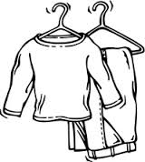When people have nowhere to stay, we welcome them into our
4. When people don’t have warm things to wear, we offer them
5. When people are , we visit them.

**Wednesday 3rd May Read Chapter 25 verses 31 – 46**

### The Plot to Kill Jesus

*1 Now it came to pass, when Jesus had finished all these sayings, that He said to His disciples, 2“You know that after two days is the Passover, and the Son of Man will be delivered up to be crucified.” 3Then the chief priests, the scribes,and the elders of the people assembled at the palace of the high priest, who was called Caiaphas, 4and plotted to take Jesus by trickery and kill Him. 5But they said, “Not during the feast, lest there be an uproar among the people.”*

### The Anointing at Bethany

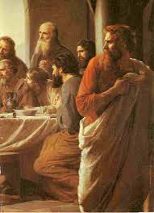*6And when Jesus was in Bethany at the house of Simon the leper, 7a woman came to Him having an alabaster flask of very costly fragrant oil, and she poured it on His head as He sat at the table. 8But when His disciples saw it, they were indignant, saying, “Why this waste? 9For this fragrant oil might have been sold for much and given to the poor.” 10But when Jesus was aware of it, He said to them, “Why do you trouble the woman? For she has done a good work for Me. 11For you have the poor with you always, but Me you do not have always. 12For in pouring this fragrant oil on My body, she did it for My burial. 13Assuredly, I say to you, wherever this gospel is preached in the whole world, what this woman has done will also be told as a memorial to her.”*

### Judas Agrees to Betray Jesus

*14Then one of the twelve, called Judas Iscariot, went to the chief priests 15and said, “What are you willing to give me if I deliver Him to you?” And they counted out to him thirty pieces of silver. 16So from that time he sought opportunity to betray Him.*

### Jesus Celebrates Passover with His Disciples

*17Now on the first day of the Feast of Unleavened Bread the disciples came to Jesus, saying to Him, “Where do You want us to prepare for You to eat the Passover?” 18And He said, “Go into the city to a certain man, and say to him, ‘The Teacher says, “My time is at hand; I will keep the Passover at your house with My disciples.”’” 19So the disciples did as Jesus had directed them; and they prepared the Passover. 20When evening had come, He sat down with the twelve. 21Now as they were eating, He said, “Assuredly, I say to you, one of you will betray Me.”*

*22And they were exceedingly sorrowful, and each of them began to say to Him, “Lord, is it I?” 23He answered and said, “He who dipped his hand with Me in the dish will betray Me. 24The Son of Man indeed goes just as it is written of Him, but woe to that man by whom the Son of Man is betrayed! It would have been good for that man if he had not been born.” 25Then Judas, who was betraying Him, answered and said, “Rabbi, is it I?” He said to him, “You have said it.”*

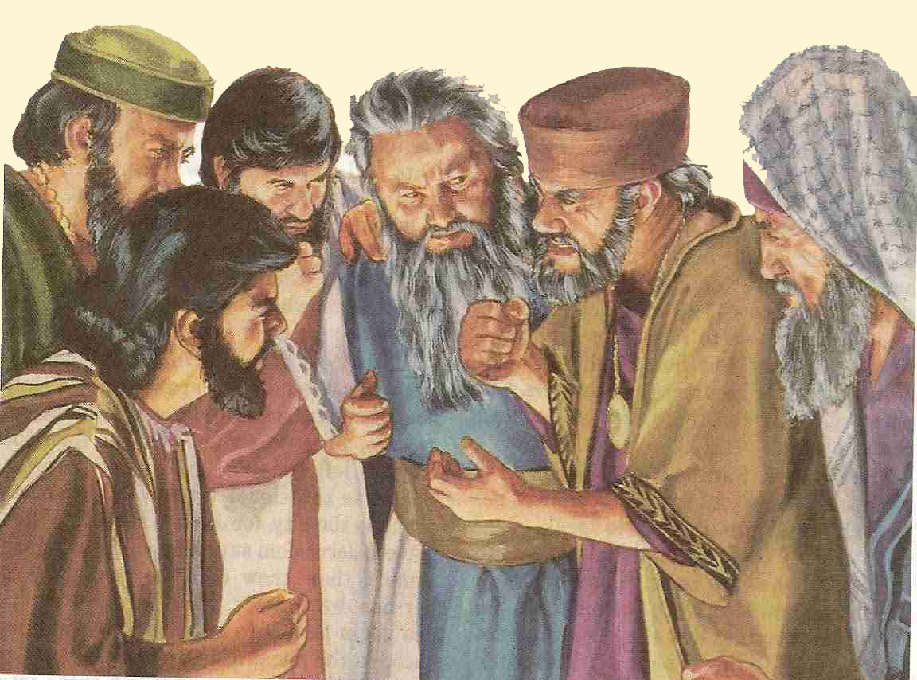

1. Highlight TRUE or FALSE for the following questions:
2. In the passage above, Jesus predicted when He will be crucified TRUE / FALSE
3. The name of the high priest was called Cellophane TRUE / FALSE
4. The chief priests didn’t want to arrest Jesus straight away in case the people got angry with them TRUE / FALSE
5. Match the question in the left column with the correct answer in the right column by placing the correct letter next to the answer.

|  |  |  |
| --- | --- | --- |
| **Question** |  | **Answer** |
| A – What did the woman pour on Jesus’ head? |  | He told them to leave her alone as she was doing a good thing for Jesus. |
| B – Why were the disciples angry? |  | What she did has been recorded in the gospels so she will never been forgotten. |
| C – How did Jesus respond to them? |  | Because they wanted to sell the oil for money. |
| D – How was the woman rewarded for what she did? |  | Fragrant oil. |

**Thursday 4th May Read Chapter 26 verses 1 – 9**

### Jesus Institutes the Lord’s Supper

*26And as they were eating, Jesus took bread, blessed and broke it, and gave it to the disciples and said, “Take, eat; this is My body.” 27Then He took the cup, and gave thanks, and gave it to them, saying, “Drink from it, all of you. 28For this is My blood of the new covenant, which is shed for many for the remission of sins. 29But I say to you, I will not drink of this fruit of the vine from now on until that day when I drink it new with you in My Father’s kingdom.” 30And when they had sung a hymn, they went out to the Mount of Olives.*

### Jesus Predicts Peter’s Denial

*31Then Jesus said to them, “All of you will be made to stumble because of Me this night, for it is written: ‘I will strike the Shepherd, And the sheep of the flock will be scattered.’ 32But after I have been raised, I will go before you to Galilee.” 33Peter answered and said to Him, “Even if all are made to stumble because of You, I will never be made to stumble.” 34Jesus said to him, “Assuredly, I say to you that this night, before the rooster crows, you will deny Me three times.” 35Peter said to Him, “Even if I have to die with You, I will not deny You!” And so said all the disciples.*

1. Complete the table by naming the person who said the statement. Choose the names from the following: Jesus, Disciples, Judas

|  |  |
| --- | --- |
| **Statement** | **Person who said it** |
| *“Where do You want us to prepare for You to eat the Passover?”* |  |
| *“Go into the city to a certain man, and say to him, ‘The Teacher says, “My time is at hand; I will keep the Passover at your house with My disciples.”* |  |
| *“Assuredly, I say to you, one of you will betray Me.”* |  |
| *“Lord, is it I?”* |  |
| *“He who dipped his hand with Me in the dish will betray Me.”* |  |
| *“Rabbi, is it I?”* |  |
| *“You have said it.”* |  |

**Friday 5th May Read Chapter 26 verses 10 – 20**

### The Prayer in the Garden

*36Then Jesus came with them to a place called Gethsemane, and said to the disciples, “Sit here while I go and pray over there.” 37And He took with Him Peter and the two sons of Zebedee, and He began to be sorrowful and deeply distressed. 38Then He said to them, “My soul is exceedingly sorrowful, even to death. Stay here and watch with Me.” 39He went a little farther and fell on His face, and prayed, saying, “O My Father, if it is possible, let this cup pass from Me; nevertheless, not as I will, but as You will.”*

### The Prayer in the Garden

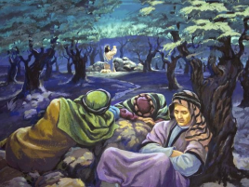*40Then He came to the disciples and found them sleeping, and said to Peter, “What! Could you not watch with Me one hour? 41Watch and pray, lest you enter into temptation. The spirit indeed is willing, but the flesh is weak.” 42Again, a second time, He went away and prayed, saying, “O My Father, if this cup cannot pass away from Me unless I drink it, Your will be done.” 43And He came and found them asleep again, for their eyes were heavy. 44So He left them, went away again, and prayed the third time, saying the same words. 45Then He came to His disciples and said to them, “Are you still sleeping and resting? Behold, the hour is at hand, and the Son of Man is being betrayed into the hands of sinners. 46Rise, let us be going. See, My betrayer is at hand.”*

### Betrayal and Arrest in Gethsemane

*47And while He was still speaking, behold, Judas, one of the twelve, with a great multitude with swords and clubs, came from the chief priests and elders of the people. 48Now His betrayer had given them a sign, saying, “Whomever I kiss, He is the One; seize Him.” 49Immediately he went up to Jesus and said, “Greetings, Rabbi!” and kissed Him. 50But Jesus said to him, “Friend, why have you come?” Then they came and laid hands on Jesus and took Him. 51And suddenly, one of those who were with Jesus stretched out his hand and drew his sword, struck the servant of the high priest, and cut off his ear. 52But Jesus said to him, “Put your sword in its place, for all who take the sword will perish by the sword. 53Or do you think that I cannot now pray to My Father, and He will provide Me with more than twelve legions of angels? 54How then could the Scriptures be fulfilled, that it must happen thus?” 55In that hour Jesus said to the multitudes, “Have you come out, as against a robber, with swords and clubs to take Me? I sat daily with you, teaching in the temple, and you did not seize Me. 56But all this was done that the Scriptures of the prophets might be fulfilled.” Then all the disciples forsook Him and fled.*

1. How many times did the disciples fall asleep while Jesus was praying?
2. Write down the correct order of what happened in Gethsemane in the boxes below. The first one has been done for you.

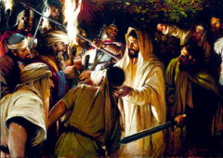A - Jesus tells His disciples to put their swords away.

B - Jesus questions why the soldiers did not try to arrest Him when He was preaching in the temple.

C - Judas arrives with the soldiers to arrest Jesus

D - The disciples run away afraid.

E - One of the disciples cuts off the ear of a high priest’s servant with a sword

F - Judas betrays Jesus with a kiss.

|  |  |  |  |  |  |
| --- | --- | --- | --- | --- | --- |
| C |  |  |  |  |  |

**Saturday 6th May Read Chapter 26 verses 21 – 35**

### Jesus Faces the Sanhedrin

*57And those who had laid hold of Jesus led Him away to Caiaphas the high priest, where the scribes and the elders were assembled. 58But Peter followed Him at a distance to the high priest’s courtyard. And he went in and sat with the servants to see the end. 59Now the chief priests, the elders, and all the council sought false testimony against Jesus to put Him to death, 60but found none. Even though many false witnesses came forward, they found none. But at last two false witnesses came forward 61and said, “This fellow said, ‘I am able to destroy the temple of God and to build it in three days.’”*

**Sanhedrin question Jesus**

*62And the high priest arose and said to Him, “Do You answer nothing? What is it these men testify against You?” 63But Jesus kept silent. And the high priest answered and said to Him, “I put You under oath by the living God: Tell us if You are the Christ, the Son of God!” 64Jesus said to him, “It is as you said. Nevertheless, I say to you, hereafter you will see the Son of Man sitting at the right hand of the Power, and coming on the clouds of heaven.” 65Then the high priest tore his clothes, saying, “He has spoken blasphemy! What further need do we have of witnesses? Look, now you have heard His blasphemy! 66What do you think?” They answered and said, “He is deserving of death.” 67Then they spat in His face and beat Him; and others struck Him with the palms of their hands, 68saying, “Prophesy to us, Christ! Who is the one who struck You?”*

### Peter Denies Jesus, and Weeps Bitterly

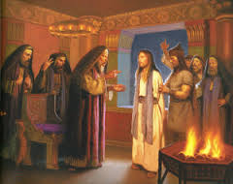*69Now Peter sat outside in the courtyard. And a servant girl came to him, saying, “You also were with Jesus of Galilee.” 70But he denied it before them all, saying, “I do not know what you are saying.” 71And when he had gone out to the gateway, another girl saw him and said to those who were there, “This fellow also was with Jesus of Nazareth.” 72But again he denied with an oath, “I do not know the Man!” 73And a little later those who stood by came up and said to Peter, “Surely you also are one of them, for your speech betrays you.” 74Then he began to curse and swear, saying, “I do not know the Man!” Immediately a rooster crowed. 75And Peter remembered the word of Jesus who had said to him, “Before the rooster crows, you will deny Me three times.” So he went out and wept bitterly.*

1. Match the following words/phrases to their meanings below:

courtyard, council, false testimony, false witness

|  |  |
| --- | --- |
| ***Word*** | ***Definition*** |
|  | a person who make’s up a story to get someone else in trouble |
|  | an open area where people gather |
|  | a made up story |
|  | a group of people who meet together to make decisions |

1. 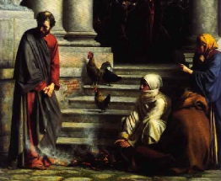Although Peter denied Jesus, he went on to become an amazing disciple who changed the lives of many people and converted them to Christianity. Why do you think he was able to do so?
2. He had hope that Jesus would forgive Him.
3. He forgot about denying Jesus.
4. He was only joking when he said he didn’t know Jesus.

**PARENTS SECTION:**

We kindly ask you as a parent to read (a little each day) in the Holy Bible with your family.

**Now email your answers to your teacher, choose ONE of the email addresses below.**

**What to do when you finish your Bible Study.**

Send it by email to your class email address or print and hand it to your servants next Sunday.

* Year 5B1 St Thomas[stthomas5b@gmail.com](mailto:stthomas5b@gmail.com) Class Servant- Uncle Andrew

(0416744100)

* Year 5B2 St Philip[saintphilip5g@gmail.com](mailto:saintphilip5g@gmail.com) Class Servant- Uncle Mark

(0413495921)

* Year 5G St Matthew [stmatthew5g@gmail.com](mailto:stmatthew5g@gmail.com) Class Servant – Aunty Dina

(0404604507)