Sunday 23rd April 2017

Name:

Class:

Due Date: Saturday 29th April 2017

Description: Description: Description: Description: Description: Description: Description: Description: http://www.timshen.truepath.com/christian/goldcrosswhite.gifCompleted Bible Study = 15 points,

Handed in by the due date = 5 points

**The GOSPEL according to ST. Matthew**

Year 5 – Bible Study 12 (Chapters 23 & 24)

**Monday 24th April Read Chapter 23 verses 1 – 15**

### Hypocrisy of the Scribes and Pharisees

**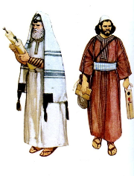***1 Then Jesus spoke to the multitudes and to His disciples, 2saying: “The scribes and the Pharisees sit in Moses’ seat. 3Therefore whatever they tell you to observe, that observe and do, but do not do according to their works; for they say, and do not do. 4For they bind heavy* ***burdens****, hard to bear, and lay them on men’s shoulders; but they themselves will not move them with one of their fingers. 5But all their works they do to be seen by men. They make their phylacteries broad and enlarge the borders of their garments. 6They love the best places at* ***feasts****, the best seats in the* ***synagogues****, 7greetings in the marketplaces, and to be called by men, ‘Rabbi, Rabbi.’ 8But you, do not be called ‘Rabbi’; for One is your Teacher, the Christ, and you are all brethren. 9Do not call anyone on earth your father; for One is your Father, He who is in heaven. 10And do not be called teachers; for One is your Teacher, the Christ. 11But he who is greatest among you shall be your servant. 12And whoever* ***exalts*** *himself will be humbled, and he who* ***humbles*** *himself will be exalted.*

### Woe to the Scribes and Pharisees

**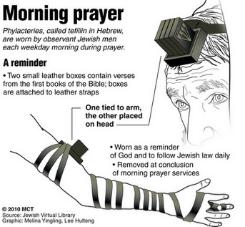***13“But woe to you, scribes and Pharisees, hypocrites! For you shut up the kingdom of heaven against men; for you neither go in yourselves, nor do you allow those who are entering to go in. 14Woe to you, scribes and Pharisees, hypocrites! For you devour widows’ houses, and for a pretense make long prayers. Therefore you will receive greater condemnation. 15“Woe to you, scribes and Pharisees, hypocrites! For you travel land and sea to win one proselyte, and when he is won, you make him twice as much a son of hell as yourselves.*

**Do you know what a phylacteries is?**

*It is a small leather box containing Hebrew texts on vellum, worn by Jewish men at morning prayer as a reminder to keep the law.*

1. Jesus was upset with the scribes and Pharisees and described them as *hypocrites*. In the passage above, a hypocrite can best be described as someone who:
2. likes to sit in the best seat in church
3. makes life hard for others
4. pretends to be holy but doesn’t live a holy life
5. likes to be called Rabbi (teacher)
6. Look up the word **proselyte** and write the definition in the box below:

**Tuesday 25th April Read Chapter 23 verses 10 – 21**

### Woe to the Scribes and Pharisees

*16“Woe to you, blind guides, who say, ‘Whoever swears by the temple, it is nothing; but whoever swears by the gold of the temple, he is obliged to perform it.’ 17Fools and blind! For which is greater, the gold or the temple that sanctifies the gold? 18And, ‘Whoever swears by the altar, it is nothing; but whoever swears by the gift that is on it, he is obliged to perform it.’ 19Fools and blind! For which is greater, the gift or the altar that sanctifies the gift? 20Therefore he who swears by the altar, swears by it and by all things on it. 21He who swears by the temple, swears by it and by Him who dwells in it. 22And he who swears by heaven, swears by the throne of God and by Him who sits on it.*

### Woe to the Scribes and Pharisees

*23“Woe to you, scribes and Pharisees, hypocrites! For you pay tithe of mint and anise and cummin, and have neglected the weightier matters of the law: justice and mercy and faith. These you ought to have done, without leaving the others undone. 24Blind guides, who strain out a gnat and swallow a camel!*

*25“Woe to you, scribes and Pharisees, hypocrites! For you cleanse the outside of the cup and dish, but inside they are full of extortion and self-indulgence.[*[*f*](https://www.biblegateway.com/passage/?search=Matthew+23&version=NKJV#fen-NKJV-23944f)*] 26Blind Pharisee, first cleanse the inside of the cup and dish, that the outside of them may be clean also. 27“Woe to you, scribes and Pharisees, hypocrites! For you are like whitewashed tombs which indeed appear beautiful outwardly, but inside are full of dead men’s bones and all uncleanness. 28Even so you also outwardly appear righteous to men, but inside you are full of hypocrisy and lawlessness. 29“Woe to you, scribes and Pharisees, hypocrites! Because you build the tombs of the prophets and adorn the monuments of the righteous, 30and say, ‘If we had lived in the days of our fathers, we would not have been partakers with them in the blood of the prophets.’*

1. The Jews were very careful not to use God’s name when making a promise. This was because of a commandment given to them in the Old Testament. Read the commandment in the book of Exodus chapter 20, verse 7 and write the verse below.

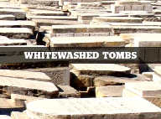

1. Cross out the incorrect word/s:

Jesus **wanted/did not want** people to be like whitewashed tombs. A whitewhashed tomb represents someone who appears **holy/unholy** on the outside but is actually **holy/unholy** on the inside.

**Wednesday 26th April Read Chapter 23 verses 22 – 27**

**Warning and Judgement to the Scribes and the Pharisees**

*31“Therefore you are witnesses against yourselves that you are sons of those who murdered the prophets. 32Fill up, then, the measure of your fathers’ guilt. 33Serpents, brood of vipers! How can you escape the condemnation of hell? 34Therefore, indeed, I send you prophets, wise men, and scribes: some of them you will kill and crucify, and some of them you will scourge in your synagogues and persecute from city to city, 35that on you may come all the righteous blood shed on the earth, from the blood of righteous Abel to the blood of Zechariah, son of Berechiah, whom you murdered between the temple and the altar. 36Assuredly, I say to you, all these things will come upon this generation.*

### Jesus Laments over Jerusalem

*37“O Jerusalem, Jerusalem, the one who kills the prophets and stones those who are sent to her! How often I wanted to gather your children together, as a hen gathers her chicks under her wings, but you were not willing! 38See! Your house is left to you desolate; 39for I say to you, you shall see Me no more till you say, ‘Blessed is He who comes in the name of the Lord!’ ”*

1. Look at the image below and write down another time Jesus was angry with people out of love.

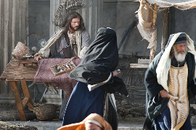*Jesus is particularly angry with the scribes and Pharisees in the verses above because they were given many opportunities to repent. God sent them prophets to warn them and their ancestors but they never changed from their evil ways. Jesus’ anger is however based on love. He loves everyone so much and wants us all to be with Him in His kingdom.*

1. Choose the picture below which shows how Jesus wants to gather all people to Himself as described above.

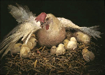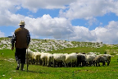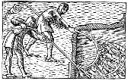

A

B

C

D

**Thursday 27th April Read Chapter 24 verses 1 – 14**

### Jesus Predicts the Destruction of the Temple

*1Then Jesus went out and departed from the temple, and His disciples came up to show Him the buildings of the temple. 2And Jesus said to them, “Do you not see all these things? Assuredly, I say to you, not one stone shall be left here upon another, that shall not be thrown down.”*

### The Signs of the Times and the End of the Age

*3Now as He sat on the Mount of Olives, the disciples came to Him privately, saying, “Tell us, when will these things be? And what will be the sign of Your coming, and of the end of the age?”*

*4And Jesus answered and said to them: “Take heed that no one deceives you. 5For many will come in My name, saying, ‘I am the Christ,’ and will deceive many. 6And you will hear of wars and rumors of wars. See that you are not troubled; for all these things must come to pass, but the end is not yet. 7For nation will rise against nation, and kingdom against kingdom. And there will be famines, pestilences, and earthquakes in various places. 8All these are the beginning of sorrows.*

*9“Then they will deliver you up to tribulation and kill you, and you will be hated by all nations for My name’s sake. 10And then many will be offended, will betray one another, and will hate one another. 11Then many false prophets will rise up and deceive many. 12And because lawlessness will abound, the love of many will grow cold. 13But he who endures to the end shall be saved. 14And this gospel of the kingdom will be preached in all the world as a witness to all the nations, and then the end will come.*

1. Number the signs of the end of the world below in the order they are mentioned in the passage. One has been done for you.

Believers will be hated by others.

1

Many will deceive and claim they are Christ.

False prophets will trick people into believing other things.

There will be famines, pestilences, and earthquakes in various places.

Nations will fight against each other.

1. Fill in the missing words and memorise the verse by heart.

‘But he who to the end will be ’ v13

**Friday 28th April Read Chapter 24 verses 15 – 31**

### The Great Tribulation

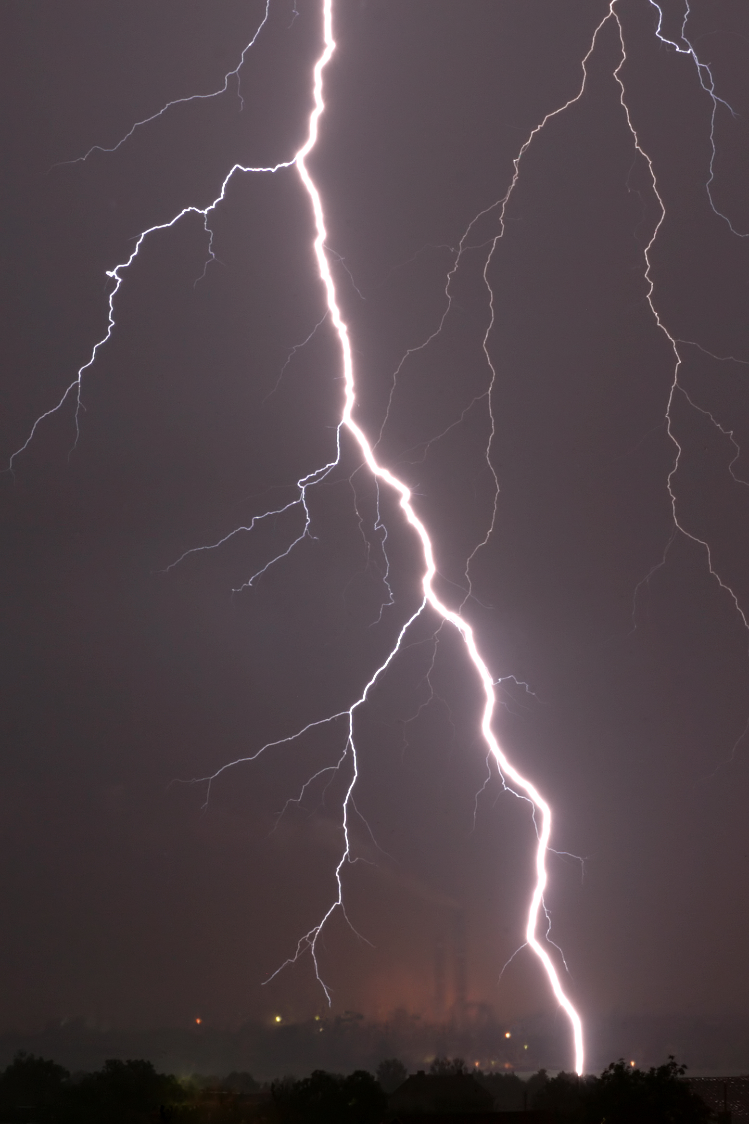*15“Therefore when you see the ‘abomination of desolation,’ spoken of by Daniel the prophet, standing in the holy place” (whoever reads, let him understand), 16“then let those who are in Judea flee to the mountains. 17Let him who is on the housetop not go down to take anything out of his house. 18And let him who is in the field not go back to get his clothes. 19But woe to those who are pregnant and to those who are nursing babies in those days! 20And pray that your flight may not be in winter or on the Sabbath. 21For then there will be great tribulation, such as has not been since the beginning of the world until this time, no, nor ever shall be. 22And unless those days were shortened, no flesh would be saved; but for the elect’s sake those days will be shortened. 23“Then if anyone says to you, ‘Look, here is the Christ!’ or ‘There!’ do not believe it. 24For false christs and false prophets will rise and show great signs and wonders to deceive, if possible, even the elect. 25See, I have told you beforehand. 26“Therefore if they say to you, ‘Look, He is in the desert!’ do not go out; or ‘Look, He is in the inner rooms!’ do not believe it. 27For as the lightning comes from the east and flashes to the west, so also will the coming of the Son of Man be. 28For wherever the carcass is, there the eagles will be gathered together.*

### The Coming of the Son of Man

*29“Immediately after the tribulation of those days the sun will be darkened, and the moon will not give its light; the stars will fall from heaven, and the powers of the heavens will be shaken. 30Then the sign of the Son of Man will appear in heaven, and then all the tribes of the earth will mourn, and they will see the Son of Man coming on the clouds of heaven with power and great glory. 31And He will send His angels with a great sound of a trumpet, and they will gather together His elect from the four winds, from one end of heaven to the other.*

1. One sign of the end of the world is that some people will try to convince others they are Christ. How will people know they are not *really* Christ?
2. They will look different to pictures we have seen.
3. They will be too young to be Christ.
4. Christ’s coming will be very very quick.
5. 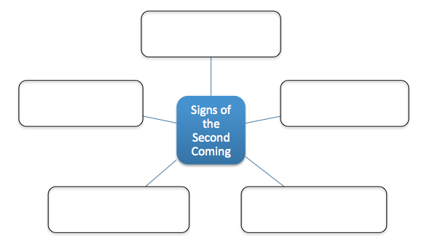They will not be able to do miracles like Christ can.
6. In the bubbles below, write down five signs of the second coming of Christ.

**Saturday 29th April Read Chapter 24 verses 32 – 51**

### The Parable of the Fig Tree

*32“Now learn this parable from the fig tree: When its branch has already become tender and puts forth leaves, you know that summer is near. 33So you also, when you see all these things, know that it is near—at the doors! 34Assuredly, I say to you, this generation will by no means pass away till all these things take place. 35Heaven and earth will pass away, but My words will by no means pass away.*

### No One Knows the Day or Hour

*36“But of that day and hour no one knows, not even the angels of heaven,[[e](https://www.biblegateway.com/passage/?search=Matthew+24&version=NKJV" \l "fen-NKJV-23994e" \o "See footnote e)] but My Father only. 37But as the days of Noah were, so also will the coming of the Son of Man be. 38For as in the days before the flood, they were eating and drinking, marrying and giving in marriage, until the day that Noah entered the ark, 39and did not know until the flood came and took them all away, so also will the coming of the Son of Man be. 40Then two men will be in the field: one will be taken and the other left. 41Two women will be grinding at the mill: one will be taken and the other left. 42Watch therefore, for you do not know what hour[*[*f*](https://www.biblegateway.com/passage/?search=Matthew+24&version=NKJV#fen-NKJV-24000f)*] your Lord is coming. 43But know this, that if the master of the house had known what hour the thief would come, he would have watched and not allowed his house to be broken into. 44Therefore you also be ready, for the Son of Man is coming at an hour you do not expect.*

### The Faithful Servant and the Evil Servant

*45“Who then is a faithful and wise servant, whom his master made ruler over his household, to give them food in due season? 46Blessed is that servant whom his master, when he comes, will find so doing. 47Assuredly, I say to you that he will make him ruler over all his goods. 48But if that evil servant says in his heart, ‘My master is delaying his coming,’ 49and begins to beat his fellow servants, and to eat and drink with the drunkards, 50the master of that servant will come on a day when he is not looking for him and at an hour that he is not aware of, 51and will cut him in two and appoint him his portion with the hypocrites. There shall be weeping and gnashing of teeth.*

1. Unscramble the verse below and type it in the box provided.

“means words pass my will but means no away heaven will away pass earth and by”

1. Jesus often spoke in parables, which are stories to help people understand a message. Can you think of another parable Jesus used? The image below has a few different parables to help you.

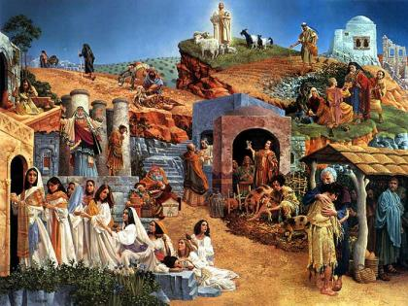

**Parable:**

**PARENTS SECTION:**

We kindly ask you as a parent to read (a little each day) in the Holy Bible with your family.

**Now email your answers to your teacher, choose ONE of the email addresses below.**

**What to do when you finish your Bible Study.**

Send it by email to your class email address or print and hand it to your servants next Sunday.

* Year 5B1 St Thomas[stthomas5b@gmail.com](mailto:stthomas5b@gmail.com) Class Servant- Uncle Andrew

(0416744100)

* Year 5B2 St Philip[saintphilip5g@gmail.com](mailto:saintphilip5g@gmail.com) Class Servant- Uncle Mark

(0413495921)

* Year 5G St Matthew [stmatthew5g@gmail.com](mailto:stmatthew5g@gmail.com) Class Servant – Aunty Dina

(0404604507)