C:\Documents and Settings\suzy\Local Settings\Temporary Internet Files\Content.IE5\3JXW24R5\MC900383922[1].wmfSunday 23 April, 2017

Name:

Class:

Finish Date: Saturday 30 April, 2017

Completed Bible Study = 15 points

Email Homework by the due date = 5 points

**Year 6 Bible Study 1 Peter Chapters 1-3**

**For the questions below Highlight or change the font colour to choose the correct answer.**

* MONDAY: Read 1 Peter Chapter 1:1-12 and answer the questions:

***Greeting to the Elect Pilgrims***

*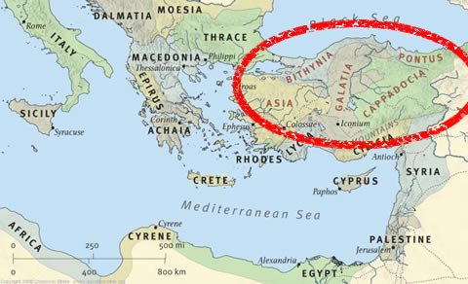Peter, an apostle of Jesus Christ,*

*To the pilgrims of the Dispersion in Pontus, Galatia, Cappadocia, Asia, and Bithynia, 2elect according to the foreknowledge of God the Father, in sanctification of the Spirit, for obedience and sprinkling of the blood of Jesus Christ:*

*Grace to you and peace be multiplied.*

***A Heavenly Inheritance***

*3Blessed be the God and Father of our Lord Jesus Christ, who according to His abundant mercy has begotten us again to a living hope through the resurrection of Jesus Christ from the dead, 4to an inheritance incorruptible and undefiled and that does not fade away, reserved in heaven for you, 5who are kept by the power of God through faith for salvation ready to be revealed in the last time.*

*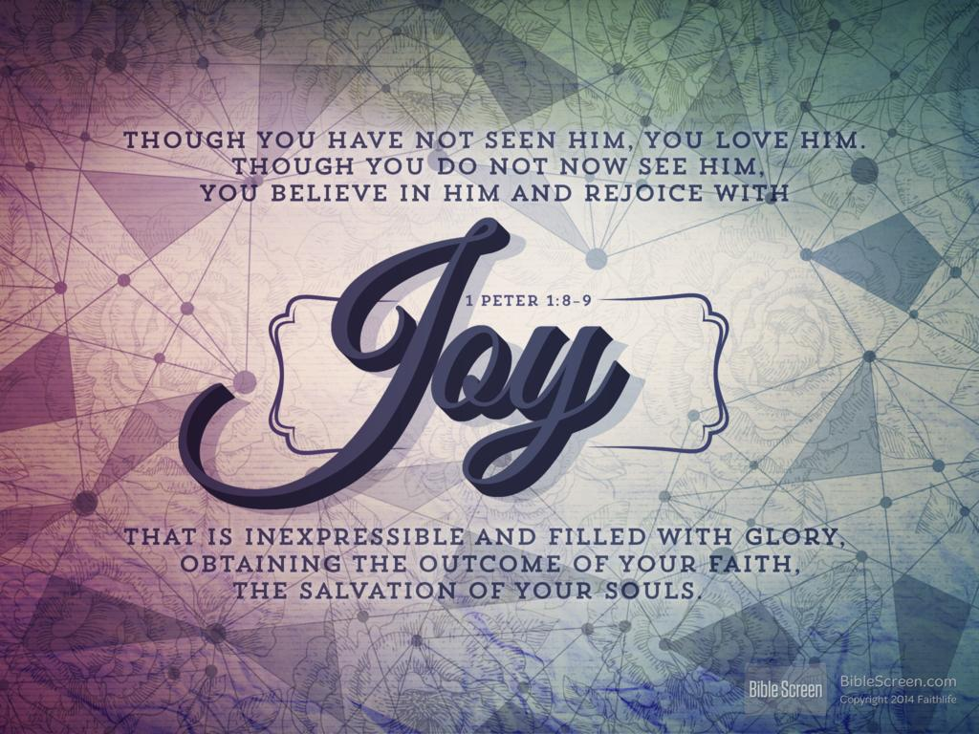6In this you greatly rejoice, though now for a little while, if need be, you have been grieved by various trials, 7that the genuineness of your faith, being much more precious than gold that perishes, though it is tested by fire, may be found to praise, honor, and glory at the revelation of Jesus Christ, 8whom having not seen you love. Though now you do not see Him, yet believing, you rejoice with joy inexpressible and full of glory, 9receiving the end of your faith—the salvation of your souls.*

*10Of this salvation the prophets have inquired and searched carefully, who prophesied of the grace that would come to you, 11searching what, or what manner of time, the Spirit of Christ who was in them was indicating when He testified beforehand the sufferings of Christ and the glories that would follow. 12To them it was revealed that, not to themselves, but to us they were ministering the things which now have been reported to you through those who have preached the gospel to you by the Holy Spirit sent from heaven—things which angels desire to look into.*

**Question 1**

Match the definitions to the correct words below. “Undefiled” is done for you.

|  |  |
| --- | --- |
|  | **Definition** |
| Abundant | Spotless/ unstained |
| Incorruptible | Plentiful |
| Undefiled | Moral / honest |
| Grieved | Indescribable |
| Inexpressible | Prediction |
| Prophesied | Saddened |

**Question 2**

Peter describes a person’s faith as being more precious than what? Hint: verse 7

1. diamonds
2. life
3. gold

* TUESDAY: Read 1 Peter Chapter 1:13-25 and answer the questions:

*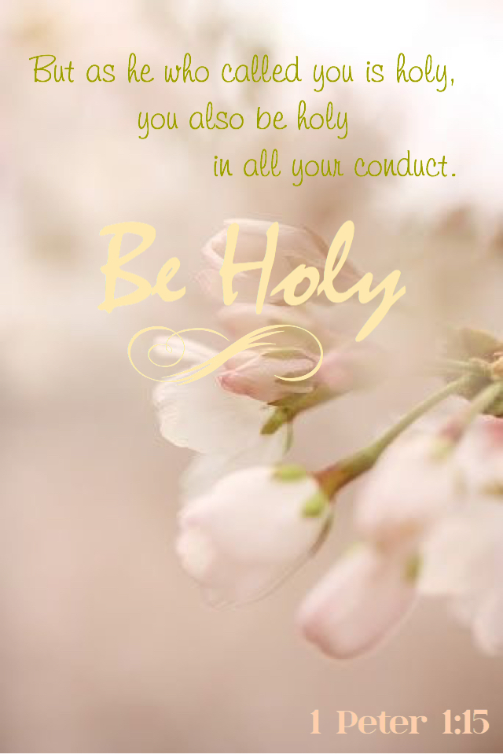****Living Before God Our Father***

*13Therefore gird up the loins of your mind [=keep a strong frame of mind], be sober, and rest your hope fully upon the grace that is to be brought to you at the revelation of Jesus Christ; 14as obedient children, not conforming yourselves to the former lusts, as in your ignorance; 15but as He who called you is holy, you also be holy in all your conduct, 16because it is written, “Be holy, for I am holy.”*

*17And if you call on the Father, who without partiality judges according to each one’s work, conduct yourselves throughout the time of your stay here in fear; 18knowing that you were not redeemed with corruptible things, like silver or gold, from your aimless conduct received by tradition from your fathers, 19but with the precious blood of Christ, as of a lamb without blemish and without spot. 20He indeed was foreordained before the foundation of the world, but was manifest in these last times for you 21who through Him believe in God, who raised Him from the dead and gave Him glory, so that your faith and hope are in God.*

***The Enduring Word***

*22Since you have purified your souls in obeying the truth through the Spirit[[d](https://www.biblegateway.com/passage/?search=1+Peter+1&version=NKJV" \l "fen-NKJV-30397d" \o "See footnote d)] in sincere love of the brethren, love one another fervently with a pure heart, 23having been born again, not of corruptible seed but incorruptible, through the word of God which lives and abides forever,[*[*e*](https://www.biblegateway.com/passage/?search=1+Peter+1&version=NKJV#fen-NKJV-30398e)*] 24because*

*“All flesh is as grass,  
And all the glory of man[[f](https://www.biblegateway.com/passage/?search=1+Peter+1&version=NKJV" \l "fen-NKJV-30399f" \o "See footnote f)] as the flower of the grass.  
The grass withers,  
And its flower falls away,  
25But the word of the Lord endures forever.”[*[*g*](https://www.biblegateway.com/passage/?search=1+Peter+1&version=NKJV#fen-NKJV-30400g)*]*

*Now this is the word which by the gospel was preached to you.*

**Question 3**

Peter tells us we are called to be holy because Christ called us to be holy, as He is holy. Complete the missing words in verse 16 below:

“because it is written, “Be , for I am .”

* WEDNESDAY: Read 1 Peter Chapter 2:1-12 and answer the questions:

*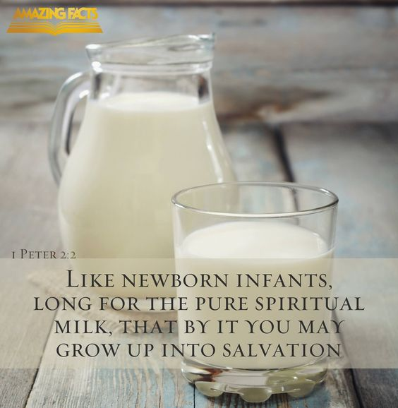Therefore, laying aside all malice, all deceit, hypocrisy, envy, and all evil speaking, 2as newborn babes, desire the pure milk of the word, that you may grow thereby,[[a](https://www.biblegateway.com/passage/?search=1%20Peter+2&version=NKJV" \l "fen-NKJV-30402a" \o "See footnote a)] 3if indeed you have tasted that the Lord is gracious.*

***The Chosen Stone and His Chosen People***

*4Coming to Him as to a living stone, rejected indeed by men, but chosen by God and precious, 5you also, as living stones, are being built up a spiritual house, a holy priesthood, to offer up spiritual sacrifices acceptable to God through Jesus Christ. 6Therefore it is also contained in the Scripture,*

*“Behold, I lay in Zion  
A chief cornerstone, elect, precious,  
And he who believes on Him will by no means be put to shame.”[*[*b*](https://www.biblegateway.com/passage/?search=1%20Peter+2&version=NKJV#fen-NKJV-30406b)*]*

*7Therefore, to you who believe, He is precious; but to those who are disobedient,[[c](https://www.biblegateway.com/passage/?search=1%20Peter+2&version=NKJV" \l "fen-NKJV-30407c" \o "See footnote c)]*

*“The stone which the builders rejected  
Has become the chief cornerstone,”[*[*d*](https://www.biblegateway.com/passage/?search=1%20Peter+2&version=NKJV#fen-NKJV-30407d)*]*

*8and*

*“A stone of stumbling  
And a rock of offense.”[*[*e*](https://www.biblegateway.com/passage/?search=1%20Peter+2&version=NKJV#fen-NKJV-30408e)*]*

*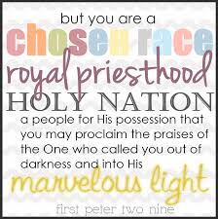They stumble, being disobedient to the word, to which they also were appointed.*

*9But you are a chosen generation, a royal priesthood, a holy nation, His own special people, that you may proclaim the praises of Him who called you out of darkness into His marvelous light; 10who once were not a people but are now the people of God, who had not obtained mercy but now have obtained mercy.*

***Living Before the World***

*11Beloved, I beg you as sojourners and pilgrims, abstain from fleshly lusts which war against the soul, 12having your conduct honorable among the Gentiles, that when they speak against you as evildoers, they may, by your good works which they observe, glorify God in the day of visitation.*

**Question 4**

Who is Peter referring to in verse 9 when he says “His own special people?”

* THURSDAY: Read 1 Peter Chapter 2:13-25and answer the questions:

***Submission to Government***

*13Therefore submit yourselves to every ordinance of man for the Lord’s sake, whether to the king as supreme, 14or to governors, as to those who are sent by him for the punishment of evildoers and for the praise of those who do good. 15For this is the will of God, that by doing good you may put to silence the ignorance of foolish men— 16as free, yet not using liberty as a cloak for vice, but as bondservants of God. 17Honor all people. Love the brotherhood. Fear God. Honor the king.*

***Submission to Masters***

*18Servants, be submissive to your masters with all fear, not only to the good and gentle, but also to the harsh. 19For this is commendable, if because of conscience toward God one endures grief, suffering wrongfully. 20For what credit is it if, when you are beaten for your faults, you take it patiently? But when you do good and suffer, if you take it patiently, this is commendable before God. 21For to this you were called, because Christ also suffered for us,[[f](https://www.biblegateway.com/passage/?search=1%20Peter+2&version=NKJV" \l "fen-NKJV-30421f" \o "See footnote f)] leaving us[*[*g*](https://www.biblegateway.com/passage/?search=1%20Peter+2&version=NKJV#fen-NKJV-30421g)*] an example, that you should follow His steps:*

*22“Who committed no sin,  
Nor was deceit found in His mouth”; [*[*h*](https://www.biblegateway.com/passage/?search=1%20Peter+2&version=NKJV#fen-NKJV-30422h)*]*

*23who, when He was reviled, did not revile in return; when He suffered, He did not threaten, but committed Himself to Him who judges righteously; 24who Himself bore our sins in His own body on the tree, that we, having died to sins, might live for righteousness—by whose stripes you were healed. 25 For you were like sheep going astray, but have now returned to the Shepherd and Overseer[[i](https://www.biblegateway.com/passage/?search=1%20Peter+2&version=NKJV" \l "fen-NKJV-30425i" \o "See footnote i)] of your souls.*

**Question 5**

King and God. Who does it say we should fear, and who should we honour? Insert the correct answers in the table below.

|  |  |
| --- | --- |
| *Fear* |  |
| *Honour* |  |

* FRIDAY: Read 1 Peter Chapter 3:1-12 and answer the questions:

### *Submission to Husbands*

*Wives, likewise, be submissive to your own husbands, that even if some do not obey the word, they, without a word, may be won by the conduct of their wives, 2when they observe your chaste conduct accompanied by fear. 3Do not let your adornment be merely outward—arranging the hair, wearing gold, or putting on fine apparel— 4rather let it be the hidden person of the heart, with the incorruptible beauty of a gentle and quiet spirit, which is very precious in the sight of God. 5For in this manner, in former times, the holy women who trusted in God also adorned themselves, being submissive to their own husbands, 6as Sarah obeyed Abraham, calling him lord, whose daughters you are if you do good and are not afraid with any terror.*

### *A Word to Husbands*

*7Husbands, likewise, dwell with them with understanding, giving honor to the wife, as to the weaker vessel, and as being heirs together of the grace of life, that your prayers may not be hindered.*

### *Called to Blessing*

*8Finally, all of you be of one mind, having compassion for one another; love as brothers, be tenderhearted, be courteous;[[a](https://www.biblegateway.com/passage/?search=1%20Peter+3&version=NKJV" \l "fen-NKJV-30433a" \o "See footnote a)] 9not returning evil for evil or reviling for reviling, but on the contrary blessing, knowing that you were called to this, that you may inherit a blessing. 10For*

*“He who would love life  
And see good days,  
Let him refrain his tongue from evil,  
And his lips from speaking deceit.  
11Let him turn away from evil and do good;  
Let him seek peace and pursue it.  
12For the eyes of the Lord*are*on the righteous,  
And His ears are open to their prayers;  
But the face of the Lord*is*against those who do evil.”[*[*b*](https://www.biblegateway.com/passage/?search=1%20Peter+3&version=NKJV#fen-NKJV-30437b)*]*

**Question 6**

### True/false

|  |  |
| --- | --- |
| The incorruptible beauty of a gentle and quiet spirit is not very precious in the sight of God. | *True/false* |
| Husbands are to give honour to their wives and wives are to submit to their husbands. | *True/false* |
| If someone wrongs you, you should return that evil | *True/false* |
| The eyes f the Lord are on the righteous and He hears their prayers. | *True/false* |

* SATURDAY: Read 1 Peter Chapter 3:13-22 and answer the questions:

### *Suffering for Right and Wrong*

*13And who is he who will harm you if you become followers of what is good? 14But even if you should suffer for righteousness’ sake, you are blessed. “And do not be afraid of their threats, nor be troubled.”[*[*c*](https://www.biblegateway.com/passage/?search=1%20Peter+3&version=NKJV#fen-NKJV-30439c)*] 15But sanctify the Lord God[[d](https://www.biblegateway.com/passage/?search=1%20Peter+3&version=NKJV" \l "fen-NKJV-30440d" \o "See footnote d)] in your hearts, and always be ready to give a defense to everyone who asks you a reason for the hope that is in you, with meekness and fear; 16having a good conscience, that when they defame you as evildoers, those who revile your good conduct in Christ may be ashamed. 17For it is better, if it is the will of God, to suffer for doing good than for doing evil.*

### *Christ’s Suffering and Ours*

*18For Christ also suffered once for sins, the just for the unjust, that He might bring us[[e](https://www.biblegateway.com/passage/?search=1%20Peter+3&version=NKJV" \l "fen-NKJV-30443e" \o "See footnote e)] to God, being put to death in the flesh but made alive by the Spirit, 19by whom also He went and preached to the spirits in prison, 20who formerly were disobedient, when once the Divine longsuffering waited[*[*f*](https://www.biblegateway.com/passage/?search=1%20Peter+3&version=NKJV#fen-NKJV-30445f)*] in the days of Noah, while the ark was being prepared, in which a few, that is, eight souls, were saved through water. 21There is also an antitype which now saves us—baptism (not the removal of the filth of the flesh, but the answer of a good conscience toward God), through the resurrection of Jesus Christ, 22who has gone into heaven and is at the right hand of God, angels and authorities and powers having been made subject to Him.*

**Question 7**

Peter was writing this letter to Christians who were being persecuted for their faith, encouraging them to stand firm in Christ. He reminds them of someone else who suffered for us first – who is that?

**What to do when you finish your Bible Study.**

Send it by email to your class email address or print and hand it to your servants next Sunday.

* Year 6B1 St Mark [stmark6b1@gmail.com](mailto:stmark6b1@gmail.com) Class Servant- Uncle Adel (0422884699)
* Year 6B2 St Luke [stluke6b2@gmail.com](mailto:stluke6b2@gmail.com) Class Servant- Uncle Fady (0424740775)
* Year 6G St John[stjohn6g@gmail.com](mailto:stjohn6g@gmail.com) Class Servant- Aunty Nancy (0400212921)