Sunday 19th March 2017
Name:
Class:
Due Date: Saturday 25th March 2017

Completed Bible Study = 15 points,
Handed in by the due date = 5 extra points

The GOSPEL according to ST. Matthew
Year 5 – Bible Study 7 (Chapters 13 & 14)

Monday 20th March Read Chapter 13 verses 1 – 23

The Parable of the Sower
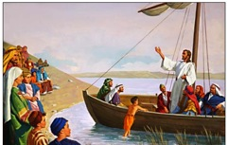
¹On the same day Jesus went out of the house and sat by the sea. ² And great multitudes were gathered together to Him, so that He got into a boat and sat; and the whole multitude stood on the shore. ³ Then He spoke many things to them in parables, saying: “Behold, a sower went out to sow. ⁴ And as he sowed, some seed fell by the wayside; and the birds came and devoured them. ⁵ Some fell on stony places, where they did not have much earth; and they immediately sprang up because they had no depth of earth. ⁶ But when the sun was up they were scorched, and because they had no root they withered away. ⁷ And some fell among thorns, and the thorns sprang up and choked them. ⁸ But others fell on good ground and yielded a crop: some a hundredfold, some sixty, some thirty. ⁹ He who has ears to hear, let him hear!”

The Purpose of Parables
¹⁰ And the disciples came and said to Him, “Why do You speak to them in parables?”
¹¹ He answered and said to them, “Because it has been given to you to know the mysteries of the kingdom of heaven, but to them it has not been given. ¹² For whoever has, to him more will be given, and he will have abundance; but whoever does not have, even what he has will be taken away from him. ¹³ Therefore I speak to them in parables, because seeing they do not see, and hearing they do not hear, nor do they understand. ¹⁴ And in them the prophecy of Isaiah is fulfilled, which says: ‘Hearing you will hear and shall not understand, And seeing you will see and not perceive; ¹⁵ For the hearts of this people have grown dull. Their ears are hard of hearing, And their eyes they have closed, Lest they should see with their eyes and hear with their ears, Lest they should understand with their hearts and turn, So that I should heal them.’ ¹⁶ But blessed are your eyes for they see, and your ears for they hear; ¹⁷ for assuredly, I say to you that many prophets and righteous men desired to see what you see, and did not see it, and to hear what you hear, and did not hear it.

The Parable of the Sower Explained
¹⁸ “Therefore hear the parable of the sower: ¹⁹ When anyone hears the word of the kingdom, and does not understand it, then the wicked one comes and snatches away what was sown in his heart. This is he who received seed by the wayside. ²⁰ But he who received the seed on stony places, this is he who hears the word and immediately receives it with joy; ²¹ yet he has no root in himself, but endures only for a while. For when tribulation or persecution arises because of the word, immediately he stumbles. ²² Now he who received seed among the thorns is he who hears the word, and the cares of this world and the deceitfulness of riches choke the word, and he becomes unfruitful. ²³ But he who received seed on the good ground is he who hears the word and understands it, who indeed bears fruit and produces: some a hundredfold, some sixty, some thirty.”

1. In the parable of the sower, the seeds were planted in 4 different ways. Find the verse that describes each of the pictures below.
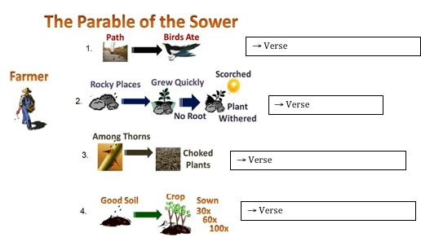
2. True or false
- Jesus teaches in parables to separate those who have "ears" and those who don't. True/False
- The use of the word "ears" is another way of saying "those who want to know about God's kingdom". True/False.
- Those who do not want to learn from Jesus will be able to understand what these parables are saying. True/False.
- The knowledge of the secrets of the Kingdom of Heaven have been given to those who have ears to hear will hear. True/False
- But those who do not want to know about God's kingdom or learn from Jesus just won't get it... even what they know will be taken away from them, so that even though they have ears - they won't be able to hear; and even though they have eyes - they won't be able to see... because they have hardened their heart against Jesus. True/False

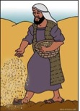

Tuesday 21st March Read Chapter 13 verses 24 – 43

The Parable of the Wheat and the Tares
²⁴ Another parable He put forth to them, saying: “The kingdom of heaven is like a man who sowed good seed in his field; ²⁵ but while men slept, his enemy came and sowed tares among the wheat and went his way. ²⁶ But when the grain had sprouted and produced a crop, then the tares also appeared. ²⁷ So the servants of the owner came and said to him, ‘Sir, did you not sow good seed in your field? How then does it have tares?’ ²⁸ He said to them, ‘An enemy has done this.’ The servants said to him, ‘Do you want us then to go and gather them up?’ ²⁹ But he said, ‘No, lest while you gather up the tares you also uproot the wheat with them. ³⁰ Let both grow together until the harvest, and at the time of harvest I will say to the reapers, “First gather together the tares and bind them in bundles to burn them, but gather the wheat into my barn.”’”

The Parable of the Mustard Seed


³¹ Another parable He put forth to them, saying: “The kingdom of heaven is like a mustard seed, which a man took and sowed in his field, ³² which indeed is the least of all the seeds; but when it is grown it is greater than the herbs and becomes a tree, so that the birds of the air come and nest in its branches.

Prophecy and the Parables
³⁴ All these things Jesus spoke to the multitude in parables; and without a parable He did not speak to them, ³⁵ that it might be fulfilled which was spoken by the prophet, saying: “I will open My mouth in parables; I will utter things kept secret from the foundation of the world.”

The Parable of the Tares Explained
³⁶ Then Jesus sent the multitude away and went into the house. And His disciples came to Him, saying, “Explain to us the parable of the tares of the field.” ³⁷ He answered and said to them: “He who sows the good seed is the Son of Man. ³⁸ The field is the world, the good seeds are the sons of the kingdom, but the tares are the sons of the wicked one. ³⁹ The enemy who sowed them is the devil, the harvest is the end of the age, and the reapers are the angels. ⁴⁰ Therefore as the tares are gathered and burned in the fire, so it will be at the end of this age. ⁴¹ The Son of Man will send out His angels, and they will gather out of His kingdom all things that offend, and those who practice lawlessness, ⁴² and will cast them into the furnace of fire. There will be wailing and gnashing of teeth. ⁴³ Then the righteous will shine forth as the sun in the kingdom of their Father. He who has ears to hear, let him hear!
Do you know what Tare is?
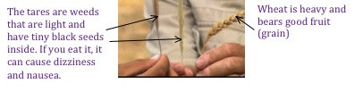

3. Use the words in the word list below to match it with its meaning: Harvest, Enemy, Reapers, Sower, Tares (weed), Good seed(wheat), Field.
Word | Meaning
 | Jesus Christ and His Apostles
 | Followers of Jesus
 | World
 | Satan
 | Followers of Satan
 | Angels
 | Jesus’ second coming

4. The prophecy in verse 35 came from the Old Testament Book , Psalm 78:2.
This is another prophecy about Jesus that has been fulfilled.
- What word in Tuesday night’s Bible reading mean “things kept secret”? Hint: Verse 11

- Jesus told 46 parables. In this week’s Bible study you learned 3 parables.
Can you think of two other parables you know you didn’t read this week.
1.
2.

Wednesday 22nd March Read Chapter 13 verses 44 – 58

The Parable of the Hidden Treasure

⁴⁴ “Again, the kingdom of heaven is like treasure hidden in a field, which a man found and hid; and for joy over it he goes and sells all that he has a buys that field.

The Parable of the Pearl of Great Price

⁴⁵ “Again, the kingdom of heaven is like a merchant seeking beautiful pearls, ⁴⁶ who, when he had found one pearl of great price, went and sold all that he had and bought it.
The Parable of the Dragnet
(or the Parable of the Various Kinds of Fish)
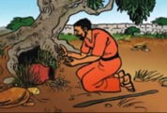
⁴⁷ “Again, the kingdom of heaven is like a dragnet that was cast into the sea and gathered some of every kind, ⁴⁸ which, when it was full, they drew to shore; and they sat down and gathered the good into vessels, but threw the bad away. ⁴⁹ So it will be at the end of the age. The angels will come forth, separate the wicked from among the just, ⁵⁰ and cast them into the furnace of fire. There will be wailing and gnashing of teeth.” ⁵¹ Jesus said to them, “Have you understood all these things?” They said to Him, “Yes, Lord.” ⁵² Then He said to them, “Therefore every scribe instructed concerning the kingdom of heaven is like a householder who brings out of his treasure things new and old.”

Jesus Rejected at Nazareth
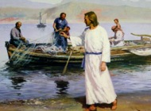
⁵³ Now it came to pass, when Jesus had finished these parables, that He departed from there. ⁵⁴ When He had come to His own country, He taught them in their synagogue, so that they were astonished and said, “Where did this Man get this wisdom and these mighty works? ⁵⁵ Is this not the carpenter’s son? Is not His mother called Mary? And His brothers James, Joses, Simon, and Judas? ⁵⁶ And His sisters, are they not all with us? Where then did this Man get all these things?” ⁵⁷ So they were offended at Him. But Jesus said to them, “A prophet is not without honor except in his own country and in his own house.” ⁵⁸ Now He did not do many mighty works there because of their unbelief.

5. True or False
- The pearl is a very valuable stone. True/False
- The man in the story sold the things he didn’t like so that he could buy the pearl. True/False
- We should we be happy when we have to give up Earthly things so that we can have Heaven. True/False

6. The people were astonished (surprised) at Jesus’ teaching in the synagogue. Explain why?


Do you know what a dragnet is?
Fishermen using a dragnet, a weighted net dragged along the bottom of a body of water to collect an assortment of fish.
In the parable, the dragnet is cast into the sea and pulled onto shore full of all kinds of fish. Then the fishermen sat down to the business of sorting the fish into the “good” and the “bad.” The fish worth keeping were gathered into containers, but the rest were tossed away.
Jesus then interprets the parable for His disciples: “This is how it will be at the end of the age. The angels will come and separate the wicked from the righteous.
Thursday 23rd March Read Chapter 14 verses 13 – 27

Jesus has compassion for the thousands of people who were following Him
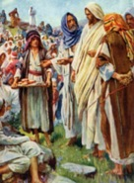
¹³ When Jesus heard it, He departed from there by boat to a deserted place by Himself. But when the multitudes heard it, they followed Him on foot from the cities. ¹⁴ And when Jesus went out He saw a great multitude; and He was moved with compassion for them, and healed their sick. ¹⁵ When it was evening, His disciples came to Him, saying, “This is a deserted place, and the hour is already late. Send the multitudes away, that they may go into the villages and buy themselves food.”

Feeding the Five Thousand
¹⁶ But Jesus said to them, “They do not need to go away. You give them something to eat.” ¹⁷ And they said to Him, “We have here only five loaves and two fish.” ¹⁸ He said, “Bring them here to Me.” ¹⁹Then He commanded the multitudes to sit down on the grass. And He took the five loaves and the two fish, and looking up to heaven, He blessed and broke and gave the loaves to the disciples; and the disciples gave to the multitudes. ²⁰ So they all ate and were filled, and they took up twelve baskets full of the fragments that remained. ²¹ Now those who had eaten were about five thousand men, besides women and children.

Jesus Walks on the Sea

²² Immediately Jesus made His disciples get into the boat and go before Him to the other side, while He sent the multitudes away. ²³ And when He had sent the multitudes away, He went up on the mountain by Himself to pray. Now when evening came, He was alone there. ²⁴ But the boat was now in the middle of the sea, tossed by the waves, for the wind was contrary. ²⁵ Now in the fourth watch of the night Jesus went to them, walking on the sea. ²⁶ And when the disciples saw Him walking on the sea, they were troubled, saying, “It is a ghost!” And they cried out for fear.
²⁷ But immediately Jesus spoke to them, saying, “Be of good cheer! It is I; do not be afraid.”

7. True or False
- Jesus’ followers loved Him so much that they followed Him by boat. True/ False
- Jesus wanted to be by himself for a while so was unhappy to be followed by the people. True/ False
- Jesus performed miracles. True/ False
- The disciples were worried about how to feed the people that followed Jesus. True / False

8. What was Jesus doing whilst the disciples took the boat ahead to the other side?
- praying
- sleeping
- performing a miracle

Friday 24th March Read Chapter 12 verses 28 – 36
²⁸ And Peter answered Him and said, “Lord, if it is You, command me to come to You on the water.” ²⁹ So He said, “Come.” And when Peter had come down out of the boat, he walked on the water to go to Jesus. ³⁰ But when he saw that the wind was boisterous (fierce) he was afraid; and beginning to sink he cried out, saying, “Lord, save me!” ³¹ And immediately Jesus stretched out His hand and caught him, and said to him, “O you of little faith, why did you doubt?” ³² And when they got into the boat, the wind ceased. ³³ Then those who were in the boat came and worshiped Him, saying, “Truly You are the Son of God.

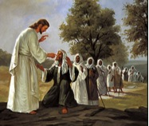
Many Touch Him and Are Made Well
³⁴ When they had crossed over, they came to the land of Gennesaret. ³⁵ And when the men of that place recognized Him, they sent out into all that surrounding region, brought to Him all who were sick, ³⁶ and begged Him that they might only touch the hem of His garment. And as many as touched it were made perfectly well.

9. Jesus came to the disciples on the boat walking on water in the midst of the storm. Peter, believing that it was Jesus was also able to walk on the water. What was it that made Jesus realise that Peter’s faith in Him was shaken for a moment?

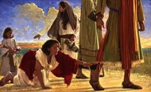
10. Jesus heals all those you simply touch his clothes. This also happened in Matthew 9 when a lady who had been bleeding for 12 years came behind Him and touched His garment. What did Jesus say had healed her? (Hint- Matt 9:22) Complete the missing word:

“Be of good cheer, daughter; your has made you well.”

Saturday 25th March Read Memory Verse
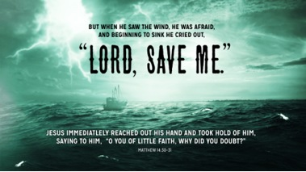

Do you know this little prayer?
Even when Peter’s faith fails him and he finds himself sinking, he cries quickly
“LORD, SAVE ME.” His prayer was as full as it was short and Jesus did not delay in responding. He immediately reached out His hand… Peter was nearer to our Lord when He was sinking than when he was walking. Then he resumed the walk of faith. How easy it is to have faith when Christ Himself is at our side! Lord, when our faith fails us hear us cry “Lord, save me” and we shall walk on the wave.

PARENTS SECTION:
We kindly ask you as a parent to read (a little each day) in the Holy Bible with your family.
Now email your answers to your teacher, choose ONE of the email addresses below.
What to do when you finish your Bible Study.
Send it by email to your class email address or print and hand it to your servants next Sunday.
- Year 5B1 St Thomas stthomas5b@gmail.com Class Servant- Uncle Andrew (0416744100)
- Year 5B2 St Philip saintphilip5g@gmail.com Class Servant- Uncle Mark (0413495921)
- Year 5G St Matthew stmatthew5g@gmail.com Class Servant – Aunty Dina (0404604507)

