C:\Documents and Settings\suzy\Local Settings\Temporary Internet Files\Content.IE5\3JXW24R5\MC900383922[1].wmfSunday 19th March, 2017

Name:

Class:

Finish Date: Saturday 25th March, 2017

Completed Bible Study = 15 points

Email by the due date = 5 extra points

**Year 3 Bible Study Mark Chapter 6**

**For the questions below Highlight or change the font colour to choose the correct answer.**

# Monday: Read Mark Chapter 6:1-6 and answer the questions:

### Jesus Rejected at Nazareth

*1Then He went out from there and came to His* ***own country****, and His disciples followed Him. 2And when the Sabbath had come, He began to teach in the synagogue. And many hearing Him were astonished, saying, “Where did this Man get these things? And what wisdom is this which is given to Him, that such mighty works are performed by His hands! 3Is this not the carpenter, the Son of Mary, and brother of James, Joses, Judas, and Simon? And are not His sisters here with us?” So they were offended at Him.*

*4But Jesus said to them, “A prophet is not without honor except in his own country, among his own relatives, and in his own house.” 5Now He could do no mighty work there, except that He laid His hands on a few sick people and healed them. 6And He marveled because of their unbelief. Then He went about the villages in a circuit, teaching.*

**Question 1**

Jesus own country was Nazareth. He went back to Nazareth to teach the people He grew up with, His family and friends, about the kingdom of God.

1. Where did Jesus teach on the Sabbath?
2. The Jews were astonished (surprised) by Jesus’ teaching. They could not believe that He came with God’s message. They said Jesus taught with a lot of

W

1. What do you think is meant by **‘***such mighty works are performed by His hands’*
2. that Jesus was a carpenter and made furniture from wood
3. that Jesus performed miracles and healed many sick people
4. that Jesus could make bread with His hands

# Tuesday: Read Mark Chapter 6: 7 - 13 and answer the questions:

### Sending Out the Twelve

*7And He called the twelve to Himself, and began to send*

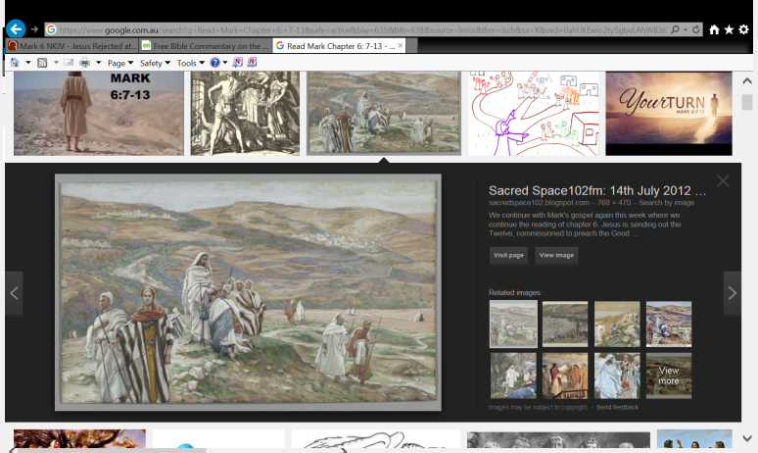

Staff in their hands

*them out two by two, and gave them power over*

*unclean spirits. 8He commanded them to take nothing*

*for the journey except a staff—no bag, no bread,*

*no copper in their money belts— 9but to wear sandals,*

*and not to put on two tunics.*

*10Also He said to them, “In whatever place you enter a house, stay there till you depart from that place. 11And whoever will not receive you nor hear you, when you depart from there, shake off the dust under your feet as a testimony against them. Assuredly, I say to you, it will be more tolerable for Sodom and Gomorrah in the day of judgment than for that city!”*

*12So they went out and preached that people should repent. 13And they cast out many demons, and anointed with oil many who were sick, and healed them.*

**Question 2**

After He called the twelve disciples, Jesus sent them:

1. As a group together
2. Everyone on his own
3. Two by two

**Question 3**

What was the only thing the disciples were allowed to take with them when Jesus sent them out to teach people to repent?

**Question 4**

What two other important things did the disciples do as well as teach people to repent?

i)

ii)

# Wednesday: Read Mark Chapter 6:14-29 and answer the questions:

**John the Baptist**

*14Now King Herod heard of Him, for His name had become well known. And he said, “John the Baptist is risen from the dead, and therefore these powers are at work in him.”*

*15Others said, “It is Elijah.”*

*And others said, “It is the Prophet, or like one of the prophets.”*

*16But when Herod heard, he said, “This is John, whom I beheaded; he has been raised from the dead!” 17For Herod himself had sent and laid hold of John, and bound him in prison for the sake of Herodias, his brother Philip’s wife; for he had married her. 18Because John had said to Herod, “It is not lawful for you to have your brother’s wife.”*

*19Therefore Herodias held it against him and wanted to kill him, but she could not; 20for Herod feared John, knowing that he was a just and holy man, and he protected him. And when he heard him, he did many things, and heard him gladly.*

*21Then an opportune day came when Herod on his birthday gave a feast for his nobles, the high officers, and the chief men of Galilee. 22And when Herodias’ daughter herself came in and danced, and pleased Herod and those who sat with him, the king said to the girl, “Ask me whatever you want, and I will give it to you.” 23He also swore to her, “Whatever you ask me, I will give you, up to half my kingdom.”*

*24So she went out and said to her mother, “What shall I ask?”*

*And she said, “The head of John the Baptist!”*

*25Immediately she came in with haste to the king and asked, saying, “I want you to give me at once the head of John the Baptist on a platter.”*

*26And the king was exceedingly sorry; yet, because of the oaths and because of those who sat with him, he did not want to refuse her. 27Immediately the king sent an executioner and commanded his head to be brought. And he went and beheaded him in prison, 28brought his head on a platter, and gave it to the girl; and the girl gave it to her mother. 29When his disciples heard of it, they came and took away his corpse and laid it in a tomb.*

**Question 5**

Match the question in the left side with the correct answer in the right side. The first one has been done for you.

|  |  |  |
| --- | --- | --- |
| **Question** |  | **Answer** |
| A **What** did king Herod say when he heard about Jesus? | **B** | Some thought He was Elijah and others thought He was a prophet! |
| **B**  Who did people think Jesus was? |  | Because John the Baptist *was* a just and holy man |
| **D** Why did King Herod fear John the Baptist? |  | He said, “John the Baptist is risen from the dead, and therefore these powers are at work in him.” |
| **E** Why did king Herod agree to give Herodias daughter the head of John the Baptist? |  | Because of the oath (promise) he made to Herodias to have anything except more than half his kingdom. |

# Thursday: Read Mark Chapter 6: 30 - 44 and answer the questions:

### Feeding the Five Thousand

*30Then the apostles gathered to Jesus and told Him all things, both what they had done and what they had taught. 31And He said to them, “Come aside by yourselves to a deserted place and rest a while.” For there were many coming and going, and they did not even have time to eat. 32So they departed to a deserted place in the boat by themselves.*

*33But the multitudes saw them departing, and many knew Him and ran there on foot from all the cities. They arrived before them and came together to Him. 34And Jesus, when He came out, saw a great multitude and was moved with compassion for them, because they were like sheep not having a shepherd. So He began to teach them many things. 35When the day was now far spent, His disciples came to Him and said, “This is a deserted place, and already the hour is late. 36Send them away, that they may go into the surrounding country and villages and buy themselves bread; for they have nothing to eat.”*

*37But He answered and said to them, “You give them something to eat.”*

*And they said to Him, “Shall we go and buy two hundred denarii worth of bread and give them something to eat?”*

*38But He said to them, “How many loaves do you have? Go and see.”*

*And when they found out they said, “Five, and two fish.”*

*39Then He commanded them to make them all sit down in groups on the green grass. 40So they sat down in ranks, in hundreds and in fifties. 41And when He had taken the five loaves and the two fish, He looked up to heaven, blessed and broke the loaves, and gave them to His disciples to set before them; and the two fish He divided among them all. 42So they all ate and were filled. 43And they took up twelve baskets full of fragments and of the fish. 44Now those who had eaten the loaves were about five thousand men.*

### Question 6

1. Jesus told the disciples to get into a boat to find a quiet place. However, many people saw Jesus leaving. They really wanted to see Him. **True/False**
2. When Jesus looked at all the people, He had no compassion on them although they were like sheep without a shepherd to Him. **True/False**
3. He looked up to Heaven and thanked God for the 2 fish and 5 loaves of bread. Jesus began to break the food into small pieces and gave it to His disciples to pass out to the people. **True/False**
4. There was not enough food to feed all the people. **True/False**
5. They collected 2 baskets of leftover food when the people finished eating. **True/False**

# Friday: Read Mark Chapter 6: 45 - 52 and answer the questions:

### Jesus Walks on the Sea

*45Immediately He made His disciples get into the boat and go before Him to the other side, to Bethsaida, while He sent the multitude away. 46And when He had sent them away, He departed to the mountain to pray. 47Now when evening came, the boat was in the middle of the sea; and He was alone on the land. 48Then He saw them straining at rowing, for the wind was against them. Now about the fourth watch of the night He came to them, walking on the sea, and would have passed them by. 49And when they saw Him walking on the sea, they supposed it was a ghost, and cried out; 50for they all saw Him and were troubled. But immediately He talked with them and said to them, “Be of good cheer! It is I; do not be afraid.” 51Then He went up into the boat to them, and the wind ceased. And they were greatly amazed in themselves beyond measure, and marveled. 52For they had not understood about the loaves, because their heart was hardened.*

**Question 7**

The disciples were caught in a storm on the sea. They had worked hard to get to the other side. At the forth hour in the morning the disciples saw Jesus walking on the water and

1. they were afraid
2. They thought He was a spirit or ghost.
3. Yet it was their friend Jesus coming to them
4. All of the above

**Question 8**

*“Be of good cheer! It is I; do not be afraid.”*

1. Jesus said that when He sent them to Bethsaida
2. Jesus said that when He spoke to them during the storm
3. Neither of the above

# Saturday: Read Mark Chapter 6: 53 - 56 and answer the questions:

*53When they had crossed over, they came to the land of Gennesaret and anchored there. 54And when they came out of the boat, immediately the people recognized Him, 55ran through that whole surrounding region, and began to carry about on beds those who were sick to wherever they heard He was. 56Wherever He entered, into villages, cities, or the country, they laid the sick in the marketplaces, and begged Him that they might just touch the hem of His garment. And as many as touched Him were made well.*

Question 9

1. Did the people recognise Jesus when He got out of the boat? **YES/NO**
2. Did the people stay away from Jesus? **YES/NO**
3. Did the people beg Jesus to just touch the edge of His clothes so they can be made well? **YES/NO**

**What to do when you finish your Bible Study.**

Send it by email to your class email address or print and hand it to your servants next Sunday.

* Year 3A St Bishoy[stbishoy3a@gmail.com](mailto:stbishoy3a@gmail.com) Class Servant: Uncle Emile (0416895236)
* Year 3B St Paul[saintpaul3b@gmail.com](mailto:saintpaul3b@gmail.com) Class Servant: Aunty Marena (0433677290)
* Year 3C St Moses [stmoses3c@gmail.com](mailto:stmoses3c@gmail.com) Class Servant: Uncle Mina (0433520175)