C:\Documents and Settings\suzy\Local Settings\Temporary Internet Files\Content.IE5\3JXW24R5\MC900383922[1].wmfSunday 12 March 2017

Name:

Class:

Finish Date: Saturday 18March 2017

Completed Bible Study = 15 points

Email Homework by the due date = 5 points

**Year 4 Bible Study Luke Chapter 8 and Chapter 9 Part 1**

**For the questions below Highlight or change the font colour to choose the correct answer.**

* Monday 13 March :Read **Luke 8: 1-10** and answer the questions:

### *Many Women Minister to Jesus*

*1 Now it came to pass, afterward, that He went through every city and village, preaching and bringing the glad tidings of the kingdom of God. And the twelve were with Him, 2and certain women who had been healed of evil spirits and infirmities—Mary called Magdalene, out of whom had come seven demons, 3and Joanna the wife of Chuza, Herod’s steward, and Susanna, and many others who provided for Him[*[*a*](https://www.biblegateway.com/passage/?search=Luke+8&version=NKJV#fen-NKJV-25249a)*] from their substance.*

**Question 1**

How many demons came out from Mary Magdalene?

### The Parable of the Sower

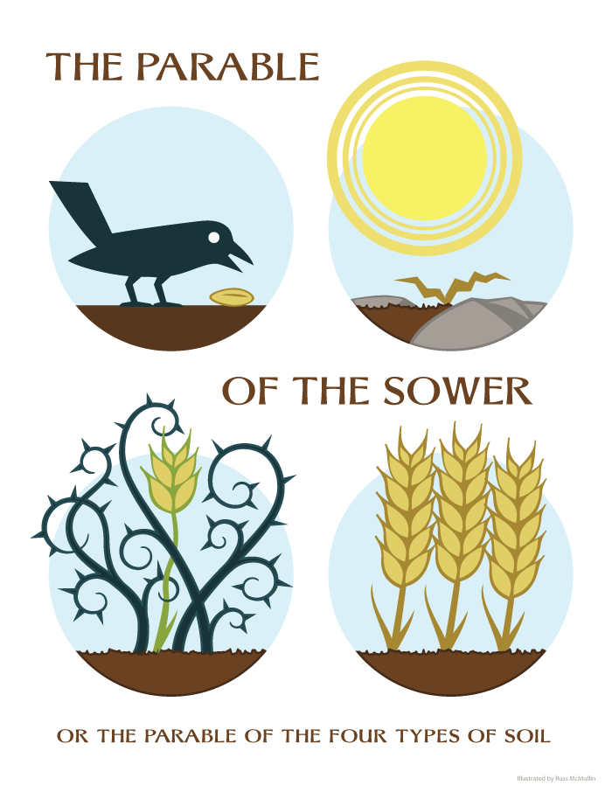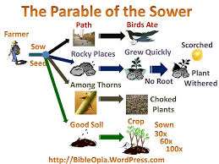*4And when a great multitude had gathered, and they had come to Him from every city, He spoke by a parable: 5“A sower went out to sow his seed. And as he sowed, some fell by the wayside; and it was trampled down, and the birds of the air devoured it. 6Some fell on rock; and as soon as it sprang up, it withered away because it lacked moisture. 7And some fell among thorns, and the thorns sprang up with it and choked it. 8But others fell on good ground, sprang up, and yielded a crop a hundredfold.” When He had said these things He cried, “He who has ears to hear, let him hear!”*

**Question 2**

Which seeds were able to thrive and grow? Circle the correct one by dragging the blue circle below on top of the correct picture form the four to the right.

**Question 3**

Look up Luke Chapter 8 verse 9-10. We read last night the “parable of the sower”, the disciples ask Jesus, *“What does this parable mean?”*

What did Jesus say to them?

* Tuesday 14th March: Read **Luke Chapter 8: 11-21** and answer the questions:

### The Parable of the Sower Explained

*11“Now the parable is this: The seed is the word of God. 12Those by the wayside are the ones who hear; then the devil comes and takes away the word out of their hearts, lest they should believe and be saved. 13But the ones on the rock are those who, when they hear, receive the word with joy; and these have no root, who believe for a while and in time of temptation fall away. 14Now the ones that fell among thorns are those who, when they have heard, go out and are choked with cares, riches, and pleasures of life, and bring no fruit to maturity. 15But the ones that fell on the good ground are those who, having heard the word with a noble and good heart, keep it and bear fruit with patience.*

**Question 4**

How do you think we can prepare our hearts so that they are like the good ground?

### The Parable of the Revealed Light

*16“No one, when he has lit a lamp, covers it with a vessel or puts it under a bed, but sets it on a lampstand, that those who enter may see the light. 17For nothing is secret that will not be revealed, nor anything hidden that will not be known and come to light. 18Therefore take heed how you hear. For whoever has, to him more will be given; and whoever does not have, even what he seems to have will be taken from him.”*

**Jesus’ Mother and Brothers Come to Him**

*19Then His mother and brothers came to Him, and could not approach Him because of the crowd. 20And it was told Him by some, who said, “Your mother and Your brothers are standing outside, desiring to see You.”*

*21But He answered and said to them, “My mother and My brothers are these who hear the word of God and do it.”*

**Question 5** In this passage the Word of God is likened to a lamp. What then does this imply God wants us to do with His Word? Highlight the correct answer.

1. Keep it as a secret weapon
2. Teach the whole world about it
3. Rememeber the Word of God in our hearts only for us

* Wednesday 15th March :Read **Luke 8: 22-39** and answer the questions:

### Wind and Wave Obey Jesus

**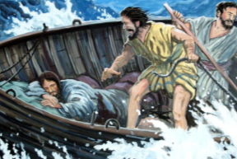***22Now it happened, on a certain day, that He got into a boat with His disciples. And He said to them, “Let us cross over to the other side of the lake.” And they launched out. 23But as they sailed He fell asleep. And a windstorm came down on the lake, and they were filling with water, and were in jeopardy. 24And they came to Him and awoke Him, saying, “Master, Master, we are perishing!”*

*Then He arose and rebuked the wind and the raging of the water. And they ceased, and there was a calm. 25But He said to them, “Where is your faith?”*

*And they were afraid, and marveled, saying to one another, “Who can this be? For He commands even the winds and water, and they obey Him!”*

**Question 6**

When the disciples saw the winds and storm they were afraid and cried out to the Lord Jesus *“Master, Master we are perishing!”* What does this show us about the faith of the disciples?

(A) they were afraid so they ran to Jesus to save them

(B) they thought that they were about to die

(C) they wanted Jesus to save them

(D) all of the above

### Jesus approaches a demon-possessed man

*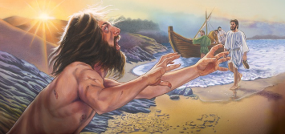26Then they sailed to the country of the Gadarenes,which is opposite Galilee. 27And when He stepped out on the land, there met Him a certain man from the city who had demons for a long time. And he wore no clothes, nor did he live in a house but in the tombs. 28When he saw Jesus, he cried out, fell down before Him, and with a loud voice said, “What have I to do with You, Jesus, Son of the Most High God? I beg You, do not torment me!” 29For He had commanded the unclean spirit to come out of the man. For it had often seized him, and he was kept under guard, bound with chains and shackles; and he broke the bonds and was driven by the demon into the wilderness.*

**Question 7**

Complete the following passage:

“When he (the demon-possessed) saw , he cried out, before Him, and with a loud voice said, “What have I to do with You, Jesus, ? I beg You, do not me!”

**Question 8**

Look up Luke Chapter 8 verse 30-31. Last night we began to read the story of the demon-possessed man Jesus healed. Tonight you read a short conversation Jesus had with the demons.

1. What did Jesus ask them?
2. What did the demons beg Jesus to do?
3. An abyss could be a
4. a deep hole
5. pond
6. mountain
7. boat

### A Demon-Possessed Man Healed

*32Now a herd of many swine was feeding there on the mountain. So they begged Him that He would permit them to enter them. And He permitted them. 33Then the demons went out of the man and entered the swine, and the herd ran violently down the steep place into the lake and drowned.*

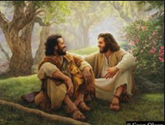*34When those who fed them saw what had happened, they fled and told it in the city and in the country. 35Then they went out to see what had happened, and came to Jesus, and found the man from whom the demons had departed, sitting at the feet of Jesus, clothed and in his right mind. And they were afraid. 36They also who had seen it told them by what means he who had been demon-possessed was healed. 37Then the whole multitude of the surrounding region of the Gadarenes asked Him to depart from them, for they were seized with great fear. And He got into the boat and returned.*

*38Now the man from whom the demons had departed begged Him that he might be with Him. But Jesus sent him away, saying, 39“Return to your own house, and tell what great things God has done for you.” And he went his way and proclaimed throughout the whole city what great things Jesus had done for him.*

**Question 9**

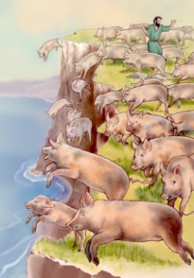Find the verse in today’s reading that describes the picture on the right

**Question 10** In verses 34 to 35 what happened to the man who was previously out of his mind and demon possessed?

* Thursday 16th March : Read **Luke 8: 40-56** and answer the questions:

### A Girl Restored to Life and Jesus heals a bleeding woman

*40So it was, when Jesus returned, that the multitude welcomed Him, for they were all waiting for Him. 41And behold, there came a man named Jairus, and he was a ruler of the synagogue. And he fell down at Jesus’ feet and begged Him to come to his house, 42for he had an only daughter about twelve years of age, and she was dying.*

*But as He went, the multitudes thronged Him. 43Now a woman, having a flow of blood for twelve years, who had spent all her livelihood on physicians and could not be healed by any, 44came from behind and touched the border of His garment. And immediately her flow of blood stopped.*

*45And Jesus said, “Who touched Me?”*

*When all denied it, Peter and those with him said, “Master, the multitudes throng and press You, and You say, ‘Who touched Me?’”*

*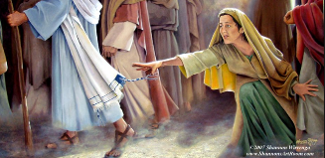46But Jesus said, “Somebody touched Me, for I perceived power going out from Me.” 47Now when the woman saw that she was not hidden, she came trembling; and falling down before Him, she declared to Him in the presence of all the people the reason she had touched Him and how she was healed immediately.*

*48And He said to her, “Daughter, be of good cheer; your faith has made you well. Go in peace.”*

**Question 11**

1. What was the matter with the woman who came and touched Jesus (from verse 43 )?
2. And for how long was she sick?

### Jesus brings back to life a dead girl

**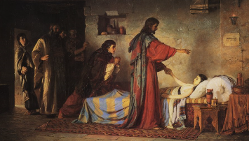***49While He was still speaking, someone came from the ruler of the synagogue’s house, saying to him, “Your daughter is dead. Do not trouble the Teacher.”*

*50But when Jesus heard it, He answered him, saying, “Do not be afraid; only believe, and she will be made well.” 51When He came into the house, He permitted no one to go inexcept Peter, James, and John and the father and mother of the girl. 52Now all wept and mourned for her; but He said, “Do not weep; she is not dead, but sleeping.” 53And they ridiculed Him, knowing that she was dead.*

*54But He put them all outside,took her by the hand and called, saying, “Little girl, arise.” 55Then her spirit returned, and she arose immediately. And He commanded that she be given something to eat. 56And her parents were astonished, but He charged them to tell no one what had happened.*

**Question 12**

This chapter is full of miracles and signs that Jesus did and now we read of the death of the ruler of the synagogue’s daughter. Jesus performs a miracle and brings the little girl back to life. When we are afraid Jesus gives us a promise. What does Jesus promise? Hint: verse 50 .

Write the promise in the textbox below and try and remember this everytime you are afraid.

* Friday 17 March :Read **Luke 9: 1-17** and answer the questions:

### Sending Out the Twelve

*1Then He called His twelve disciples together and gave them power and authority over all demons, and to cure diseases. 2He sent them to preach the kingdom of God and to heal the sick. 3And He said to them, “Take nothing for the journey, neither staffs nor bag nor bread nor money; and do not have two tunics apiece.*

*4“Whatever house you enter, stay there, and from there depart. 5And whoever will not receive you, when you go out of that city, shake off the very dust from your feet as a testimony against them.”*

*6So they departed and went through the towns, preaching the gospel and healing everywhere.*

**Question 13**

After carefully reading the above passage, answer true or false to the following. If your answer is FALSE then put the correction into the third column.

|  |  |  |
| --- | --- | --- |
| **FACT?!** | **TRUE OR FALSE** | **CORRECTION** |
| Christ gave the disciples authority over demons only. |  |  |
| Christ sent the disciples to preach the Kingdom of God and to heal the sick. |  |  |
| He told the disciples to make sure they pack light. |  |  |
| Christ told the disciples: If a place does not receive you, as you leave that place shake off the very dust from your feet as a testimony against them. |  |  |

### Herod Seeks to See Jesus

*7Now Herod the tetrarch heard of all that was done by Him; and he was perplexed, because it was said by some that John had risen from the dead, 8and by some that Elijah had appeared, and by others that one of the old prophets had risen again. 9Herod said, “John I have beheaded, but who is this of whom I hear such things?” So he sought to see Him.*

Remember: *Herod Antipas remembered that he had ordered John the Baptist’s death at the request of Herodias. Herod had a guilty conscience about this, and popular opinion about Jesus confused him. He wondered who Jesus was. Later he did get an opportunity to see Jesus. That was when Pilate sent Jesus to Herod (Luke 23:6-12).*

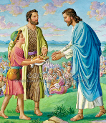

### Feeding the Five Thousand

*10And the apostles, when they had returned, told Him all that they had done. Then He took them and went aside privately into a deserted place belonging to the city called Bethsaida. 11But when the multitudes knew it, they followed Him; and He received them and spoke to them about the kingdom of God, and healed those who had need of healing. 12When the day began to wear away, the twelve came and said to Him, “Send the multitude away, that they may go into the surrounding towns and country, and lodge and get provisions; for we are in a deserted place here.”*

*13But He said to them, “You give them something to eat.”*

*And they said, “We have no more than five loaves and two fish, unless we go and buy food for all these people.” 14For there were about five thousand men.*

*Then He said to His disciples, “Make them sit down in groups of fifty.” 15And they did so, and made them all sit down.*

*16Then He took the five loaves and the two fish, and looking up to heaven, He blessed and broke them, and gave them to the disciples to set before the multitude. 17So they all ate and were filled, and twelve baskets of the leftover fragments were taken up by them.*

**Question 14a**

All of the following events happened in the Bible. But only some of them happened in this story. Type “YES” for the events that took place in this story.

|  |  |
| --- | --- |
| Jesus turned regular water into wine to save a wedding party |  |
| Jesus told his disciples to feed the 5,000 families. |  |
| A young boy offered to share his five loaves of bread and two fish. |  |
| Satan tried to get Jesus to turn stones into bread. |  |
| God sent down bread falling from the sky to feed the Israelites. |  |
| Jesus told the disciples to pick up all the leftover bread. |  |

**Question 14b**

How much food was left over after everyone had eaten?

* Saturday 18th March: Read **Luke Chapter 9: 18-27** and answer the questions:

### Peter Confesses Jesus as the Christ

*18And it happened, as He was alone praying, that His disciples joined Him, and He asked them, saying, “Who do the crowds say that I am?”*

*19So they answered and said, “John the Baptist, but some say Elijah; and others say that one of the old prophets has risen again.”*

***If Jesus prayed, even though He is God, how much more should we pray?!***

***Begin your day with God, just like Christ did.***

*20He said to them, “But who do you say that I am?”*

*Peter answered and said, “The Christ of God.”*

**Question 15**

When Jesus asked the Disciples “who do you say that I am?”

1. Who answered Him?
2. And what was this disciple’s answer?

**Question 16:**

Look up Luke Chapter 9 verse 21-22. Jesus predicts His death and resurrection in these 2 verses.

### Who are “them” in verse 21?

### Who will Jesus be rejected by?

### What did Jesus say about His death and resurrection?

### Take Up the Cross and Follow Him

*23Then He said to them all, “If anyone desires to come after Me, let him deny himself, and take up his cross daily,and follow Me. 24For whoever desires to save his life will lose it, but whoever loses his life for My sake will save it. 25For what profit is it to a man if he gains the whole world, and is himself destroyed or lost? 26For whoever is ashamed of Me and My words, of him the Son of Man will be ashamed when He comes in His own glory, and in His Father’s, and of the holy angels. 27But I tell you truly, there are some standing here who shall not taste death till they see the kingdom of God.”*

**Question 17**

In this passage Jesus teaches us at least 2 major lessons. For each of the lessons below think of a way that we can live that lesson in our every day lives.

For example: One way that we can carry our cross daily is to be nice to someone who doesn’t treat us nicely.

Think of one example for each lesson. Feel free to ask mum and dad for help.

**SCENARIO 1:**

**LESSON 1:** *“If anyone desires to come after Me, let him deny himself, and take up his cross daily,and follow Me.”*

**SCENARIO 2:**

**LESSON 2:** *For whoever is ashamed of Me and My words, of him the Son of Man will be ashamed when He comes in His own glory, and in His Father’s, and of the holy angels.*

**What to do when you finish your Bible Study.**

Send it by email to your class email address or print and hand it to your servants next Sunday.

* Year 4A St Makarious [StMakarios4A@gmail.com](mailto:StMakarios4A@gmail.com) Class Servant- Aunty Labiba (0421891567)
* Year 4B St Bakhomious [StBakhomios4B@gmail.com](mailto:StBakhomios4B@gmail.com) Class Servant- Aunty Mira (0415595556)
* Year 4C St Anthony [StAnthony4C@gmail.com](mailto:StAnthony4C@gmail.com) Class Servant- Aunty Olivia (0433257617)