C:\Documents and Settings\suzy\Local Settings\Temporary Internet Files\Content.IE5\3JXW24R5\MC900383922[1].wmfSunday 5th March, 2017

Name:

Class:

Finish Date: Saturday 11th March, 2017

Completed Bible Study = 15 points

Email by due date = 5 extra points

**Year 3 Bible Study Mark Chapter 4**

**For the questions below Highlight or change the font colour to choose the correct answer.**

# Monday: Read Mark Chapter 4:1-2 and answer the questions:

*1And again He began to teach by the sea. And a great multitude was gathered to Him, so that He got into a boat and sat in it on the sea; and the whole multitude was on the land facing the sea. 2Then He taught them many things by parables, and said to them in His teaching*

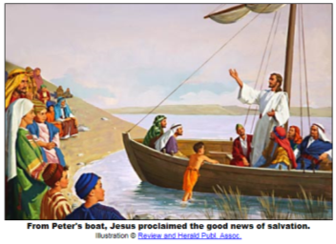**Question 1**

Jesus taught the people because He loved them so much. Jesus taught them by telling them parables. What is a parable?

1. The name of a person
2. A simple, short story used to teach people a lesson and how to behave to please God
3. Explains how to grow a garden

# Tuesday: Read Mark Chapter 4:3-9 and answer the questions:

**The Parable of the Sower**

*3“Listen! Behold, a sower went out to sow. 4And it happened, as he sowed, that some seed fell by the wayside; and the birds of the aircame and devoured it. 5Some fell on stony ground, where it did not have much earth; and immediately it sprang up because it had no depth of earth. 6But when the sun was up it was scorched, and because it had no root it withered away. 7And some seed fell among thorns; and the thorns grew up and choked it, and it yielded no crop. 8But other seed fell on good ground and yielded a crop that sprang up, increased and produced: some thirtyfold, some sixty, and some a hundred.”*

*9And He said to them, “He who has ears to hear, let him hear!”*

**Question 2**

In the parable of the sower, the seeds were planted in 4 different ways. Find the verse that describes each of the pictures below. The first one has been done for you.

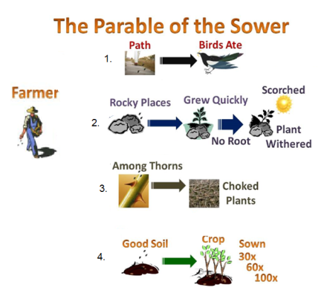

→ Verse 4

→ Verse

→ Verse

→ Verse

# Wednesday: Read Mark Chapter 4:13-17 and answer the questions:

### The Parable of the Sower Explained

*13And He said to them, “Do you not understand this parable? How then will you understand all the parables? 14The sower sows the word. 15 And these are the ones by the wayside where the word is sown. When they hear, Satan comes immediately and takes away the word that was sown in their hearts. 16 These likewise are the ones sown on stony ground who, when they hear the word, immediately receive it with gladness; 17 and they have no root in themselves, and so endure only for a time. Afterward, when tribulation or persecution arises for the word’s sake, immediately they stumble. 18 Now these are the ones sown among thorns;* they are *the ones who hear the word, 19 and the cares of this world, the deceitfulness of riches, and the desires for other things entering in choke the word, and it becomes unfruitful. 20 But these are the ones sown on good ground, those who hear the word, accept* it, *and bear fruit: some thirtyfold, some sixty, and some a hundred.”*

### Question 3

Match the following soil type with its meaning. The first one has been done for you.

|  |  |  |  |
| --- | --- | --- | --- |
| **Soil Type** | | **Explanation** | |
| 1 | The seed that fell among thorns | **3** | Satan comes immediately and takes away God’s word that was sown in their hearts |
| 2 | Stony ground |  | Those who hear the word, accept it, and become good children and love God more than anything. They do many good things pleasing to God: some thirtyfold, some sixty, and some a hundred. |
| 3 | The wayside |  | When they hear the word, immediately receive it with gladness;but afterward, when they go through a difficult time they do not remember God’s words. |
| 4 | Good ground |  | they are the ones who hear God’s word,  they get distracted and worry about everything, cares of this world, the dishonesty of money, and do things that do not please God. |

# Thursday: Read Mark Chapter 4:21-25 and answer the questions:

### Light Under a Basket

*21Also He said to them, “Is a lamp brought to be put under a basket or under a bed? Is it not to be set on a lampstand? 22For there is nothing hidden which will not be revealed, nor has anything been kept secret but that it should come to light. 23If anyone has ears to hear, let him hear.”*

***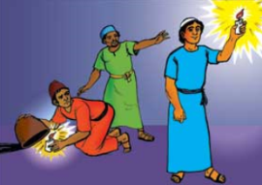****24Then He said to them, “Take heed what you hear. With the same measure you use, it will be measured to you; and to you who hear, more will be given. 25For whoever has, to him more will be given; but whoever does not have, even what he has will be taken away from him.”*

*In the picture we see one man trying to hide his light under a basket. What use is that light? The other man is holding his light up high for all to see. The true light is Jesus. When we do good works in Jesus' name we are letting the light of Jesus shine through us. Then people will praise Jesus. Many people will not listen to what we say, but they will see what we do. Our lives often show God's love more than our words do. We are not doing good works so that people will praise us, but that God will be praised.*

### Question 4

1. A lamp would be of no use if people hid it under something. **TRUE/FALSE**
2. A lamp should light up a room so that people can see. **TRUE/FALSE**
3. Jesus’ disciples must not hide their faith. They must allow other people to see the ‘light’ of God’s good news. **TRUE/FALSE**
4. People who try to cover up their actions, words and thoughts will be successful. **TRUE/FALSE**
5. Adam and Eve tried to hide from God, but they failed (Genesis 3:8-9). **TRUE/FALSE.**

# Friday: Read Mark Chapter 4:30-32 and answer the questions:

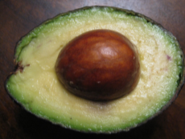

avacado seed

mustard seed

Look at the difference in the size of a mustard seed and an avacado seed. Think of how small the mustard seed is when you read the verses below.

**Jesus told them another story : The parable of the mustard seed.**

*30 Then He said, “To what shall we liken the kingdom of God? Or with what parable shall we picture it? 31*It is *like a mustard seed which, when it is sown on the ground, is smaller than all the seeds on earth; 32but when it is sown, it grows up and becomes greater than all herbs, and shoots out large branches, so that the birds of the air may nest under its shade.” 33And with many such parables He spoke the word to them as they were able to hear it. 34But without a parable He did not speak to them. And when they were alone, He explained all things to His disciples.*

**Question 5**

Jesus said that the mustard seed represents

1. a herb
2. the kingdom of God
3. a home for the birds
4. disciples

**Do you know why the mustard seed and not the avocado seed was chosen to represent the kingdom of God?**

*Great things grow from small beginnings. How is that a picture of the kingdom of God? Well, when Jesus first began his earthly ministry, he had no followers. One by one, Jesus called his disciples until there were twelve of them. That is still a pretty small beginning, isn't it? Jesus sent out the twelve and they brought others to Jesus and the kingdom of God grew. From a very small beginning, the kingdom of God has grown and grown until it has spread over the entire earth.*

**Question 6**

Jesus spoke to the people only in parables. **TRUE/FALSE**

# Saturday: Read Mark Chapter 4: 35-41 and answer the questions:

### Wind and Wave Obey Jesus

*35On the same day, when evening had come, He said to them, “Let us cross over to the other side.” 36Now when they had left the multitude, they took Him along in the boat as He was. And other little boats were also with Him. 37And a great windstorm arose, and the waves beat into the boat, so that it was already filling. 38But He was in the stern, asleep on a pillow. And they awoke Him and said to Him, “Teacher, do You not care that we are perishing?”*

***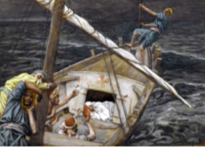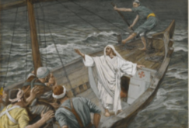****39Then He arose and rebuked the wind, and said to the sea, “Peace, be still!” And the wind ceased and there was a great calm. 40But He said to them, “Why are you so fearful? How is it that you have no faith?” 41And they feared exceedingly, and said to one another, “Who can this be, that even the wind and the sea obey Him!”*

**Question 7**

Write down the correct order of what happened on the boat in the boxes below. The first one has been done for you.

* Then he arose and rebuked the wind
* And the wind ceased and there was a great calm

**1**

* And a great wind storm arose
* And He said to the sea, “Peace, be still!”

|  |  |  |  |
| --- | --- | --- | --- |
| **C** |  |  |  |

**What to do when you finish your Bible Study.**

Send it by email to your class email address or print and hand it to your servants next Sunday.

* Year 3A St Bishoy[stbishoy3a@gmail.com](mailto:stbishoy3a@gmail.com) Class Servant: Uncle Emile (0416895236)
* Year 3B St Paul[saintpaul3b@gmail.com](mailto:saintpaul3b@gmail.com) Class Servant: Aunty Marena (0433677290)
* Year 3C St Moses [stmoses3c@gmail.com](mailto:stmoses3c@gmail.com) Class Servant: Uncle Mina (0433520175)