Sunday 26th February 2017
Name:
Class:
Due Date: Saturday 4th March 2017

Completed Bible Study = 15 points,
Handed in by due date = 5 extra points

The GOSPEL according to ST. Matthew
Year 5 – Bible Study 4 (Chapters 7 & 8)

Monday 27th February Read Chapter 7 verses 1 – 14

Do Not Judge
“Judge not, that you be not judged. ² For with what judgment you judge, you will be judged; and with the measure you use, it will be measured back to you. ³ And why do you look at the speck in your brother’s eye, but do not consider the plank in your own eye? ⁴ Or how can you say to your brother, ‘Let me remove the speck from your eye’; and look, a plank is in your own eye? ⁵Hypocrite! First remove the plank from your own eye, and then you will see clearly to remove the speck from your brother’s eye. ⁶ “Do not give what is holy to the dogs; nor cast your pearls before swine, lest they trample them under their feet, and turn and tear you in pieces.
Keep Asking, Seeking, Knocking
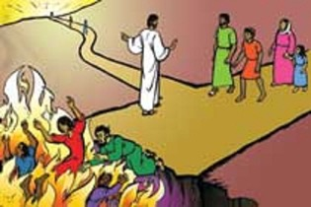
⁷ “Ask, and it will be given to you; seek, and you will find; knock, and it will be opened to you. ⁸ For everyone who asks receives, and he who seeks finds, and to him who knocks it will be opened. ⁹ Or what man is there among you who, if his son asks for bread, will give him a stone? ¹⁰ Or if he asks for a fish, will he give him a serpent? ¹¹ If you then, being evil, know how to give good gifts to your children, how much more will your Father who is in heaven give good things to those who ask Him! ¹² Therefore, whatever you want men to do to you, do also to them, for this is the Law and the Prophets.
The Narrow Way
¹³"Enter by the narrow gate; for wide is the gate and broad is the way that leads to destruction, and there are many who go in by it. ¹⁴Because narrow is the gate and difficult is the way which leads to life, and there are few who find it.

- Why should we not judge other people?

2. Which gate can we enter the kingdom of heaven by? (Underline the correct answer)
narrow / wide
Tuesday 28th February Read Chapter 7 verses 15 – 29

You Will Know Them by Their Fruits
¹⁵ “Beware of false prophets, who come to you in sheep’s clothing, but inwardly they are ravenous wolves. ¹⁶ You will know them by their fruits. Do men gather grapes from thornbushes or figs from thistles? ¹⁷ Even so, every good tree bears good fruit, but a bad tree bears bad fruit. ¹⁸ A good tree cannot bear bad fruit, nor can a bad tree bear good fruit. ¹⁹ Every tree that does not bear good fruit is cut down and thrown into the fire. ²⁰ Therefore by their fruits you will know them.

I Never Knew You
²¹ “Not everyone who says to Me, ‘Lord, Lord,’ shall enter the kingdom of heaven, but he who does the will of My Father in heaven. ²² Many will say to Me in that day, ‘Lord, Lord, have we not prophesied in Your name, cast out demons in Your name, and done many wonders in Your name?’ ²³ And then I will declare to them, ‘I never knew you; depart from Me, you who practice lawlessness!’

Build on the Rock
²⁴ “Therefore whoever hears these sayings of Mine, and does them, I will liken him to a wise man who built his house on the rock: ²⁵ and the rain descended, the floods came, and the winds blew and beat on that house; and it did not fall, for it was founded on the rock.
²⁶ “But everyone who hears these sayings of Mine, and does not do them, will be like a foolish man who built his house on the sand: ²⁷ and the rain descended, the floods came, and the winds blew and beat on that house; and it fell. And great was its fall.”
²⁸ And so it was, when Jesus had ended these sayings, that the people were astonished at His teaching, ²⁹ for He taught them as one having authority, and not as the scribes.

- Jesus said to be careful of false prophets. Can false prophets appear to teach good things, behave in a way that appears pleasing to God, yet lead people away from Christ.
True/false

- Label which type of person built these houses


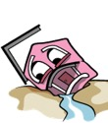

Wednesday 1st March Read Chapter 8 verses 1 – 13

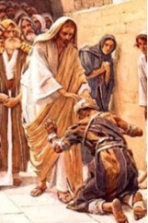
Jesus Cleanses a Leper
¹When He had come down from the mountain, great multitudes followed Him. ² And behold, a leper came and worshiped Him, saying, “Lord, if You are willing, You can make me clean.” ³ Then Jesus put out His hand and touched him, saying, “I am willing; be cleansed.” Immediately his leprosy was cleansed. ⁴ And Jesus said to him, “See that you tell no one; but go your way, show yourself to the priest, and offer the gift that Moses commanded, as a testimony to them.”
Jesus Heals a Centurion’s Servant
⁵ Now when Jesus had entered Capernaum, a centurion came to Him, pleading with Him, ⁶ saying, “Lord, my servant is lying at home paralyzed, dreadfully tormented.” ⁷ And Jesus said to him, “I will come and heal him.” ⁸ The centurion answered and said, “Lord, I am not worthy that You should come under my roof. But only speak a word, and my servant will be healed. ⁹ For I also am a man under authority, having soldiers under me. And I say to this one, ‘Go,’ and he goes; and to another, ‘Come,’ and he comes; and to my servant, ‘Do this,’ and he does it.”
¹⁰ When Jesus heard it, He marveled, and said to those who followed, “Assuredly, I say to you, I have not found such great faith, not even in Israel! ¹¹ And I say to you that many will come from east and west, and sit down with Abraham, Isaac, and Jacob in the kingdom of heaven. ¹² But the sons of the kingdom will be cast out into outer darkness. There will be weeping and gnashing of teeth.” ¹³ Then Jesus said to the centurion, “Go your way; and as you have believed, so let it be done for you.” And his servant was healed that same hour.

- How did Jesus heal the Leper?

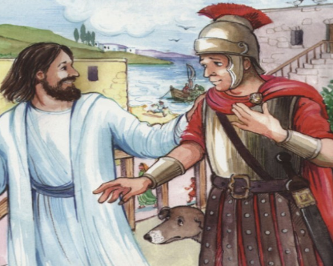
Person A
Person B
a) Who do you think is Person A pictured on

the right?

b) Who do you think is Person B pictured on
the right?

Thursday 2nd March Read Chapter 8 verses 14 – 22

Peter’s Mother-in-Law Healed
¹⁴ Now when Jesus had come into Peter’s house, He saw his wife’s mother lying sick with a fever. ¹⁵ So He touched her hand, and the fever left her. And she arose and served them.^{[a]}

Many Healed in the Evening
¹⁶ When evening had come, they brought to Him many who were demon-possessed. And He cast out the spirits with a word, and healed all who were sick, ¹⁷ that it might be fulfilled which was spoken by Isaiah the prophet, saying: “He Himself took our infirmities And bore our sicknesses.”

The Cost of Discipleship
¹⁸ And when Jesus saw great multitudes about Him, He gave a command to depart to the other side. ¹⁹ Then a certain scribe came and said to Him, “Teacher, I will follow You wherever You go.” ²⁰ And Jesus said to him, “Foxes have holes and birds of the air have nests, but the Son of Man has nowhere to lay His head.” ²¹ Then another of His disciples said to Him, “Lord, let me first go and bury my father.’ ²² But Jesus said to him, “follow Me, and let the dead bury their own dead.”
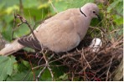
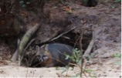
A bird in a nest
A fox in a hole

- Name the prophet that said that Jesus healed the sick, took our pain, and took away the suffering.

- A prophecy is when
a) A story about something that has happened in the past.
b) When you say something true that will happen in the future
c) A miracle
d) Jewish Law

Friday 3rd March Read Chapter 8 verses 23 – 27

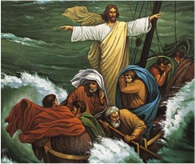
Wind and Wave Obey Jesus
²³ Now when He got into a boat, His disciples followed Him. ²⁴ And suddenly a great tempest arose on the sea, so that the boat was covered with the waves. But He was asleep. ²⁵ Then His disciples came to Him and awoke Him, saying, “Lord, save us! We are perishing!”
²⁶ But He said to them, “Why are you fearful, O you of little faith?” Then He arose and rebuked the winds and the sea, and there was a great calm. ²⁷ So the men marveled, saying, “Who can this be, that even the winds and the sea obey Him?”

- Why were the disciples afraid?
- Because they thought Jesus did not care if they drowned.
- They were drifting too far from the land
- They lacked faith that Jesus would save them
- Jesus enjoyed the rough ride on the boat.

- What/who obeyed Jesus?

Saturday 4th March Read Chapter 8 verses 28 – 34

Two Demon-Possessed Men Healed
²⁸ When He had come to the other side, to the country of the Gergesenes,^{[c]} there met Him two demon-possessed men, coming out of the tombs, exceedingly fierce, so that no one could pass that way. ²⁹ And suddenly they cried out, saying, “What have we to do with You, Jesus, You Son of God? Have You come here to torment us before the time?” ³⁰ Now a good way off from them there was a herd of many swine feeding. ³¹ So the demons begged Him, saying, “If You cast us out, permit us to go away^{[d]} into the herd of swine.” ³² And He said to them, “Go.” So when they had come out, they went into the herd of swine. And suddenly the whole herd of swine ran violently down the steep place into the sea, and perished in the water. ³³ Then those who kept them fled; and they went away into the city and told everything, including what had happened to the demon-possessed men. ³⁴ And behold, the whole city came out to meet Jesus. And when they saw Him, they begged Him to depart from their region.

- After you finished reading the verses above, choose the verse that matches the picture.

Picture | Verse number
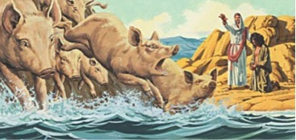
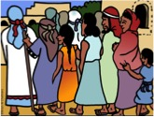
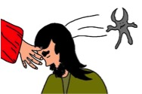
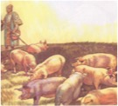

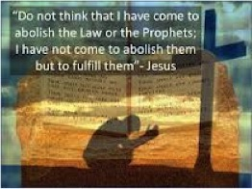
Memory verse

To try to remember the verse, write it out below:

PARENTS SECTION:
We kindly ask you as a parent to read (a little each day) in the Holy Bible with your family.

Now email your answers to your teacher, choose ONE of the email addresses below.
What to do when you finish your Bible Study.
Send it by email to your class email address or print and hand it to your servants next Sunday.
- Year 5B1 St Thomas stthomas5b@gmail.com Class Servant- Uncle Andrew (0416744100)
- Year 5B2 St Philip saintphilip5g@gmail.com Class Servant- Uncle Mark (0413495921)
- Year 5G St Matthew stmatthew5g@gmail.com Class Servant – Aunty Dina (0404604507)

