C:\Documents and Settings\suzy\Local Settings\Temporary Internet Files\Content.IE5\3JXW24R5\MC900383922[1].wmfSunday 26th February 2017

Name:

Class:

Finish Date: Saturday 4 March 2017

Completed Bible Study = 15 points

Email by due date = 5 extra points

**Year 4 Bible Study Luke Chapter 5 and Chapter 6 Part 1**

**For the questions below Highlight or change the font colour to choose the correct answer.**

* Monday 27th February: Read **Luke 5: 1-11** and answer the questions:

### Four Fishermen Called as Disciples

*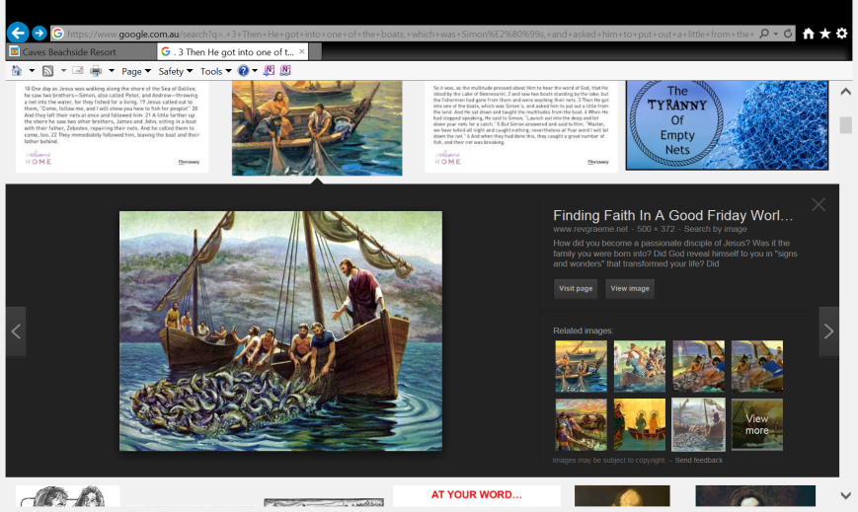1So it was, as the multitude pressed about Him to hear the word of God, that He stood by the Lake of Gennesaret, 2and saw two boats standing by the lake; but the fishermen had gone from them and were washing their nets. 3Then He got into one of the boats, which was Simon’s, and asked him to put out a little from the land. And He sat down and taught the multitudes from the boat.*

*4When He had stopped speaking, He said to Simon, “Launch out into the deep and let down your nets for a catch.”*

*5But Simon answered and said to Him, “Master, we have toiled all night and caught nothing; nevertheless at Your word I will let down the net.” 6And when they had done this, they caught a great number of fish, and their net was breaking. 7So they signaled to their partners in the other boat to come and help them. And they came and filled both the boats, so that they began to sink. 8When Simon Peter saw it, he fell down at Jesus’ knees, saying, “Depart from me, for I am a sinful man, O Lord!”*

***9****For he and all who were with him were astonished at the catch of fish which they had taken;****10****and so also were James and John, the sons of Zebedee, who were partners with Simon. And Jesus said to Simon, “Do not be afraid. From now on you will catch men.”****11****So when they had brought their boats to land, they forsook all and followed Him.*

**Question 1**

1. Gennesaret is another name for the Sea of Galilee. **True/False**
2. Simon was a fisherman. **True/False**
3. Jesus taught the multitudes on the sand. **True/False**
4. Simon caught many fish during the night as this was the best time to fish. **True/False**
5. Simon felt that Jesus was holy, but that he himself was not holy, that is why Simon called Jesus Lord. **True/False**

**Question 2**

Look up Luke Chapter 5 verses 9-11. Read the passage and answer the questions below.

1. How did Simon and the others react to the miraculous large catch of fish?
2. Name the other 2 disciples who witnessed this large catch of fish?
3. What did Jesus say to Simon?

* Tuesday 28th February: Read **Luke 5: 12-26** and answer the questions:

### Jesus Cleanses a Leper

*12And it happened when He was in a certain city, that behold, a man who was full of leprosy saw Jesus; and he fell on his face and implored Him, saying, “Lord, if You are willing, You can make me clean.”*

*13Then He put out His hand and touched him, saying, “I am willing; be cleansed.” Immediately the leprosy left him. 14And He charged him to tell no one, “But go and show yourself to the priest, and make an offering for your cleansing, as a testimony to them, just as Moses commanded.”*

*15However, the report went around concerning Him all the more; and great multitudes came together to hear, and to be healed by Him of their infirmities. 16So He Himself often withdrew into the wilderness and prayed.*

**Do you know what Leprosy is?**

*Leprosy is a type of skin disease and those who had leprosy had to keep far away from other people. They must call out ‘I am not clean!’ They warned other people not to come near them. Therefore, they could not be with their family or friends. The leper came close enough to Jesus to fall down near his feet. He was desperate. He needed Jesus’ help.*

**Question 3**

Identify the verse number that shows

Verse

1. The leper trusted that Jesus could heal him. He was not sure that Jesus would want to.
2. A priest acted as a medical officer of health. If the priest declared that the man was healthy, then he could go back among the people. And the man who was now well would make the necessary offerings. Although Jesus did not keep the Sabbath traditions, he obeyed the law of Moses.

Verse

1. Jesus took no notice of the fact that He would make himself ‘unclean’ if he touched a person with leprosy.

Verse

### Jesus Forgives and Heals a Paralytic

*17Now it happened on a certain day, as He was teaching, that there were Pharisees and teachers of the law sitting by, who had come out of every town of Galilee, Judea, and Jerusalem. And the power of the Lord was present to heal them. 18Then behold, men brought on a bed a man who was paralyzed, whom they sought to bring in and lay before Him. 19And when they could not find how they might bring him in, because of the crowd, they went up on the housetop and let him down with his bed through the tiling into the midst before Jesus.*

*20When He saw their faith, He said to him, “Man, your sins are forgiven you.”*

*21And the scribes and the Pharisees began to reason, saying, “Who is this who speaks blasphemies? Who can forgive sins but God alone?”*

*22But when Jesus perceived their thoughts, He answered and said to them, “Why are you reasoning in your hearts? 23Which is easier, to say, ‘Your sins are forgiven you,’ or to say, ‘Rise up and walk’? 24But that you may know that the Son of Man has power on earth to forgive sins”—He said to the man who was paralyzed, “I say to you, arise, take up your bed, and go to your house.”*

*25Immediately he rose up before them, took up what he had been lying on, and departed to his own house, glorifying God. 26And they were all amazed, and they glorified God and were filled with fear, saying, “We have seen strange things today!”*

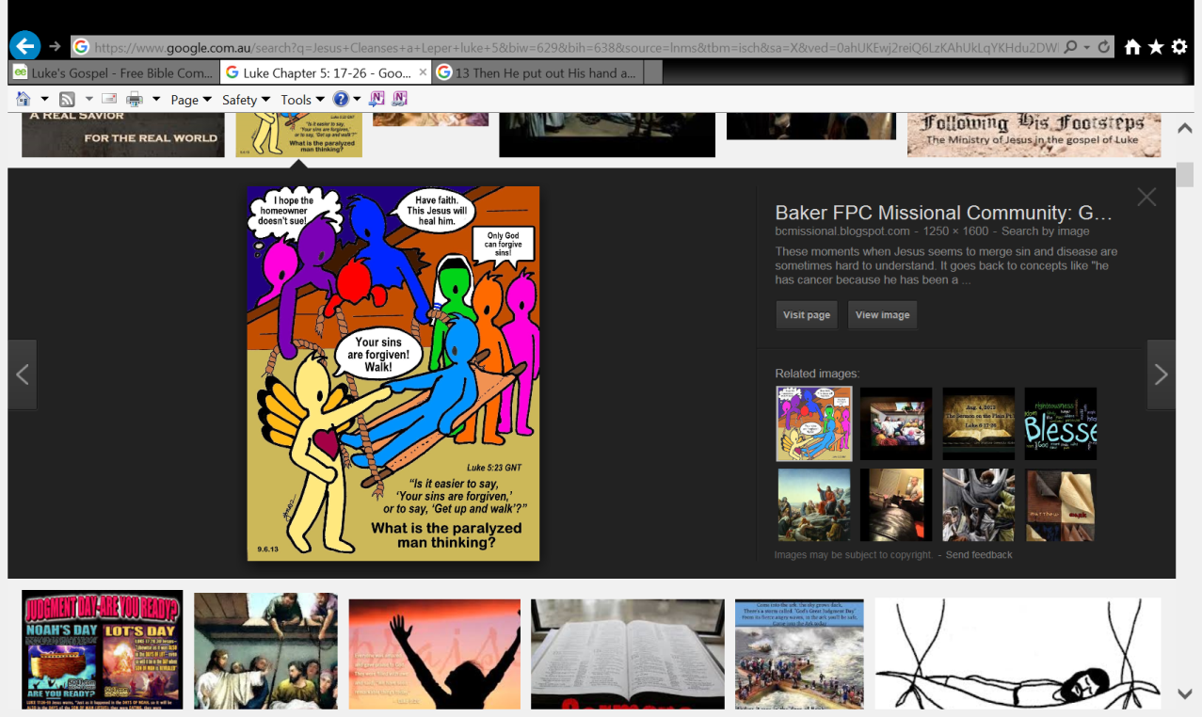

**D**

**C**

**B**

**A**

**Question 4.**

Identify the following people by putting the letter

A, B, C or D in the table below.

|  |  |
| --- | --- |
| **Person** | **Letter** |
| Jesus |  |
| Pharisees and teachers of the law |  |
| The paralytic |  |
| Men who had faith Jesus would heal the paralytic |  |

* Wednesday 1 March: Read **Luke 5: 27-39** and answer the questions:

### Matthew the Tax Collector

*27After these things He went out and saw a tax collector named Levi, sitting at the tax office. And He said to him, “Follow Me.” 28So he left all, rose up, and followed Him.*

*29Then Levi gave Him a great feast in his own house. And there were a great number of tax collectors and others who sat down with them. 30And their scribes and the Phariseescomplained against His disciples, saying, “Why do You eat and drink with tax collectors and sinners?”*

*31Jesus answered and said to them, “Those who are well have no need of a physician, but those who are sick. 32I have not come to call the righteous, but sinners, to repentance.”*

**Question 5**

1. What was Matthew’s name before he came to follow Jesus?

L

1. People hated tax-collectors because it was easy for them to cheat, steal and take too much tax from people. Explain why you think Jesus was having dinner with Matthew and other tax collectors? Hint: Verse 31-32

### Jesus Is Questioned About Fasting

*33Then they said to Him, “Why do the disciples of John fast often and make prayers, and likewise those of the Pharisees, but Yours eat and drink?”*

*34And He said to them, “Can you make the friends of the bridegroom fast while the bridegroom is with them? 35But the days will come when the bridegroom will be taken away from them; then they will fast in those days.”*

*36Then He spoke a parable to them: “No one puts a piece from a new garment on an old one; otherwise the new makes a tear, and also the piece that was taken out of the new does not match the old. 37And no one puts new wine into old wineskins; or else the new wine will burst the wineskins and be spilled, and the wineskins will be ruined. 38But new wine must be put into new wineskins, and both are preserved. 39And no one, having drunk old wine, immediately desires new; for he says, ‘The old is better.’”*

**Question 6**

Who is the bridegroom?

**Question 7**

Jesus uses two examples from daily life to describe what he was teaching. He taught this as a parable. Cross out the incorrect word(s) in the explanation of the parable below:

1. Jesus was not aiming to ‘mend’ the Jewish faith. He was not aiming to put new fabric on an old garment. He was teaching new things, not what the Pharisees were teaching. The teachings of the Pharisees were like a ***new/old***piece of cloth.

1. New wine is strong enough to burst the old skins. The new things that Jesus taught were as powerful as ***old/new*** wine.
2. Some people would not like what Jesus was teaching. They would be like a man (a Pharisee) who says that old wine (their teaching) is better than new wine (Jesus’ teaching). The Pharisees, were ***refusing/accepting*** the joy that Jesus could give them.
3. The Pharisees preferred the ‘old wine’ of their own traditions. They asked a question about fasting. It had shown that they ***were/weren’t*** willing to change their ways. Their attitude was like an ***old/new*** wineskin.
4. The Pharisees could not accept new ideas. Jesus’ message made people free from sin. They could have joy as they obeyed God. However, Jesus’ message would destroy the religion of the Pharisees. This is the ***old/new*** wine.

* Thursday 2 March :Read **Luke 6: 1-10** and answer the questions:

### Jesus Is Lord of the Sabbath

[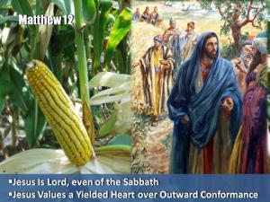](http://www.google.com.au/url?sa=i&rct=j&q=&esrc=s&source=images&cd=&cad=rja&uact=8&ved=0ahUKEwjzhLCUua_KAhXGmpQKHZNjBOcQjRwIBw&url=http://mudpreacher.org/tag/mary/&psig=AFQjCNGEZaUO3C19uLLxsbb9F3QkAvt-ng&ust=1453071960067058)*1 Now it happened on the second Sabbath after the first that He went through the grainfields. And His disciples plucked the heads of grain and ate them, rubbing them in their hands. 2And some of the Pharisees said to them, “Why are you doing what is not lawful to do on the Sabbath?”*

*3But Jesus answering them said, “Have you not even read this, what David did when he was hungry, he and those who were with him: 4how he went into the house of God, took and ate the showbread, and also gave some to those with him, which is not lawful for any but the priests to eat?” 5And He said to them, “The Son of Man is also Lord of the Sabbath.”*

**Understanding the Sabbath**

In the beginning God sanctified the Sabbath day as a day of rest.  It was in honor of His own resting after the Creation, Genesis 2:2-3.  This law was carried over in the Ten Commandants to promote rest and worship, Exodus 20:8-11.  By the time we arrive in the New Testament the Pharisees had issued strict laws over the Sabbath day, separating it from its original intention.  Being more concerned with strictness of traditions rather than human compassion, they stopped at nothing to insure their way of interpreting the law was preserved rather than the mercy of God.

**Some of the activities that were not allowed on the Sabbath included:**  
**Question 8**

Sowing, Plowing, Reaping, Binding sheaves, Threshing, Winnowing, Selecting. Grinding, Sifting, Kneading, Baking, Shearing wool, Washing wool…

What was more important to Jesus?

1. The Sabbath laws. OR (B) Caring for His children (His people).

**In Verse 5, Jesus Christ said to His disciples that** *“The Son of Man is also Lord of the Sabbath.”*

**Read the following passage to understand this verse a little more.**

**Question: "What does it mean that Jesus is the Lord of the Sabbath?"  
  
Answer:** The phrase “the Lord of the Sabbath” is found in [Matthew 12:8](http://biblia.com/bible/esv/Matt%2012.8), [Mark 2:28](http://biblia.com/bible/esv/Mark%202.28), and [Luke 6:5](http://biblia.com/bible/esv/Luke%206.5). In all three instances Jesus is referring to Himself as the Lord of the Sabbath or, as Mark records it, “The Son of Man is Lord even of the Sabbath” ([Mark 2:28](http://biblia.com/bible/esv/Mark%202.28)). In these verses, Jesus is proclaiming that He is the One who exercises authority even over the rules and regulations that govern the Sabbath day.

**[](http://www.google.com.au/url?sa=i&rct=j&q=&esrc=s&source=images&cd=&cad=rja&uact=8&ved=0ahUKEwiosuypya_KAhWKk5QKHfV6CDAQjRwIBw&url=http://ngmnexpo.com/bible-clip-art-5531/&bvm=bv.112064104,d.dGo&psig=AFQjCNGD0uhBjA7xn82TaK2Q6ggFgf2rrA&ust=1453076336464490)**

**Question 9**

For the list below type in where you can find each ïtem” either in…

**OLD TESTAMENT (OT) OR NEW TESTAMENT (NT) OR BOTH (B)**

|  |  |
| --- | --- |
| 1. Prophecies |  |
| 1. Creation story |  |
| 1. The Life of Jesus |  |
| 1. The laws of Moses |  |
| 1. The teachings/Words of Jesus |  |
| 1. The Commandments |  |
| 1. Role Models |  |
| 1. Letters from the Apostles to believers |  |
| 1. Lessons on Mercy, Grace and Faith. |  |
| 1. Our Journey of faith with Jesus |  |

### Healing on the Sabbath

*6Now it happened on another Sabbath, also, that He entered the synagogue and taught. And a man was there whose right hand was withered. 7So the scribes and Pharisees watched Him closely, whether He would heal on the Sabbath, that they might find an accusation against Him. 8But He knew their thoughts, and said to the man who had the withered hand, “Arise and stand here.” And he arose and stood. 9Then Jesus said to them, “I will ask you one thing: Is it lawful on the Sabbath to do good or to do evil, to save life or to destroy?” 10And when He had looked around at them all, He said to the man, “Stretch out your hand.” And he did so, and his hand was restored as whole as the other.*

**Question 10**

From this passage, what did Jesus do on the Sabbath?

**Question 11**

Jesus was trying to teach the Pharisees a lesson about the Sabbath. What was the lesson?

1. That the Sabbath laws should be followed no matter what the situation.
2. That the Sabbath laws were no longer to be followed.
3. That it is more important to do good on the Sabbath than to do evil, even if that means breaking the Sabbath laws.
4. That Jesus was the only one who could break the Sabbath because it was His law.

* Friday 3rd March : **Luke 6: 11-16**:

**Question 12**

Look up Luke Chapter 6 verse 11; copy it in the textbox below:

**Question 13**

How did the Scribes and the Pharisees feel about Jesus healing on the sabbath?

### [https://stjudasmaccabaeus.files.wordpress.com/2012/12/twelve_apostles_1.png](https://www.google.com.au/url?sa=i&rct=j&q=&esrc=s&source=images&cd=&cad=rja&uact=8&ved=0ahUKEwjy7fDuyK_KAhUKnJQKHRiHBzMQjRwIBw&url=https://stjudasmaccabaeus.wordpress.com/tag/12-tribes-of-israel/&bvm=bv.112064104,d.dGo&psig=AFQjCNEg9OexIwck_FVTzC9QKx5KcaUvaA&ust=1453076167521579)The Twelve Apostles

*12Now it came to pass in those days that He went out to the mountain to pray, and continued all night in prayer to God. 13And when it was day, He called His disciples to Himself; and from them He chose twelve whom He also named apostles: 14Simon, whom He also named Peter, and Andrew his brother; James and John; Philip and Bartholomew; 15Matthew and Thomas; James the son of Alphaeus, and Simon called the Zealot; 16Judas the son of James, and Judas Iscariot who also became a traitor.*

**Question 14**

What did Jesus do the night before he chose his disciples?

**Question 15**

Therefore when we are making a decision, whether big or small, what should we also do?

**Question 16**

Fill in the names of the 12 disciples.

|  |  |  |
| --- | --- | --- |
|  |  |  |
|  |  |  |
|  |  |  |
|  |  |  |

### Saturday 4th March: Read Luke 6: 20-26 and answer the questions:The Beatitudes

*20Then He lifted up His eyes toward His disciples, and said:*

*[](http://www.google.com.au/url?sa=i&rct=j&q=&esrc=s&source=images&cd=&cad=rja&uact=8&ved=0ahUKEwiZ_o-LyK_KAhUGH5QKHYsTDLMQjRwIBw&url=http://www.gcurley.info/news/2015/03/the-beatitudes-part-1/&bvm=bv.112064104,d.dGo&psig=AFQjCNHA5z6YsJ8efBbVuEBWPzu7PHQvrA&ust=1453075992075514)“Blessed are you poor,  
    For yours is the kingdom of God.  
21Blessed are you who hunger now,  
    For you shall be filled.  
Blessed are you who weep now,  
    For you shall laugh.  
22Blessed are you when men hate you,*  *And when they exclude you,  
    And revile you, and cast out your name as evil,  
    For the Son of Man’s sake.  
23Rejoice in that day and leap for joy!  
    For indeed your reward is great in heaven,  
    For in like manner their fathers did to the prophets.*

**Question 17**

Jesus taught His disciples, and us, the Beatitudes. St. Matthew also wrote them down in His Gospel. Read Matthew 5: 1-12. St. Matthew recorded some extra ones. Highlight in the passage below the ones that St. Luke missed in the above passage.

### Matthew 5: 1-12 - The Beatitudes

3“Blessed are the poor in spirit,  
    for theirs is the kingdom of heaven.  
4Blessed are those who mourn,  
    for they will be comforted.  
5Blessed are the meek,  
    for they will inherit the earth.  
6Blessed are those who hunger and thirst for righteousness,  
    for they will be filled.  
7Blessed are the merciful,  
    for they will be shown mercy.  
8Blessed are the pure in heart,  
    for they will see God.  
9Blessed are the peacemakers,  
    for they will be called children of God.  
10Blessed are those who are persecuted because of righteousness,  
    for theirs is the kingdom of heaven.

11“Blessed are you when people insult you, persecute you and falsely say all kinds of evil against you because of me. 12Rejoice and be glad, because great is your reward in heaven, for in the same way they persecuted the prophets who were before you.

### [https://s-media-cache-ak0.pinimg.com/736x/f6/bd/e8/f6bde818804b1830cf4a2bb611cc750e.jpg](https://www.google.com.au/url?sa=i&rct=j&q=&esrc=s&source=images&cd=&cad=rja&uact=8&ved=0ahUKEwiyjOjEyK_KAhWMGZQKHeKsCWQQjRwIBw&url=https://www.pinterest.com/pin/87749892715193016/&bvm=bv.112064104,d.dGo&psig=AFQjCNGdS8dLdds2Qd7j-WDcjMSbotnH-g&ust=1453076086525320)Jesus Pronounces Woes

*24“But woe to you who are rich,  
    For you have received your consolation.  
25Woe to you who are full,*  *For you shall hunger.  
Woe to you who laugh now,  
    For you shall mourn and weep.  
26Woe to you when all men speak well of you,  
    For so did their fathers to the false prophets.*

**Question 18**

In these above verses Jesus is teaching us and warning us that if we are not careful then there are temptations in life that can distract us from praying, giving thanks, and being Holy.

What 4 things was Jesus warning us against?

|  |
| --- |
|  |
|  |
|  |
|  |

**Question 19**

Jesus was not saying these things are WRONG but we need to use them on our journey to heaven. Can you suggest one way a rich man/woman can please God?

**What to do when you finish your Bible Study.**

Send it by email to your class email address or print and hand it to your servants next Sunday.

* Year 4A St Makarious [StMakarios4A@gmail.com](mailto:StMakarios4A@gmail.com) Class Servant- Aunty Labiba (0421891567)
* Year 4B St Bakhomious [StBakhomios4B@gmail.com](mailto:StBakhomios4B@gmail.com) Class Servant- Aunty Mira (0415595556)
* Year 4C St Anthony [StAnthony4C@gmail.com](mailto:StAnthony4C@gmail.com) Class Servant- Aunty Olivia (0433257617)