C:\Documents and Settings\suzy\Local Settings\Temporary Internet Files\Content.IE5\3JXW24R5\MC900383922[1].wmfSunday 19 February 2017

Name:

Class:

Finish Date: Saturday 25th February, 2017

Completed Bible Study = 15 points

Email by due date = 5 extra points

**Year 4 Bible Study Luke Chapters 3 & 4**

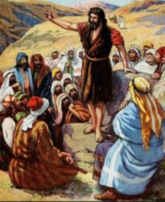 **For the questions below Highlight or change the font colour to choose the correct answer.**

* Monday: Read **Luke 3: 1-6** and answer the questions:

### John the Baptist Prepares the Way

*1 Now in the fifteenth year of the reign of Tiberius Caesar, Pontius Pilate being governor of Judea, Herod being tetrarch of Galilee, his brother Philip tetrarch of Iturea and the region of Trachonitis, and Lysanias tetrarch of Abilene, 2while Annas and Caiaphas were high priests, the word of God came to John the son of Zacharias in the wilderness. 3And he went into all the region around the Jordan, preaching a baptism of repentance for the remission of sins,*

**Prophecy about John the Baptist**

**(Written in Old Testament Book of Isaiah Chapter 40 verses 3-5)**

*4as it is written in the book of the words of Isaiah the prophet, saying:*

*“The voice of one crying in the wilderness:  
‘Prepare the way of the Lord;  
Make His paths straight.  
5Every valley shall be filled  
And every mountain and hill brought low;  
The crooked places shall be made straight  
And the rough ways smooth;  
6And all flesh shall see the salvation of God.’”*

**Question 1**

In verses 4-6 John was preparing the way of the Lord. This means

1. John was prepaing a feast for Jesus
2. John was teaching both jews and gentiles to remove all their wrong attitudes that prevented God from saving them. They must put right everything that was wrong in their lives. They must put right everything that was against what God wanted.
3. John was organising meetings with Jesus
4. John took Jesus to teach in the synagogues

**Question 2**

Who is the ***“The voice of one crying in the wilderness”***?

* Tuesday: Read **Luke 3: 7-20** and answer the questions:

### John Preaches to the People

*7Then he said to the multitudes that came out to be baptized by him, “Brood of vipers! Who warned you to flee from the wrath to come? 8Therefore bear fruits worthy of repentance, and do not begin to say to yourselves, ‘We have Abraham as our father.’ For I say to you that God is able to raise up children to Abraham from these stones. 9And even now the ax is laid to the root of the trees. Therefore every tree which does not bear good fruit is cut down and thrown into the fire.”*

*10So the people asked him, saying, “What shall we do then?”*

*11He answered and said to them, “He who has two tunics, let him give to him who has none; and he who has food, let him do likewise.”*

*12Then tax collectors also came to be baptized, and said to him, “Teacher, what shall we do?”*

*13And he said to them, “Collect no more than what is appointed for you.”*

*14Likewise the soldiers asked him, saying, “And what shall we do?”*

*So he said to them, “Do not intimidate anyone or accuse falsely, and be content with your wages.”*

**Question 3**

Identify the verses that John tells us how people should behave

1. Ordinary people must stop being selfish. They must care for the needs of other people.

Verse 

1. Soldiers must not use their authority to make money for themselves. They must not frighten people with physical attacks. They must not make people pay money to avoid trouble about some crime. The soldiers had been accusing people of crimes that they had not done.

Verse

1. Tax collectors must not use their work to cheat people. They must be honest.

Verse

**John baptizes with water**

*15Now as the people were in expectation, and all reasoned in their hearts about John, whether he was the Christ or not, 16John answered, saying to all, “I indeed baptize you with water; but One mightier than I is coming, whose sandal strap I am not worthy to loose. He will baptize you with the Holy Spirit and fire. 17His winnowing fan is in His hand, and He will thoroughly clean out His threshing floor, and gather the wheat into His barn; but the chaff He will burn with unquenchable fire.”*

*18And with many other exhortations he preached to the people. 19But Herod the tetrarch, being rebuked by him concerning Herodias, his brother Philip’s wife, and for all the evils which Herod had done, 20also added this, above all, that he shut John up in prison.*

**Question 4**

1. Who did the people think John the Baptist was?
2. Whose sandal is John unworthy to untie?
3. What did John baptize with?
4. What does Jesus baptize with?

* Wednesday: Read **Luke 3: 21-38** and answer the questions:

### John Baptizes Jesus

*21When all the people were baptized, it came to pass that Jesus also was baptized; and while He prayed, the heaven was opened. 22And the Holy Spirit descended in bodily form like a dove upon Him, and a voice came from heaven which said, “You are My beloved Son; in You I am well pleased.”*

**Question 5**

Which picture below describes most correctly what you have read in tonight’s passage?

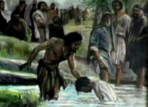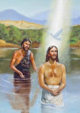

**A**

**B**

**C**

### The Genealogy of Jesus Christ

23Now Jesus Himself began *His ministry at* about thirty years of age, being (as was supposed) *the* **son** of Joseph, *the son* of Heli, 24*the* ***son*** of Matthat, *the* ***son*** of Levi, *the* ***son*** of Melchi, *the* ***son*** of Janna, *the* ***son*** of Joseph, 25*the* ***son*** of Mattathiah, *the* ***son*** of Amos, *the* ***son*** of Nahum, *the* ***son*** of Esli, *the* ***son*** of Naggai, 26*the* ***son*** of Maath, *the* ***son*** of Mattathiah, *the* ***son*** of Semei, *the* ***son*** of Joseph, *the* ***son*** of Judah, 27*the* ***son*** of Joannas, *the* ***son*** of Rhesa, *the* ***son*** of Zerubbabel, *the* ***son*** of Shealtiel, *the* ***son*** of Neri, 28*the* ***son*** of Melchi, *the* ***son*** of Addi, *the* ***son*** of Cosam, *the* ***son*** of Elmodam, *the* ***son*** of Er, 29*the* ***son*** of Jose, *the* ***son*** of Eliezer, *the* ***son*** of Jorim, *the* ***son*** of Matthat, *the* ***son*** of Levi, 30*the* ***son*** of Simeon, *the* ***son*** of Judah, *the* ***son*** of Joseph, *the* ***son*** of Jonan, *the* ***son*** of Eliakim, 31*the* ***son*** of Melea, *the* ***son*** of Menan, *the* ***son*** of Mattathah, *the* ***son*** of Nathan, *the* ***son*** of David, 32*the* ***son*** of Jesse, *the* ***son*** of Obed, *the* ***son*** of Boaz, *the* ***son*** of Salmon, *the* ***son*** of Nahshon, 33*the* ***son*** of Amminadab, *the* ***son*** of Ram, *the* ***son*** of Hezron, *the* ***son*** of Perez, *the* ***son*** of Judah, 34*the* ***son*** of Jacob, *the* ***son*** of Isaac, *the* ***son*** of Abraham, *the* ***son*** of Terah, *the* ***son*** of Nahor, 35*the* ***son*** of Serug, *the* ***son*** of Reu, *the* ***son*** of Peleg, *the* ***son*** of Eber, *the* ***son*** of Shelah, 36*the* ***son*** of Cainan, *the* ***son*** of Arphaxad, *the* ***son*** of Shem, *the* ***son*** of Noah, *the* ***son*** of Lamech, 37*the* ***son*** of Methuselah, *the* ***son*** of Enoch, *the* ***son*** of Jared, *the* ***son*** of Mahalalel, *the* ***son*** of Cainan, 38*the* ***son*** of Enosh, *the* ***son*** of Seth, *the* ***son*** of Adam, *the* ***son*** of God.

**Question 6**

Genealogy is a bit like a family tree. It shows us How many generations existed before Jesus was born in the flesh since Adam. Can you count how many “sons”? This will help count the number of generations. How many generations existed between Adam and Jesus when Jesus lived in the flesh?

1. 25
2. 30
3. 2
4. 75

* Thursday: Read **Luke 4: 1-15** and answer the questions:

### Satan Tempts Jesus

*1 Then Jesus, being filled with the Holy Spirit, returned from the Jordan and was led by the Spirit into the wilderness, 2being tempted for forty days by the devil. And in those days He ate nothing, and afterward, when they had ended, He was hungry.*

*3And the devil said to Him, “If You are the Son of God, command this stone to become bread.”*

*4But Jesus answered him, saying, “It is written, ‘Man shall not live by bread alone, but by every word of God.’”*

*5Then the devil, taking Him up on a high mountain, showed Him all the kingdoms of the world in a moment of time. 6And the devil said to Him, “All this authority I will give You, and their glory; for this has been delivered to me, and I give it to whomever I wish. 7Therefore, if You will worship before me, all will be Yours.”*

*8And Jesus answered and said to him, “Get behind Me, Satan! For it is written, ‘You shall worship the Lord your God, and Him only you shall serve.’ ”*

*9Then he brought Him to Jerusalem, set Him on the pinnacle of the temple, and said to Him, “If You are the Son of God, throw Yourself down from here. 10For it is written:*

*‘He shall give His angels charge over you,  
To keep you,’*

*11and,*

*‘In their hands they shall bear you up,  
Lest you dash your foot against a stone.’”*

*12And Jesus answered and said to him, “It has been said, ‘You shall not tempt the Lord your God.’ ”*

*13Now when the devil had ended every temptation, he departed from Him until an opportune time.*

**Question 7**

After Jesus was baptised by John the Baptist He went into the desert for 40 days. Why do you think Jesus did this?

1. He was praying and fasting about His work as a Messiah
2. He wanted to be tempted by the devil
3. He wanted to show the devil He could not be tempted by him.
4. He wanted to be away from the crowds because He was tired.

*14Then Jesus returned in the power of the Spirit to Galilee, and news of Him went out through all the surrounding region. 14And He taught in their synagogues, being glorified by all.*

**Question 8**

Jesus has returned from the wilderness with the power of the Spirit . We read last night that Jesus prayed and fasted for 40 days. Why do you think Jesus did this?

1. To prepare Himself for His teaching of the kingdom of God to everyone including the Jews in the synagogues
2. Because He wanted to be tempted by the devil
3. Because he was tired and wanted to be alone
4. He loved to be in the wilderness

* Friday: Read **Luke 4: 16-30** and answer the questions:

**Jesus reads to the people the prophecy about Him**

*16So He came to Nazareth, where He had been brought up. And as His custom was, He went into the synagogue on the Sabbath day, and stood up to read. 17And He was handed the book of the prophet Isaiah. And when He had opened the book, He found the place where it was written:*

*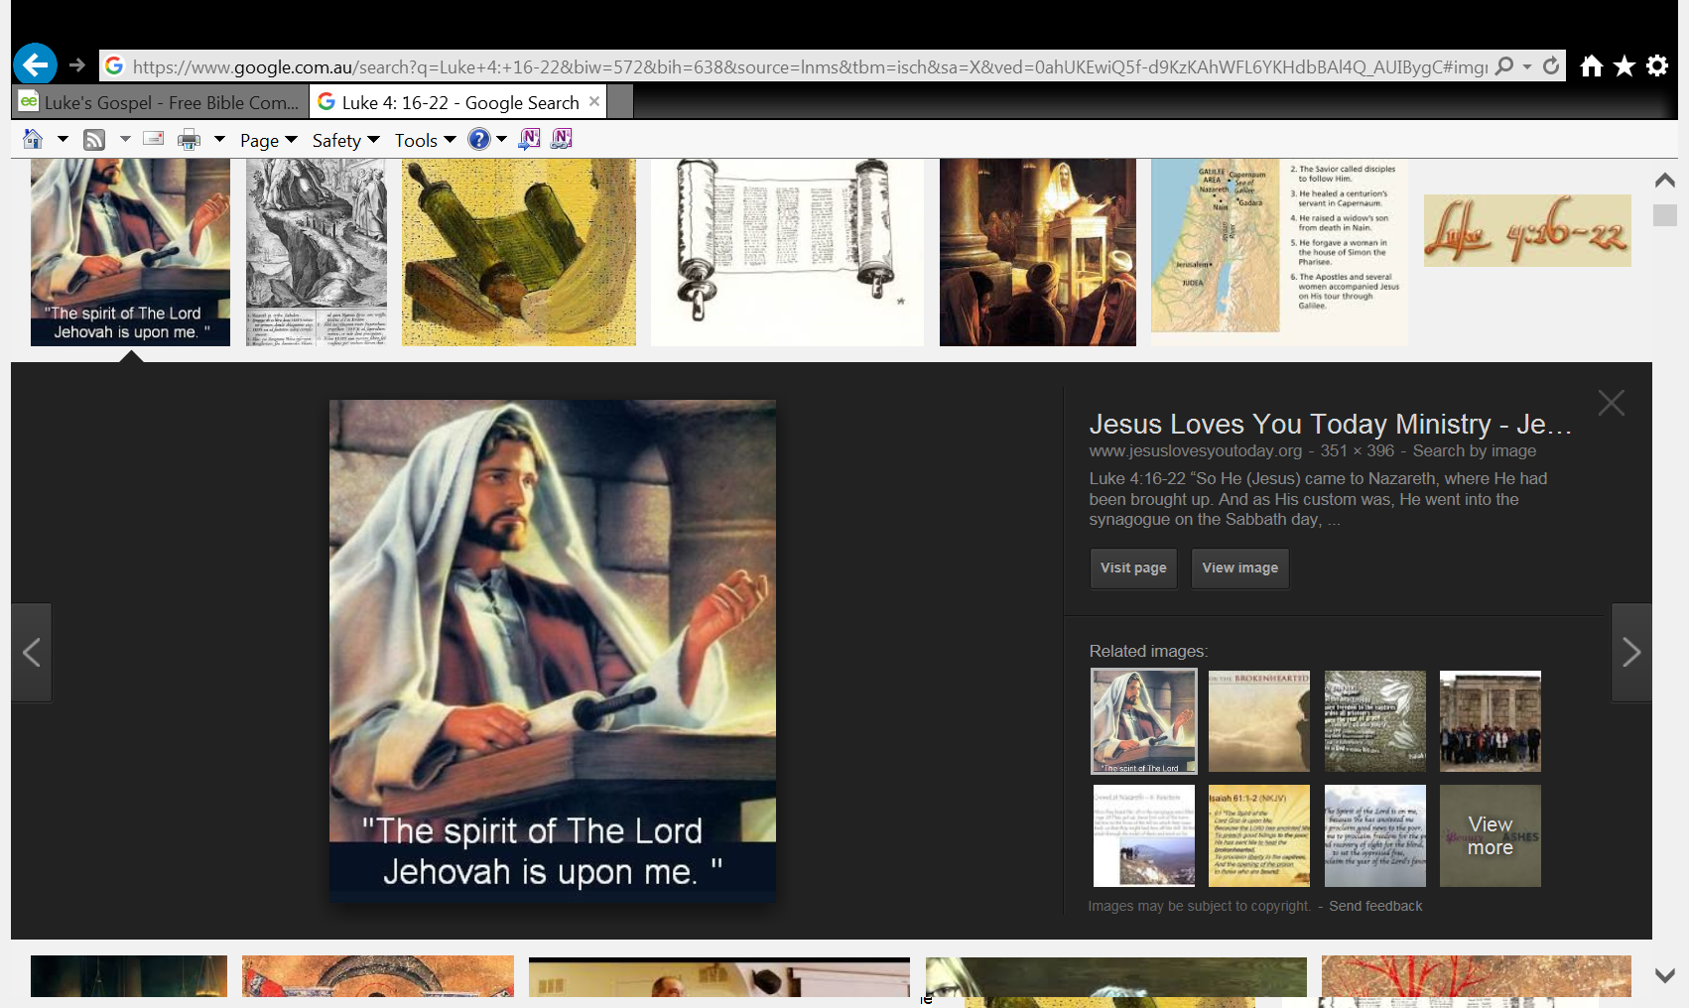18“The Spirit of the Lord is upon Me,  
Because He has anointed Me  
To preach the gospel to the poor;  
He has sent Me to heal the brokenhearted,  
To proclaim liberty to the captives  
And recovery of sight to the blind,   
To set at liberty those who are oppressed;  
19To proclaim the acceptable year of the Lord.”*

*20Then He closed the book, and gave it back to the attendant and sat down. And the eyes of all who were in the synagogue were fixed on Him. 21And He began to say to them, “Today this Scripture is fulfilled in your hearing.” 22So all bore witness to Him, and marveled at the gracious words which proceeded out of His mouth. And they said, “Is this not Joseph’s son?”*

**Question 9**

Verses 18-19 come from an Old Testament book called Isaiah. Isaiah was a prophet who prophesized about Jesus. Match the verses from Isaiah to the explanations in the table below.

The first one has been done for you.

|  |  |
| --- | --- |
| **Verse from Isaiah** | **Explanation** |
| To proclaim liberty to the captives | To announce freedom for people in prison |
|  | To give sight to people who can’t see but also to people who are not blind but can’t see the truth. Jesus wanted to also help these people understand his words. |
|  | To offer hope in the Lord to those who are sad. |

### Jesus Rejected at Nazareth

*23He said to them, “You will surely say this proverb to Me, ‘Physician, heal yourself! Whatever we have heard done in Capernaum,do also here in Your country.’” 24Then He said, “Assuredly, I say to you, no prophet is accepted in his own country. 25But I tell you truly, many widows were in Israel in the days of Elijah, when the heaven was shut up three years and six months, and there was a great famine throughout all the land; 26but to none of them was Elijah sent except to Zarephath, in the region of Sidon, to a woman who was a widow. 27And many lepers were in Israel in the time of Elisha the prophet, and none of them was cleansed except Naaman the Syrian.”*

*28So all those in the synagogue, when they heard these things, were filled with wrath, 29and rose up and thrust Him out of the city; and they led Him to the brow of the hill on which their city was built, that they might throw Him down over the cliff. 30Then passing through the midst of them, He went His way*

**Question 10**

Jesus told the Jews how Elijah and Elisha were rejected in their time in the same way some of the Jews will reject Him. We know this because we are told that when they heard Jesus speak they *“were filled with wrath” (anger).* What did they want to do to Jesus?

* Saturday: Read **Luke 4: 31-44** and answer the questions:

### Jesus Casts Out an Unclean Spirit

*31Then He went down to Capernaum, a city of Galilee, and was teaching them on the Sabbaths. 32And they were astonished at His teaching, for His word was with authority. 33Now in the synagogue there was a man who had a spirit of an unclean demon. And he cried out with a loud voice, 34saying, “Let us alone! What have we to do with You, Jesus of Nazareth? Did You come to destroy us? I know who You are—the Holy One of God!”*

*35But Jesus rebuked him, saying, “Be quiet, and come out of him!” And when the demon had thrown him in their midst, it came out of him and did not hurt him. 36Then they were all amazed and spoke among themselves, saying, “What a word this is! For with authority and power He commands the unclean spirits, and they come out.” 37And the report about Him went out into every place in the surrounding region.*

**Do you know what is special about Capernaum?**

*Capernaum was a city on the shore of the Sea of Galilee. It was an important port for buying and selling things from faraway places. Jesus used it as His home. He went out from there to teach in Galilee.*

### Peter’s Mother-in-Law Healed

*38Now He arose from the synagogue and entered Simon’s house. But Simon’s wife’s mother was sick with a high fever, and they made request of Him concerning her. 39So He stood over her and rebuked the fever, and it left her. And immediately she arose and served them.*

### Many Healed After Sabbath Sunset

*40When the sun was setting, all those who had any that were sick with various diseases brought them to Him; and He laid His hands on every one of them and healed them. 41And demons also came out of many, crying out and saying, “You are the Christ, the Son of God!”*

*And He, rebuking them, did not allow them to speak, for they knew that He was the Christ.*

### Jesus Preaches in Galilee

*42Now when it was day, He departed and went into a deserted place. And the crowd sought Him and came to Him, and tried to keep Him from leaving them; 43but He said to them, “I must preach the kingdom of God to the other cities also, because for this purpose I have been sent.” 44And He was preaching in the synagogues of Galilee.*

**Question 11**

1. Jesus healed Simon. **TRUE/FALSE**
2. Jesus laid His hands on all the sick people and healed them. **TRUE/FALSE**
3. The Demons (wicked spirits) did not know who Jesus is. **TRUE/FALSE**
4. The crowd wanted Jesus to go away. **TRUE/FALSE**
5. Jesus came to preach the kingdom of God. **TRUE/FALSE**

**What to do when you finish your Bible Study.**

Send it by email to your class email address or print and hand it to your servants next Sunday.

* Year 4A St Makarious [StMakarios4A@gmail.com](mailto:StMakarios4A@gmail.com) Class Servant- Aunty Labiba (0421891567)
* Year 4B St Bakhomious [StBakhomios4B@gmail.com](mailto:StBakhomios4B@gmail.com) Class Servant- Aunty Mira (0415595556)
* Year 4C St Anthony [StAnthony4C@gmail.com](mailto:StAnthony4C@gmail.com) Class Servant- Aunty Olivia (0433257617)