
Sunday 12th February 2017
Name:
Class:
Due Date: Saturday 18th February 2017
Completed Bible Study = 15 points,
Handed in by the due date = 5 points

The GOSPEL according to ST. Matthew
Year 5 – Bible study 2 (Chapters 3 & 4)

Highlight or Underline answers that are not written in textboxes.

Monday: Read Matthew Chapter 3 verses 1-12

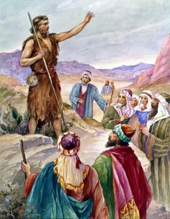
John the Baptist Prepares the Way
3 In those days John the Baptist came preaching in the wilderness of Judea, ² and saying, “Repent, for the kingdom of heaven is at hand!” ³ For this is he who was spoken of by the prophet Isaiah, saying:
“The voice of one crying in the wilderness:
‘Prepare the way of the Lord;
Make His paths straight.’”^{[a]}
⁴ Now John himself was clothed in camel’s hair, with a leather belt around his waist; and his food was locusts and wild honey. ⁵ Then Jerusalem, all Judea, and all the region around the Jordan went out to him ⁶ and were baptized by him in the Jordan, confessing their sins.
⁷ But when he saw many of the Pharisees and Sadducees coming to his baptism, he said to them, “Brood of vipers! Who warned you to flee from the wrath to come? ⁸ Therefore bear fruits worthy of repentance, ⁹ and do not think to say to yourselves, ‘We have Abraham as our father.’ For I say to you that God is able to raise up children to Abraham from these stones. ¹⁰ And even now the ax is laid to the root of the trees. Therefore every tree which does not bear good fruit is cut down and thrown into the fire. ¹¹ I indeed baptize you with water unto repentance, but He who is coming after me is mightier than I, whose sandals I am not worthy to carry. He will baptize you with the Holy Spirit and fire.^{[b]} ¹² His winnowing fan is in His hand, and He will thoroughly clean out His threshing floor, and gather His wheat into the barn; but He will burn up the chaff with unquenchable fire.”
1. St John the Baptist was the forerunner to Christ. Which means his purpose was to prepare the way for Christ. How did he do that?

Tuesday: Read Chapter 3 verse 13 – 17

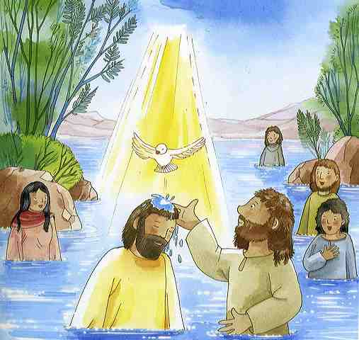
John Baptizes Jesus
¹³ Then Jesus came from Galilee to John at the Jordan to be baptized by him. ¹⁴ And John tried to prevent Him, saying, “I need to be baptized by You, and are You coming to me?”
¹⁵ But Jesus answered and said to him, “Permit it to be so now, for thus it is fitting for us to fulfill all righteousness.” Then he allowed Him.
¹⁶ When He had been baptized, Jesus came up immediately from the water; and behold, the heavens were opened to Him, and He^{[c]} saw the Spirit of God descending like a dove and alighting upon Him. ¹⁷ And suddenly a voice came from heaven, saying, “This is My beloved Son, in whom I am well pleased.”
2. Whose voice was heard from heaven saying “This is My beloved Son, in who I am well pleased”?

a) Joseph the carpenter
b) God the Father
c) John the Baptist
d) The Holy Spirit

Wednesday: Read Matthew Chapter 4 verse 1 – 11

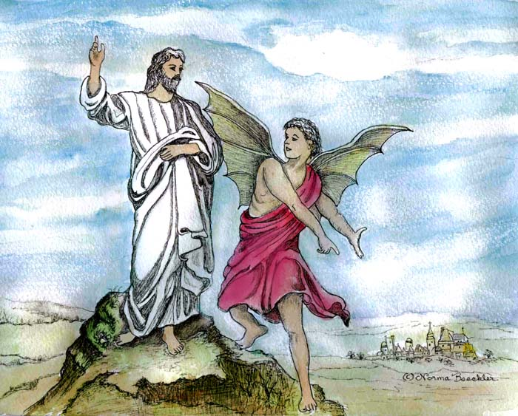
Satan Tempts Jesus

4 Then Jesus was led up by the Spirit into the wilderness to be tempted by the devil. ² And when He had fasted forty days and forty nights, afterward He was hungry. ³ Now when the tempter came to Him, he said, “If You are the Son of God, command that these stones become bread.”
⁴ But He answered and said, “It is written, ‘Man shall not live by bread alone, but by every word that proceeds from the mouth of God.’”^{[a]}
⁵ Then the devil took Him up into the holy city, set Him on the pinnacle of the temple, ⁶ and said to Him, “If You are the Son of God, throw Yourself down. For it is written:

‘He shall give His angels charge over you,’ and, ‘In their hands they shall bear you up,
Lest you dash your foot against a stone.’”^{[b]}
⁷ Jesus said to him, “It is written again, ‘You shall not tempt the Lord your God.’”^{[c]}
⁸ Again, the devil took Him up on an exceedingly high mountain, and showed Him all the kingdoms of the world and their glory. ⁹ And he said to Him, “All these things I will give You if You will fall down and worship me.”
¹⁰ Then Jesus said to him, “Away with you,^{[d]} Satan! For it is written, ‘You shall worship the Lord your God, and Him only you shall serve.’”^{[e]11} Then the devil left Him, and behold, angels came and ministered to Him.

3. How did Jesus reply to Satan every time, he tempted Jesus?

Thursday: Read Chapter 4 verse 12 – 17

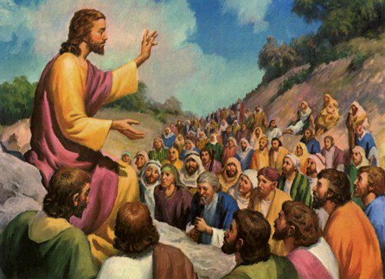
Jesus Begins His Galilean Ministry
¹² Now when Jesus heard that John had been put in prison, He departed to Galilee. ¹³ And leaving Nazareth, He came and dwelt in Capernaum, which is by the sea, in the regions of Zebulun and Naphtali, ¹⁴ that it might be fulfilled which was spoken by Isaiah the prophet, saying:
¹⁵ “The land of Zebulun and the land of Naphtali,
By the way of the sea, beyond the Jordan,
Galilee of the Gentiles:
¹⁶ The people who sat in darkness have seen a great light,
And upon those who sat in the region and shadow of death Light has dawned.”^{[f]}
¹⁷ From that time Jesus began to preach and to say, “Repent, for the kingdom of heaven is at hand.”
4. Fill in the gaps

“Repent for the of is at ”

Friday: Read Chapter 4 verse 18 – 22

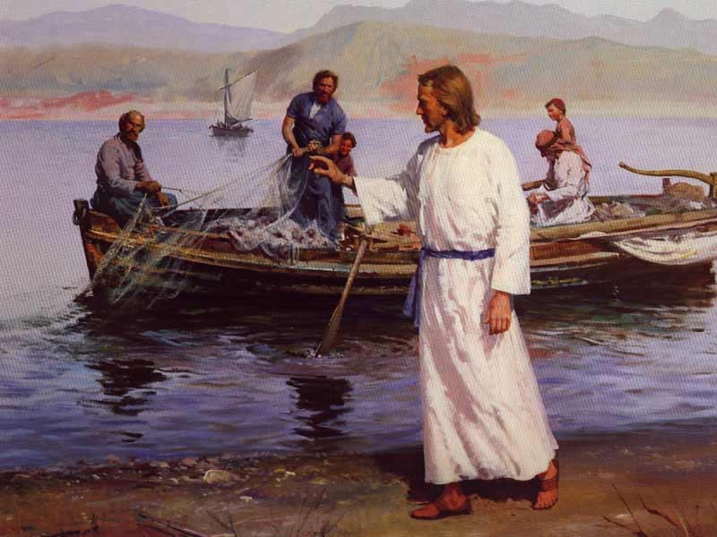
Four Fishermen Called as Disciples
¹⁸ And Jesus, walking by the Sea of Galilee, saw two brothers, Simon called Peter, and Andrew his brother, casting a net into the sea; for they were fishermen. ¹⁹ Then He said to them, “Follow Me, and I will make you fishers of men.” ²⁰ They immediately left their nets and followed Him.
²¹ Going on from there, He saw two other brothers, James the son of Zebedee, and John his brother, in the boat with Zebedee their father, mending their nets. He called them, ²² and immediately they left the boat and their father, and followed Him.

5. To whom did Jesus Christ say “Follow Me, and I will make you fishers of men”?
1.
2.

6. What did Christ do that made many people follow him?

Saturday: Read Matthew 4:23-25

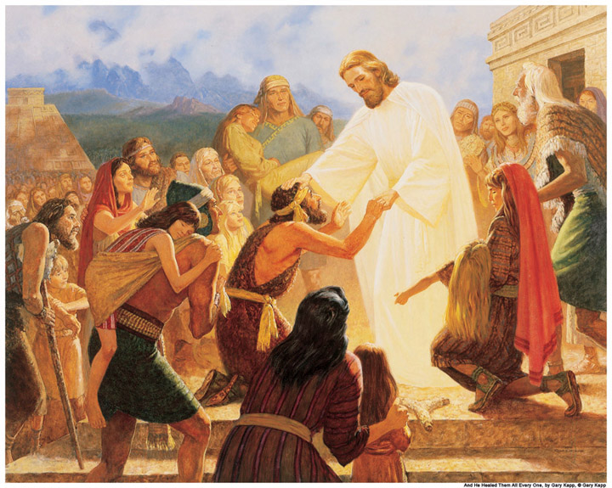
Jesus Heals a Great Multitude
²³ And Jesus went about all Galilee, teaching in their synagogues, preaching the gospel of the kingdom, and healing all kinds of sickness and all kinds of disease among the people. ²⁴ Then His fame went throughout all Syria; and they brought to Him all sick people who were afflicted with various diseases and torments, and those who were demon-possessed, epileptics, and paralytics; and He healed them. ²⁵ Great multitudes followed Him—from Galilee, and from Decapolis, Jerusalem, Judea, and beyond the Jordan.

7. Name three types of diseased/tormented people that Jesus healed:
1.
2.
3.
Memory verse

To try to remember the verse, write it out below

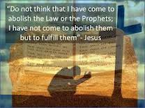

What to do when you finish your Bible Study.
Send it by email to your class email address or print and hand it to your servants next Sunday.
- Year 5B1 St Thomas stthomas5b@gmail.com Class Servant- Uncle Andrew (0416744100)
- Year 5B2 St Philip saintphilip5g@gmail.com Class Servant- Uncle Mark (0413495921)
- Year 5G St Matthew stmatthew5g@gmail.com Class Servant – Aunty Dina (0404604507)

